Badger Class Year 5 Home Learning
Year 5 have collated the following resources to support learning at home during this time. These are a guide and if you find anything else please use it.
Topic
Next term, Year 5 will be learning about the differences between the north and south of England. As part of our learning, we will be comparing Canterbury with Newcastle. The children could choose to record some facts about what Canterbury is like today.
Other ideas:
• Find out ten interesting facts about Newcastle.
• Write a story set in the local area of Canterbury
• Design an advert persuading people to come to Canterbury for a holiday.
English
https://www.topmarks.co.uk/english-games/7-11-years/spelling-and-grammar
https://gridclub.com/activities/comma-castle
https://www.topmarks.co.uk/Flash.aspx?e=spelling-grammar02
http://www.crickweb.co.uk/ks2literacy.html
https://www.literacyshed.com/the-adventure-shed.html
• Write a short adventure story using speech.
• Write an alternative ending to Holes.
• Write a character description of Stanley Yelnats.
Maths
• Revision of fractions, decimals and percentages.
https://www.oppia.org/collection/4UgTQUc1tala
https://www.topmarks.co.uk/maths-games/7-11-years/fractions-and-decimals
https://www.splashlearn.com/fraction-games
http://www.maths-games.org/percentage-games.html
Science
You can research more information on Earth and Space.
• Research the planets.
• Can you remember the planets in order?
• Find the differences and similarities between Earth and a planet of your choice.
Our next topic will be Animals including Humans. This topic focuses on teeth and the function of teeth, food chains and the digestive system.
• Write a guide to brushing your teeth for a younger child.
• Design a poster to encourage people to look after their teeth, eg dental hygiene, food and drink, visiting the dentist etc.
• Research different animal teeth and draw some pictures.
• Research food chains and make some up of your own using animals that you know.
The Arts
• Make a model of a rocket.
• Draw the planets or make a model of the planets.
• Write a song
• Make up a rap of each times table to help your quick recall
• Research your favourite artist and make a copy of their work.
French
• Revise numbers, colours, family and subjects.
https://wsh.wokingham.gov.uk/_resources/assets/inline/full/0/235078.pdf

Twinkl

Twinkl are offering free subscription so you can access resources.

How do I sign up for the free month?
Step 1: Go to www.twinkl.co.uk/offer
Step 2: Enter the code CVDTWINKLHELPS .
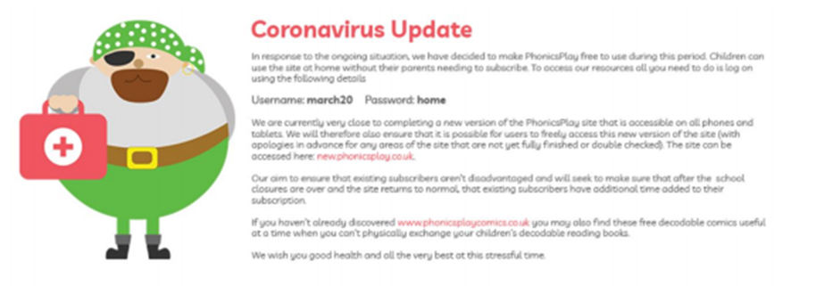
Step 3: Share the offer code and website link with anyone who could benefit

