Year 3 Home Learning
Year 3 have collated the following resources to support learning at home during this time. These are a guide and if you find anything else please feel free to use it.
Topic
Our topic at present is Mighty Metals, our lead text is Iron Man and in terms 5 we will be moving onto Julia Donaldson.
• Find out ten interesting facts about Julia Donaldson and create a fact file about her life and work.
http://www.juliadonaldson.co.uk/
Any research within these areas would be beneficial.
• Find out ten interesting facts about Modern Greece
• Design an advert persuading people to go to Scotland for a holiday.
• Research food and drink in Greece
• Research and present some facts about a famous river eg The River Nile, The River Thames.
• Name some of the rivers in the UK or discover the main rivers around the world. .
http://www.primaryhomeworkhelp.co.uk/greece/today.html
https://www.bbc.co.uk/bitesize/clips/zb39jxs
https://www.theschoolrun.com/homework-help/
https://www.twinkl.co.uk/
English
• Continue to learn your Year 3/4 spelling words and practise using them in a sentence.
• Record a diary account of a particular day.
• Read books as often as you can and if you find a book that’s particularly good, write a book review.
• Write an alternative story ending to Katie Morag delivers the mail.
• Write a persuasive advert encouraging people to visit Scotland.
https://www.topmarks.co.uk/english-games/7-11-years/spelling-and-grammar
https://www.topmarks.co.uk/Flash.aspx?e=spelling-grammar02
http://www.crickweb.co.uk/ks2literacy.html
• Practise blending and segmenting words (phase 4 and 5) https://www.phonicsplay.co.uk/
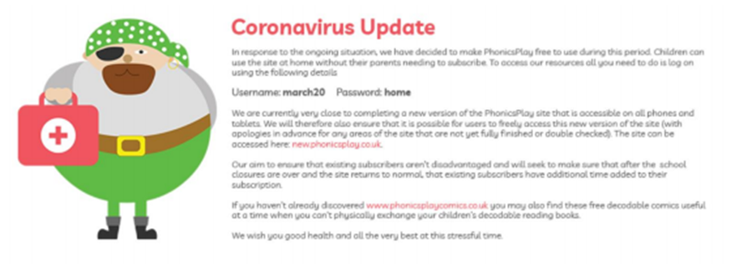
Maths
In term 5 we will be moving on to fractions of a whole, fractions of numbers and fractions of objects.
• Match fractions to the correct image and look for fractions in everyday life eg half a pizza, one
quarter of an apple etc
• Revise finding perimeters of a shape.
• Practise telling the time using an analogue and digital clock.
• Invent some fun times tables games that you could play with a friend to practise your times tables
https://www.bbc.co.uk/bitesize/topics/zvmxsbk/articles/zsr4k7h
https://www.oppia.org/collection/4UgTQUc1tala
https://phet.colorado.edu/sims/html/fraction-matcher/latest/fraction-matcher_en.html
https://www.splashlearn.com/fraction-games
Science
Our next topic will be Rocks followed by The Life process of a plant.
• Research the different types of rocks, how they are formed and their uses.
• Find out the different stages (life process of a plant).
https://www.natgeokids.com/uk/discover/science/nature/the-life-cycle-of-flowering-plants/
The Arts
• Create your own Iron Man
• Write a song
• Make up a rap of each times table to help your quick recall

Twinkl

Twinkl are offering free subscription so you can access resources.

How do I sign up for the free month?
Step 1: Go to www.twinkl.co.uk/offer
Step 2: Enter the code CVDTWINKLHELPS .
Step 3: Share the offer code and website link with anyone who could benefit

