Year 2 Home Learning
Year 2 teachers have collated the following resources to support learning at home during this time. These are a guide and if you find anything else, please use it.
Topic / English
Our topic at present is Mighty Metals, our lead text is Iron Man and in terms 5 we will be moving onto Julia Donaldson.
• Find out ten interesting facts about Julia Donaldson and create a fact file about her life and work.
http://www.juliadonaldson.co.uk/
• Can you write your own story or create a character that may appear in one of her stories?
• Handwriting practise using joined up letters (cursive).
• Read with an adult at least 3 times a week
Practise reading and writing the year 1 and 2 common exception words
https://www.woodlands.kent.sch.uk/attachments/download.asp?file=161&type=pdf
• Practise blending and segmenting words (phase 4 and 5) https://www.phonicsplay.co.uk/
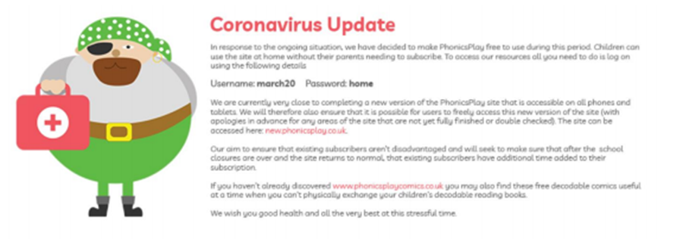
• Phonics / Spelling: Learn about homophones from BBC Bitesize. Make your own matching pairs game.
• https://www.topmarks.co.uk/english-games/
Maths
• Practise doubling and halving to 20.
• Number bonds to 20 and 100
• Practise different calculations with mixed operations, addition, subtraction, multiplication and division (numbers up to 100).
• Practise telling the time, o clock, half past, quarter past and to 5 minutes.
https://www.splashlearn.com/time-games
https://www.bbc.co.uk/teach/supermovers/ks1-collection/zbr4scw
• Develop reasoning skills. Twinkl have offered free subscription for their resources.
There are also various maths games to play at the following websites:
https://www.topmarks.co.uk/maths-games/5-7-years/counting
http://www.primaryhomeworkhelp.co.uk/maths/
https://www.youtube.com/channel/UCWKuiktSh-V3E4ysPU0VC3Q
https://www.youtube.com/results?sp=mAEB&search_query=jack+hartmann
Science
Our next topic will be plants.
• Research the parts of a plant.
• Create a poster to show what do all plants need?
• Can you design a new animal and its habitat and/or research an animal and its habitat.
https://www.topmarks.co.uk/Search.aspx?Subject=26
• Research plastic pollution and how we can help to improve this. Create a poster to show your research.
The Arts
• Write a song about plants
• Make up a rap of each times table to help your quick recall
• Can you draw a picture of a plant and label the different parts?
PE:
• How many star jumps can you do in 1 minute?
• Design a healthy lunchbox
• Create a poster to show how can keep healthy and safe.
• Learn to tie your shoelaces.

