Year 1 Home Learning

Year 1 have collated the following resources to support learning at home during this time. These are
a guide and if you find anything else please feel free to use it.

Topic / English:
Our topic at present is Journeys and in Term 5 the children in Year 1 will be learning about Farms.
Children could learn about:
• Landscape features in the country
• Places of interest in Canterbury
• Farm facts
• Space facts
http://www.sciencekids.co.nz/sciencefacts/space.html
https://www.nasa.gov/kidsclub/index.html
• Neil Armstrong and other real astronauts
https://www.natgeokids.com/uk/discover/science/space/neil-armstrong-facts/
https://www.youtube.com/channel/UCRFIPG2u1DxKLNuE3y2SjHA

English:
The children have been learning about We’re Going on a Bear Hunt this term:
https://www.youtube.com/watch?v=Waoa3iG3bZ4.
• Can your child write the story including as many adjectives for the settings as possible
• Can they put themselves in the story and re-write it
Next term their lead text will be Farmer Duck
https://www.youtube.com/watch?v=Rt5zQ1UO6rE
• Can children write the story?
• Can they identify adjectives in the story?
• Can they describe the characters and settings?
• Children can also practice their handwriting using pre-cursive letter formation.
• Can they write their own stories with them in it using adjectives and connectives (and, but, so, because).
Twinkl have offered free subscription for their resources;
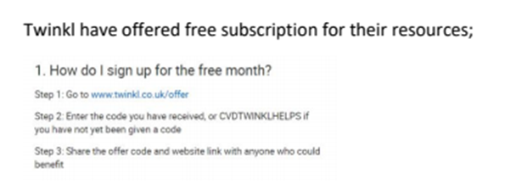
Phonics/Reading:
The children are getting really good at phonics but will always benefit from practicing more!
Here are some resources:
https://www.ictgames.com/mobilePage/literacy.html
https://www.phonicshero.com/new-login/ - some free resources or a 7 day parent trial if you wish.
https://www.phonicsplay.co.uk/ - lots of free phonics games with a free months subscription
• There are also lots of Youtube videos which focus on specific phonic sounds such as
Alphablocks and Geraldine Giraffe.
• Children would benefit from reading as much as possible while at home.
https://www.phonicsplaycomics.co.uk/
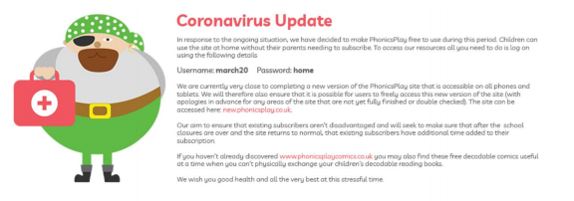
• Can they design an alien and use the sounds they know to make up a name. Remember it
must be an alien (made up) word.

Maths:
• This term the children have been learning tens and ones with numbers up to 50.
• They have also been adding and taking away with numbers within 20
• They have been measuring length, height and weight.
Next term the children will be focusing on multiplication and division by;
• Counting in tens
• Making equal groups
• Adding equal groups
• Learning doubles
• Grouping and sharing equal groups
The following websites have a lot of good resources
https://www.ictgames.com/mobilePage/index.html
https://www.topmarks.co.uk/
• Your child could also practice their number formation for numbers up to and beyond 50
• Your child can practice all the different ways of making 10 and then 20.
• The Numbots website and they can practice counting and number recognition on this site
https://numbots.com/

Science:
The children have been learning about The Seasons with a focus on Spring this term
Next term the focus will be Growing Plants
Children could:
• Plant seeds and make a growth diary
• Learn the names of plants
• Learn the different parts of plants
• Help in the garden
The Arts:
• Draw pictures depicting seasonal change
• Create their own shoe box farm
• Practise the Spring Chicken song that we have been learning in assembly
https://www.youtube.com/watch?v=IEey4LZLeGw

PE:
• Children have been enjoying practising mindfulness via the use of Cosmic Yoga
https://www.cosmickids.com/
• How many star jumps can they do in one minute?
• Design a poster about how we can stay healthy and fit

