Here are the links for the pre-recorded topic lessons:
Monday | Tuesday | Wednesday
Science:  How do fossils provide evidence for evolution?  In this lesson, we are going to learn how fossils are formed and how they provide evidence for the theory of evolution. We will learn what the fossil record is and why there are parts missing from the record. In this lesson, you will need a piece of paper and a pencil.  Please click the link to access the lesson and task:  How do fossils provide evidence for evolution? (thenational.academy)  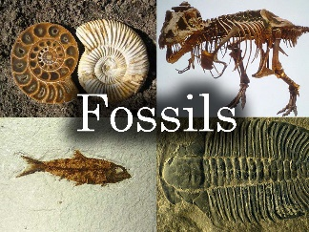 | RE:  What are the five pillars of Islam?  In this lesson, we will be studying in detail the five main pillars of Islam; Shahadah, Salat, Zakat, Sawm and Hajj. These are considered by Muslims to be the most important practices of their religion.  Please click the link to access the lesson and task:  What are the five pillars of Islam? (thenational.academy)  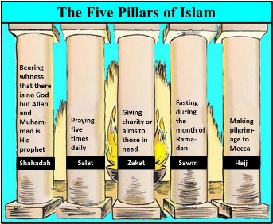 | Music:  To layer syncopated rhythms  In this lesson, you will review syncopation. You will learn some syncopated rhythms and layer them to create a three part texture. You will also review the song we learnt in lesson one.  Please click the link to access the lesson and task:  To layer syncopated rhythms (thenational.academy)

Thursday | Friday
History:  Which animals lived in Prehistoric Britain?  In this lesson we will learn about some prehistoric animals. These beasts roamed earth during the stone age, and many of them are now extinct. What happened?  Please click the link to access the lesson and task:  Which animals lived in Prehistoric Britain? (thenational.academy)  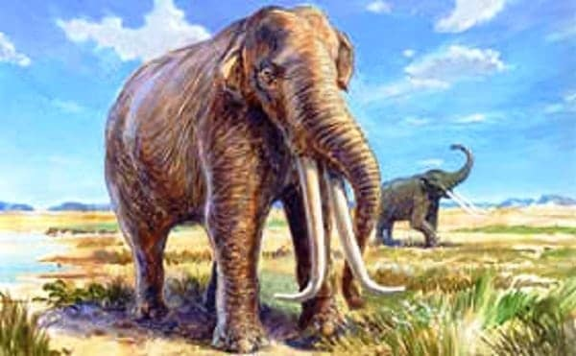 | Geography:  What is the geography of Wales?  In this lesson, we will recap our knowledge of the seven continents, and locate the UK on a world map. We will then zoom into Wales and look at the different human and physical geographical features. We can then compare these to the area where we live, as well as comparing them to Scotland.  Please click the link to access the lesson and task:  What is the geography of Wales? (thenational.academy)  