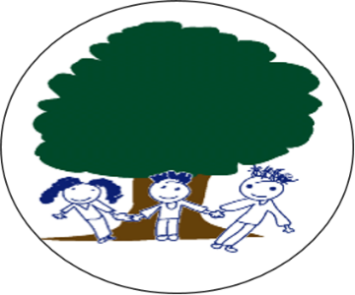
PARKSIDE COMMUNITY PRIMARY SCHOOL
Term 6 Newsletter

Friday 5th June 2020
Dear Parents/Carers,
Welcome to what is a very strange start to Term 6 and the final term of this academic year. I hope that you and your families are all keeping safe and well. This term we have welcomed back some of our Reception, Year 1 and Year 6 pupils and we are looking forward to the time when all pupils are able to safely return to school. The staff are missing the pupils and have enjoyed catching up with them when they have phoned home. The teachers are busily preparing work for the Home Learning, which can be found on the school website, https://www.parksidecommunityprimaryschool.co.uk .
We would love to see some of the projects you have been completing at home so please email some pictures to info@parkside.kent.sch.uk and we will share these photos on the website. Or you could just send your teacher an email and I am sure they will respond to you.
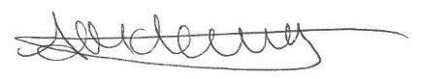
I would like to take this opportunity to thank all of the parents, carers and friends of Parkside for making me feel so welcome throughout this year and for your continued support. I am looking forward to seeing you soon when normality resumes. Take care of yourselves and your families and keep safe.

Mrs Anthea McLevy
Head of School

Kent Test - Although no decision has yet been made as to the final arrangements for the Kent Test, which will apply to current Year 5 children, the application to register your child for it is now open and available at www.kent.gov.uk/ola. The closing date for registering is Wednesday 1st July and the test itself is currently scheduled for Thursday 10th September. Please do contact the school to speak to your child’s class teacher if you have any questions.
VE Day – Our Key Worker Children were thinking about life during World War II and Miss Thompson found a nice chocolate cake recipe using only ingredients that were available during WWII. The children enjoyed the baking and tasting. We also made some flags and bunting to decorate the classroom and on VE Day we had a tea party. The children enjoyed all the activities throughout the week.

Fitness – Mr Groombridge wanted to share a few new items on the BBC Sports website;
https://www.bbc.co.uk/sport/live/52647509 - Mark Wright
https://www.bbc.co.uk/sport/av/52480996 - Jesse Lingard
https://www.bbc.co.uk/sport/av/football/52837253 - Cooking class with Kevin De Bruyne

Reading – Mrs Messenger has kindly shared a couple of links to websites for FREE reading as we know the children enjoy stories and reading. There are more links to explore on our school website, under the Whole School tab.
https://www.lovereading4kids.co.uk/
https://home.oxfordowl.co.uk/

Rainbows - The children have made some rainbows to decorate our school gates to thank all of the great work Key Workers have been doing. Send us some pictures of the rainbows you have made at home. Please send them to info@parkside.kent.sch.uk

Parkside Quiz Night – The PTFA ran Parkside’s first Quiz Night on Saturday 14th March which was a great success. Thank you to all parents, staff and members of the community who came along and joined in the fun evening. A special thanks for Mr Fallon for organising the evening. Well done to Mr Williams and his team for winning the trophy. Look out for the date of the next Quiz Night and see if you can win the trophy!

Until we see you again, please stay safe and stay well, from all the staff at Parkside!

