PARKSIDE COMMUNITY PRIMARY SCHOOL
Term 1 Newsletter (2)

Thursday 21st October 2021
Dear Parents/Carers,
We have had a very busy start to this academic year! The children have had the opportunity to take part in many activities through their learning and whole school events. For me, I have enjoyed welcoming parents and carers back into the school to join in with craft sessions and class assemblies. I am looking forward to seeing many of you at the upcoming events next term.
The school has had many wonderful opportunities so far and I think the highlight has to be being selected as a school to have a tree planted in the grounds in honour of the Queens Jubilee. We welcomed Lady Colgrain, the Lord Lieutenant of Kent and the children enjoyed talking to her asking questions and representing the school. Lady Colgrain was very complimentary of the children and commented on how polite they were. We also welcomed the chairman of KCC Ann Decker, The Sheriff of Canterbury and representatives of Canterbury City Council. It was certainly a big day for the school
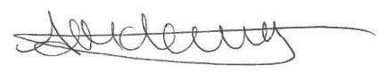
Thank you for all your support in making the start to the academic a success. I wish you all a safe and happy half term and am looking forward to next term and all the exciting plans we have.

Mrs Anthea McLevy
Head of School
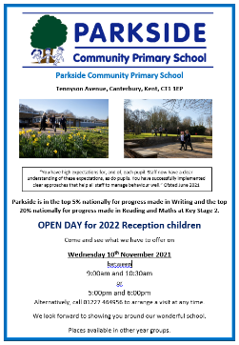
New Starters Open Day – The school will be holding an Open Day on Wednesday 10th November 2022 between 9:00am and 10:30am and 5:00pm and 6:00pm for the children that are due to start school in September 2022. It will be woderful to see you if you have a child that could start school in September 2022, let your friends and family know as well.
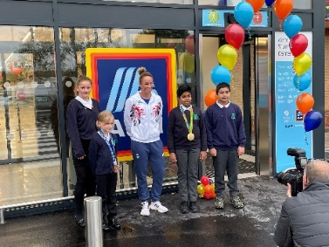

Aldi Store Grand Opening – Some children were invited to the grand opening of the new Aldi store in Canterbury. We then welcomed an Olympian, Susannah Townsend, to the school where she presented an assembly to all the children. She brought along her gold and bronze medal to show the children. We were all surprised at how heavy the medals were and enjoyed learning about how she became a successful hockey player.
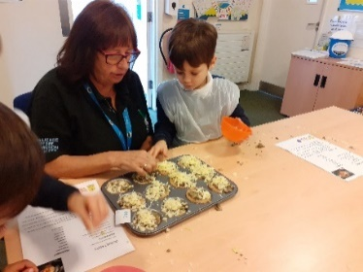

Poets Corner – The children in Otter and Hedgehog class enjoyed going to Poets Corner to complete some cookery sessions. They enjoyed making delicious cheese and mushroom Croustades. Thank you to all at Poets Corner for inviting us.

Macmillan Coffee Morning – Thank you so much to everyone that supported the Macmillan Coffee Morning and cake sale. We managed to raise £73.00 to donate to this well-deserved charity.

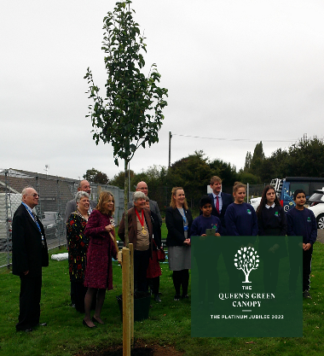
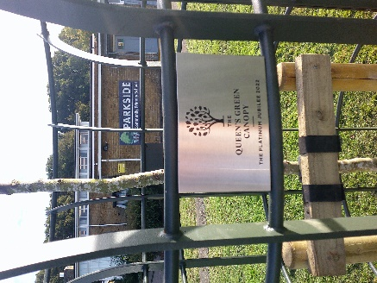
Queen’s Green Canopy – Parkside were one of 70 primary schools across Britain that were selected to have a tree planted in honour of the Queen’s Jubilee. We feel very proud to have been chosen and were pleased to welcome several dignitaries to the school. The tree can be found on the grassed area at the front of the school. The children were a credit to you all and welcomed the guests to the school. Have a look at the website and see if you can find the school’s tree. https://queensgreencanopy.org/

Bikeability – Well done to all the children that took part in the bikeability this term. They completed Level 1 and some went on to complete Level 2.

Upcoming dates:
First Day of Term 2 – Monday 1st November 2021
Halloween Disco – Friday 29th October 2021 5pm to 7pm. Get your tickets from the office.
Parents Evening – Wednesday 3rd November 2021 3pm to 7pm. Book your appointment with the class teacher.
Open Day for Reception Children 2022 – Ask at the office for details.
Remembrance Assembly – Thursday 11th November 2021 10:50am. All welcome.
Children in Need – Friday 19th November 2021. £1.00 donation.
Non-uniform Day – Friday 26th November 2021. Tombola gift as payment for non-uniform.
Christmas Fair – Friday 3rd December 2021. Raffle tickets are available from the PTFA or School Office.
Christmas Nativity at All Saints Church – Friday 10th December 2021. All welcome.
Christmas Jumper Day – Monday 13th December 2021.
Christingle – Tuesday 14th December 2021. All welcome.
Christmas Dinner Day – 15th December 2021
Christmas Party Day – Wednesday 15th December 2021.
Last Day of Term – Thursday 16th December 2021.

Christmas Fair – The PTFA are busy organising the Christmas Fair which will be on Friday 3rd December 2021, starting at 2pm. We have many exciting things planned for the fair and have had many wonderful prizes donated to the school for the raffle. Tickets are available from Mrs Cross, Miss Austen or the School Office for £1.00 a strip. If you would like a table at the Fair please contact Mrs Cross or Miss Austin. We would like to thank all of the companies that have donated to us and made this possible. We are all looking forward to a wonderful afternoon and hope to see you all there.

