PARKSIDE COMMUNITY PRIMARY SCHOOL
Term 1
Newsletter
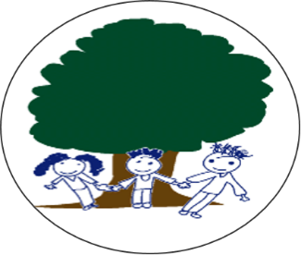

Welcome back…
Dear Parents/Carers
Welcome back to the new academic year!
Firstly, I would like to mention how lovely and smart the children look in their uniform and school PE kit on their PE days. It has been a delight to see them all and I am very proud of how well they have settled back into their classes and taken on board the changes that have been put in place to keep the children safe during these unusual times. We are looking forward to the times when we can welcome you back into classes for craft sessions and events.
As I am sure you have noticed there have been some changes to the site over the summer break and many improvements have been made. The mosaics that have been added are spectacular and certainly brighten up the school. There have been some small building projects taking place to repair the boiler and improve the nursery classroom, and we are awaiting the start date for roofing and window work to begin. All of this work is helping to improve the learning environment for the children and make Parkside a school to be proud of.
Finally, I would like to welcome Caterpillar Class from St Nicholas School in Canterbury, who have settled into the nursery classroom on site so they can provide an appropriate provision for the children that attend their school.
I am looking forward to another productive year with the children continuing to make me proud to be a part of Team Parkside.
Yours faithfully,
Mrs McLevy

Covid19 Update – Just a reminder to parents and carers of the importance of social distancing whilst waiting to enter the school grounds. Please limit the number of adults entering the site to one per family to ease congestion and make distancing easier. There will be a slight change to the timings of when the school gates will be opening and these are as follows:
- 8.40 until 9.00am – Gate open for children to arrive at school
- 2.50 until 3.10pm – Gate open for parents to collect their children from the playground
As we have extended the gate opening times, please do not feel that you must arrive as the gates open. Fewer people arriving on site at the same time will help to restrict contact between adults.
Children who are attending Breakfast Club, open from 8.10-8.25am, are able to come via the School Office still and all other children should go directly to their classrooms. Additionally, please can parents and carers be mindful when parking outside the school to keep clear of the gates so that these entrances are not blocked.
Water Bottles - Please can we remind you that currently children need to bring their own water bottle in and take it home at the end of the day to be washed and refilled. Children should only bring water in to drink in line with school policy. Bottles are available to purchase for £1.00 at the School Office.

Dates for your Diary:

Friday 25th September – Macmillan Coffee Morning

World's Biggest Coffee Morning is Macmillan Cancer Support's biggest fundraising event each year. We will be holding a Socially Distanced event under our playground canopy. The donations received go towards Macmillan services. Please watch out for further information on our website regarding times for this event.
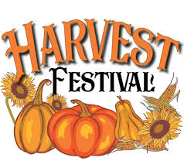

Friday 2nd October – Harvest Festival Service

Unfortunately due to current guidance we will not be able to host this service at All Saints Church this year. The children will be celebrating Harvest within their pods and we will be sharing this virtually across the school.

Monday 12th October – Black History Week

As we look forward to celebrating Black History Week this October, we will celebrate the enormous contribution Black Britons have made to our vibrant and diverse society. Children will be undertaking a variety of activities throughout the week to learn more about how our culture has been enriched through the years.

Friday 16th October – FLU Vaccinations

The School Public Health Team are able to provide FREE flu vaccinations here in school this year. This is administered as a very quick and simple nasal spray. You will need to sign your child up to receive the vaccine (link below). Given the current situation, we would really recommend that all parents and carers sign their child up for this.

https://www.kentcht.nhs.uk/forms/imms-consent-form/

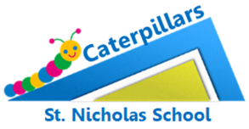
Caterpillar Nursery - We have welcomed St Nicholas Nursery to the school site and hope they will enjoy making use of the wonderful space and facilities we have here at Parkside!

Secondary School Admissions – Application for Secondary School places are now open for parents of Year 6 pupils. Please visit the link below to find the online form to apply for a secondary place for your child. The deadline for applications is Monday 2nd November 2020.
https://www.kent.gov.uk/education-and-children/schools/school-places/secondary-school-places#tab-2

Kent Test – The date for the Kent Test has been slightly delayed this year due to the impact of the Covid19 pandemic. The test date has now been confirmed as Thursday 15th October and we will let parents, whose children are taking the test, know any further updates as and when we receive them from the Local Authority.
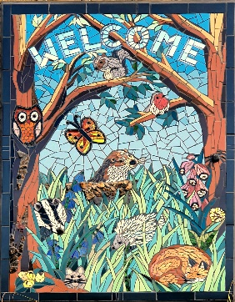
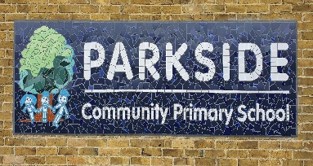
Mosaics – We are very proud and excited to unveil our two new mosaics decorating the school building, which can be seen as you approach the main entrance. A huge thanks to Tamara Froud at Mosiac Art Ltd for designing and installing the mosaics for us.
We think they look wonderful and we hope you do too!

Woodland Trust Tree Pack – Mrs Simmons has successfully applied for several trees from the Woodland Trust for Parkside! During the month of November we will be taking delivery of some sapling trees which can be planted around the school site to enhance the area for both pupils and staff alike and for the local wildlife to enjoy as well. As we have so many trees coming as part of the pack, if you would be interested in one for your garden please telephone or email the school office. I am sure your children would enjoy planting these with you.

FOR NEXT TIME:

After-School Clubs –

PTFA anyone? –
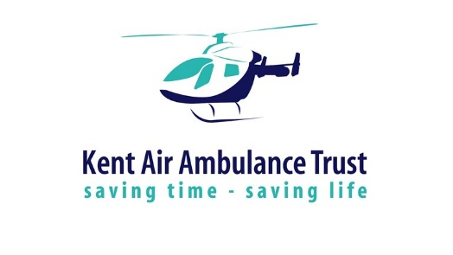
UK Air Ambulance Stamps Collection – Help the UK Air Ambulance Services by recyling your Used Postage Stamps. All you need to do is cut or carefully tear the stamped corner of any envelope or packet that you receive in the post and send your stamps into school – we will do the rest.
CRISP PACKETS
Batteries – We are still running the Battery Recycle scheme through Kent County Council and people are welcome to bring old batteries to the main school officfe for us to recycle. If we manage to recycle a certain amount we could qualify for vouchers to use on stationary products for around the school – so the more brought in the better! We thank parents and carers for their support with this so far!

