Summer Term Week 1
Literacy- Squirrels!

Starter Activity- Spend 5/10 minutes writing your name.

We are learning about ‘Why do Squirrels hide their nuts?’
Please find out about squirrels using non-fiction books or the internet (remember to choose a safe search site such as Google Kids).
Draw a picture of a squirrel and find out interesting facts. See if you can have a go at writing these facts to create a fact file

Phonics
Watch Mr Thorne does phonics, Bitesize or signup to Phonics play Phase 2 sounds. Please learn a new sound each day and practise writing the letter and CVC words.
https://www.youtube.com/results?search_query=mr+thorne+does+phonics+phase+2
https://www.phonicsplay.co.uk/
https://www.bbc.co.uk/bitesize/topics/zf2yf4j

Reading
Listen to an E-book and practise your blending to read. Read a bedtime story every night and talk about it in your own words.
https://www.oxfordowl.co.uk/for-home/find-a-book/library-page
https://www.teachyourmonstertoread.com/

Number 1

This week, we will be looking at number 1! Watch this short clip all about number 1!
https://www.youtube.com/watch?v=Zjan6evga7g
Paint and draw number 1 in as many ways as you can.

Can you find 1 of a variety of things from around the house?
1 shoe?
1 Book?
1 Apple?
1 Teddy?

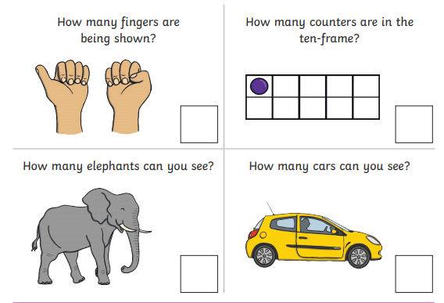
Extension Activity Number 5

This week, we will be looking at number 5! Watch this short clip all about number 5!
https://www.youtube.com/watch?v=H2HRA0HYx9U
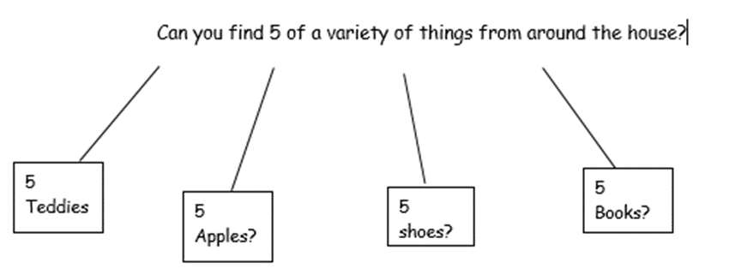

Use this number chart and things from around the house to find different ways of making number 5!

_+_=5 _+_=5

_+_=5 _+_=5

_+_=5 _+_=5

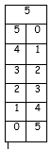

P:E Try Cosmic Kids Yoga https://www.youtube.com/user/CosmicKidsYoga

