**Class 3 Maths task - SHOPPING FOR SNACKS AND DRINKS**

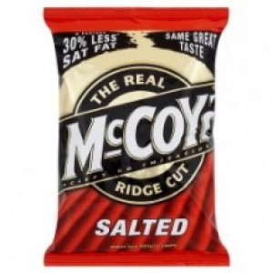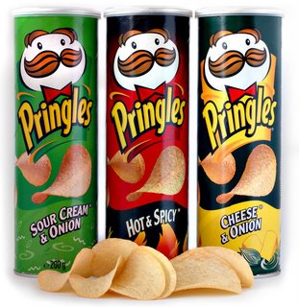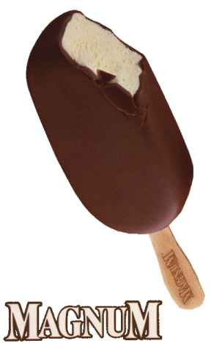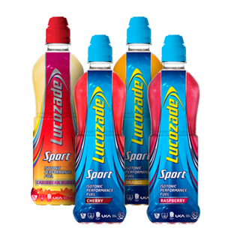

£1.25 40p 60p £1.90 £1.45

Task 1 - Work out how much it costs to buy 2, 3, or 4 of each item.

|  |  |  |  |  |
| --- | --- | --- | --- | --- |
|  | 1 | 2 | 3 | 4 |
| http://3.bp.blogspot.com/-TGnWfs1Ai90/TvCLVSvL5pI/AAAAAAAAAME/cvvUrWv2enI/s1600/magnum1.JPG |  |  |  |  |
| http://www.lucozadeshop.com/images/offer/large/lucozadesport-case72-specialoffer.jpg |  | £1.25 x 2  =£2.50 |  |  |
| http://www.thedrum.com/uploads/styles/home_page_featured/public/drum_basic_article/88954/main_images/chewy%203d%20sticks%20bcurrant,%20sberry,%20fsalad.jpg?itok=bPTHb4ad |  |  |  |  |
| http://eng509cea177e41b.img.mygostore.co.uk/80A623/cdn/media/en/g5/09/ce/a1/77/e4/1b/catalog/product/cache/1/image/300x/9df78eab33525d08d6e5fb8d27136e95/m/c/mccoys_original_36x50g.jpg |  |  |  |  |
| http://handsfromtheriver.com/wp-content/uploads/2013/07/pringles.jpg |  |  |  |  |

Task 2 - Work out how much it costs to buy a mixture of items.

How much change would you receive if you paid with a £5 note?

|  |  |  |  |  |
| --- | --- | --- | --- | --- |
|  | http://www.lucozadeshop.com/images/offer/large/lucozadesport-case72-specialoffer.jpg£1.25 | http://www.thedrum.com/uploads/styles/home_page_featured/public/drum_basic_article/88954/main_images/chewy%203d%20sticks%20bcurrant,%20sberry,%20fsalad.jpg?itok=bPTHb4ad40p | http://eng509cea177e41b.img.mygostore.co.uk/80A623/cdn/media/en/g5/09/ce/a1/77/e4/1b/catalog/product/cache/1/image/300x/9df78eab33525d08d6e5fb8d27136e95/m/c/mccoys_original_36x50g.jpg60p | http://handsfromtheriver.com/wp-content/uploads/2013/07/pringles.jpg£1.90 |
| http://3.bp.blogspot.com/-TGnWfs1Ai90/TvCLVSvL5pI/AAAAAAAAAME/cvvUrWv2enI/s1600/magnum1.JPG£1.45 | *£1.45 + £1.25 =*  £2.70 |  |  |  |
| £1.25http://www.lucozadeshop.com/images/offer/large/lucozadesport-case72-specialoffer.jpg |  |  |  |  |
| http://www.thedrum.com/uploads/styles/home_page_featured/public/drum_basic_article/88954/main_images/chewy%203d%20sticks%20bcurrant,%20sberry,%20fsalad.jpg?itok=bPTHb4ad40p |  |  |  |  |
| http://eng509cea177e41b.img.mygostore.co.uk/80A623/cdn/media/en/g5/09/ce/a1/77/e4/1b/catalog/product/cache/1/image/300x/9df78eab33525d08d6e5fb8d27136e95/m/c/mccoys_original_36x50g.jpg60p |  |  |  |  |
| http://handsfromtheriver.com/wp-content/uploads/2013/07/pringles.jpg£1.90 |  |  |  |  |

**Challenge**

How much would it cost to buy 2 of everything?

How much would it cost to buy 3 lots of Pringles and 4 bottles of Lucozade? How much change would you get if you gave the cashier £20?

How much would it cost to buy 6 bags of McCoy’s crisps, 2 packets of Chewits and 3 bottles of Lucozade? How much change would you get if you gave the cashier £15?

How much would it cost to buy a Magnum, a packet of Chewits, a tube of Pringles and a Lucozade drink for five of your friends?