12th May 2020

Dear Parents and Carers,

I hope that both you and your families continue to remain safe and well and you are managing to get through these difficult times together. I am sure that you are aware of the recent announcement made by the Prime Minister, which outlined some easing of the ‘lockdown’ measures that we have been living with. As part of this, schools are to prepare to welcome back Nursery, Reception, Year 1 and Year 6 pupils from Monday 1st June.

I am sure that I am not alone in having some questions with regard to what this will look like and even since the announcement, some further guidance has already been given to us by the Department for Education. In my experience, this information will continue to trickle through over the coming days and I will also be speaking to other headteachers and we will endeavour to ensure that we are doing everything we can to make sure that any return is focused on the safety of pupils, staff and families. It is my understanding that the childcare provision that we are currently offering to the children of key workers, will continue for pupils in Years 2, 3, 4 and 5.

Could I also please remind you that whilst school is essentially ‘closed’ at the moment, teachers are working hard to provide online teaching activities that are available on our school websites and many have also told me how nice it has been to hear from parents and pupils via the email system that we have set up for your use. Please do email a message to teachers or send a picture of any activities that you are enjoying with your children – many are put on the school website for everyone to see! The email address is info@parkside.kent.sch.uk .

I would also like to remind you that the office staff at school are currently still working (remotely), so if there are any issues, please do either call us on 01227 464956 or email info@parkside.kent.sch.uk and you will receive a reply.

Thank you all once again for support of the school and its staff. We are truly looking forward to seeing your children back as and when it is safe to do so and we will do all we can to ensure that we catch up on any learning missed.

Yours faithfully,

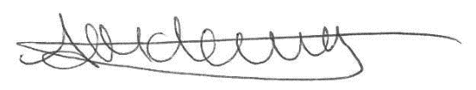

Anthea McLevy
Head of School

