Phonics & Literacy Home Learning Yy, Zz, ZZ zz, Qu qu Week 4
For literacy this week I would like you to draw a story map of ‘The Noisy House’ narrated by Adam. Play the story video then join in with Adam as he retells the story and models how to draw the story map. https://classroom.thenational.academy/lessons/to-draw-a-story-map-c9h6ad?activity=video&step=1
Then step out the story with Adam and retell it to someone in your family.
https://classroom.thenational.academy/lessons/to-use-actions-to-step-out-a-story-cmtk6d?activity=video&step=1
Phonics: In Squirrel Class we do two daily phonic sessions. We focus on blending (reading) during the morning 15 minute session and in the afternoon we practise segmenting (spelling). This pack is designed with this in mind.
Sing the alphabet song together by following the link
https://www.bbc.co.uk/cbeebies/watch/get-squiggling-letters-alphabet-song?collection=little-learnerss://www.youtube.com/watch?v=OQ1AnMCGTzg
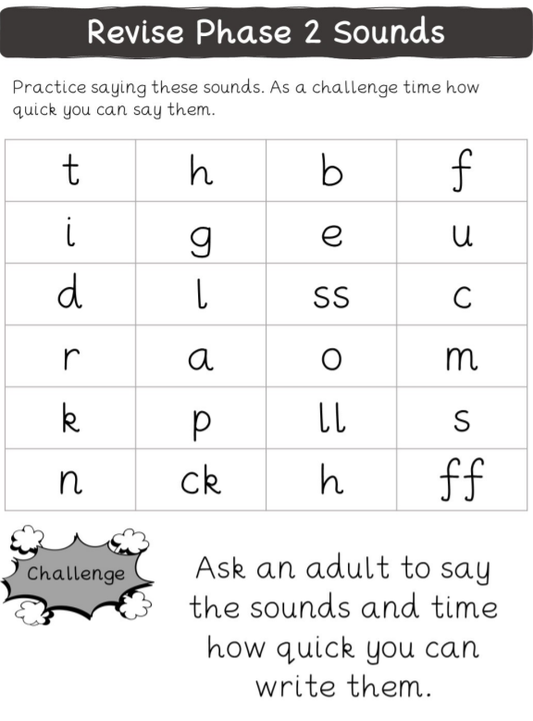

Practise writing your name? What sound does your name begin with? What are the names of your family members? What sound does their name begin with?

Please follow the link to watch the Letters and Sounds video each day to introduce new sounds.
https://www.youtube.com/watch?v=jFR1LoM6Giw Yy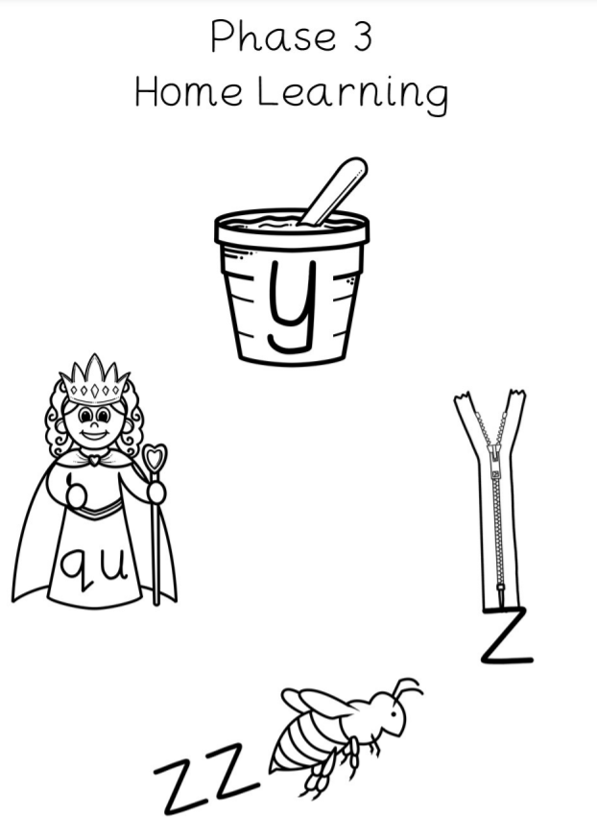

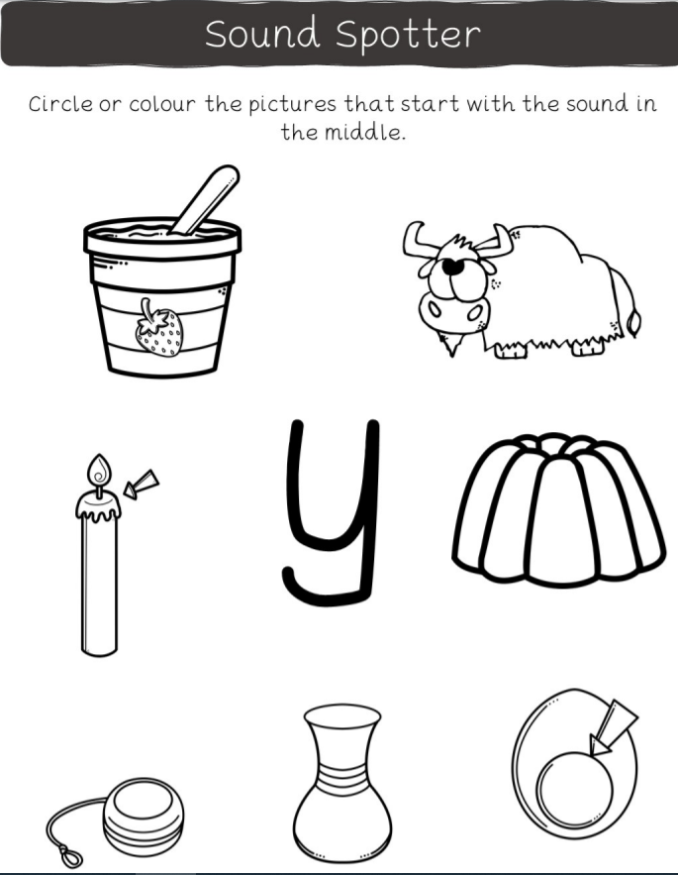

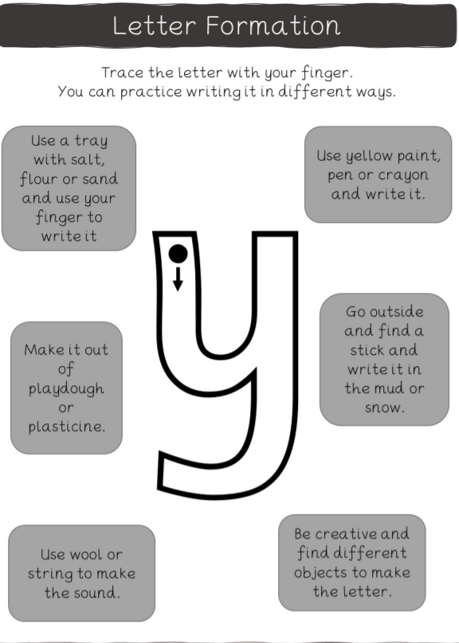

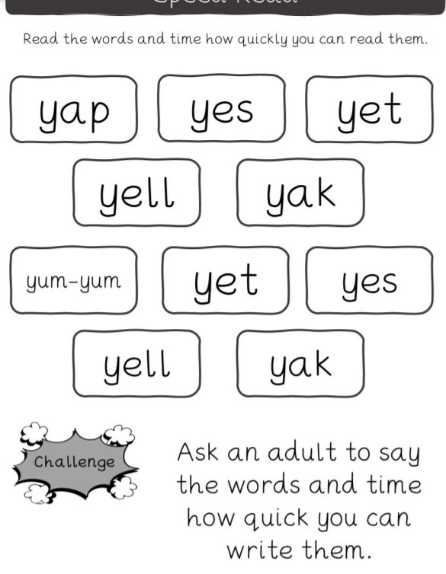

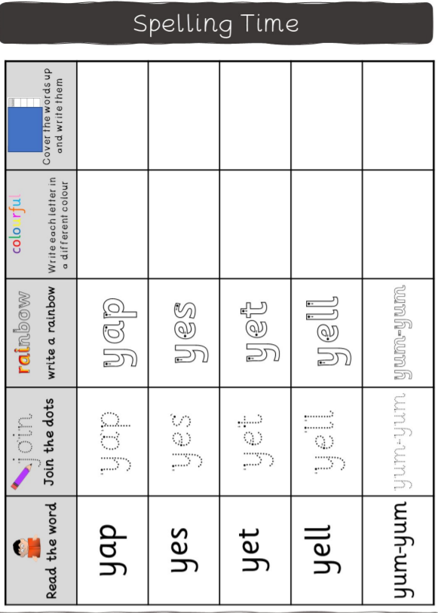

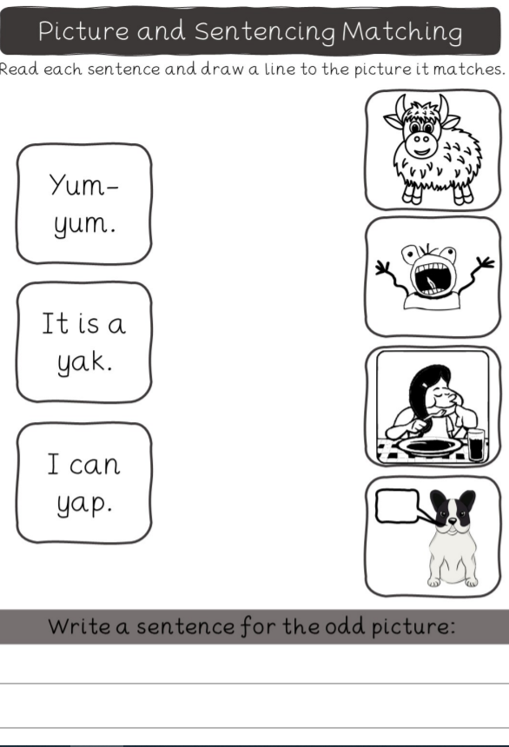

https://www.youtube.com/watch?v=mTpbxjasiQI
Zz
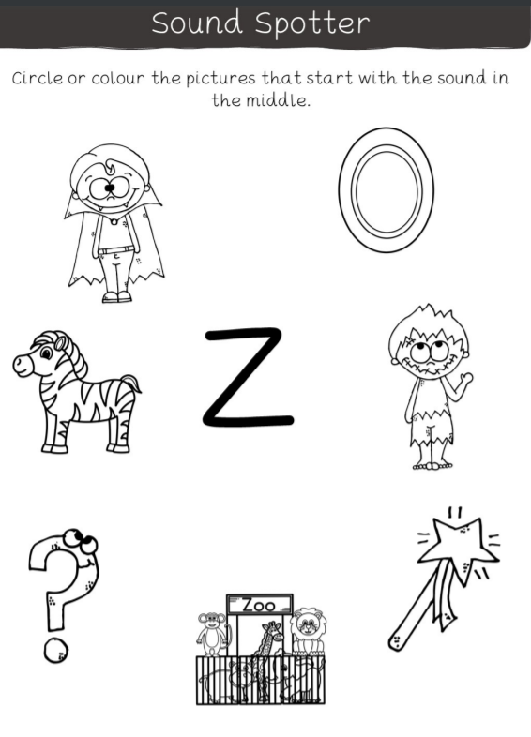

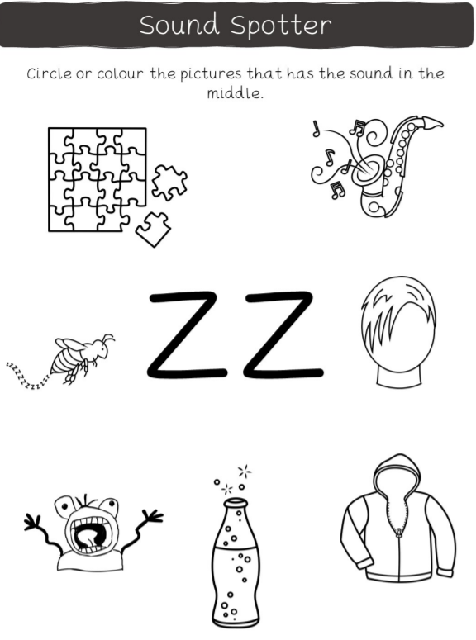

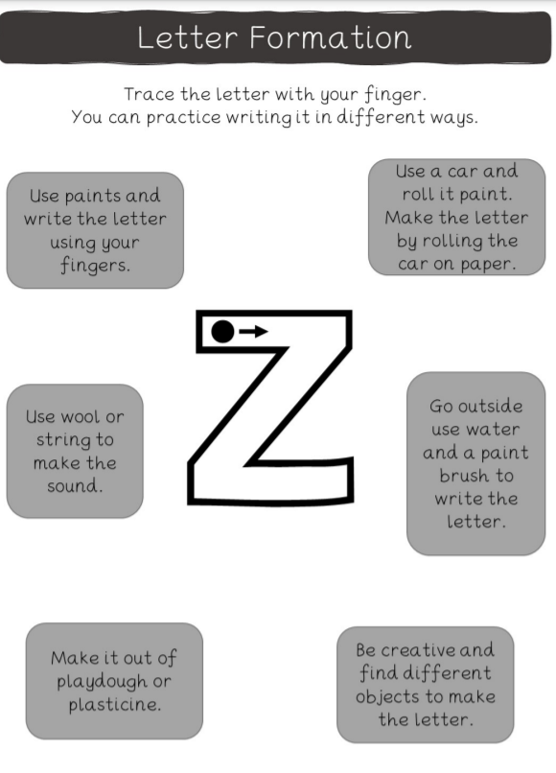

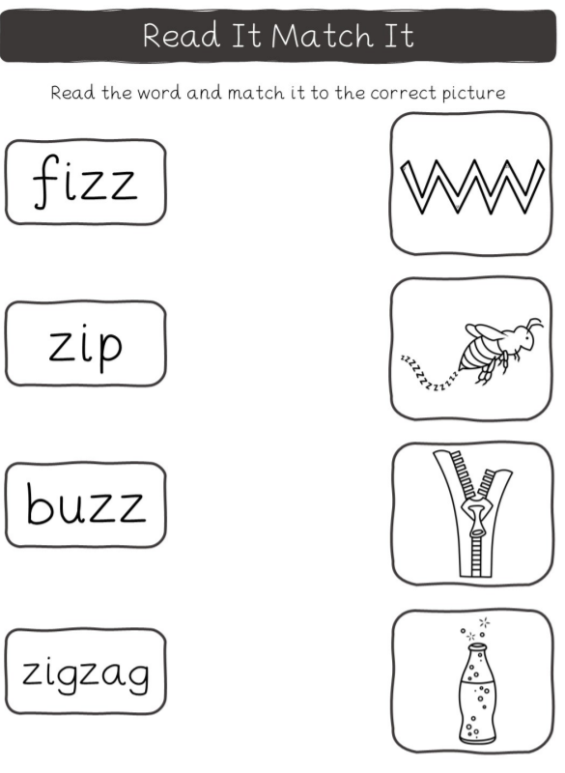

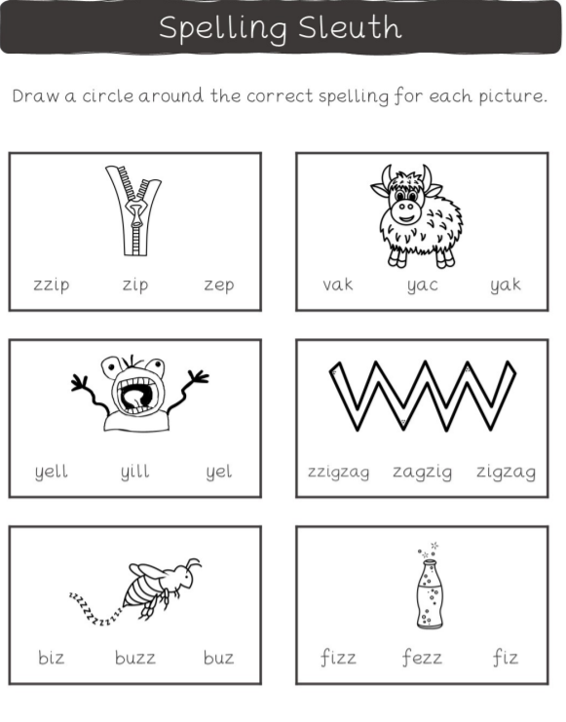

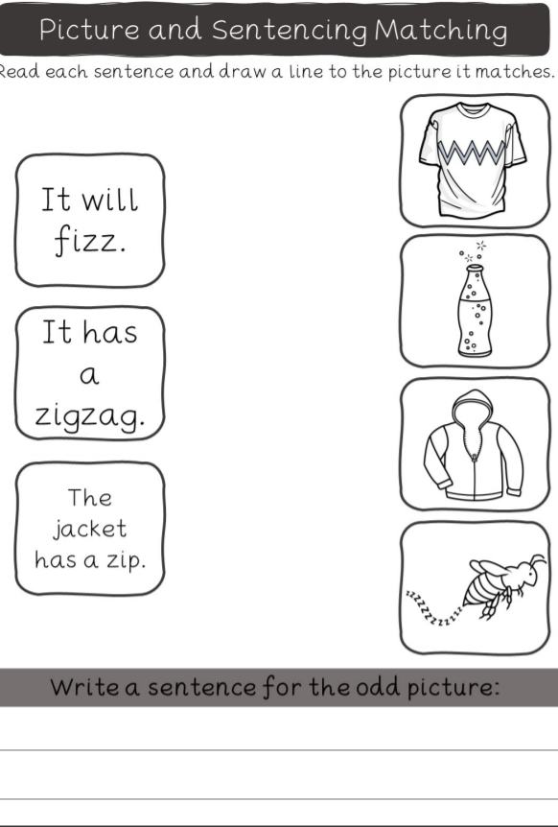

https://www.youtube.com/watch?v=I-hzMXDz_zA Longer words
https://www.youtube.com/watch?v=WyeO5KFNtZU QU qu
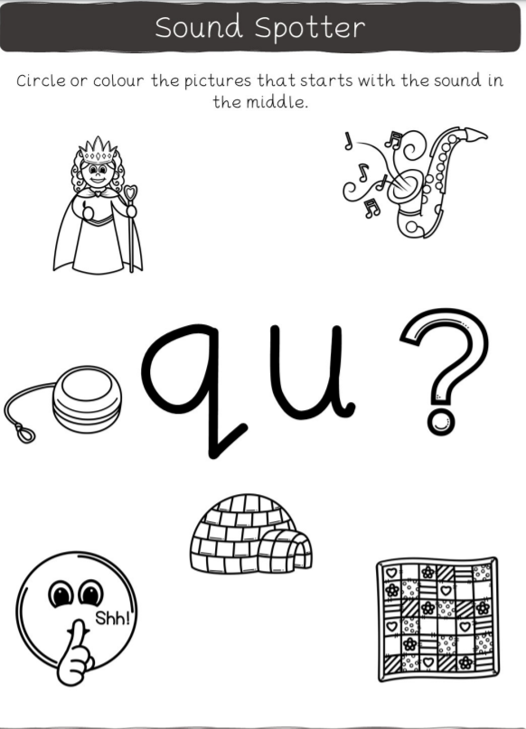
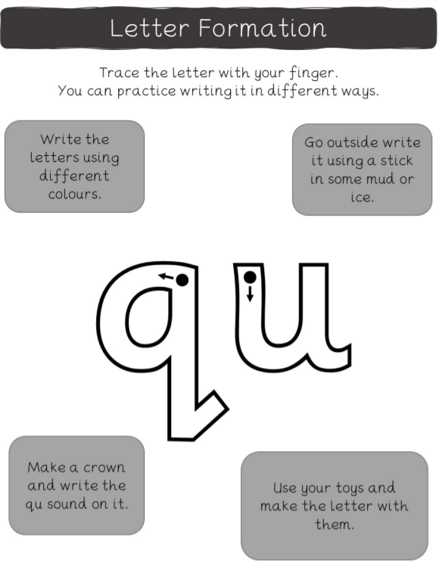

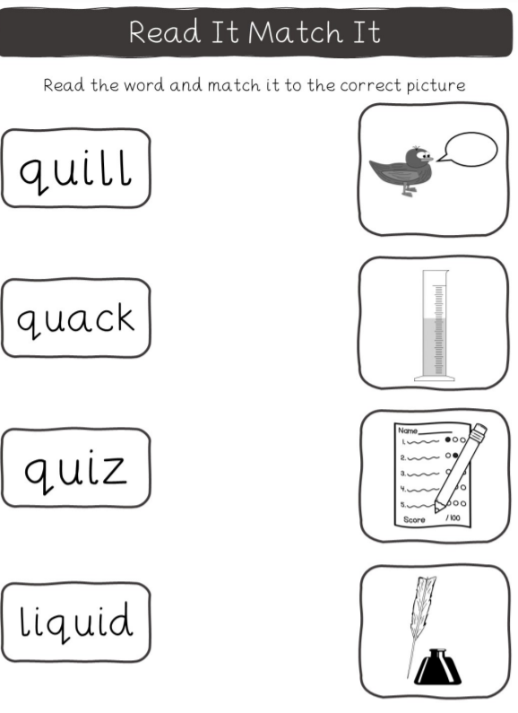

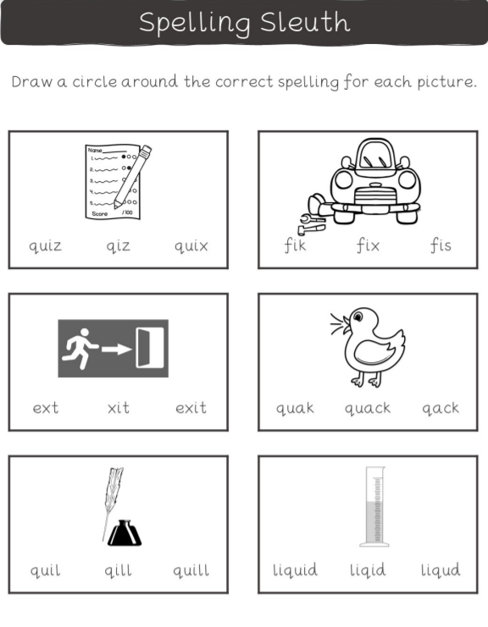

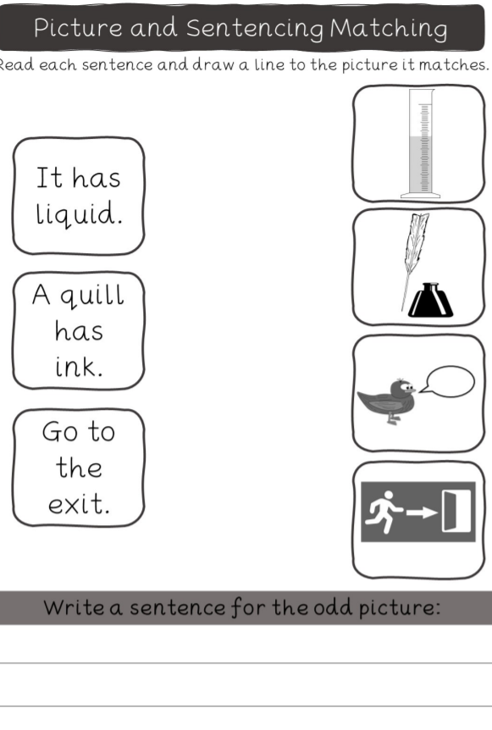

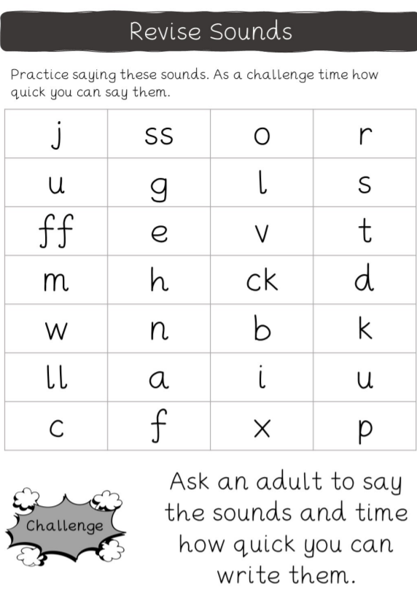

https://www.youtube.com/watch?v=6HvzusTPPuE
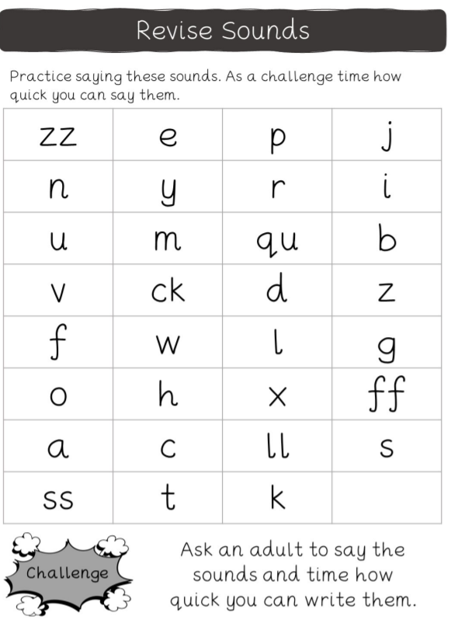
Review sounds
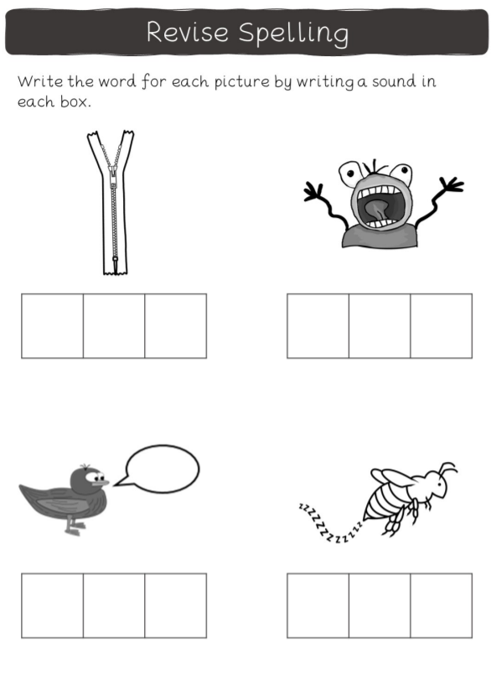

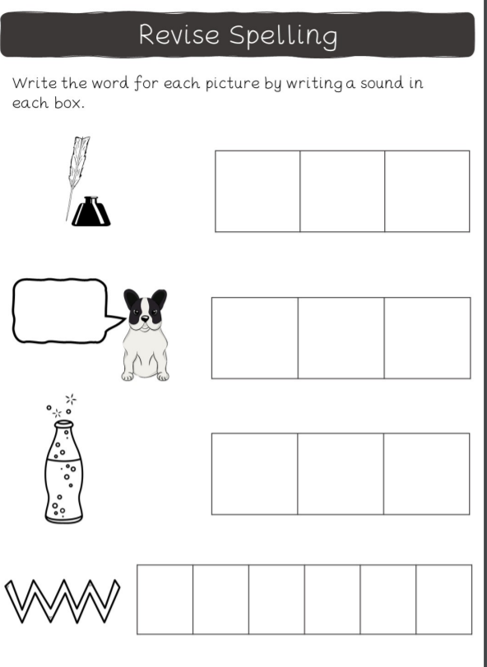

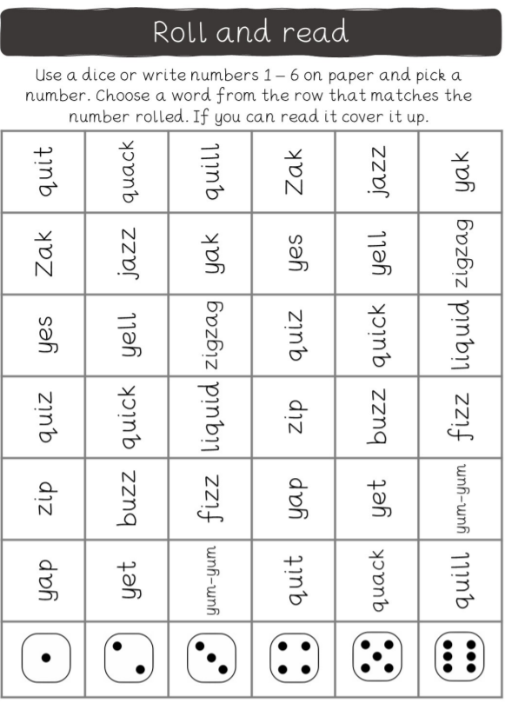

https://www.youtube.com/watch?v=M0QvWgRZBys
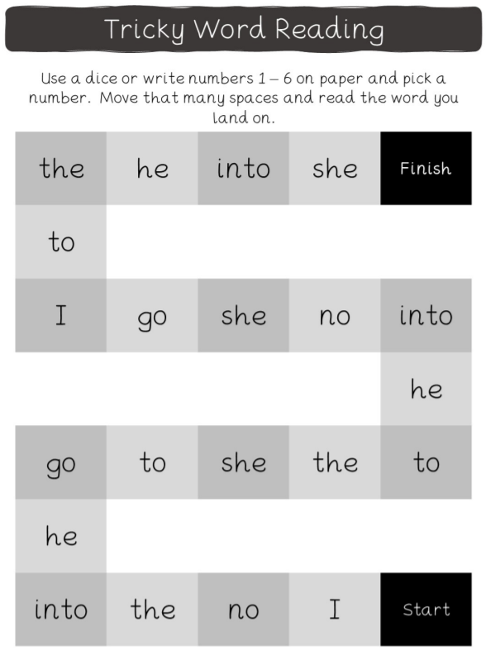
Tricky words he, she,
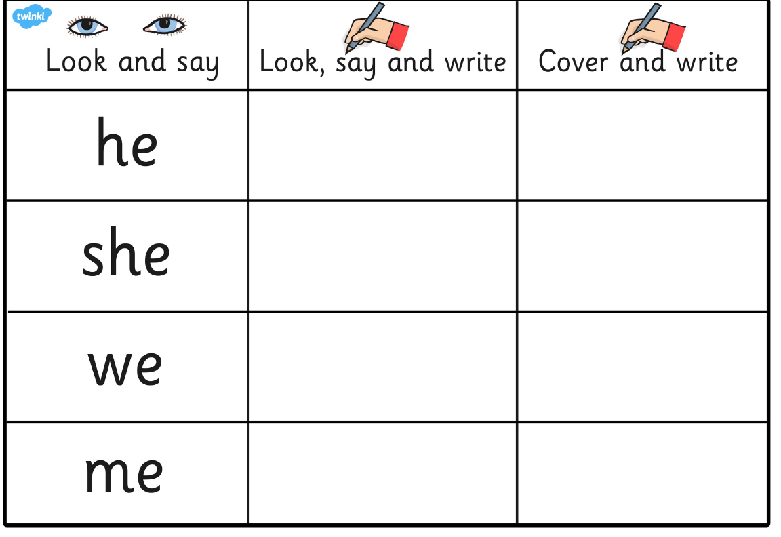
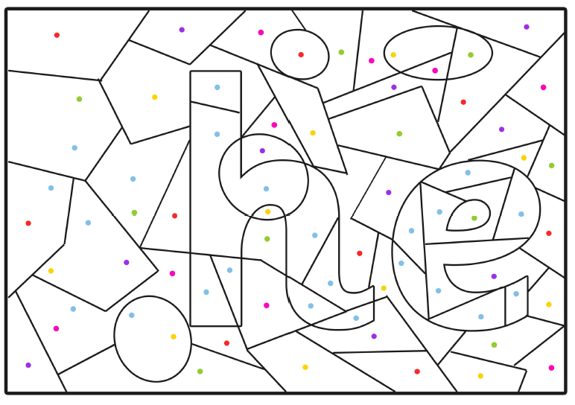
Colour match the tricky words. Can you read and spell them?

