Number 4

This week, we will be looking at number 4! Watch this short clip all about number 4!
https://www.youtube.com/watch?v=ZOFZI7LcGMQ

Can you find 3 of a variety of things from around the house?
4 shoes?
4 bowls?
Before | 4 | After
4 books?
4 t-shirts?

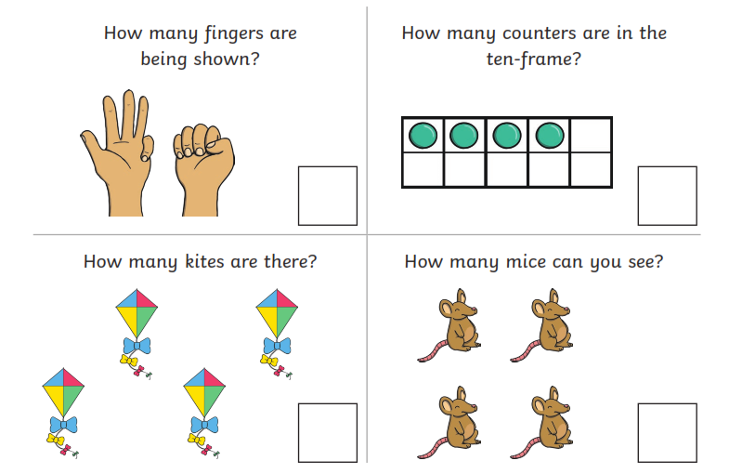

Number 8

This week, we will be looking at number 8! Watch this short clip all about number 8! https://www.youtube.com/watch?v=3mvnXhlYkzQ
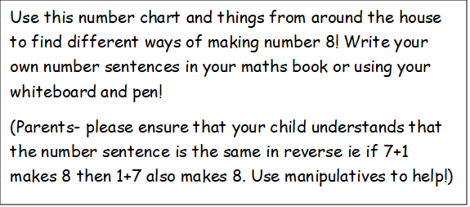
Find 8 objects from around your house. How many groups of 8 can you make?
7
8 | 0
7 | 1
6 | 2
5 | 3
4 | 4
3 | 5
2 | 6
1 | 7
0 | 8
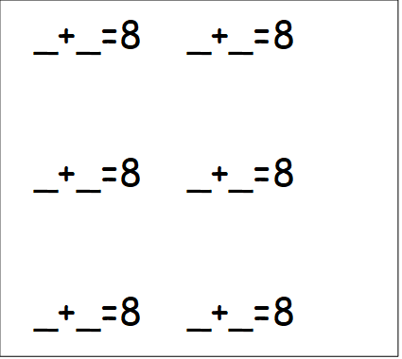

https://www.bbc.co.uk/iplayer/episode/p077rk5n/numbersongs-lets-all-draw-numbers
Please practise forming number from 0-9 at home.
- You might like to paint them using water and see how long they take to evaporate in the heat.
- You could chalk them and then use a water pistol or squeezy bottle to wash them away.
- You could create rainbow coloured numbers in support of the NHS.
- You might like to do a scavenger hunt in your garden and form numbers using natural materials such as sticks, pebbles, grass, leaves etc.
- See how many different ways you can form numbers!
- Remember – practise the number 8!!
P:E this week try: Just Dance https://www.youtube.com/channel/UC0Vlhde7N5uGDIFXXWWEbFQ

