Squirrel Class suggested home learning activities

Reception:
Spelling:
Below is a list of the phase 4 Decodable High Frequency Words (HFW) and phase 4 Tricky words that the children can have a practice of. The decodable words (highlighted in green) are a continuation of last weeks and can be sounded out phonetically and the tricky words (highlighted in blue) are the words than cannot be sounded about and therefore need to be learnt. Repetition is still the key to support their understanding of both tricky and decodable words.
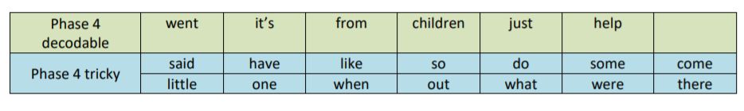

Don’t forget, the Department of Education are still doing daily phonics teaching aimed at Reception at 10am and Year 1 at 10:30am with support on blending sounds at 11am. All of the information can be found on our school website.

Literacy:
As we know, it takes a lot longer than a week for a plant to grow, so we felt that this week we would give you some time to do your plant stories and diaries. If you’d like some ideas of things to plant, here is the vegetable waste website from last week:
https://foodrevolution.org/blog/reduce-food-waste-regrowfrom-scraps/.
If you choose to try and grow your own plants or want to do some research, why not try:
• How are your plants growing? Don’t forget to write down any changes you see and things you do to help it grow.

• You could write a helicopter story alongside you plant. Have a look at this story, ‘The Tiny Seed’ by Eric Carle. It is all about the journey of a seed! Maybe you could have a go at telling your own and asking someone to write it down for you.
https://www.youtube.com/watch?v=ls6wTeT2cKA

Maths on WhiteRose:
https://whiterosemaths.com/homelearning/early-years/
This week on WhiteRose, we will be moving on to the lesson plans entitled ‘Summer Term – Week 3 (w/c 4th Maw). The activities this week follow the stories ‘The Very Hungry Caterpillar’. The focus areas of maths this week are: shapes, number, patterns in art, grouping, addition and subtraction, doubling, halving, odds and evens and measuring!
So many different things to have a go at this week with some useful ideas on the slideshows provided. Here is a link to the animated story of ‘The Very Hungry Caterpillar’ by Eric Carle. Please feel free to use this to support your child’s learning if you don’t have a copy of the story: https://www.youtube.com/watch?v=75NQK-Sm1YY

Squirrel Class suggested home learning activities
Year One

Spelling:
The new daily phonics lessons produced by the DFE are proving to be popular: www.youtube.com/channel/UCP_FbjYUP_UtldV2K_-niWw/ featured. Please get in touch if you would like guidance on this.

Writing
This week we have a non-fiction writing task based on a topic of your child’s choice! The children have already been taught the key features of writing a fact file when they wrote about tigers earlier in the year. This is your child’s opportunity to write about something that interests them. It could be their favourite dinosaur, an animal they love, an historical event or person, a country or place they have visited or even writing about their own family or pet!
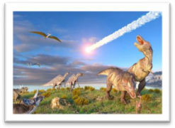
We suggest your child spends some time thinking about what they want to find out about within their chosen topic. This will then enable them to come up with sub-headings for their fact file. The sub-headings can be written as questions (e.g. What did dinosaurs eat? How long ago did dinosaurs

live?) or as statements (Zebras eat. A Zebra’s habitat) We suggest 3 or 4 sub-headings, however some children may want to think of more! They can then start researching their topic, with support, by using books, the internet or talking to family members that might be knowledgeable in their chosen area! When writing their facts, we suggest your child writes 1 or 2 sentences under each sub-heading, to challenge, try and encourage them to use conjunctions such as ‘and’, ‘because’, ‘so’, ‘but’, ‘or’, ‘when’ in order to extend and add more detail to their sentences. Lastly, your child will need to come up with a title for their fact file and then add illustrations. Try to encourage your child to think carefully about their illustrations and to match their drawings to what they have written about!

A writing frame is available on the next page for you to print if you wish to use it. If you don’t have a printer at home feel free to copy the template onto plain or lined paper. However, please feel free to be as creative as you want; the children could produce a large poster by cutting and sticking or they may want to create a fact file booklet. Below are some useful websites that may help with this week’s task.
https://www.twinkl.co.uk/resource/t-t-15852-animal-factfile-template-worksheets
- more writing frame templates
https://www.natgeokids.com/uk/category/discover/animals/ - animal facts https://animalfactguide.com/animal-facts/ - animal facts
http://www.bbc.co.uk/history/forkids/ - History facts for kids
https://learningmole.com/ - great site with lots of different factual topics for young children including videos to watch!

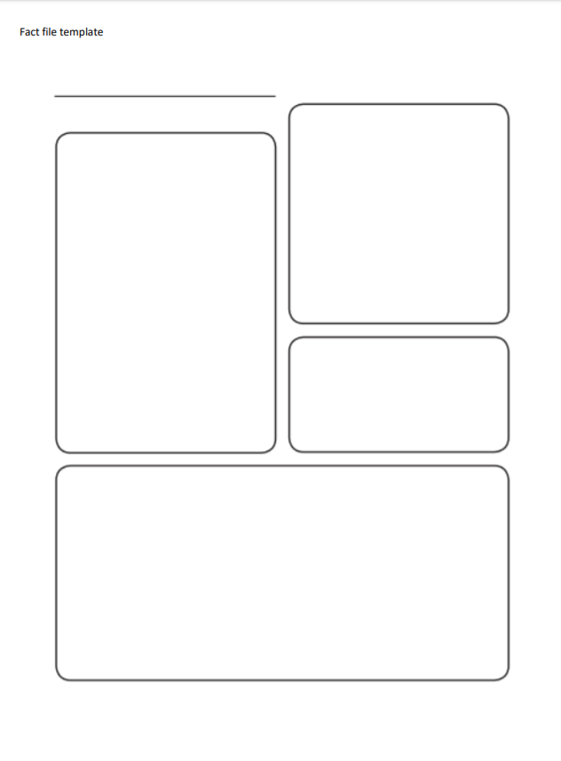

Maths:
Maths on White Rose: https://whiterosemaths.com/homelearning/year-1/
https://whiterosemaths.com/homelearning/year-1/ Apologies for the mix up last week. It should have been Fractions (Summer Term Week 2 w/c 27th April) and this week is week 3 (w/c 4 th May) number bonds. We know that some of you found the fractions work anyway but please don’t panic if you didn’t. It’s important to explain that we teach fractions as equal parts of a whole. A half is 1 out 2 equal parts. A quarter is 1 out of 4 equal parts. Number bonds are presented at this stage as number sentences, partwhole models and bar models – all of which the children are already familiar with. As previously explained, it’s important to use objects to count and move around to support children’s understanding and as a tool for calculating. We are working towards the children being able to recall these number bonds so it’s important to revisit these frequently.
