Squirrel Class suggested home learning activities
Physical and emotional well being
Exercise For our exercise idea this week why not try Cosmic Kids Yoga; an online yoga channel to help your children stay active. Follow the link below if you are interested: https://www.youtube.com/user/CosmicKidsYoga
If you do not have access to the internet, why not try Yoga Jenga. Use a pencil to write down a yoga move on each JENGA block. Set up the tower and play the game as usual, but every time a block is pulled out, every player has to do the specific yoga move. If the tower falls, do the plank for 30 seconds. If you don’t have jenga, you could use empty cardboard boxes.
PSHE Go for a walk in a nearby nature area or just around the neighbourhood. Stay silent for 5-15 minutes, depending on your child’s age and attention span, and listen carefully to all the sounds around you. After the time is up, discuss what you heard and where the sounds may come from. Variation: For a more meditative experience, do the listening exercise while lying down on the ground with closed eye

Reception:
Spelling:
Below is a list of the phase 4 Decodable High Frequency Words (HFW) and phase 4 Tricky words that the children can have a practice of. The decodable words (highlighted in green) are a continuation of last weeks and can be sounded out phonetically and the tricky words (highlighted in blue) are the words than cannot be sounded about and therefore need to be learnt. Repetition is still the key to support their understanding of both tricky and decodable words.
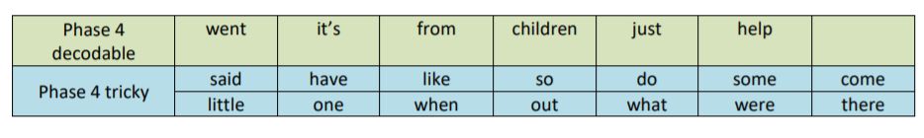

Don’t forget, the Department of Education are still doing daily phonics teaching aimed at Reception at 10am and Year 1 at 10:30am with support on blending sounds at 11am. All of the information can be found on our school website.

Literacy:
For this week’s writing activity, we are looking at how plants grow and what they may need to do so. At the moment seed packets can be hard to come by, however your left over vegetables might be of use! This website shows you how you can grow new plants from your vegetable waste: https://foodrevolution.org/blog/reduce-food-waste-regrow-from-scraps/
If you choose to try and grow your own plants or want to do some research, why not try:
• Making a list of all of the things a plant needs to grow. Can you find out why they need them too?
• Draw, label and write a ‘plant diary’. Keep an eye on your plant as it changes- draw a picture of what it looks like, label the picture and write down any changes you see (or don’t see). See example at the end of the newsletter.
• Once you have found out a little bit about how a plant grows, can you come up with your own helicopter story about a plant? Maybe, a little seed felt sad and alone under the soil so one day, he decided to push through the soil until he saw the sunshine…what did he find when he got to the surface?

Maths on WhiteRose: https://whiterosemaths.com/homelearning/early-years/
This week on WhiteRose, we will be moving on to the lesson plans entitled ‘Summer Term – Week 2 (w/c 27th April).
The activities this week follow the stories ‘The Night Pirate’ and ‘Troll’. The focus areas of maths this week are: shapes and pattern making, prediction, weight and buoyancy, positional language and number recognition. This week, most of these activities are using objects at home to explore and recycled materials to make things. Please do not hesitate to send us an email if you need any ideas or adaptations to best suit you. We have added the links for the stories ‘The Night Pirates’ (https://www.youtube.com/watch?v=KnVP6iBAvHg) and ‘Troll’ (https://www.youtube.com/watch?v=dZxWt4cFAyE) for you to use to support your children’s Maths this week.

Squirrel Class suggested home learning activities
Year One

Writing This week we are suggesting a non-fiction writing task; the children have already been taught about the features of instructions and you will have seen in their English books that they have previously written instructions to make a model of Supertato and sew an animal glove puppet. We have heard about a wide variety of outcomes over the last few weeks (sock puppets, Hama beads, bracelets, ice lollies, fairy cakes, fudge, toilet roll snowmen, fixing things and changing your bed sheets) and you can use any of these processes or try something else this week. It could be anything from making a jam sandwich to a model rocket; If the assault course or sleepy mobile are a hit in your house, why not write the instructions for someone else to have a go.
We suggest that your child makes their item or carries out their task before they start writing. You will need to help them identify the steps and we would suggest doing very simple drawings for each to help scaffold the writing. Then their writing needs to include a number of features. The aim is to explain to someone else what they need to do to make your chosen item. Avoiding the word you can be tricky, but is a good challenge for more able writers. A writing frame is available at the bottom of the letter for you to print. You may need more than one copy of the second page. If you don’t have a printer at home feel free to copy the template onto plain or lined page.

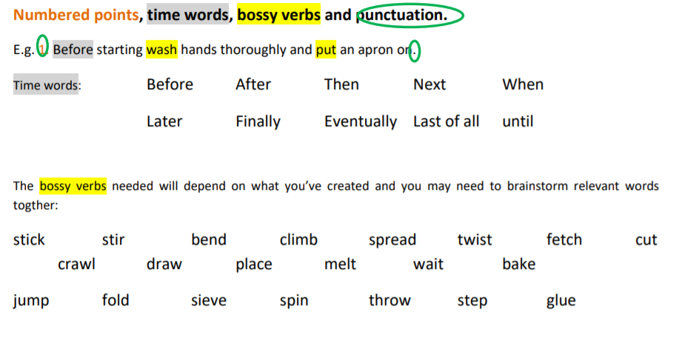

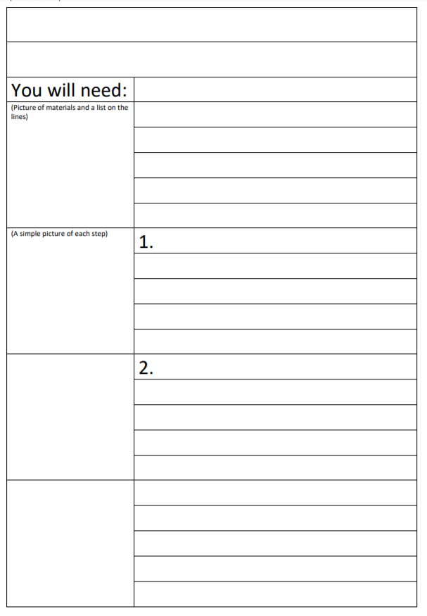

Maths:
Maths on White Rose: https://whiterosemaths.com/homelearning/year-1/
This week please start Summer term - Week 2, lesson 1, starting with comparing different capacities before exploring different ways of counting in 10s. Your child will then learn to add equal groups and explore arrays. There are 5 lessons for the week, designed to be used daily. Remember to make the lessons practical by using apparatus when answering the questions (pencils, beads, raisins). Encourage your child to count objects in groups of 2s, 5s and 10s and not to revert to counting objects in 1s. When creating arrays, encourage your child to talk about how many groups/rows they have created and how many are in each group.
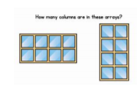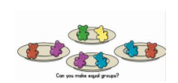

Secret numbers! Ask your partner to choose a number from 0 to 20. Then ask them some questions to find out what the secret number is. E.g. is it an odd number? Is it less than 10? Does it have a 5 in it? Is it between 10 and 20? Is it a multiple of 10? Is it a single-digit number? Is it an even number? Is it a two-digit number? Your partner can only answer ‘yes’ or ‘no’. Once you have guessed the number, swap roles. For an easier game, choose numbers up to 10. To make the game harder, limit the number of questions to 5 or use numbers up to 100.

