Squirrel Class suggested home learning activities
Physical and emotional well being
PSHE – This week we are taking notice of our surroundings and appreciating things around us that we can see.
Read the Bee here now story and see if you can find things that are the same colours as the rainbow. https://www.elsa-support.co.uk/wp-content/uploads/Rainbow-walk.pdf
Which colour did you find the most things for? Which was the hardest to find? Let us know.
Reception:
Spelling
Below is a list of the phase 2 and 3 High Frequency Words (HFW) that the children can have a practice of. In contrast to last week, these words can be sounded out phonetically (or decodable words) however repetition is still key the support their understanding. Some activities that have been used already by children include: using flash cards and alphabet cards to encourage reading and forming of the words and using words as targets – asking your children to find, throw a ball or beanbag at a word – to support recognition.

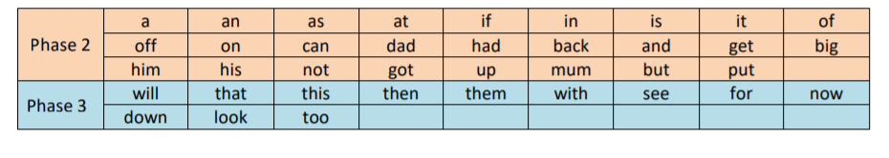
To further support with phonics teaching at home, the Department of Education have released (as of Monday 27th April) daily phonics teaching aimed at Reception at 10am and Year 1 at 10:30am with support on blending sounds at 11am. This can be found on YouTube under Letters and Sounds.

Literacy
Each week we will set a creative writing task for you to have a go at. The first two bullet points are designed to allow your child the chance to have a go at writing independently; to see whether they can hear the sounds in the word and know which letters to write. The words do not need to be spelt correctly but instead, show that they are segmenting and blending the sounds effectively to create each word.
Why not try some of these ideas:
- Can you put together your own timeline of you as a baby to now or can you do a timeline of someone in your family. You could find pictures or draw it and label it!
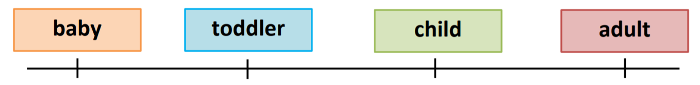
- Have a go at writing sentences about different things people can do at different times in their life. For example: A baby can crawl. A toddler can sing.
- Think about something that happened to you in your life. Can you remember it? Try and write down your story with all the details!
Maths:
Maths on WhiteRose: https://whiterosemaths.com/homelearning/early-years/
This week on WhiteRose, we will be moving on to the lesson plans entitled ‘Summer Term – Week 1 (w/c 20th April).
The suggested activities are following the story of ‘Supertato’ and look at some different areas of maths to last week. These include: opportunities for measuring height and length, shapes and their characteristics, time, patterns and number recognition as well as some extra fun activities in between.
As mentioned last week, these activities can be adaptable to the resources and space that you have at home to keep learning as practical as possible will best support your child. Please do not hesitate to contact us at school if you need any ideas or adaptations to best suit you. We have added the links for the stories ‘Supertato’ by Sue Hendra and Paul Linnet https://www.youtube.com/watch?v=QlaMeNmTG6
Feel free to turn the sound off, pause the video and read it together instead of listening to the storyteller.
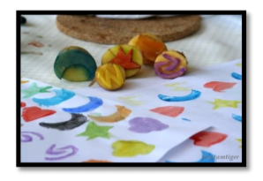

Squirrel Class suggested home learning activities
Year One:
Phonics:
We highly recommend taking a look at the New daily phonics lessons produced by the DFE. They started on April 27th and are available online:
www.youtube.com/channel/UCP_FbjYUP_UtldV2K_- niWw/
The Year One lessons are well pitched for the majority of children and the Receptions lessons provide the opportunity to revise the Phase 3 digraphs which may also be beneficial. Please get in touch if you would like guidance on this.
This week you might want to have ago at the I spy phoneme game. Make a list of phonemes (you can use the ones listed here, Phase 3 digraphs, or make up your own). Then go for a walk around your house and/or garden spotting objects that have these phonemes in. Once you have found an object, write the object next to the correct phoneme. The sheet is at the end of this letter.
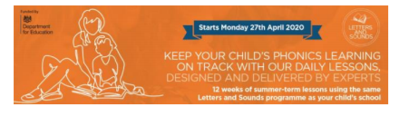
Writing:
Creative writing task.
We would like the children to write a story. The children are very familiar with a 5 part story plan which may help you to prompt them.
Beginning, Build-up, problem/adventure, resolution/cool down, ending. They may choose to base their story on ‘Jack and the Beanstalk’ or be more creative. Discuss, or draw the answers to, these questions as a plan.
Beginning: Who finds the magic beans?
Build-up: What will grow from the magic beans?
Adventure: What exciting adventure will they lead to?
Cool-down: How will the character(s) get home?
Ending: What will life be like after the adventure?

The five part structure can be used to generate five sentences, five paragraphs or five pages, so please tailor this to suit your child. We would encourage the children to ‘sound out’ their spellings, start sentences and names with capital letters and finish sentences with full stops, question marks and exclamation marks. (It’s worth noting that at this stage we steer the children way from writing dialogue).
We would suggest making a list of spellings available:
beans magic grew plant sky adventure
Alternatively, this can be treated entirely as a creative story telling exercise and you could scribe your child’s story for them as they tell it. We look forward to reading the children’s stories.
Remember the great thing about creative writing is that it can’t be wrong! This idea can also be used as a spring board for other activities if you choose. Eg. Making puppets to tell the story, painting a picture or making a model of the magical plant that grows, creating a comic strip of the story with speech bubble.

Suggested Maths Activities
Maths on White Rose: https://whiterosemaths.com/homelearning/year-1/
This week please start Summer term - Week 1, lesson 1, starting with making doubles before exploring grouping and sharing which are the foundations of division. There are 5 lessons for the week, designed to be used daily. The sheet mentions counters which you may not have at home; we would encourage use of apparatus when answering the questions and would recommend using lego, pieces of pasta, 1p coins or anything else which you have in sufficient quantity.

Maths with money Continuing with counting in 10s, 2s and 5s. Another way to reinforce counting in patterns is to make amounts with coins. How many 2ps do you need to make 10p? How many 5ps do you need to make 30p? How much will 7 10p coins make? Using just 10p s and 1ps you could set up a shop and pay the correct amounts making values up to 100. This is a great, practical way, to reinforce previous learning on tens and ones. (Using coins that have been out of circulation for at least 3 days and washing them with soap and water is recommended)

