Summer Term Week 3

Literacy- Squirrels!

Starter Activity- with an adult, sing a rhyming song or write a rhyming string.

We are learning about ‘Why do Squirrels hide their nuts?’

Now that you have found out information about squirrels, I would like you to design a squirrel feeder and write a set of instructions about how to use it. You could use books, videos or the internet to help you with research for your creation.

You could draw your design and label it or take pictures and add captions to add extra detail. Try and use the language of instructions, first, next, then, after that and finally. ☺

Phonics

Watch Mr Thorne does phonics, Bitesize or signup to Phonics play Phase 2/3 sounds for Year R. Please learn a new sound each day

and practise writing the letter and CVC words. Year 1 recap all sounds and learn a Phase 5 sound every day using Phonics Play.

<https://www.youtube.com/results?search_query=mr+thorne+does+phonics+phase+2>

<https://www.phonicsplay.co.uk/>

<https://www.bbc.co.uk/bitesize/topics/zf2yf4j>

Reading

Listen to an E-book on Oxford Owl and practise your blending to read. Read a bedtime story every night and talk about it in your own words. <https://www.oxfordowl.co.uk/for-home/find-a-book/library-page>

<https://www.teachyourmonstertoread.com/>

Number 5

This week, we will be looking at number 5!

Use the part, part whole models below to practise number bonds to 5!

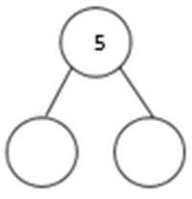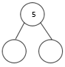

|  |  |
| --- | --- |
| Draw 5 spiders | Draw 5 apples |
| Draw 5 hats | Draw 5 smiley faces |

Try creating your own take away number sentences and recording them using pictures or numbers.

Try laying the table or hold a teddy bears picnic and count out 5 objects for the guests. Use these to practise take away as well – 5 cakes – 3 cakes =?

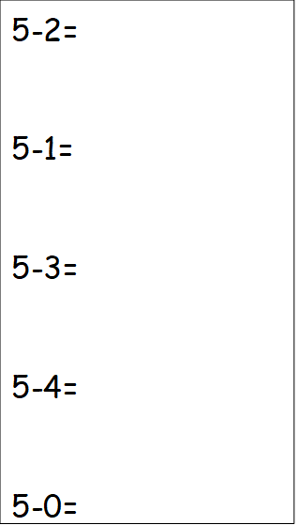

EXTENSION – number bonds to 10

P:E Cosmic Kids Yoga <https://www.youtube.com/user/CosmicKidsYoga>

Or Boogie Beebies dance <https://www.dailymotion.com/video/x6ftrz4>