Squirrel Class suggested home learning activities
Reception:

PSHE - ‘Lucy’s in Lockdown’ http://www.lucysblueday.com/product-page/lucy-s-in-lockdown

Lucy’s in Lockdown is a short, free e-book about Lucy, who is in quarantine with her family. It is designed to help children know that they are not alone in the current conditions with Covid-19, to help them understand that it’s temporary and to help them express how they are feeling. Please take a look and consider using it at home, however well your child appears to be coping.

Spelling: Below is a list of the phase 2 and 3 ‘tricky’ words that the children can practice. These words cannot be sounded out phonetically therefore repetition is key to support their understanding. This may be done by giving your child time to see if they can remember the word initially then remind them of the word. Once recapped, write out some sentences with the word in – can they spot them? You could also write each individual letter on separate pieces of paper and see if they can put them in the right order. You may want to play games such as ‘go fish’ or ‘hide and seek’ with several of the words once they become more familiar with them.

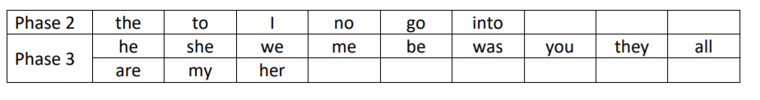

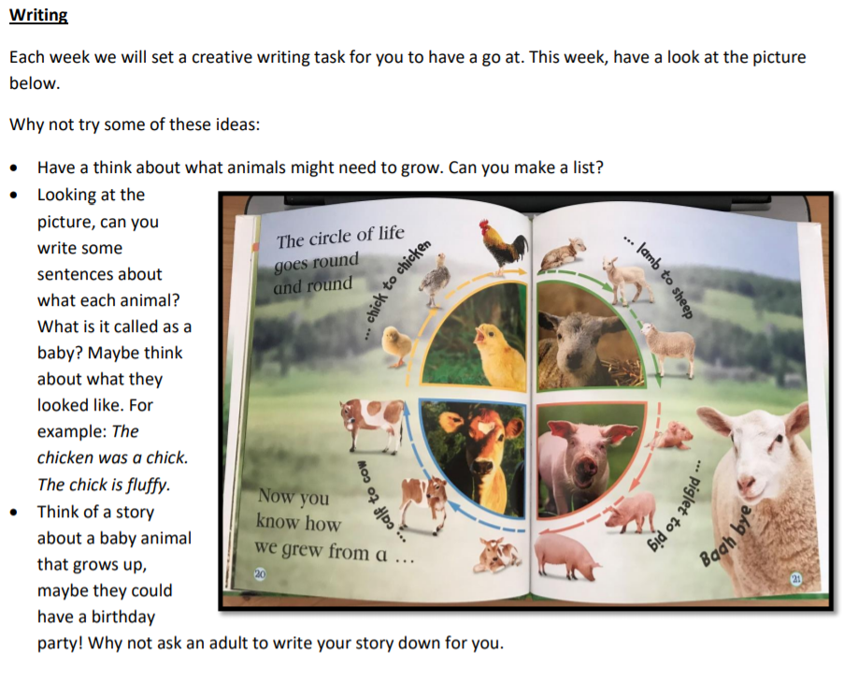

Maths on WhiteRose: https://whiterosemaths.com/homelearning/early-years/
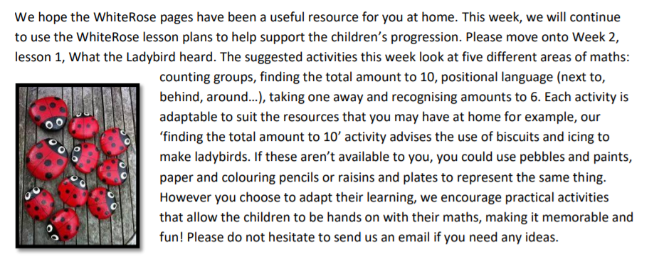

We have added the links for the stories ‘What the Ladybird heard’ https://www.youtube.com/watch?v=Eu9mPX7DuLA
and ‘What the Ladybird heard next’ https://www.youtube.com/watch?v=Cq0xiXoX8H0
to help with your learning. Feel free to turn the sound off, pause the video and read it together instead of listening to the storyteller.

Squirrel Class suggested home learning activities
Year One:

PSHE - ‘Lucy’s in Lockdown’
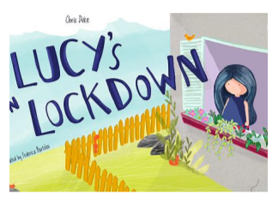
http://www.lucysblueday.com/product-page/lucy-s-in-lockdown
Lucy’s in Lockdown is a short, free ebook about Lucy, who is in quarantine with her family. It is designed to help children understand that they are not alone in the current conditions with Covid-19. It’s intention is to explain that this situation is temporary and to help young children express how they are feeling. Please take a look and consider using it at home.

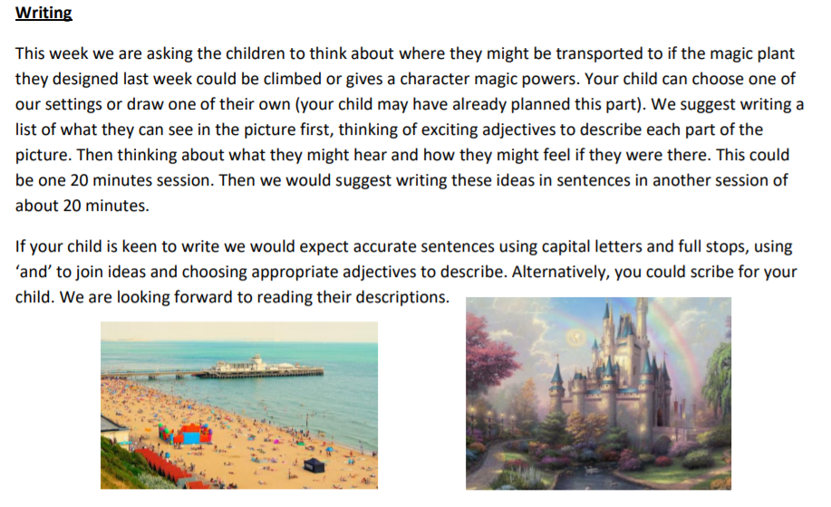

Maths on White Rose: https://whiterosemaths.com/homelearning/year-1/
Week 2 starts with one final lesson on comparing capacity and moves onto number. The sequence of learning over the four lessons recaps counting in 10s, making and adding equal groups and builds up to creating arrays. (The arrangement of equal groups in rows and columns). There are many practical ways that arrays can be reinforced at home. You may have ice cube trays, chocolate bars, muffin tins or egg boxes which the children can count. Or they can create their own arrays with rows of toy cars, building bricks, balls of play dough – or anything else!
Mistakes arise when the children use objects that are irregular in size or are more challenging to line up. It’s important that they are exposed to this so that they are made aware of this potential error by learning from their mistakes.
