Squirrel Class Topic Home Learning – Chinese New Year Week 6 Term 3
To access these lessons please click on the link above each unit.
Celebrating Chinese New Year during the half-term.
https://classroom.thenational.academy/lessons/instructional-texts-creating-a-card-c9gk2t?activity=video&step=1
- Lesson 1: Instructional Texts: Creating a Card
In this session children will learn more about different festivals and their customs. Children will then look at and follow a series of instructions to create their own celebration card. Can you find out what colours are special in Chinese customs? This lesson will require the support of an adult.
https://www.hamilton-trust.org.uk/blog/use-chinese-new-year-inspire-your-reception-class/

- Lesson 2: Why are Chinese New Year’s named after animals?
Watch the story video ‘Race across the River’ which gives an explanation. Then can you look at the chart below to see which animal you are born under?
Can you find out what animal 2021 will be?
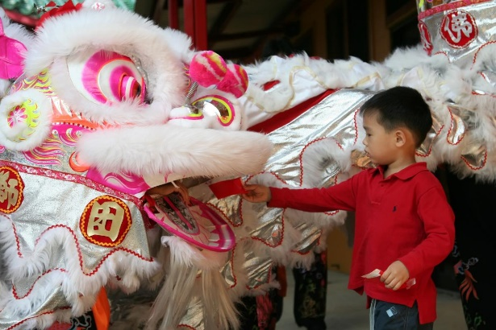
Rat: | 2008 | 1996 | 1984 | 1972 | 1960
Ox: | 2009 | 1997 | 1985 | 1973 | 1961
Tiger: | 2010 | 1998 | 1986 | 1974 | 1962
Rabbit: | 2011 | 1999 | 1987 | 1975 | 1963
Dragon: | 2012 | 2000 | 1988 | 1976 | 1964
Snake: | 2013 | 2001 | 1989 | 1977 | 1965
Horse: | 2014 | 2002 | 1990 | 1978 | 1966
Goat: | 2015 | 2003 | 1991 | 1979 | 1967
Monkey: | 2016 | 2004 | 1992 | 1980 | 1968
Rooster: | 2017 | 2005 | 1993 | 1981 | 1969
Dog: | 2018 | 2006 | 1994 | 1982 | 1970
Pig: | 2019 | 2007 | 1995 | 1983 | 1971
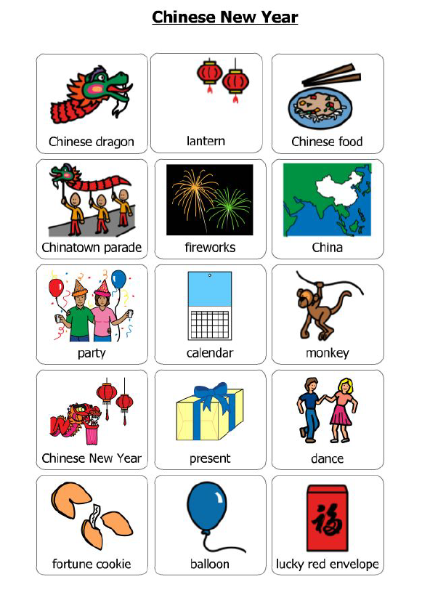
- Lesson 3: During half-term it is Chinese New Year. As part of our topic home learning, we are learning about people other than our families and how they celebrate in their homes and cultures. Can you say and learn some of these Chinese words? What things are the same in your home and what things are different?
- Music https://classroom.thenational.academy/lessons/walking-on-my-street-ccu3gr
- Lesson 1: Walking on my street. Our first adventure of this unit will take us on a journey around our neighbourhood. We will be using singing games to explore beat, note duration and rhyme. In this lesson, we will take part in our first imaginative listening activity. We will listen to a piece of music called "Promenade: Walking the Dog" by George Gershwin.

https://classroom.thenational.academy/lessons/sitting-on-the-bus-c4t64d
- Lesson 2: Sitting on the bus. Beep-Beep! Time to get on board the big red bus. Our bus journey will take us on a musical adventure through the streets of London. We will use singing games to explore note duration and improvise rhythms with a rapping bus driver. This lesson's imaginative listening will take us on a bus tour through the Queen's neighbourhood, as we listen to Eric Coates' "Knightsbridge Suite".
PSED/RHE
https://classroom.thenational.academy/lessons/the-human-race-64up6c
- Lesson 1: The human race. In this lesson you will have an understanding of different races in the world. We are all different and we need to celebrate our similarities and differences. We will look at how different animals look very similar but a closer look shows they can be different. We will be reading a story called: Not like the others by author Jana Broecker available at (www.jbroeckerbooks.com)
https://classroom.thenational.academy/lessons/festival-fun-cgrkcc
- Lesson 2: Festival fun
- In this lesson you will learn about different festivals and how people celebrate these festivals. You will have an understanding of the similarities and differences between the festivals you celebrate and those that other people from different religions celebrate.

https://classroom.thenational.academy/lessons/dress-to-impress-6cuk4d
- Lesson 3: Dress to impress. In this lesson you will understand that different people in different countries dress differently due to the customs and traditions they follow. You will use clothing from your home to dress as though you live in another country.
My Mum

A little something extra! As a class, we usually take part in ‘My Mum’ to celebrate Mother’s Day, hosted by KM Newspaper group. Unfortunately, this will not be the case this year due to the pandemic. However, if you would still like to participate then draw a picture of your mum and include a special message. You then need to follow the instructions on the KM website: www.kmmymum.co.uk and upload your picture before the closing date on 28th February 2021.

