Phonics & Literacy Home Learning: 00, OO, ar, or T4 Week 1
Lesson 1: literacy this week I would like you to listen to the story ‘The Little Red Hen’
https://classroom.thenational.academy/lessons/to-listen-and-join-in-with-a-story-c5h36t?activity=video&step=1
Lesson 2: To sing a story map.
https://classroom.thenational.academy/lessons/to-sing-and-map-a-story-6wukgd
Lesson 3: To focus on character
https://classroom.thenational.academy/lessons/to-focus-on-character-cnk3jr
Lesson 4: To re-enact a story focusing on character.
https://classroom.thenational.academy/lessons/to-reenact-a-story-focusing-on-character-6gu32t
Lesson 5: To tell the story independently, focusing on character
https://classroom.thenational.academy/lessons/to-tell-the-story-independently-focusing-on-character-crtpac

For Phonics this week:
Phonics: In Squirrel Class we do two daily phonic sessions. We focus on blending (reading) during the morning 15 minute session and in the afternoon we practise segmenting (spelling). This pack is designed with this in mind.
Sing the alphabet song together by following the link
https://www.bbc.co.uk/cbeebies/watch/get-squiggling-letters-alphabet-song?collection=little-learnerss://www.youtube.com/watch?v=OQ1AnMCGTzg

Please follow the link to watch the Letters and Sounds video each day to introduce new sounds.
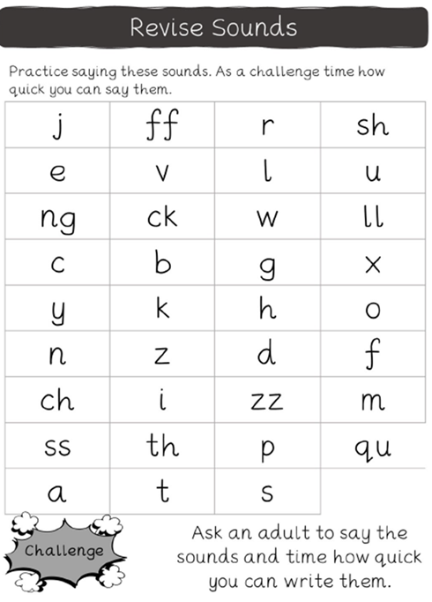

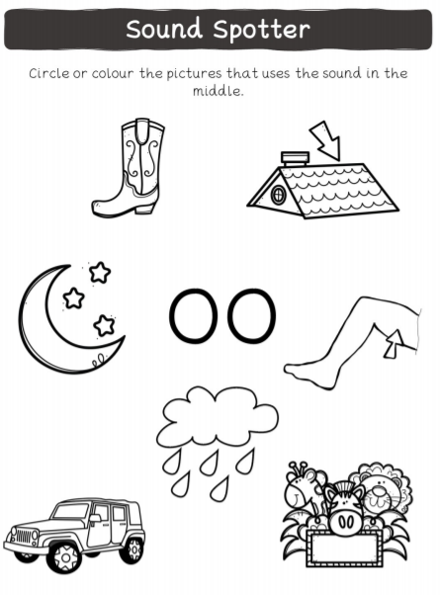
https://www.youtube.com/watch?v=VQxqTmiDmIQ

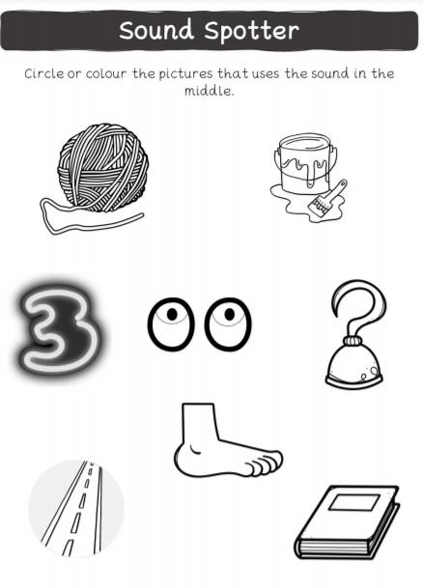
https://www.youtube.com/watch?v=McxGM5mU0uM
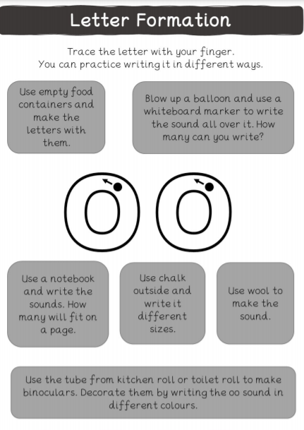
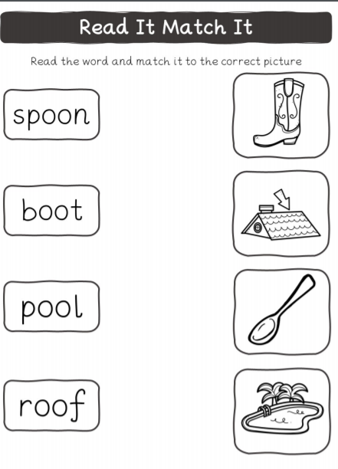
https://www.youtube.com/results?sp=mAEB&search_query=reception+spring+term+lesson+16
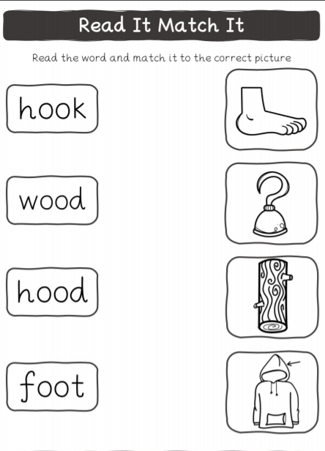
https://www.youtube.com/watch?v=MDysETvGN_I

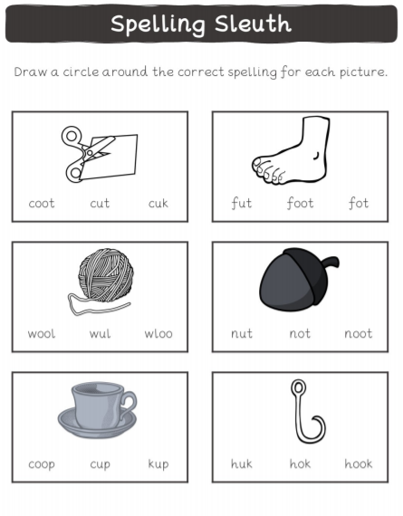
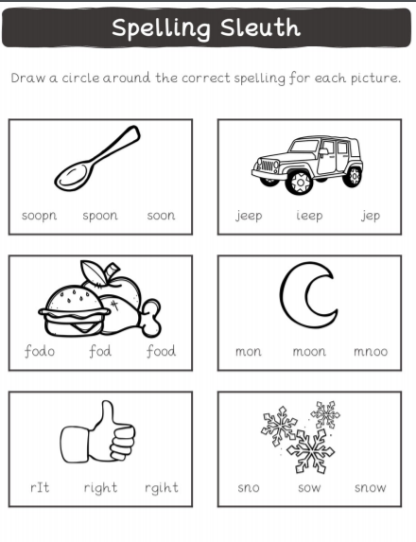

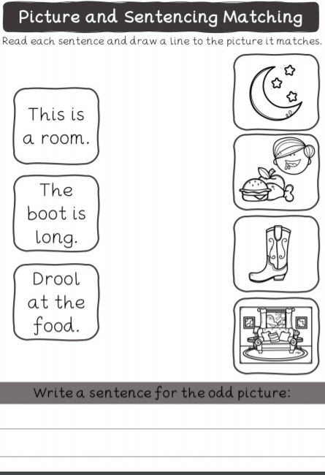
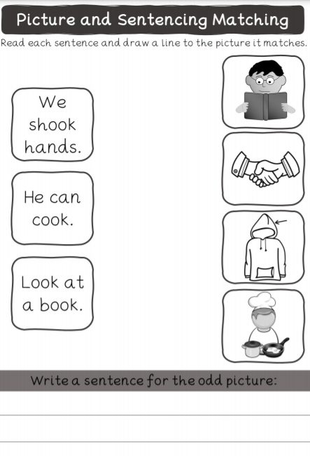
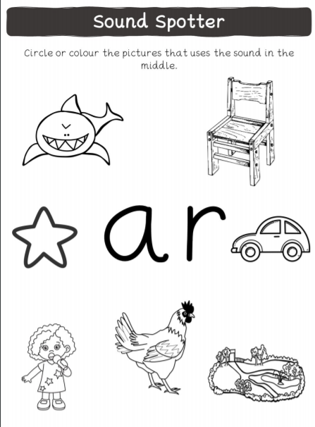
https://www.youtube.com/watch?v=yVsmYlNXU-k
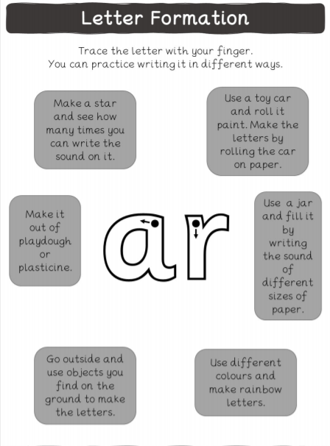
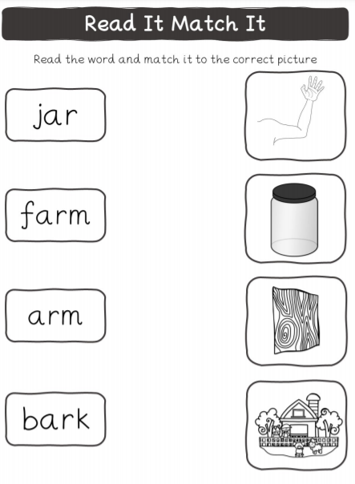
https://www.youtube.com/watch?v=IUHj1V-KYeg

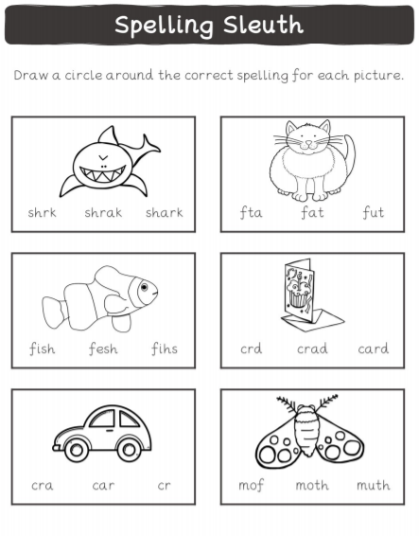

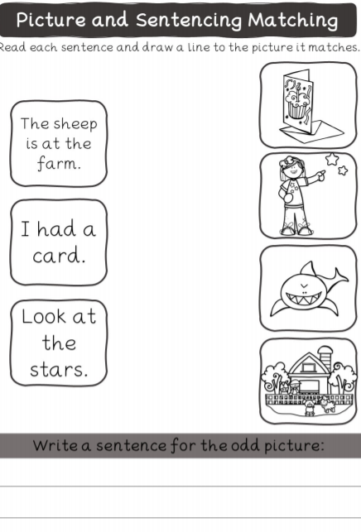

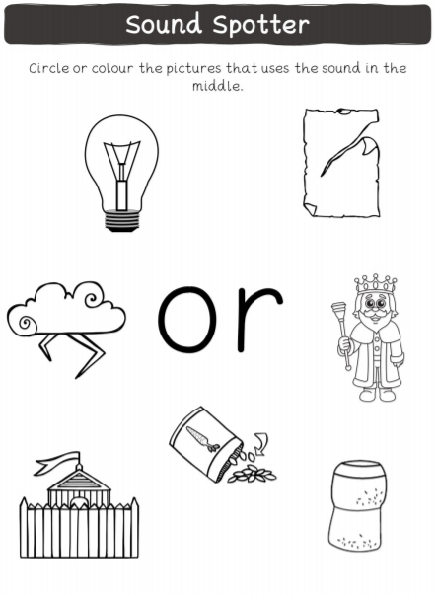
https://www.youtube.com/watch?v=68FTaim0FOQ

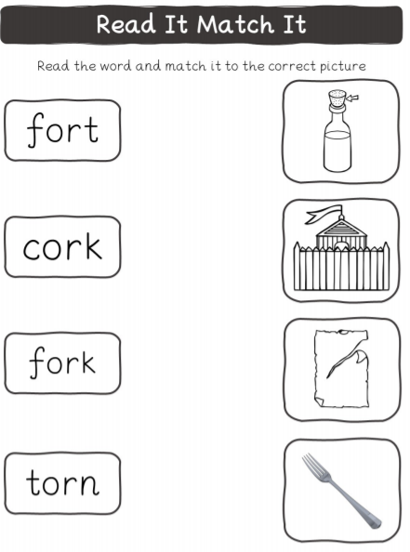
https://www.youtube.com/watch?v=HbRKL68I1WQ

