Squirrel Class Maths Home Learning Week 1 Term 4
To access these lessons please click on the link below in blue to access each unit.
Additional resources which support learning in these lessons: Jasper’s Beanstalk by Nick Butterworth Cubes or blocks to build towers with Playdough Sunflower seeds (or similar) to plant.
https://whiterosemaths.com/homelearning/early-years/growing-6-7-8-week-3/
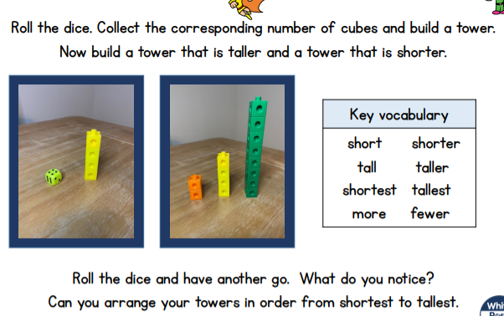
- Lesson 1: Comparing Height - Taller and Shorter
- Lesson 2: Comparing Length - Longer and Shorter
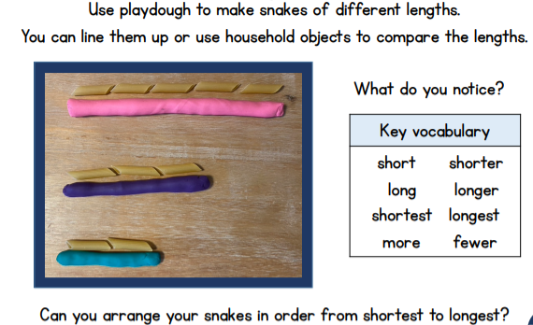

- Lesson 3: Days of the Week
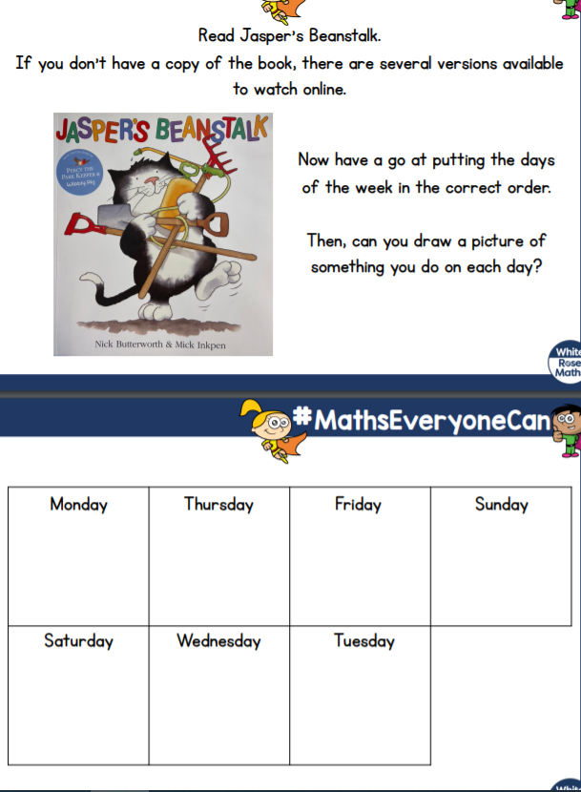

- Lesson 4: Measuring Height
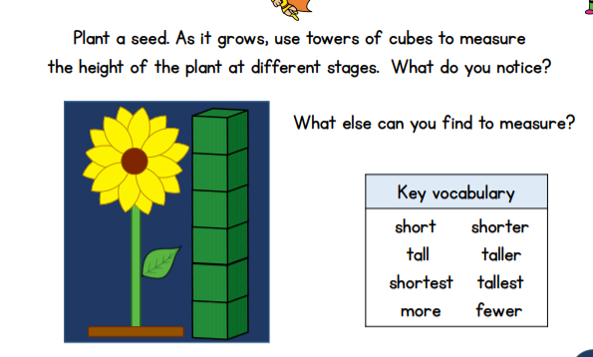
You could try measuring other things around your home including: people in your home, toys, pets, your feet, furniture or other things you can think of.
- Lesson 5: Measuring Time
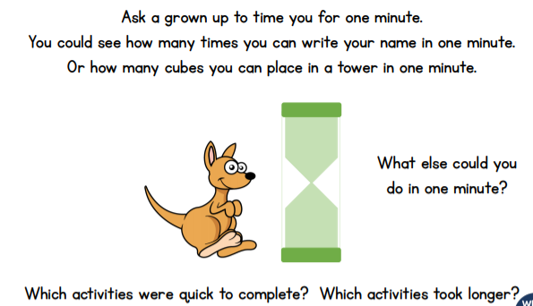
Find out about time in your home. What time do you get up? What time do you have your dinner or tea? What time do you go to bed?
Play ‘What’s the time Mr Wolf’ to practise using the language of time using o’clock.
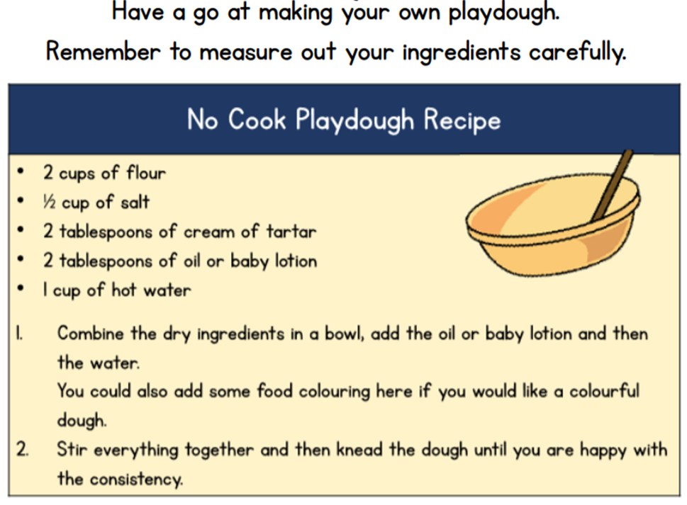
https://www.youtube.com/watch?v=Da6lxY_8jmU
Watch the story of Jaspers Beanstalk to help you learn the days of the week.

