Squirrel Class Maths Home Learning Week 2 Term 4
To access these lessons please click on the link below in blue to access each unit.
Additional resources which support learning in these lessons: Ten Black Dots by Donald Crews, objects from around the house for representing 9 and 10
https://whiterosemaths.com/homelearning/early-years/building-9-10-week-1/
- Lesson 1: Representing and Sorting 9 and 10
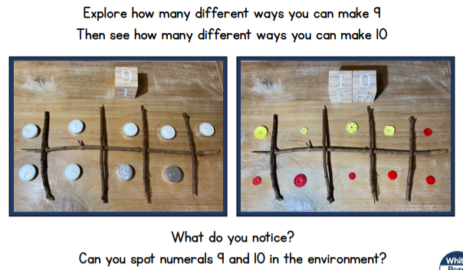
- Lesson 2: Representing and Sorting 9 and 10
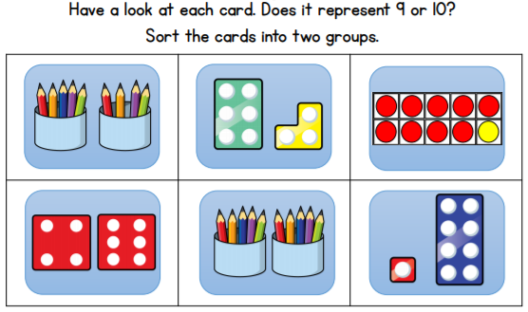
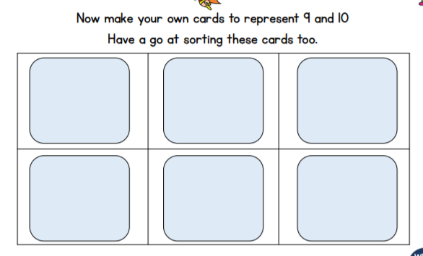

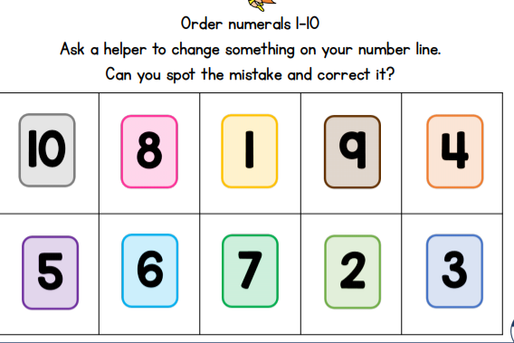
- Lesson 3: Ordering Numerals to 10

- Lesson 4: Composition of 9 and 10
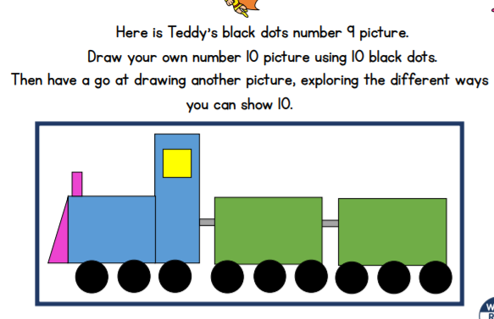
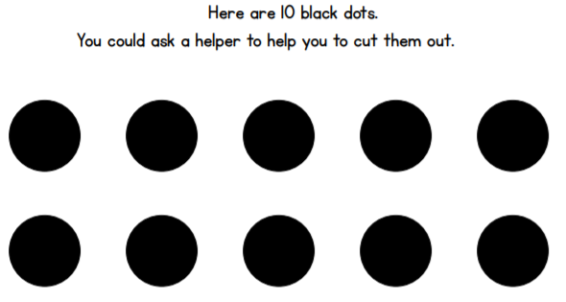

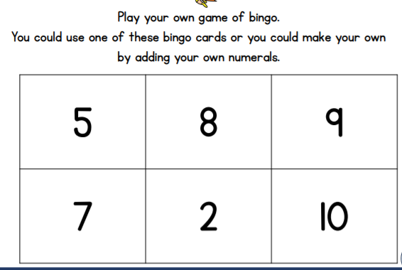
- Lesson 5: Numbers to 10 Bingo
