Squirrel Class Maths Home Learning Week 6 Term 3
To access these lessons please click on the link below in blue to access each unit.
Additional resources that would help learning in these lessons: natural objects collected on a walk, 2 dice or a set of 1-6 numeral cards
https://wrm-13b48.kxcdn.com/wp-content/uploads/2021/01/PDF-Growing-6-7-8-Week-2-Session-1.pdf
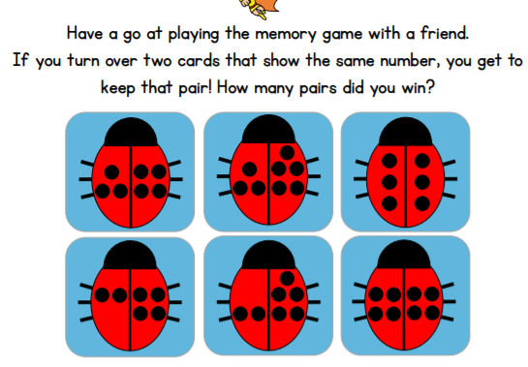
- Lesson 1: Matching 6, 7 and 8.

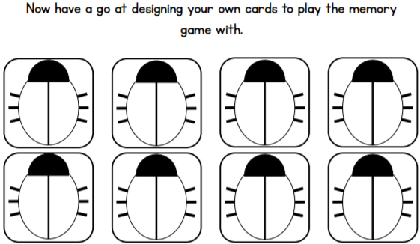

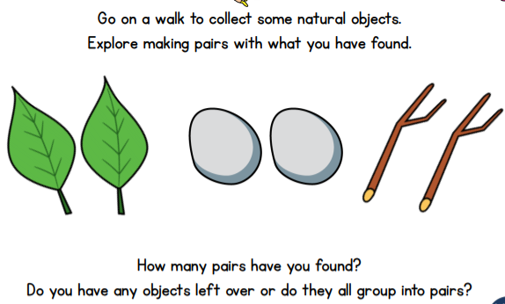
- Lesson 2: Making Pairs

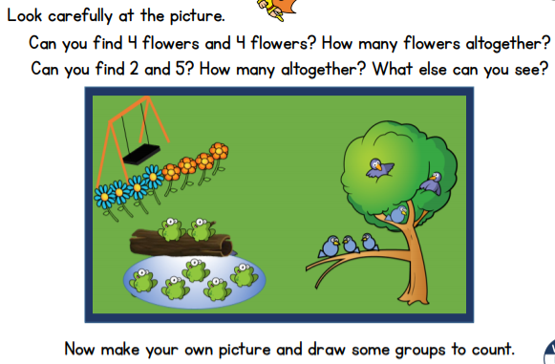
- Lesson 3: Combining 2 groups

- Lesson 4: Combining 2 groups
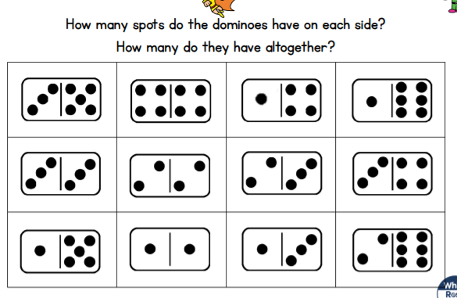

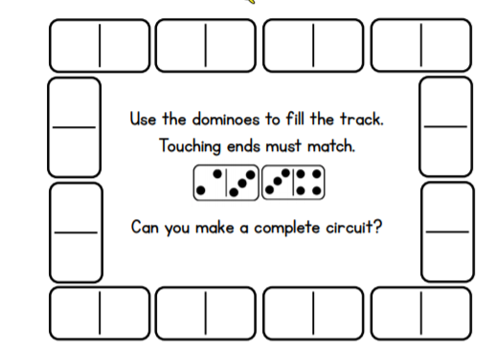

- Lesson 5: Adding more
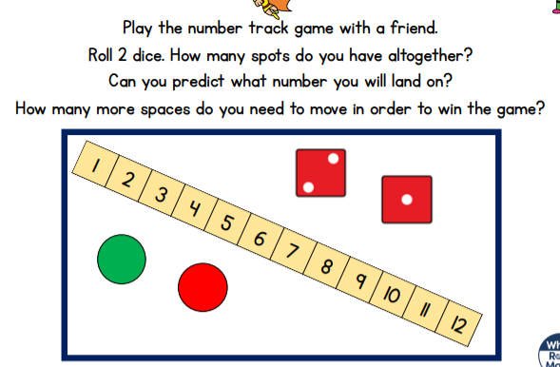
Practise counting 6, 7, 8
https://www.youtube.com/watch?v=VgVrc7M9e_w

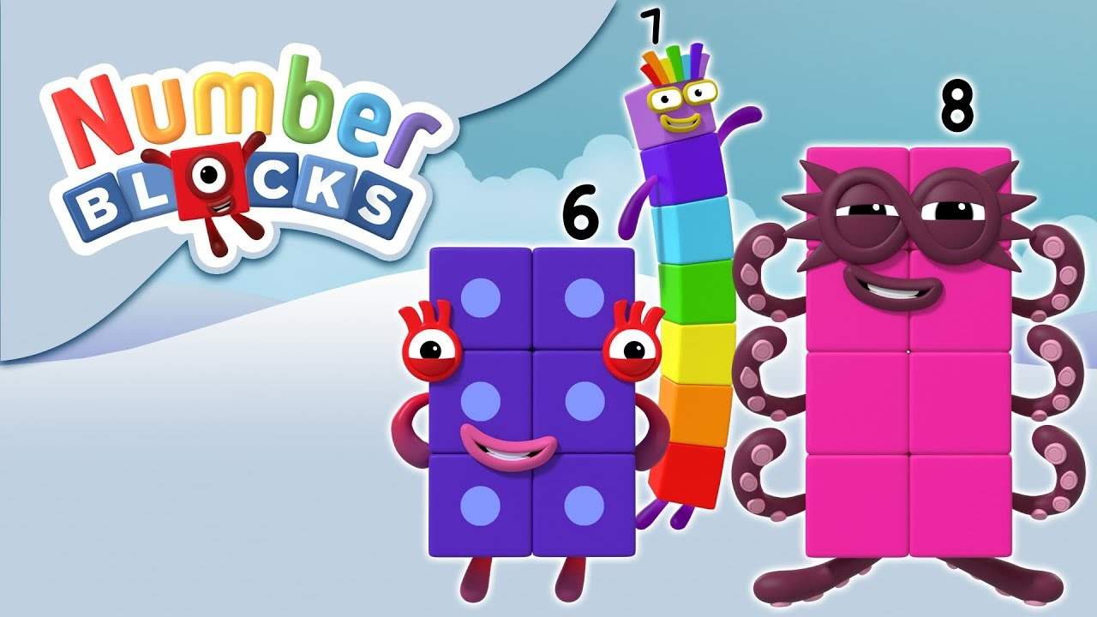
Learn to count 6, 7 and 8 using the Number Blocks video. Can you count out 6, 7 and 8 objects at home? Can you count from 0-8 and back again? Where around your house can you find the numbers 6, 7, and 8? Can you write the digits 6, 7 and 8?

Can you make your own Number Blocks from 1-8 using blocks, pebbles, cubes, rocks or sugar cubes?

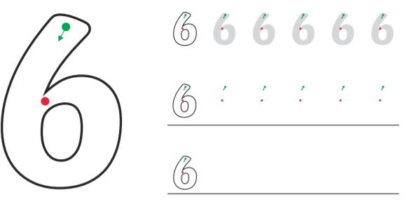
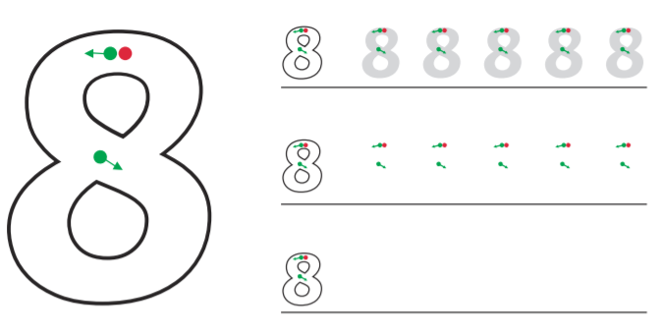
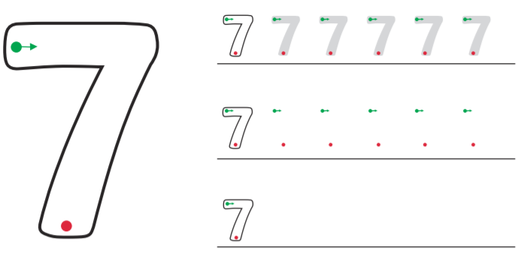

Now cover the digits and practise writing them from memory.

