Squirrel Class Maths Home Learning Week 4 Term 3
To access these lessons please click on the link below in blue to access each unit.
Useful resources to support learning using the online lessons are: different sized containers to fill. Ingredients for playdough – see recipe below.
https://whiterosemaths.com/homelearning/early-years/alive-in-5-week-3/
- Lesson 1: Comparing mass – heavier and lighter than.
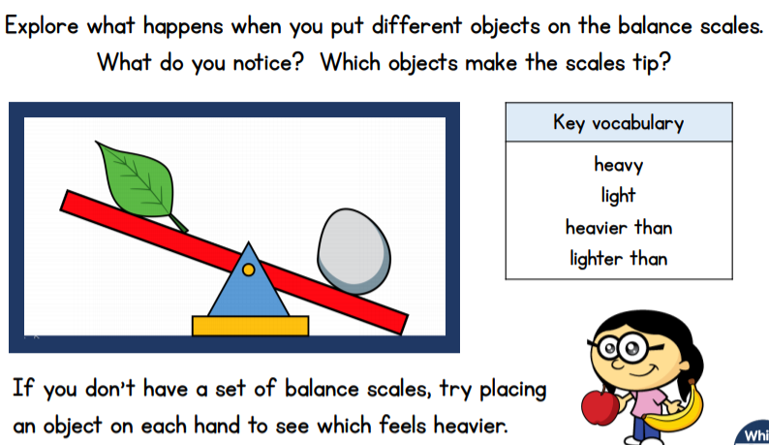

- Lesson 2: Full and empty.
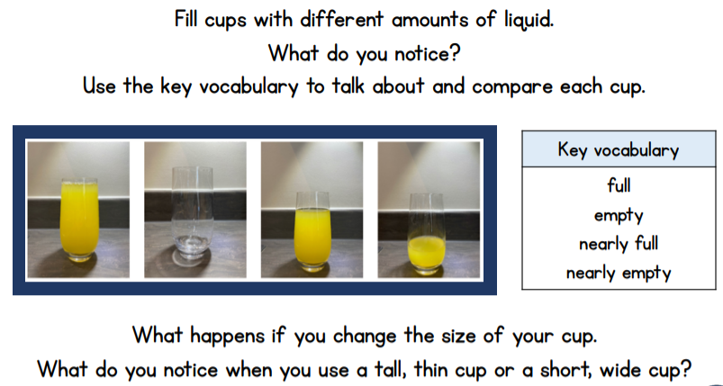
- Lesson 3: Measuring capacity.

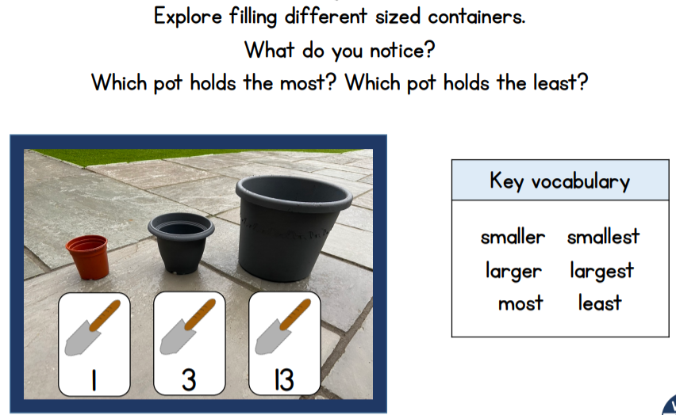

- Lesson 4 Measuring capacity – how many fit inside?
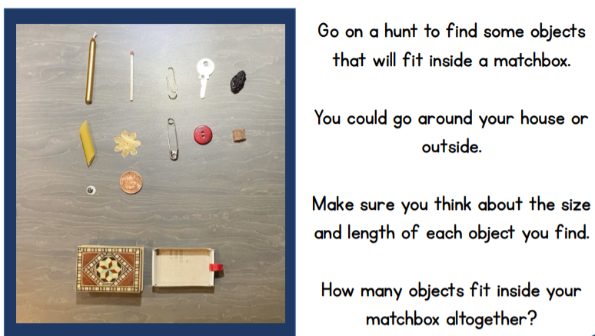
If you don’t have a matchbox then another small container will do.

- Lesson 5 Measuring ingredients.
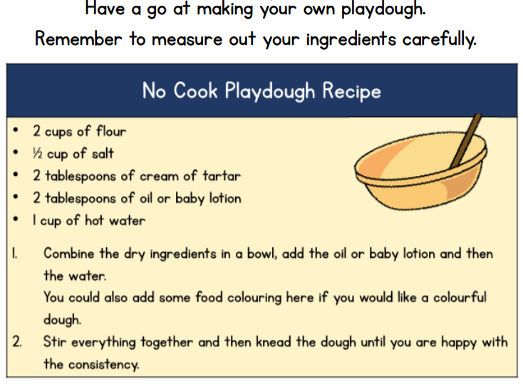
Use your playdough to make objects of different sizes (you could use a dough cutter or cut simple shapes like stars). You could try making snakes of different lengths and compare and order them from longest to shortest. What else could you compare using your playdough?
Practise counting to 6
https://www.youtube.com/watch?v=H5s2A_p3ZsU
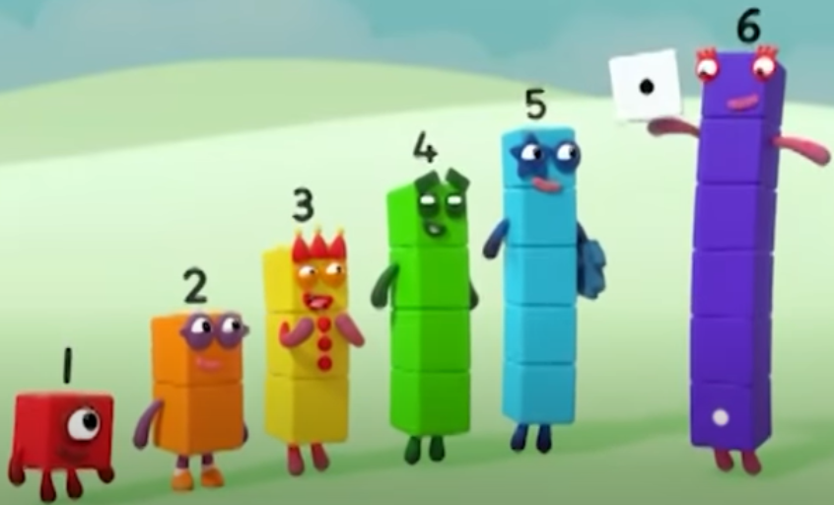
Learn to count number 6 using the Number Blocks video. Can you count out six objects at home? Can you count from 0-6 and back again? Where around your house can you find the number 6 six?
Can you make your own Number Blocks from 1-6 using blocks, pebbles, cubes, rocks or sugar cubes?

