Squirrel Class Maths Home Learning Week 3 Term 3
To access these lessons please click on the link above each unit.
Useful resources to support learning using the online lessons are: bean bags or similar objects to throw Target such as a hoop, chalk circle or bucket.
https://whiterosemaths.com/homelearning/early-years/alive-in-5-week-1/
- Lesson 1: To understand one less. Play a game by counting out up to 5 different objects. How many have you got altogether? How many have you got if you take one away?
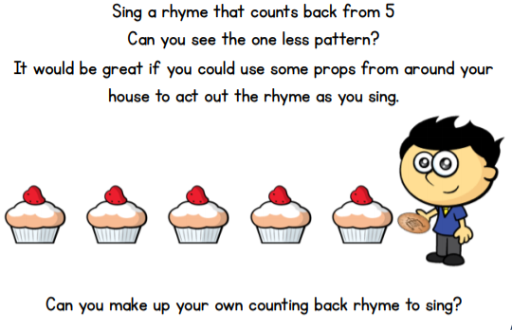

https://whiterosemaths.com/homelearning/early-years/alive-in-5-week-1/

- Lesson 2: To Represent 0.

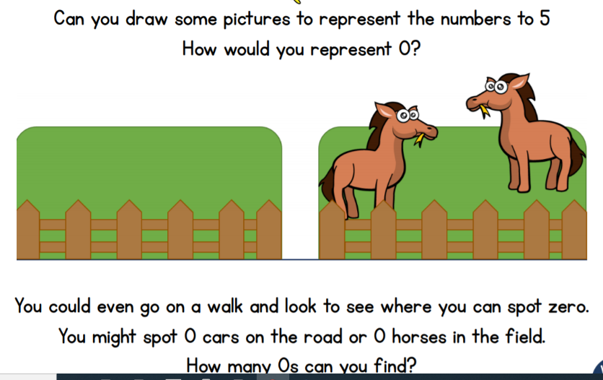

https://whiterosemaths.com/homelearning/early-years/alive-in-5-week-1/
- Lesson 3: To begin to understand the composition of number. Practise playing scoring games by counting and recording the number to 5. You could use dots as well to record your score.
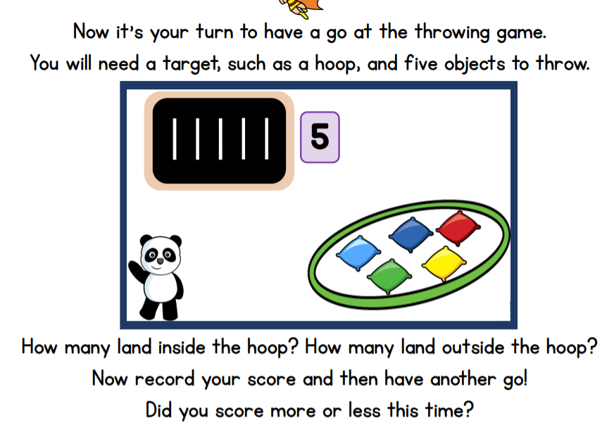

https://whiterosemaths.com/homelearning/early-years/alive-in-5-week-1/

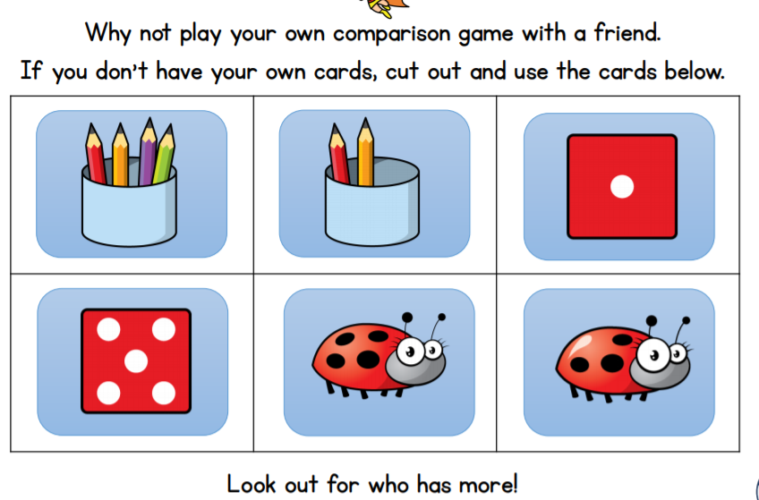
- Lesson 4 To compare numbers to 5. You could roll two different dice and count how many spots are on each. Try comparing a range of objects both real and natural to see who has more. Who has more at dinner time? What other ways could you compare?
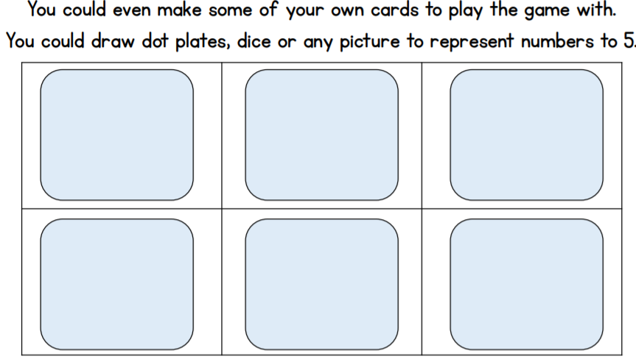
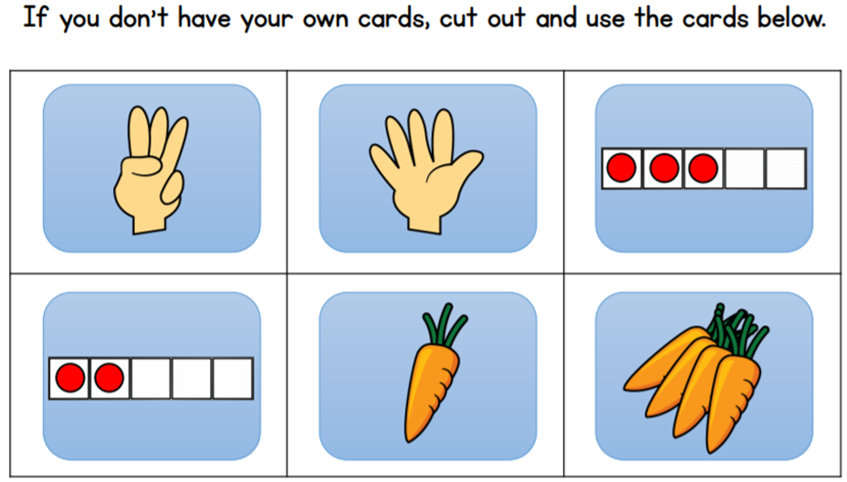
https://whiterosemaths.com/homelearning/early-years/alive-in-5-week-1/
- Lesson 5 To compare equal and unequal groups. Set up a picnic for the bears, toys, dolls etc and practise counting and sharing objects or food equally between 2 toys. Do both toys have the same? How can you tell? What could you do to make sure they have the same? Is the group equal or unequal? If 1 toy has 5 cakes and the other toy has 3 is this equal or unequal?
Now try using 3 toys or bears. How many ways will you need to share the food? How can you share the food so that each toy has the same?

