Summer Term Week 4
Literacy- Squirrels!
Starter Activity- Sing days of the week songs https://www.youtube.com/watch?v=n6ErdvCklrM Write an alliterative poem using the word ‘Squirrel’ e.g. secretive, quick, unique, inquisitive, red, etc.

We are learning about ‘Why do Squirrels hide their nuts?’
Now that you have found out information about squirrels, make a mini book. You might like to create a non-fiction information book or use your imagination to create a story about secret squirrels.
You could design a book cover and think to a catchy title for your book. Remember, it needs to hook people in so that they are interested in reading it!

Phonics
Watch Mr Thorne does phonics, Bitesize or signup to Phonics play Phase 2/3 sounds for Year R. Please learn a new sound each day
and practise writing the letter and CVC words.
Year 1 recap all sounds and learn a Phase 5 sound every day using Phonics Play. Practise spelling tricky words for each of the phases you have learnt so far.
https://www.youtube.com/results?search_query=mr+thorne+does+phonics+phase+2
https://www.phonicsplay.co.uk/

Reading

https://www.youtube.com/watch?v=pozGE-1u4Uw&feature=youtu.be
Login and read the non-fiction book ‘Animal Studies – Spider’
https://classroommagazines.scholastic.com/support/learnathome/grades-1-2.html
Listen to the story ‘Hairy Maclary’s Hat Tricks and talk about the main characters and the sequence of events in your own words.
Number 3
This week, we will be looking at number 3! Watch this short clip all about number 3!
https://www.youtube.com/watch?v=yGuBHDfWIDQ

Can you find 3 of a variety of things from around the house?
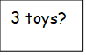
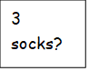
3 cushions?
3 cups?

Before | 3 | After

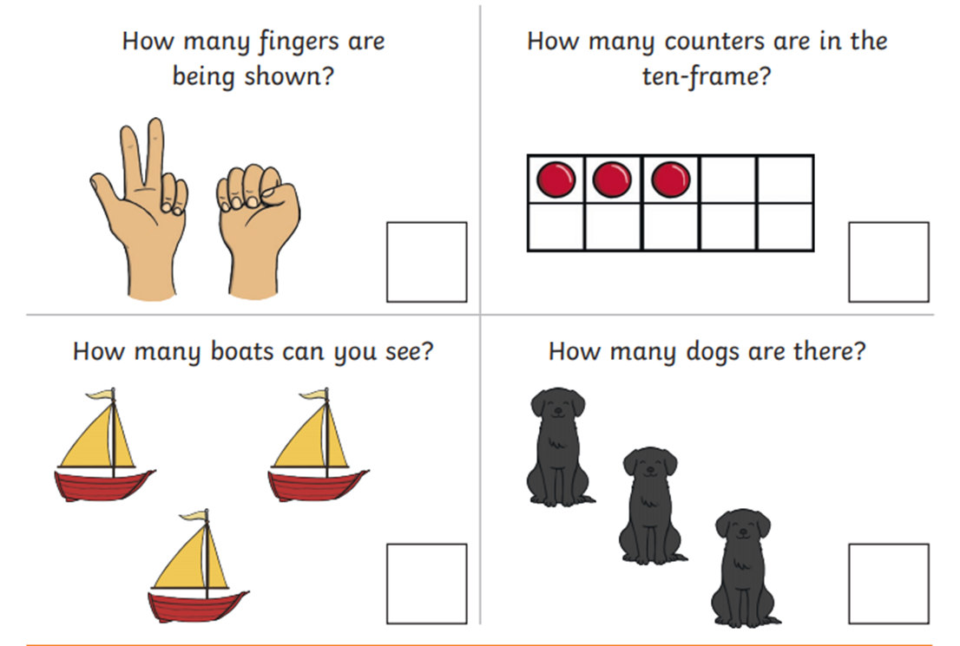
Number 7
This week, we will be looking at number 7! Watch this short clip all about number 7! https://www.youtube.com/watch?v=oj0gNnqBQJA

What groups of 7 objects can you find around your house? Can you record them using an array?
7
7 | 0
6 | 1
5 | 2
4 | 3
3 | 4
2 | 5
1 | 6
0 | 7

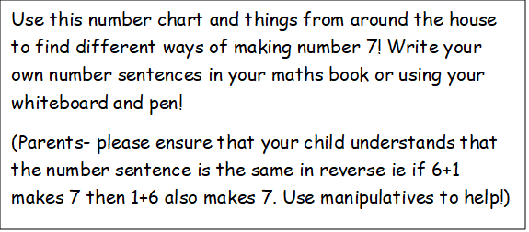

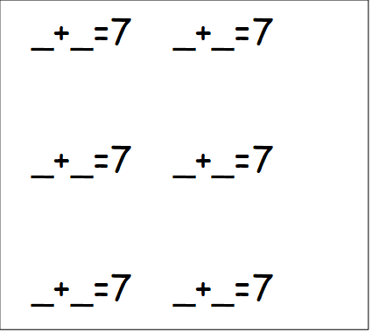
Write all the numbers bonds you can to 7.

P:E: Try Andy’s Wild Workouts https://www.bbc.co.uk/programmes/p06tmmvz

