Recommended visual timetable to support with you Home Learning.
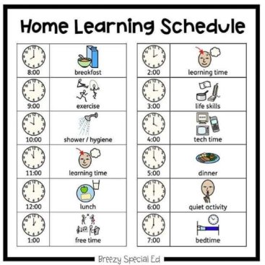
Use this to help keep your routine as normal as possible.
You might want to change some of the symbols and make it work for you and your family.

