Things to do at home
Personal, Social and Emotional development
Children enjoy carrying out small tasks, this is good for their self-esteem, resilience and confidence.
House hold activities:
- Chopping vegetables
- Stirring the cooking
- Stirring baking
- Grating cheese, carrots etc
- Helping dress baby brothers and sisters
- Folding clothes up

Let your child pick which activity from the ideas provided they would like to do. It is good for children to make some of their own decisions.
Discuss interests with your child. If your child has a certain interest e.g. planets, flags, trains, Disney, princesses, do some research with them about it – you can use books and the internet. You can make a fact book together.

Communication and Language
Talk is one of the most important parts of your child's development!
Encourage your child to ask questions this encourages a curious mind.

Ask your child open ended questions; why do you think that? How do you know that? Can you explain how you did it? How do you do that?

Go outside into your garden or on your front door step and talk about what you can see. What is different from yesterday? Discuss the weather, the cars, the birds etc

Play a game of eye spy with your child
Eye spy with my little eye something that is blue
Eye spy with my little eye something that you eat with
Eye spy with my little eye something beginning with ch

Play a positional language game
Simon says… under the table, on the chair, next to the sofa, behind the table, in front of the tv…
Your child needs to stand where Simon says. This will help their positional language understanding.

Physical Development
Moving and Handling
Fine motor skills that can be done at home
- Transfer water to ice cube trays
- Insert pipe cleaners into holes of a box
- Cut straws and make a necklace
- Collage – sticking small pieces of paper on cardboard tubes, paper etc Use a hole punch with paper
- Press pasta into playdough
- Use scissors to cut along lines
- Colouring
Get moving at home
- Remember to warm up!
- Why do we need to warm up?
- Can you teach your family the traffic light game – green for go (jogging/running), yellow (do an action eg jumping on the spot), red (stop!)
- Do some cosmic kids Yoga in the living room.
https://www.youtube.com/user/CosmicKidsYoga
- I wonder how many different ways you can move across your living room floor or garden?
- Which animals can you move like? Which vehicles can you move like?
https://www.youtube.com/watch?v=DYPTJj6hd44
- How long can you balance on 1 leg? Practice hopping, skipping and jumping.

Health & Self Care
Food sorting activity
Sort the foods in the cupboards into healthy and unhealthy food. Discuss what is good and bad about the foods.

Germs Activity
All you need is; A plate, water, pepper and washing up liquid.
Follow the link:
https://www.youtube.com/watch?v=ho0o7H6dXSU

Here are some things to practice
- Brushing their teeth
- Brushing their hair
- Cleaning their face
- Getting dressed independently
- Doing and undoing buttons on tops.
- Putting shoes on
- Putting a coat on
- Feeding themselves
- Using the toilet and washing their hands independently
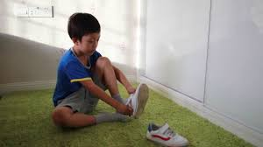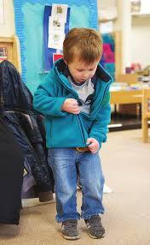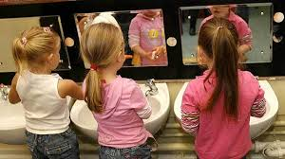
Literacy
Reading
Daily reading is very important in developing your child’s reading skills. Please, if you can, spend time sharing a book with your child, pointing to the pictures and saying the names of various objects. By drawing attention to these, your child will learn the importance of language. Reading books aloud to children stimulates their imagination and expands their understanding of the world.
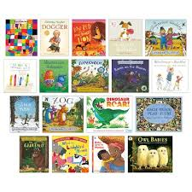
Reading
  - Sounds Cards
  - Blue book words
  - Phonics sounds- Phase 2 and 3 mats
Writing
  - Think of a sentence, say the sentence, write the sentence
  - Making Lists
  - Writing messages
  - Keeping a diary
  - Writing your name

Fine motor and gross motor activities
- Practice writing in flour or salt
- Make playdough – dough disco
https://www.youtube.com/watch?v=i-IfzeG1aC4
(there are lots of playdough recipes online)
- Writing in the air using big arm movements (get your child to say the sounds and words and write them in the air) they can do this to music to make in more fun.

Maths
So far in maths we have learnt
- All about the numbers 1-10
- Adding using resources we can count with
- About 2d and 3d shapes- these can be found all around us! I wonder which shapes you can find at home or use to make a picture.
- Counting on from a given number e.g. 3, 4, 5, 6, 7, 8, 9, 10.
- Counting back from a given number e.g. 6, 5, 4, 3, 2, 1, 0
- Take away using resources we can count with
- Recognising number 0-20.
Activity using construction bricks
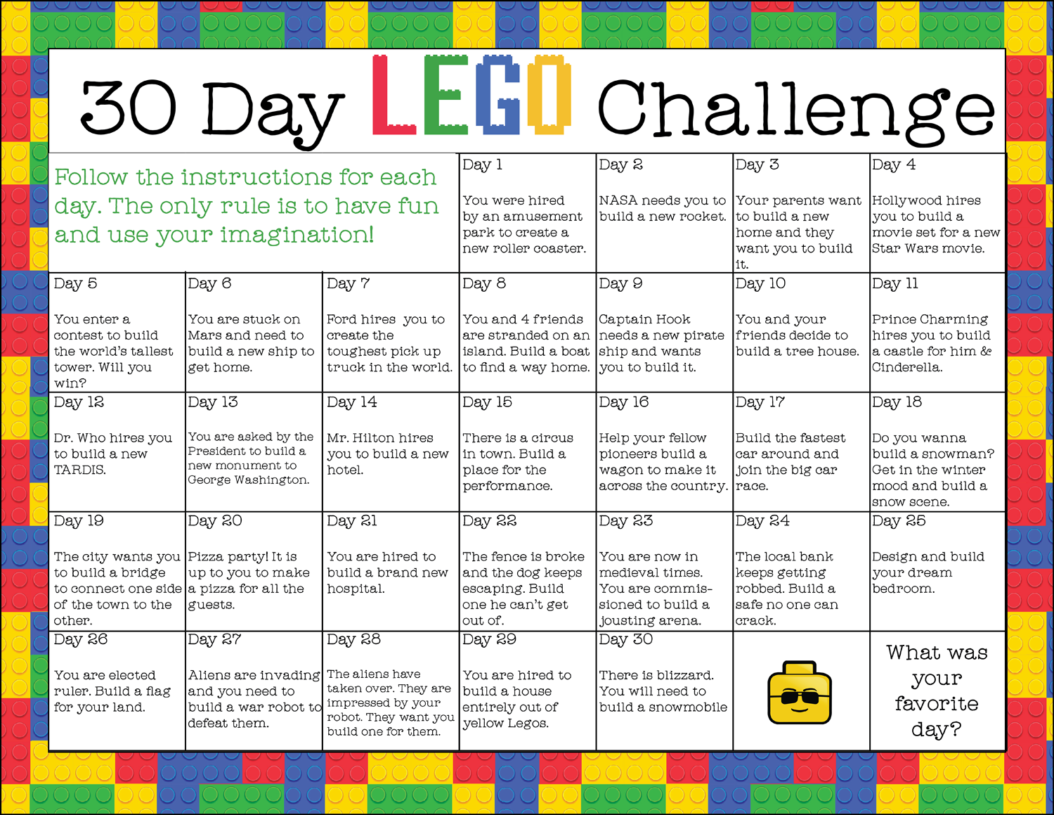

Understanding the world
We have been growing beans and cress – can you grow flowers, fruit or vegetables at home? Make sure you give them water and sunlight. You could draw pictures or take photographs of them as they grow.

Go outside in the garden or park and see what minibeasts you can find. Talk about nature with your child and explore these stories on YouTube:
https://www.youtube.com/watch?v=I_A_e6h-DhU
https://www.youtube.com/watch?v=vlhucZKcALk
https://www.youtube.com/watch?v=WhDJDIviAOg

Can you name 4 seasons?
Can you put them in order?
What happens in each season?
Can you draw/make a picture representing each season?

Cooking
Baking will help your child to begin to understand about measuring, planning, hand strengthening and counting skills!
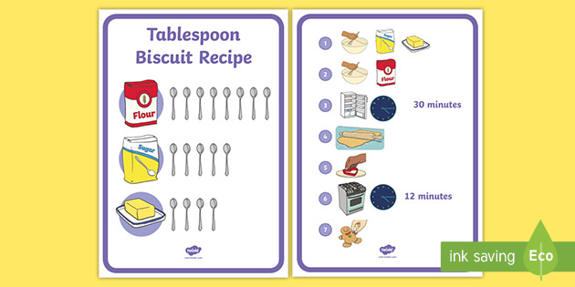
Technology
You could visit these websites for games to play and other ideas
www.topmarks.co.uk
www.bbc.co.uk/cbeebies
www.ictgames.com
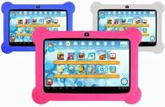

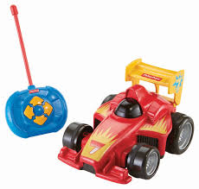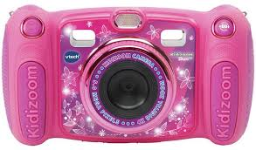
Expressive Arts and Design
Get creative
Use different materials from around your house to create a mixed media picture.
Materials you could use:
Newspaper/magazines, food colouring to paint with, wool, string and thread, old t-shirts, pencils, paper
(think outside the box!)
Take part in the Rainbow Trail challenge – draw or decorate a picture of a rainbow and place it in a window at the front of your house.
Ideas are all the time - Rainbows,
30th March to 6th April – Rainbow Flowers
6th April onwards Rainbow Eggs

Sing some of your favourite nursery rhymes – can you learn a new one?
Being Imaginative
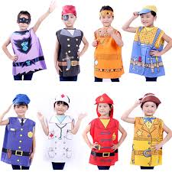
Play games with your family involving imaginative role play.
Who will you be today? A Policeman, a king/queen, a Disney character, an animal…

Put on a show for your family
This could involve; singing, magician show, acting, gymnastics…
Maybe you can act out your favourite story book

Here are some links to some of our favourite stories:
Room on the broom
https://www.youtube.com/watch?v=cWB0goTWZic
The Gingerbread Man
https://www.youtube.com/watch?v=YoQyyB5xvLk
We’re going on a bear hunt
https://www.youtube.com/watch?v=Waoa3iG3bZ4
Aliens Love underpants
https://www.youtube.com/watch?v=HmYqb4mJO7Y

