READING INTENT
At Parkside Community Primary School, we believe that reading is an essential life skill, and do our best to ensure pupils are given the greatest opportunities to develop this, in the hope that they will become life-long readers, who read confidently for meaning and regularly enjoy reading for pleasure, with the skill set necessary to tackle everyday situations that rely on reading. We encourage our children to see themselves as readers both for pleasure and purpose.
We believe that all our children can become fluent readers and writers. Therefore, we have chosen to teach reading through Little Wandle Letters and Sounds Revised, which is a systematic and synthetic phonics programme. We start teaching phonics in Reception and follow the Little Wandle Letters and Sounds Revised Progression, which ensures children build on their growing knowledge of the alphabetic code, mastering phonics to read and spell as they move through school. We also have a strong focus on language development for our children because we know that speaking and listening are crucial skills for reading and writing in all subjects.
From the start of school life, Parkside Community Primary School aims to broaden pupils' experience of books, both fiction and non-fiction. This continues as our children progress through the school. As their reading skills develop, we teach pupils to consider the language and meaning of text. This change in reading from a surface approach (gathering information) to a deeper approach (understanding and interpreting) is essential to gain the most out of texts. Reading becomes not simply a way to see what is written, but to recognise and interpret what is said, considering subtleties such as bias, assumptions, and the perspectives of the author.
Parkside Community Primary School:
Understands how a strong grounding in reading will impact the future learning and development of a pupil in all subjects and prepare them for life in modern society.
Provides a broad and balanced curriculum, which includes fluency in the use of phonics, reading practice, and widening vocabulary, reading for different purposes, reading a variety of genres, as well as focussing on standard and non-standard pronunciation.
Ensures that all teachers are aware of teaching, learning and assessment requirements for the development of reading.
Develops children’s reading stamina, so that children can read for longer periods of time, appropriate to their age, and across a range of genres.
READING IMPLEMENTATION
Phonics
A Systematic Synthetic Phonics Programme (Little Wandle) is taught daily from the start of Reception, up to and including Year 3 and Rapid Catch-up 7+ for those children in KS2 who require phonic intervention.
Our Reading Progress Spine
In Reception and Year 1 and those children still developing their phonic skills, read books matched to their secure phonic knowledge using the Little Wandle Letters and Sounds Revised assessments and book matching grids.
Children then begin the colour banded Big Cat reading books, starting with turquoise and follow a colour coded banding system adapted from other well-known schemes. The bandings enable the children to understand which level they are on it and gives them the knowledge of where to aspire to as their reading improves.
Whole Class Reading Lessons
Structured whole class reading is taught from Year 3 to Year 6, using rich, age-appropriate texts and following the VIPERS approach, which teaches and provides practice of the following reading skills:
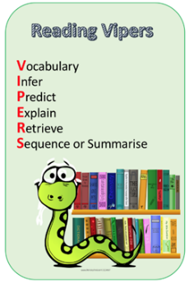
Vocabulary
Infer
Predict
Explain
Retrieve
Summarise/Sequence
Shared books are vital in developing children’s vocabulary and are carefully selected by teachers for their classes to ensure maximum impact on language development. An important part of these lessons is book talk, in which children and teachers find connections between different texts, discuss their preferences and make recommendations.
VIPERS question stems
VIPERS, questions can be applied to any text that a child is reading as well as with pictures, picture books and films! The 6 domains focus on the comprehension aspect of reading and not the mechanics: decoding, fluency, prosody etc. As such, VIPERS is not a reading scheme but rather a method of ensuring that teachers ask, and students are familiar with, a range of questions. They allow the teacher to track the type of questions asked and the children’s responses to these which allows for targeted questioning afterwards.
QUESTIONS STEMS 1 QUESTIONS STEMS 2
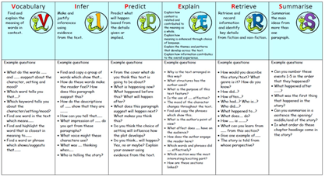
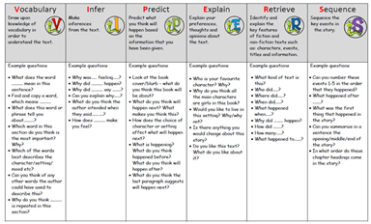
What are Vipers?
(Based on materials from The Literacy Shed)
VIPERS is an acronym to aid the recall of the 6 reading domains as part of the UK’s reading curriculum. They are the key areas which we feel children need to know and understand in order to improve their comprehension of texts. At Parkside Community Primary School we use VIPERS to help support our pupils to understand what a good reader looks like and how to approach answering reading questions. All children work on VIPERS during class reading whether this is reading as a class, in a small group or one to one with an adult.
Reading across the Curriculum
We provide a text rich environment, in order to encourage a positive culture of reading throughout all classes. Core texts, which relate to the class’ current curriculum theme, form the basis of curriculum planning and reading skills are applied across all subjects.
Reading Aloud
Every teacher reads aloud to their class each day. Stories are also shared across year groups and in assemblies. The whole school participates in Paired Reading during which classes are paired with another year group to share books and read aloud to each other. Children have regular opportunities to read aloud on a one to one basis with staff, parents and volunteer reader helpers.
A Reading-Rich Environment
Our learning environments promote and encourage reading, through well-resourced and accessible book areas, reading displays and regular opportunities for book talk.
We arrange special reading events such as ‘World Book Day’ activities, storytelling sessions and author visits. We have our own school library, which classes are encouraged to visit regularly and which is made available for classes to use during the afternoons and curriculum subject leaders play an active role in creating a rich and varied reading diet. This includes learning outside the classroom, Forest School and Eco School.
Author Visits
There is nothing more inspiring than having an actual published author visit school and work with pupils. That is why we are dedicated to regularly inviting authors to come into school and encourage, entertain and enthuse our pupils through assemblies and workshops.
We try to book a range of authors and have found these visits have led to pupils reading more and, for some, it has been an inspiration to become an author.
Recent authors have included: Jo Clarke, (Spellboda) and Paul Deslandes, (The Garden Monster) where every child in the school received a signed copy.
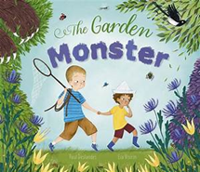

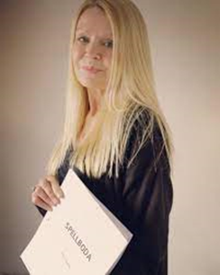
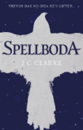


Teachers also try to connect with authors who are doing live talks over the internet, including Michael Morpurgo.

Reading at Home
We understand that parents and carers play a key role in encouraging their child to develop a positive attitude to reading. Children love to listen to and tell their own stories; talking about books and sharing them together can be an enjoyable experience for all involved. For Foundation Stage and KS1, we suggest that parents read with their child for about 10 minutes each day. Each child will read in school, and then read the eBook which is 95% decodable. They will also take home a shared reading book (which is matched to their phonic knowledge). They also have access to a Reading for Pleasure book of their choice to share and enjoy with the adults at home which is not fully decodable.
Once a child can read fluently, reading remains extremely important to their development. The opportunity to talk about what they have read is vital in developing their understanding; therefore, we recommend that parents and carers continue to listen to their children read. Children also benefit hugely from listening to family members reading aloud to them.
Ensuring reading for pleasure
‘Reading for pleasure is the single most important indicator of a child’s success.’ (OECD 2002)
‘The will influences the skill and vice versa.’ (OECD 2010)
We value reading for pleasure highly and work hard as a school to grow our Reading for Pleasure pedagogy. Every classroom has an inviting book corner that encourages a love for reading. We curate these books and talk about them to entice children to read a wide range. In Reception, children have access to the reading corner every day in their free flow time and the books are continually refreshed.

READING IMPACT
At Parkside Community Primary School, we work closely with Kingsnorth English Hub and a Senior English Advisor, to continue to refine and enhance our practice. Through high-quality teaching of phonics, our aim is for children to become fluent, confident word readers by the end of KS1. Providing children with a wealth of stories, and opportunities to share them, will promote a love of reading which goes beyond the classroom.
By the time they leave primary school we aspire for children to be fluent, confident and able readers, who can access a range of texts for pleasure, participate in discussions, and communicate their opinions and responses to what they have read. These skills will allow them to unlock future learning and provide for them limitless possibilities.
Cultural Capital in Reading
‘It is the essential knowledge that pupils need to be educated citizens, introducing them to the best that has been thought and said and helping to engender an appreciation of human creativity and achievement.’
Ofsted School Inspection Handbook 2019

