Geometry – Shape
Recognise and name 3D shapes
Day 1
Go on a Shape Safari around your home. Can you spot 3D shapes in everyday objects?
My kitchen bin is a cylinder shape, which shape is your?
Is your TV a cuboid too?
Have you got anything cone shaped or pyramid shaped in your home?
How many cubes and spheres can you find?
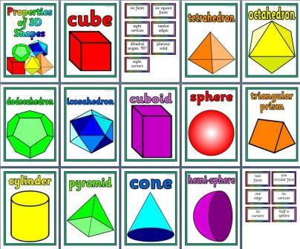

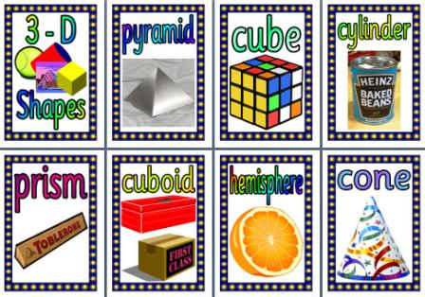

Day 2
Aut1.10.1 - Recognise and name 3-D shapes on Vimeo (Video Link) Get a pencil and paper ready.
If you are able to, click the link above to watch a video that explains how to recognise and name 3D shapes.
Next, complete the activities in the following work sheet.

Day 2 continued
Draw a line to…
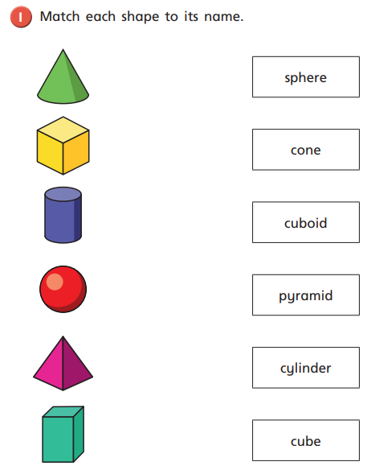
Day 3
Using the vocabulary on the previous sheet, fill in the blanks to show that you can recognise and name the 3D shapes in the picture.
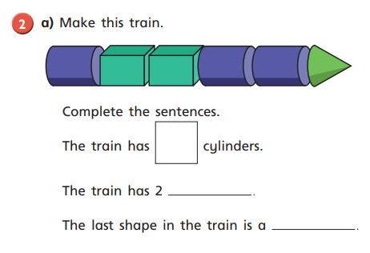 Use small 3D shapes that you have found around your home and create a picture or sculpture. You could try to make a house. You will need:
1 cuboid (for the door)
1 large cube (for the building)
1 pyramid (for the roof)
3 – 4 small cubes (for windows)
Take a look at this website which gives you lots of ideas of art projects to make with recycling (we call it junk modelling at school!) 20 great Junk Modelling ideas https://www.playlikemum.com/20-genius-junk-modelling-ideas-for-kids-to-try/
Day 4
Sort 3D shapes
Aut1.10.2 - Sort 3-D shapes on Vimeo (Video Link)
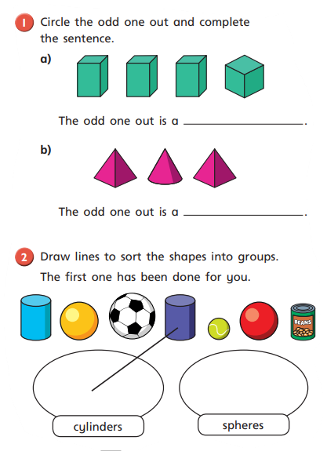
Day 5
Can sit on top of each other without falling or rolling off.
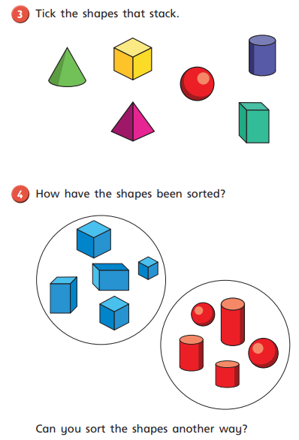
Day 6
Properties of 3D Shapes
Hopefully you were able to find some 3D shaped objects at home. Study the objects and this answer sheet to understand all the properties of 3D shapes. Tip; Vertices means points or corners.
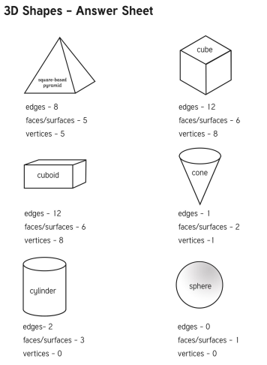
Without looking at the answer sheet, (oh alright then, just a peek!), fill in this table for each 3D shape and it’s properties
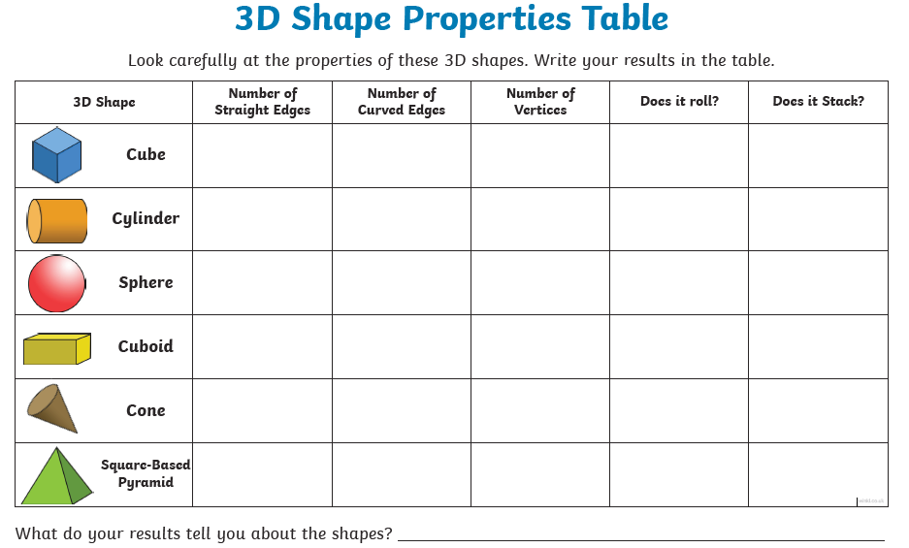

Answers!

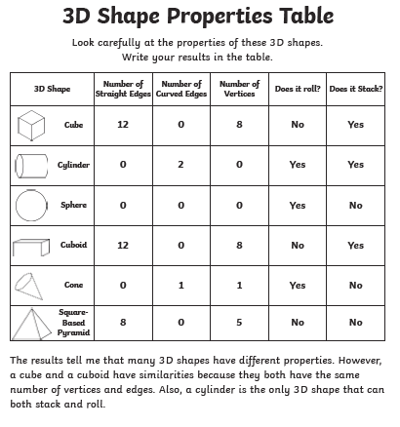

Day 7
Recognise and name 2D shapes
Go on another Shape Safari around your home, but this time look for 2D shapes. Remember that 2D shapes are flat. Not fat like 3D shapes which have sides, corners, faces, edges, depth etc. You will find 2D shapes inside books or magazines, hiding in your adults wallets, maybe under the sofa, on your wall and even inside the bin (but don’t go rummaging in there!). Look out for squares and oblongs (rectangles) triangles, circles, pentagons (5 sides) and hexagons (6 sides)!

Aut1.10.3 - Recognise and name 2-D shapes on Vimeo (Video Link)
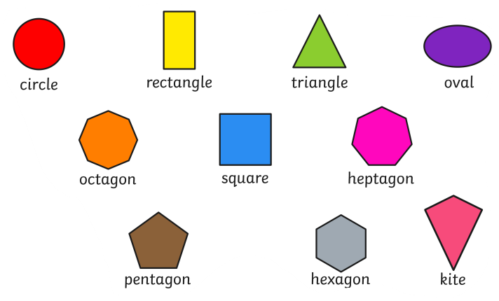

Day 8
Without looking at the previous sheet (no cheating!)…
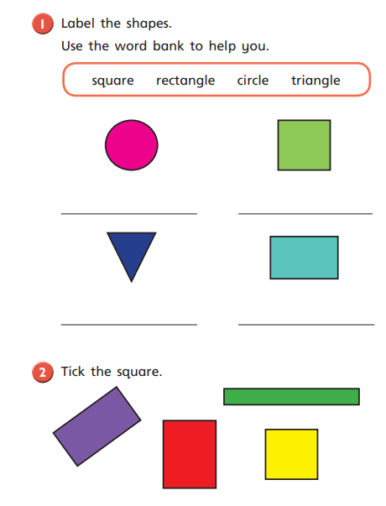

Day 9
Sort 2D Shapes
Aut1.10.4 - Sort 2–D shapes on Vimeo (Video Link)
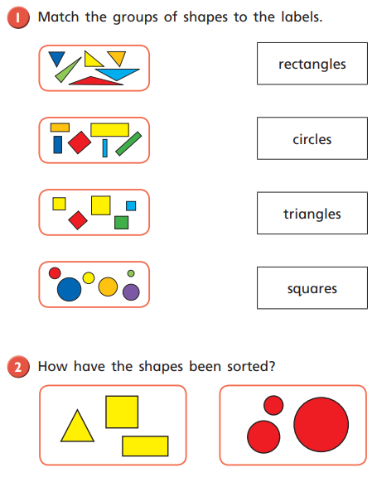
Day 10
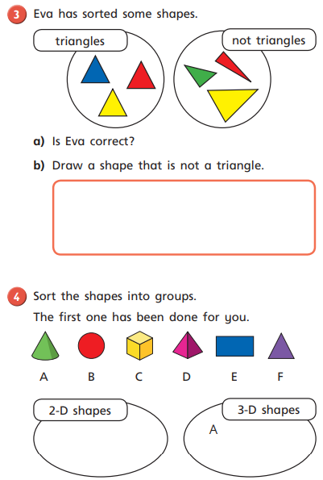
Day 11
Patterns with 3D and 2D shapes
Aut1.10.5 - Patterns with 3–D and 2-D shapes on Vimeo (Video Link)
