Phonics & Literacy Home Learning: Ur, Ear, Ow, Oi T4 Week 2
For literacy this week I would like you to continue with the traditional tale ‘The Little Red Hen.’
https://classroom.thenational.academy/lessons/to-recycle-the-story-of-the-little-red-hen-and-change-the-ending-6tk3ae
Lesson 1: To recycle the story of The Little Red Hen and change the ending
In this lesson, we will be recycling the story of the Little Red Hen and changing the ending to make a new story.
https://classroom.thenational.academy/lessons/to-join-in-with-a-telling-of-a-recycled-story-6xjk6t
Lesson 2: To join in with a telling of a recycled story
In this lesson, we will be exploring ways of telling our new story.
https://classroom.thenational.academy/lessons/to-step-a-recycled-story-and-develop-character-c4t6ad
Lesson 3: To step a recycled story and develop character
In this lesson, we will be stepping out our new story and developing character.
https://classroom.thenational.academy/lessons/to-re-enact-a-recycled-story-focusing-on-character-crv62t
Lesson 4: To re-enact a recycled story focusing on character
In this lesson, we will be acting out our new story.
https://classroom.thenational.academy/lessons/to-independently-tell-a-recycled-story-and-compare-characters-70r3gc
Lesson 5: To independently tell a recycled story and compare characters
In this lesson, we will be supporting pupils to tell the story independently.
For Phonics this week:
Phonics: In Squirrel Class we do two daily phonic sessions. We focus on blending (reading) during the morning 15 minute session and in the afternoon we practise segmenting (spelling). This pack is designed with this in mind.
Sing the alphabet song together by following the link https://www.bbc.co.uk/cbeebies/watch/get-squiggling-letters-alphabet-song?collection=little-learnerss://www.youtube.com/watch?v=OQ1AnMCGTzg
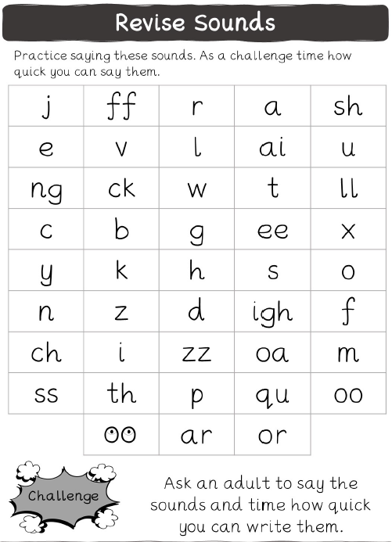
Please follow the link to watch the Letters and Sounds video each day to introduce new sounds.

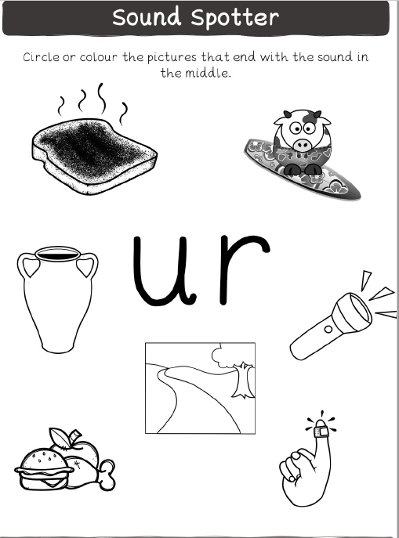
https://www.youtube.com/watch?v=fbouFmTzBn8&t=1s
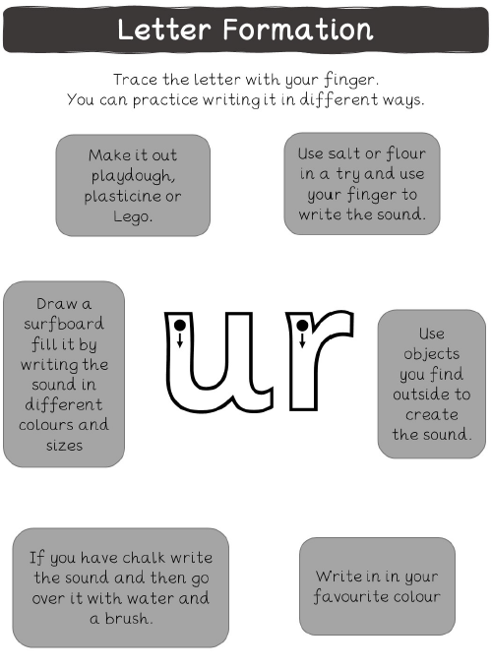
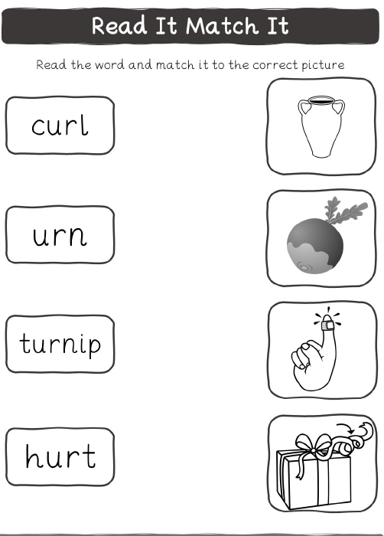
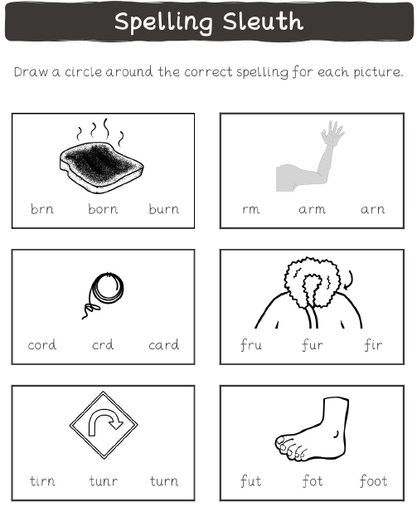

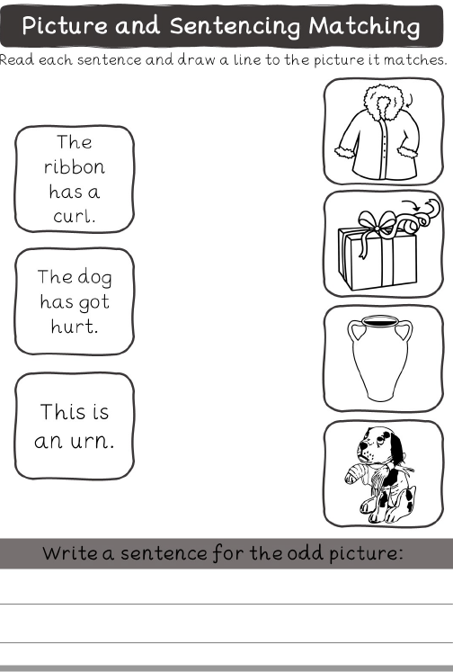
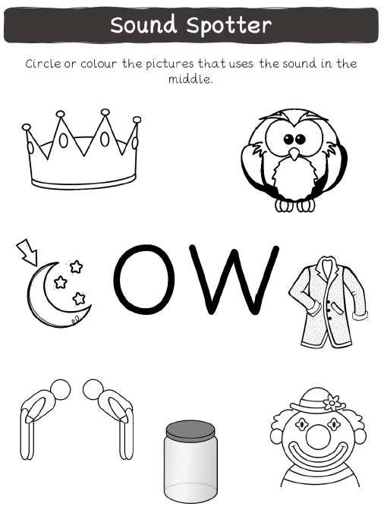
https://www.youtube.com/watch?v=Et-E9brVTYE&t=1s
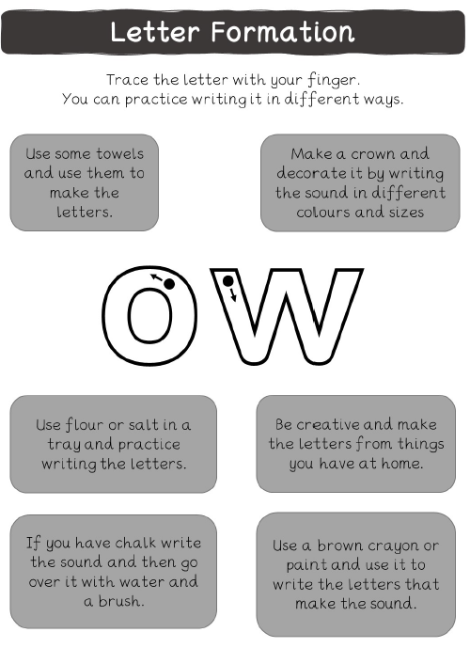
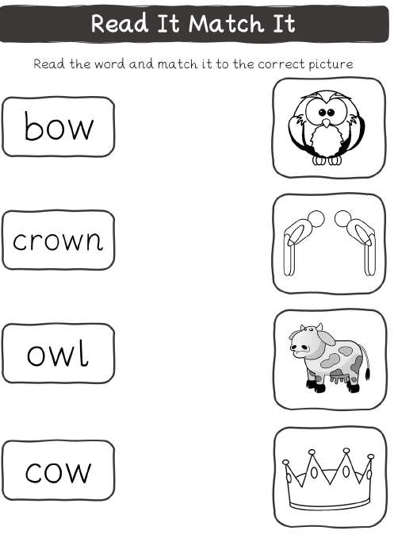

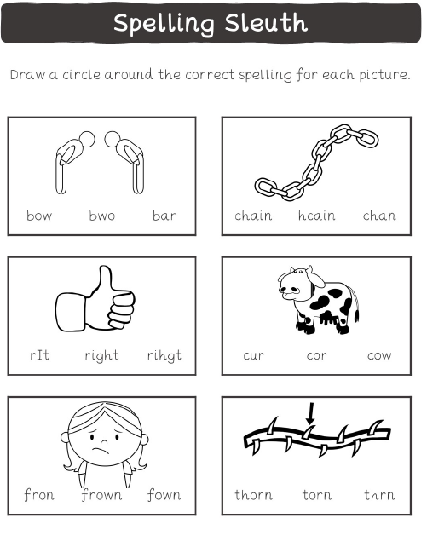

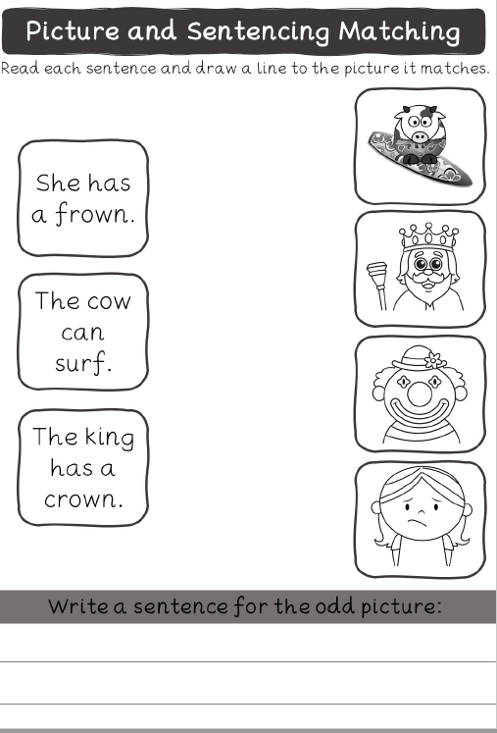
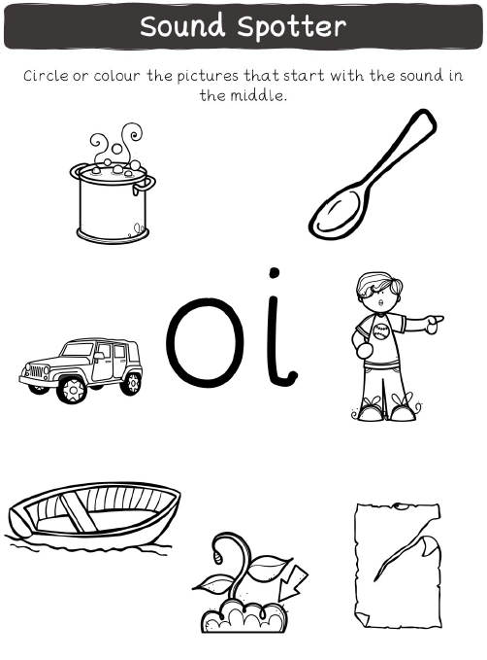
https://www.youtube.com/watch?v=iemIhNNSybw
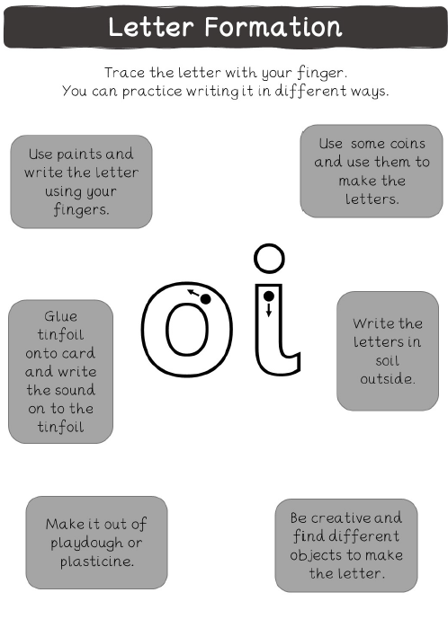
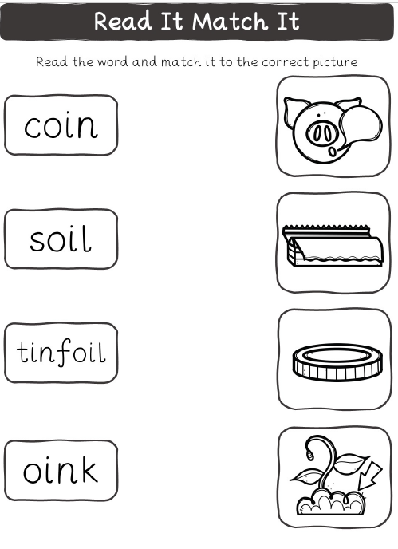
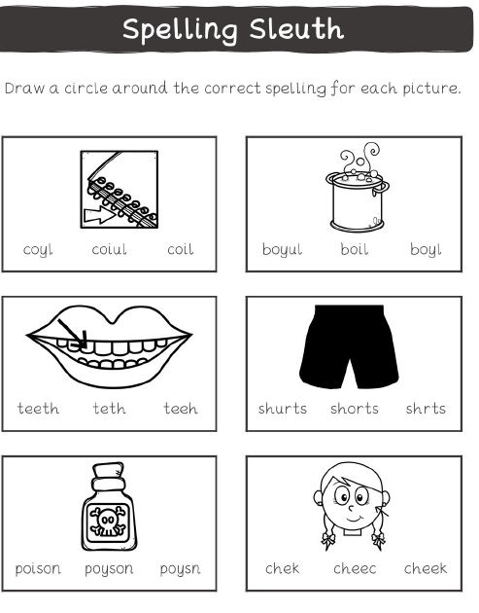

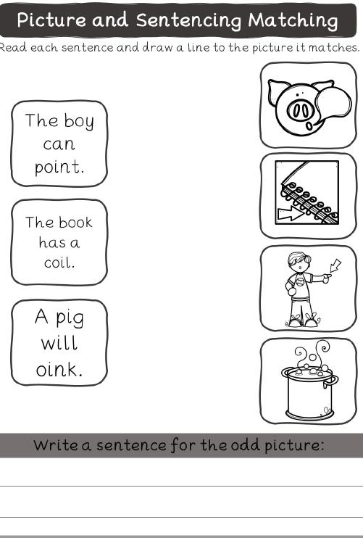
https://www.youtube.com/watch?v=9eIe4BHR4_s&t=1s
