Phonics & Literacy Home Learning: ai, ee, igh, oa Week 6
For literacy this week I would like you to recycle the story ‘The Noisy House’ with Adam and create a new one.
https://classroom.thenational.academy/lessons/to-recycle-a-story-and-create-a-new-one-cgrk0c
In this lesson, we will be recycling a story and creating a new one through a new nursery rhyme.
https://classroom.thenational.academy/lessons/to-join-in-telling-a-recycled-story-6xhp2t
In this lesson, we will be using choral storytelling to teach a retelling of a recycled story.
https://classroom.thenational.academy/lessons/to-step-a-recycled-story-74wk0d
In this lesson, we will be using actions, steps and mime to teach language through story.
https://classroom.thenational.academy/lessons/to-independently-tell-a-recycled-story-60r32c
In this lesson, we will bring the work of the last five lessons together to support independent storytelling.
For Phonics this week:
Phonics: In Squirrel Class we do two daily phonic sessions. We focus on blending (reading) during the morning 15 minute session and in the afternoon we practise segmenting (spelling). This pack is designed with this in mind.
Sing the alphabet song together by following the link
https://www.bbc.co.uk/cbeebies/watch/get-squiggling-letters-alphabet-song?collection=little-learnerss://www.youtube.com/watch?v=OQ1AnMCGTzg
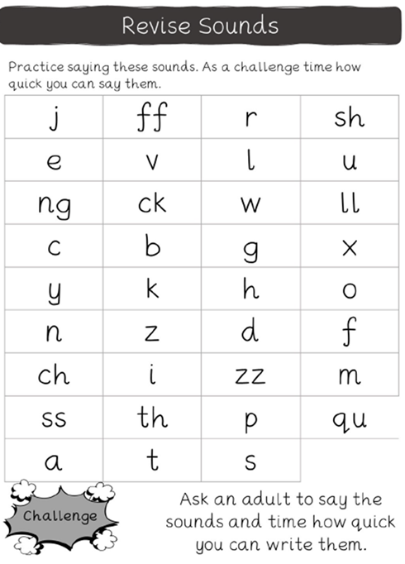

Please follow the link to watch the Letters and Sounds video each day to introduce new sounds. This week we are learning consonant digraphs.
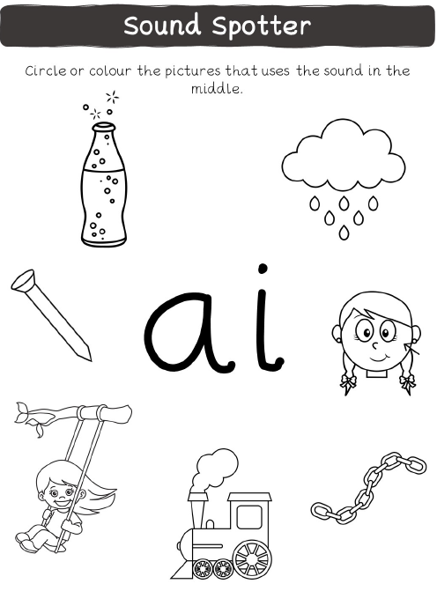
https://www.youtube.com/watch?v=MoCnunAWbGk

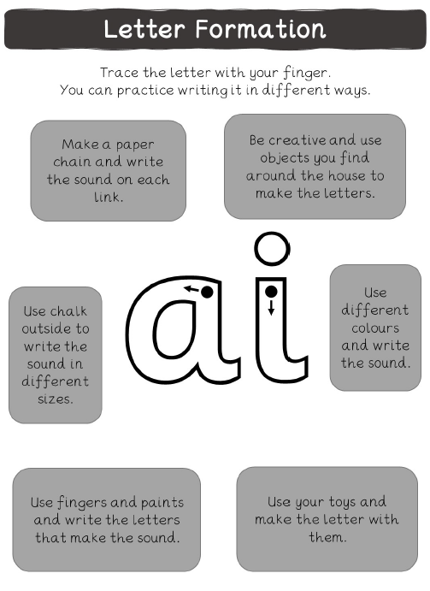
https://www.youtube.com/watch?v=siVkXoEQDNc

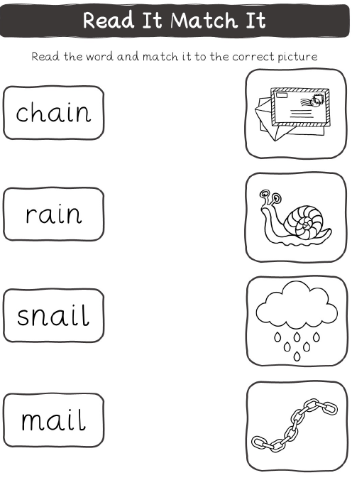
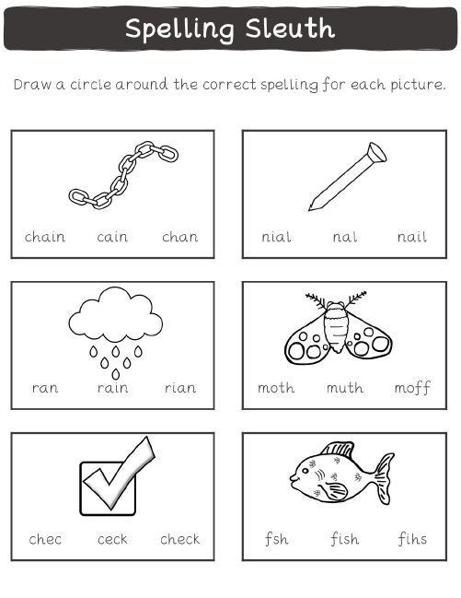
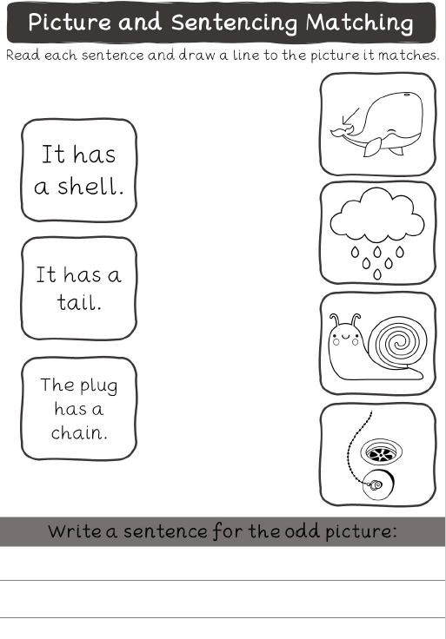
https://www.youtube.com/watch?v=cEffZUP4d_8
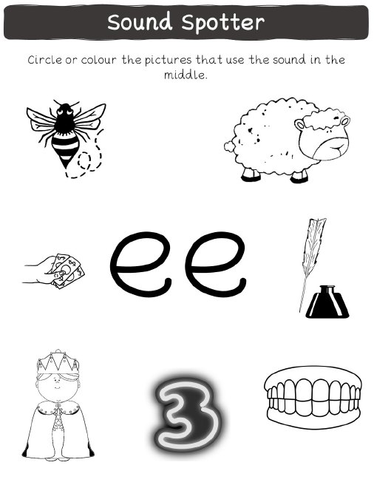

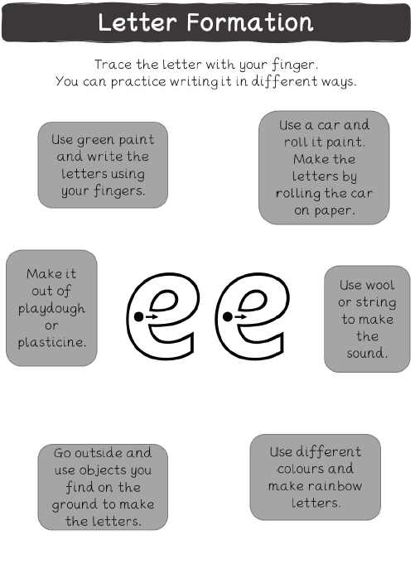
https://www.youtube.com/watch?v=hBFFUCraDt8

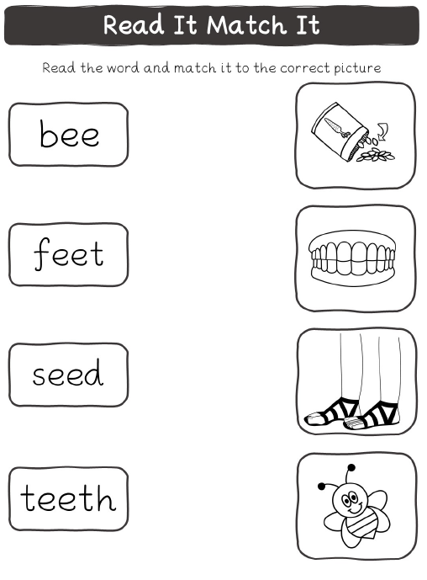
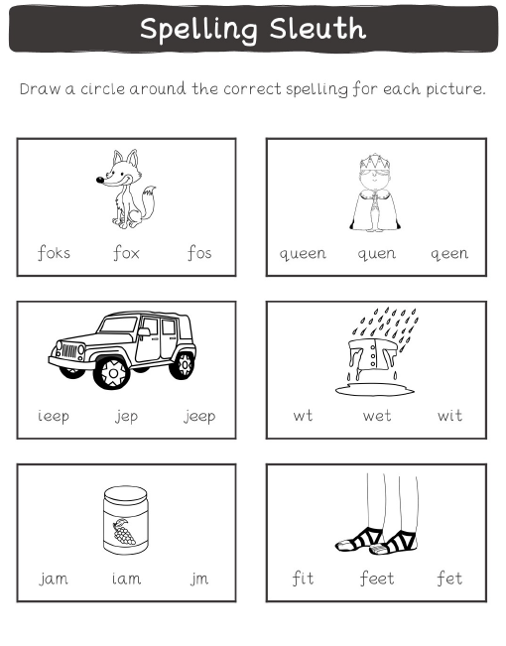
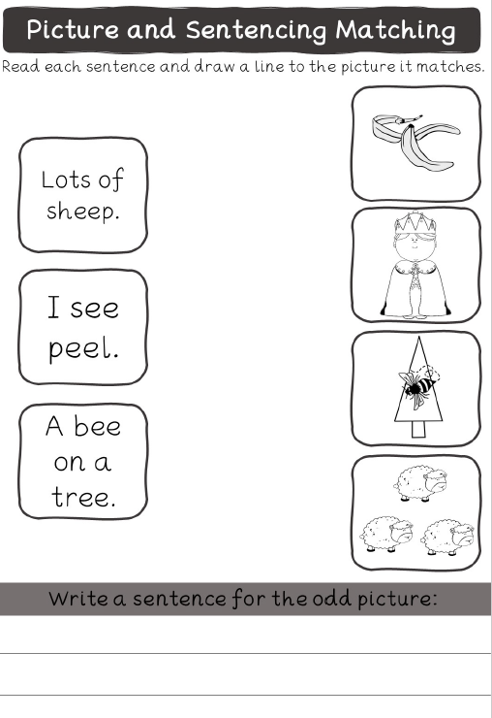
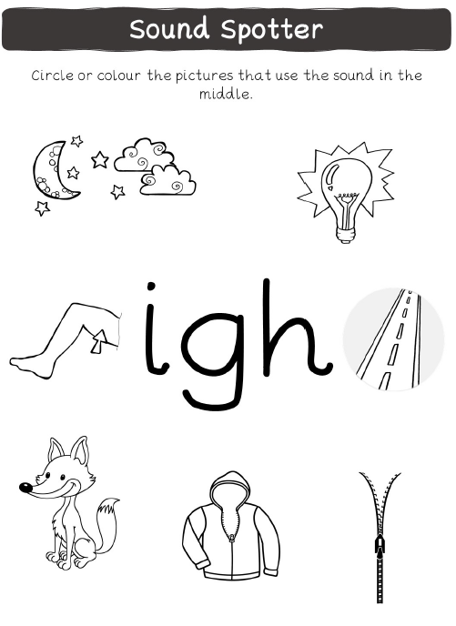
https://www.youtube.com/watch?v=cEffZUP4d_8

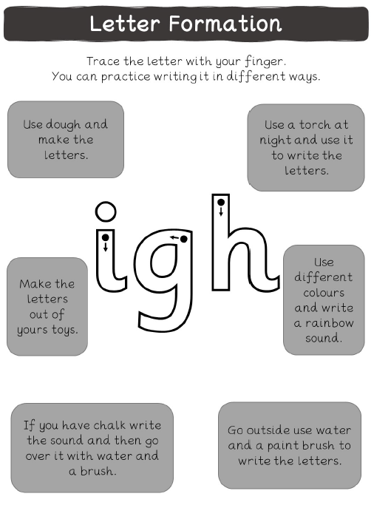
https://www.youtube.com/watch?v=7anrdHnwGbs

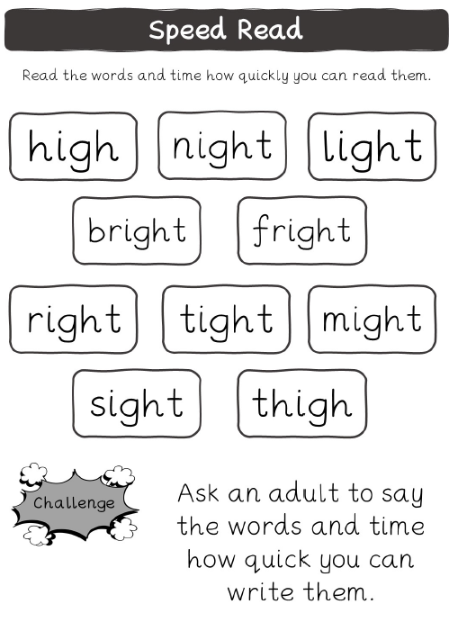
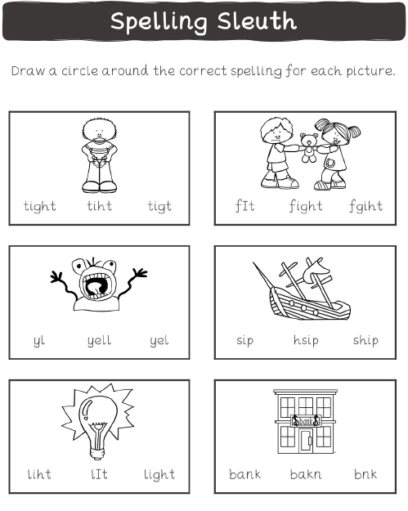
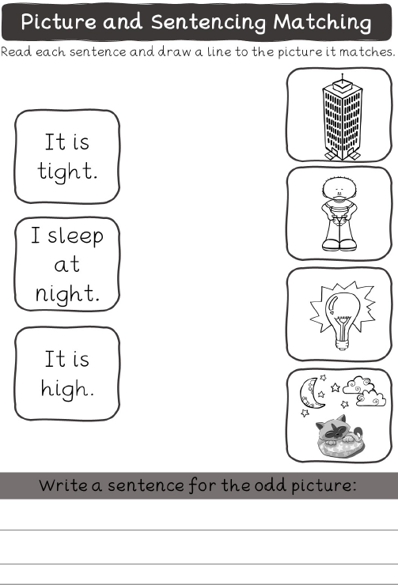
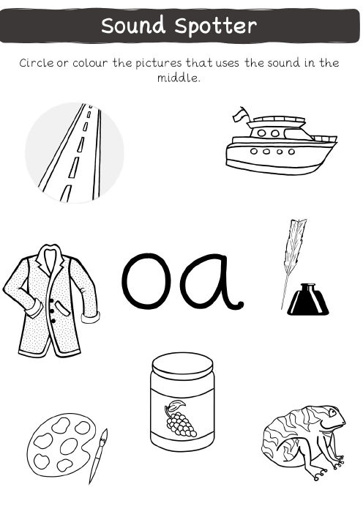
https://www.youtube.com/watch?v=d0X8phlr3Jc

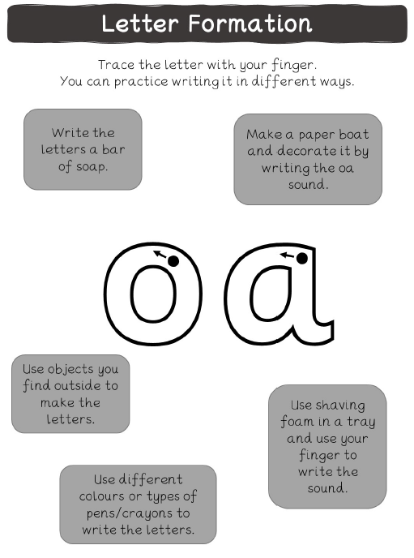
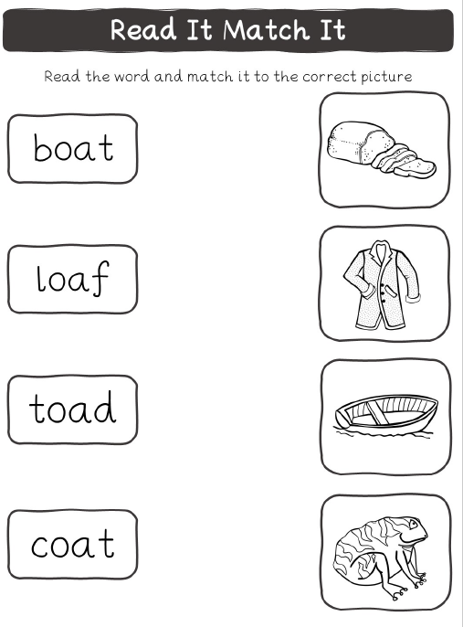

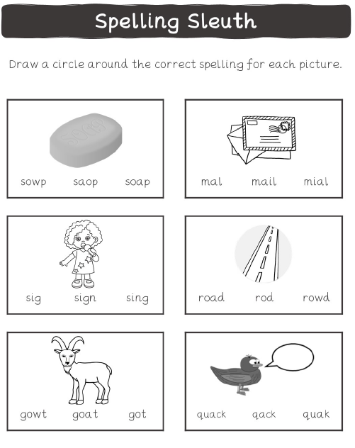

https://www.youtube.com/watch?v=rrGadCz2A1o
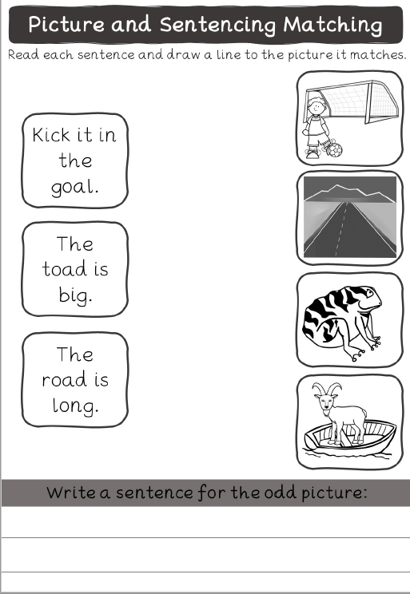

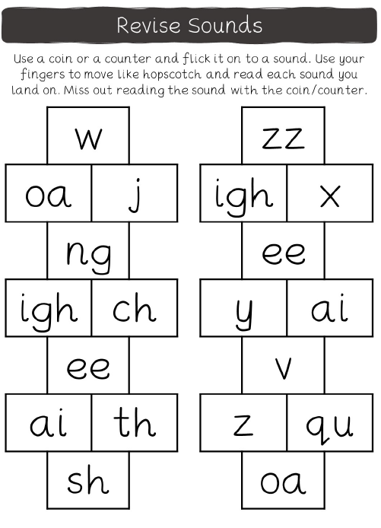

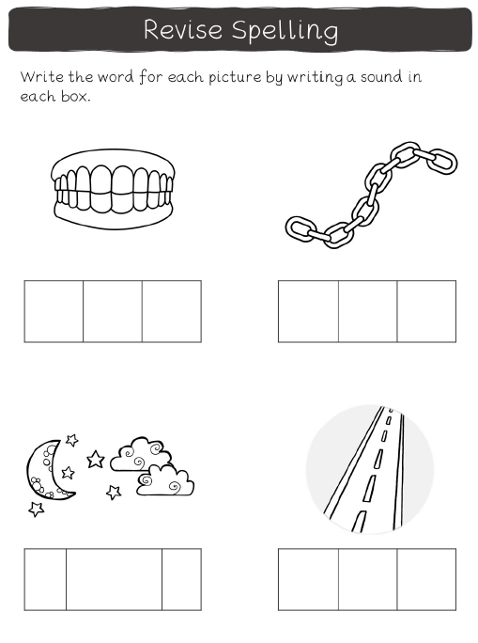
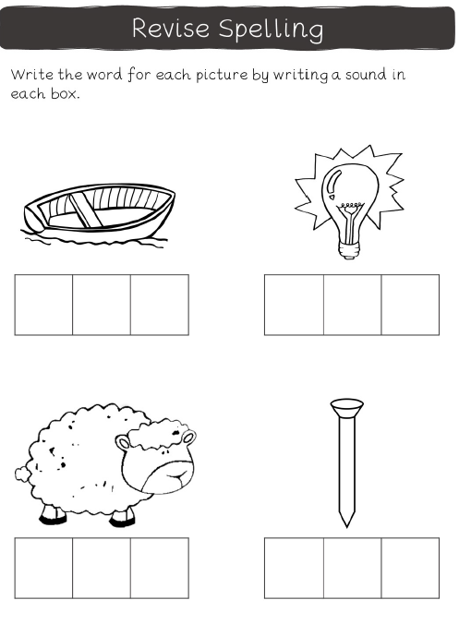
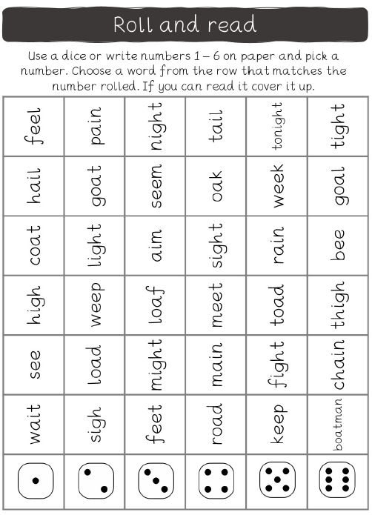
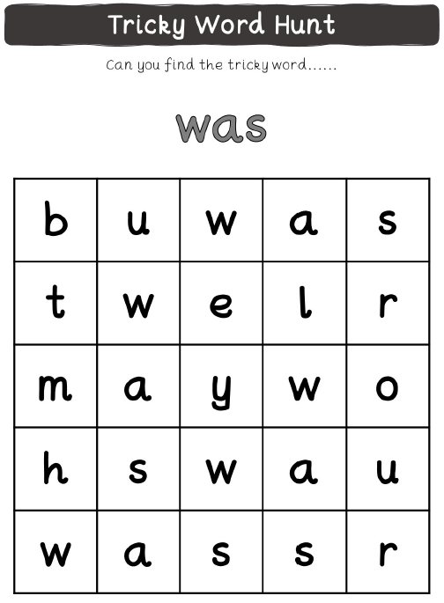
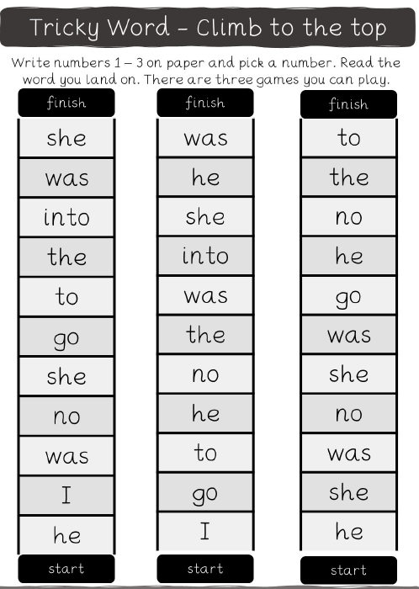
Revise Phase 2 sounds
