Phonics & Literacy Home Learning Ch ch, Sh sh,Th th, Ng ng Week 5
For literacy this week I would like you to mime the story ‘The Noisy House’ with Adam.
https://classroom.thenational.academy/lessons/to-use-actions-to-mime-a-story-chhkgd?activity=video&step=1
After miming the story I would like you to retell it to an adult in your own words.
https://classroom.thenational.academy/lessons/to-tell-a-story-independently-6xh66c
Then recycle it.
https://classroom.thenational.academy/lessons/to-recycle-a-nursery-rhyme-74u62e?activity=video&step=1
For Phonics this week:
Phonics: In Squirrel Class we do two daily phonic sessions. We focus on blending (reading) during the morning 15 minute session and in the afternoon we practise segmenting (spelling). This pack is designed with this in mind.
Sing the alphabet song together by following the link
https://www.bbc.co.uk/cbeebies/watch/get-squiggling-letters-alphabet-song?collection=little-learnerss://www.youtube.com/watch?v=OQ1AnMCGTzg
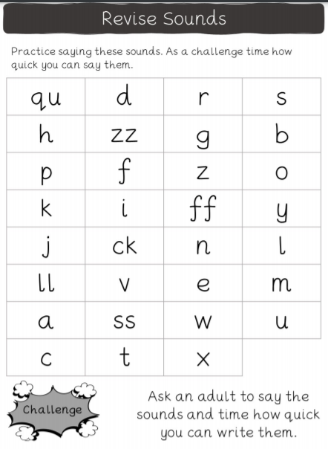

Please follow the link to watch the Letters and Sounds video each day to introduce new sounds. This week we are learning consonant digraphs.
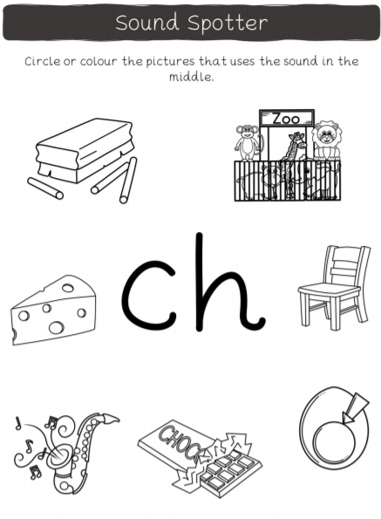
https://www.youtube.com/watch?v=tuzFWRkKh8A&list=PLuGr6z2H2KNGLy2Tckcy8Kk8u10mXgcmi&index=15 Ch ch
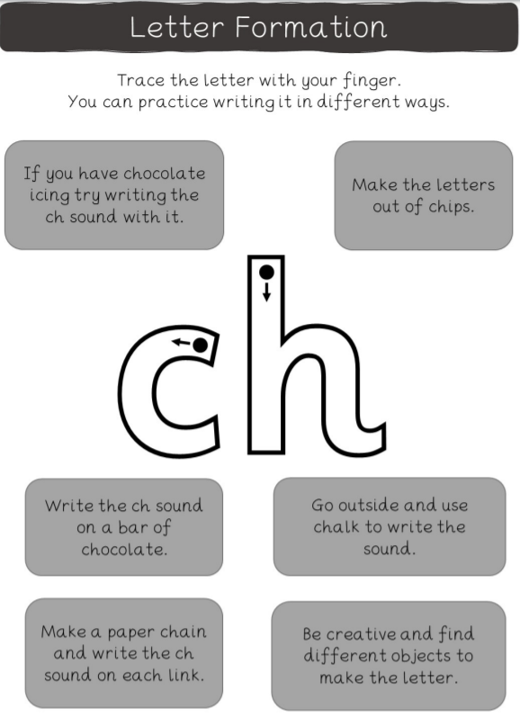
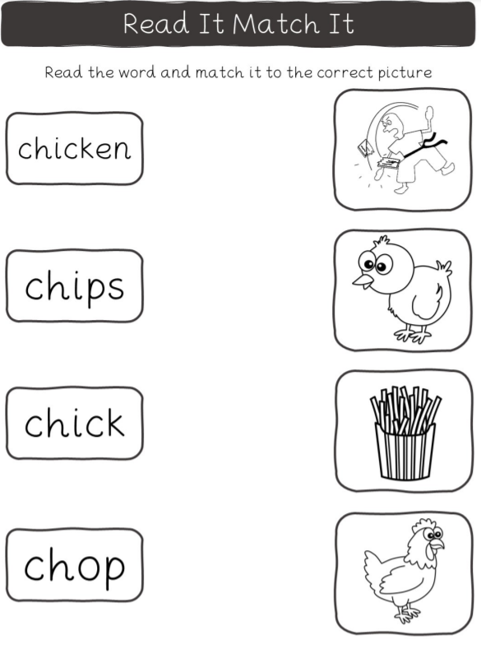
https://www.youtube.com/watch?v=U2mlqh3OVAk&list=PLuGr6z2H2KNGLy2Tcc8Kk8u10mXgcmi&index=14
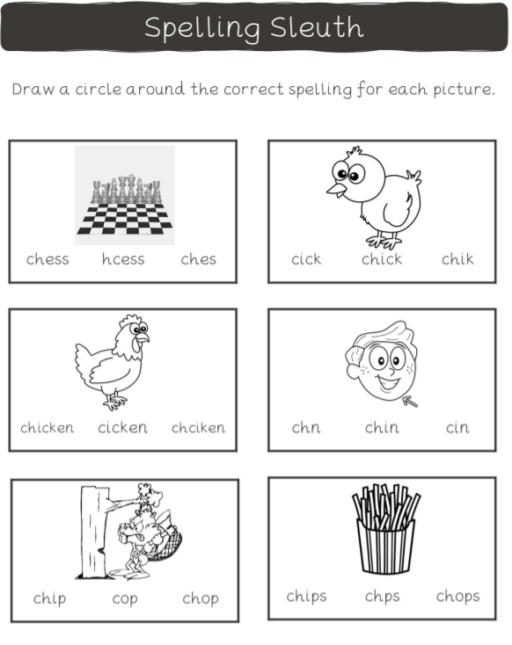

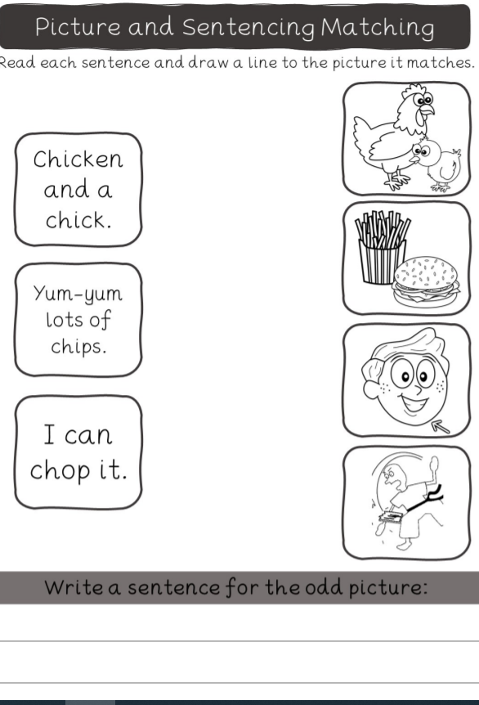
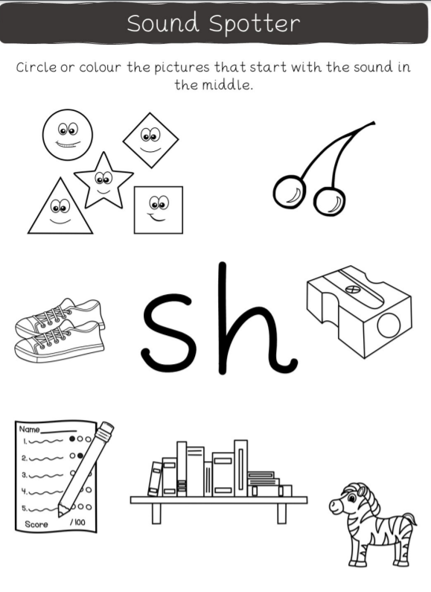
https://www.youtube.com/watch?v=7fE27v8n7Vw&list=PLuGr6z2H2KNGLy2Tckcy8Kk8u10mXgcmi&index=13
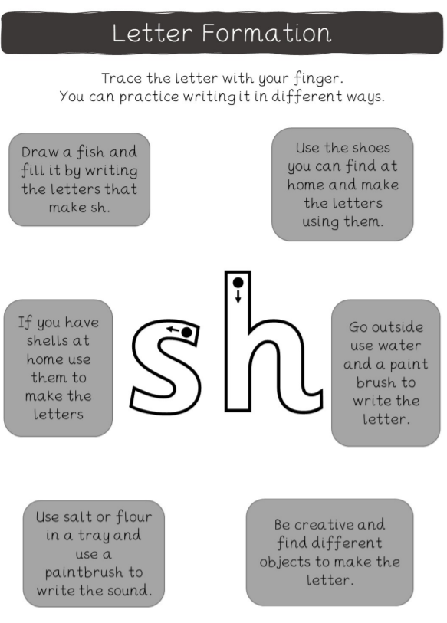
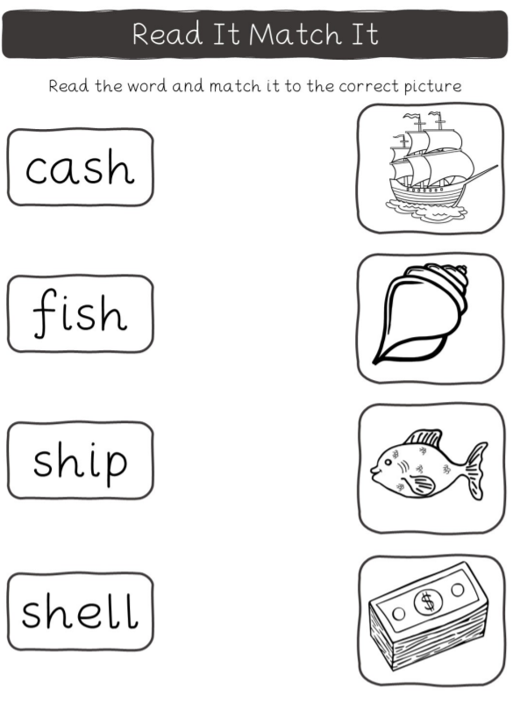
https://www.youtube.com/watch?v=xaTk1GRH29g&list=PLuGr6z2H2KNGLy2Tckcy8Kk8u10mXgcmi&index=12
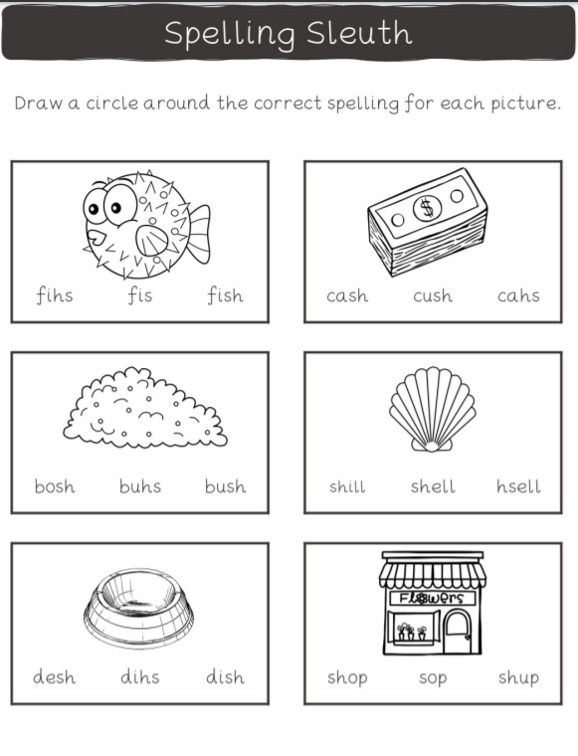
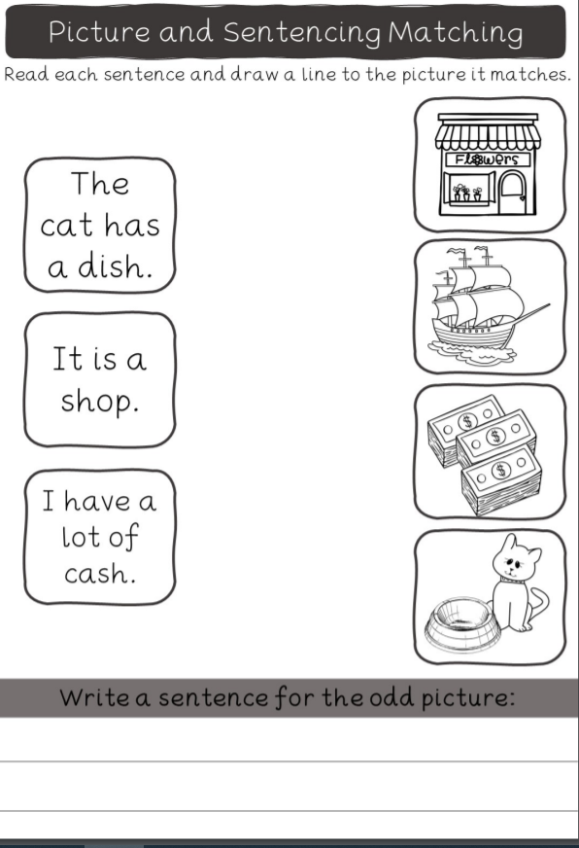
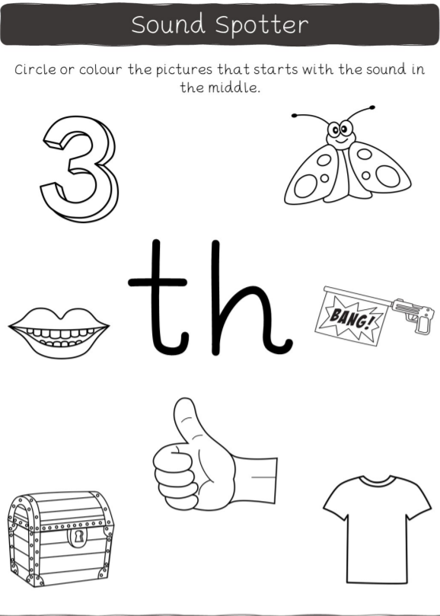
https://www.youtube.com/watch?v=kLBtb1PFV_g&list=PLuGr6z2H2KNGLy2Tckcy8Kk8u10mXgcmi&index=11
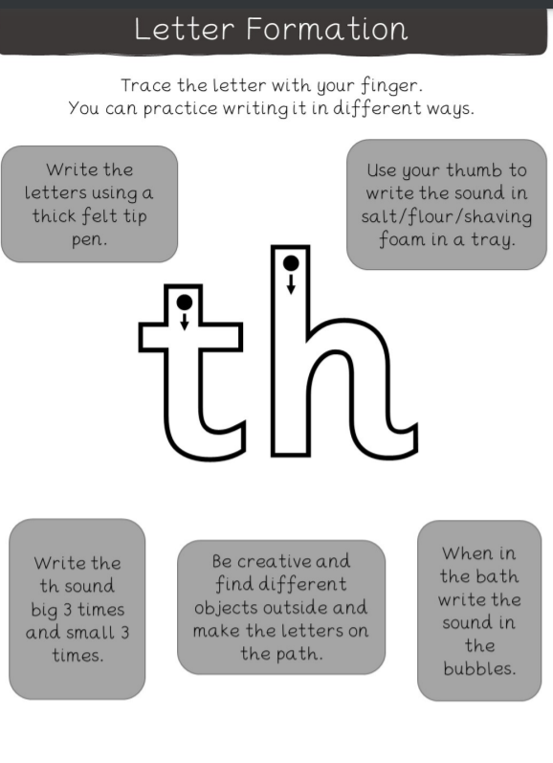
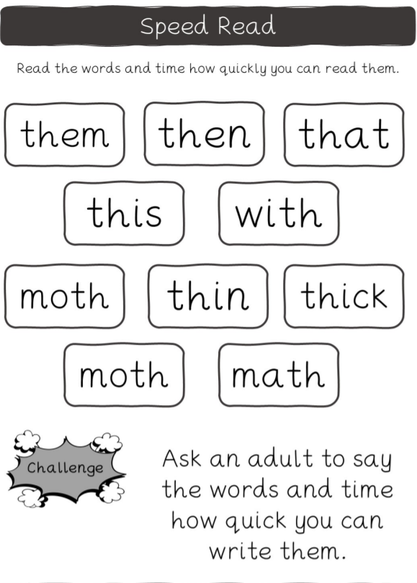
https://www.youtube.com/watch?v=kI4NZz1JbHE&list=PLuGr6z2H2KNGLy2Tckcy8Kk8u10mXgcmi&index=10
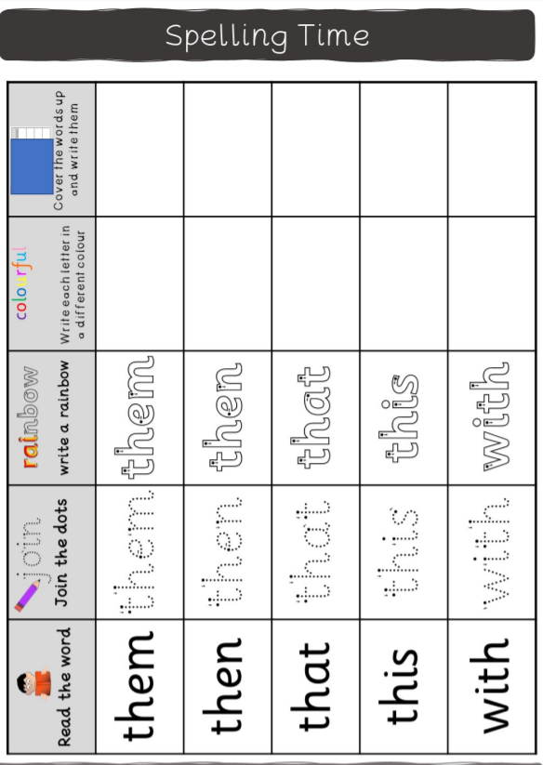
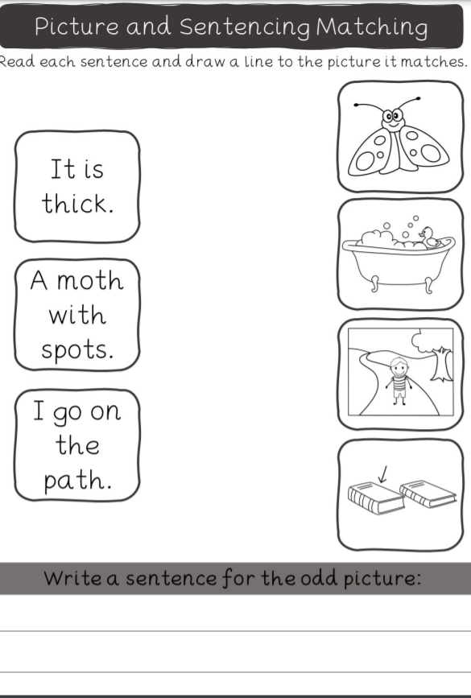
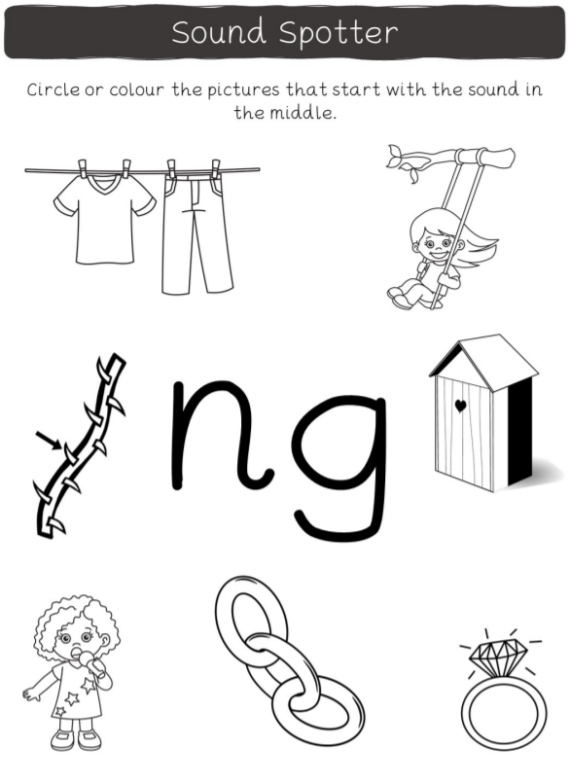
https://www.youtube.com/watch?v=DgD6yCIO3pw&list=PLuGr6z2H2KNGLy2Tckcy8Kk8u10mXgcmi&index=9
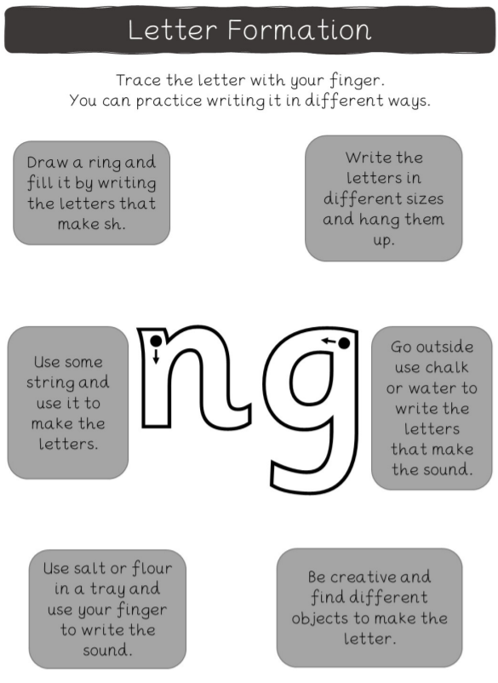
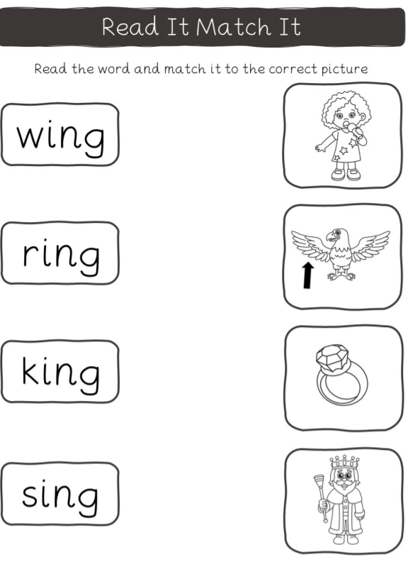
https://www.youtube.com/watch?v=eN6GmiiR_2s&list=PLuGr6z2H2KNGLy2Tckcy8Kk8u10mXgcmi&index=8
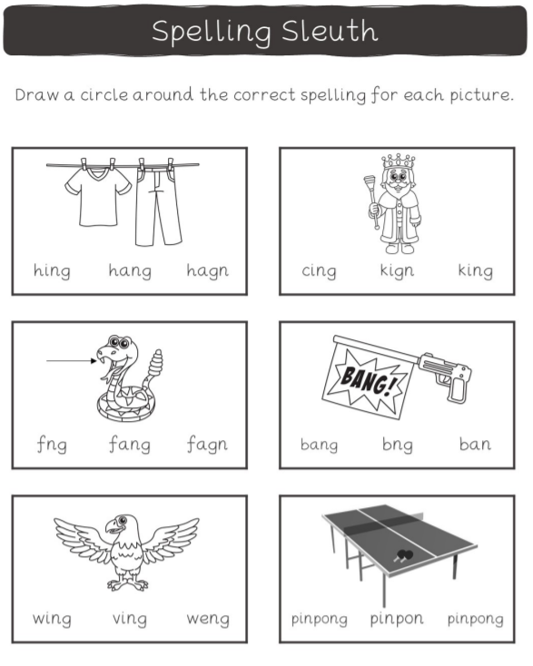
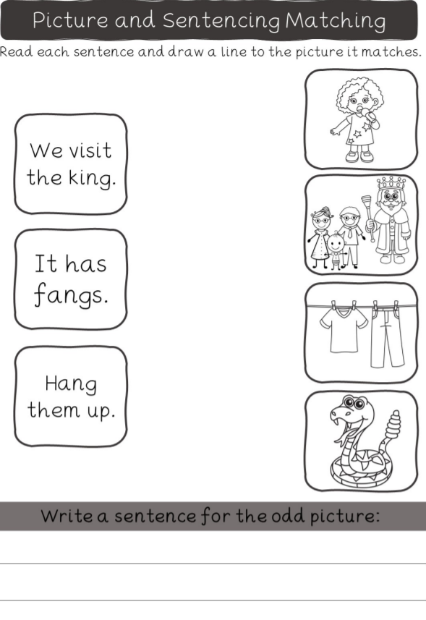
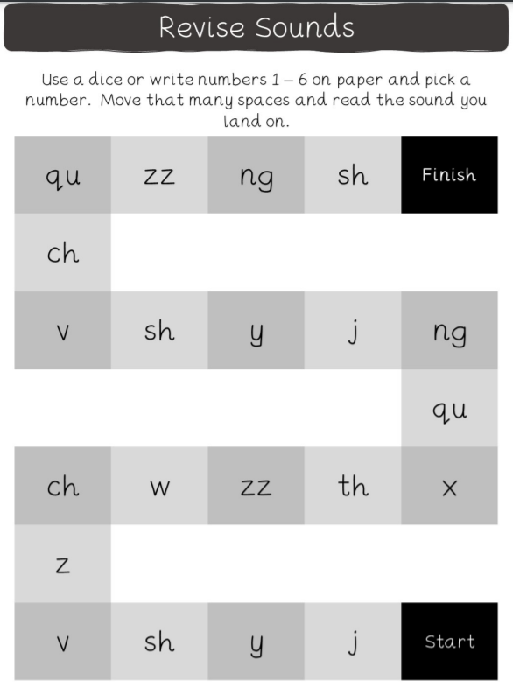
https://www.youtube.com/watch?v=bZ5XfHKJS_M&list=PLuGr6z2H2KNGLy2Tckcy8Kk8u10mXgcmi&index=6
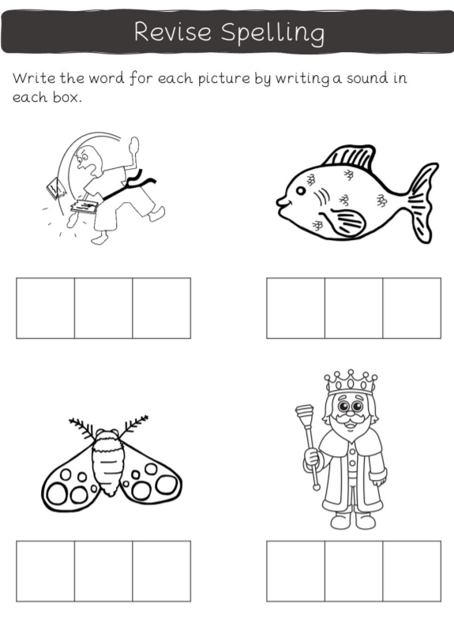
https://www.youtube.com/watch?v=cSW5dx7h_CE&list=PLuGr6z2H2KNGLy2Tckcy8Kk8u10mXgcmi&index=7
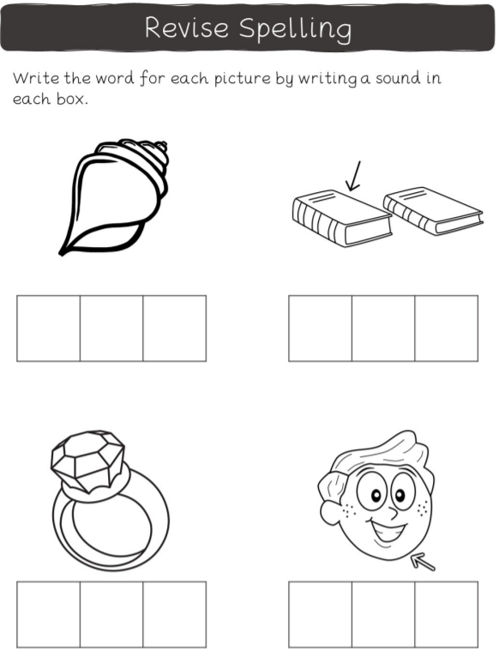
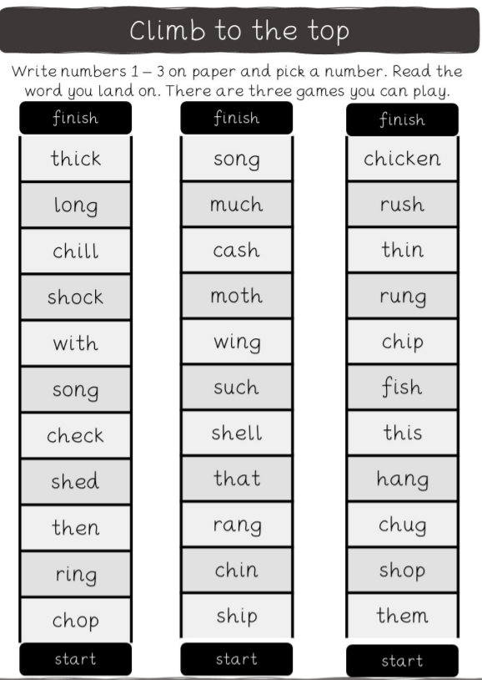
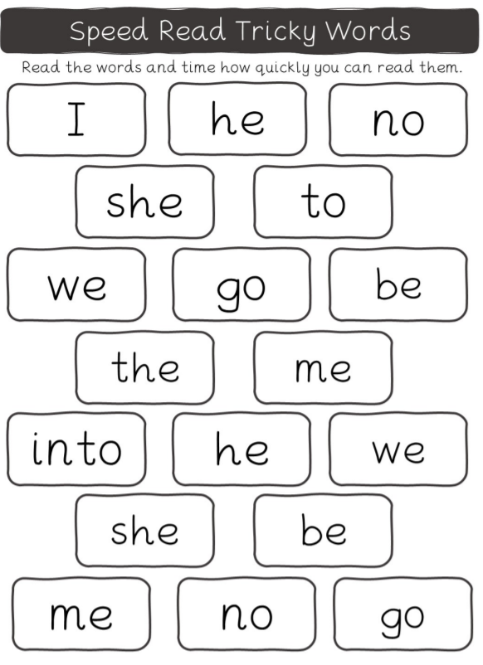
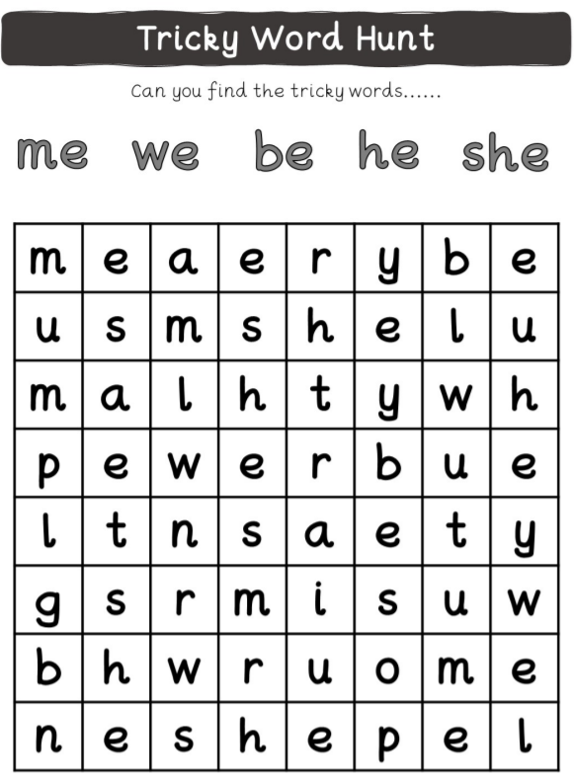
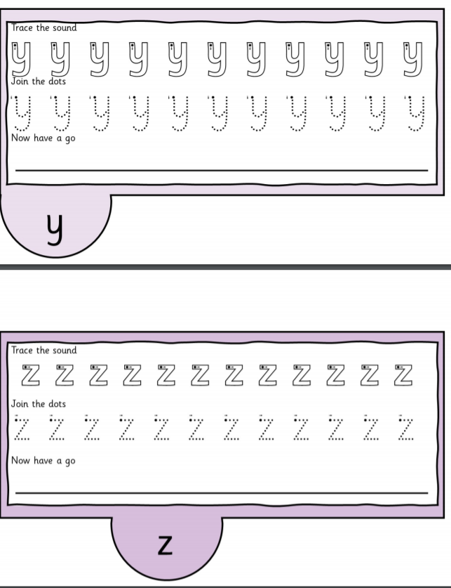
RE
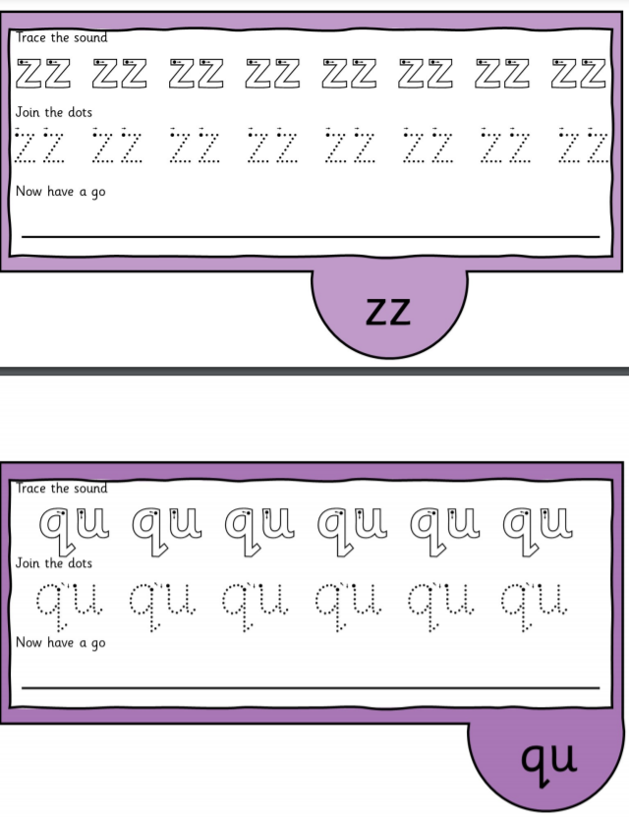
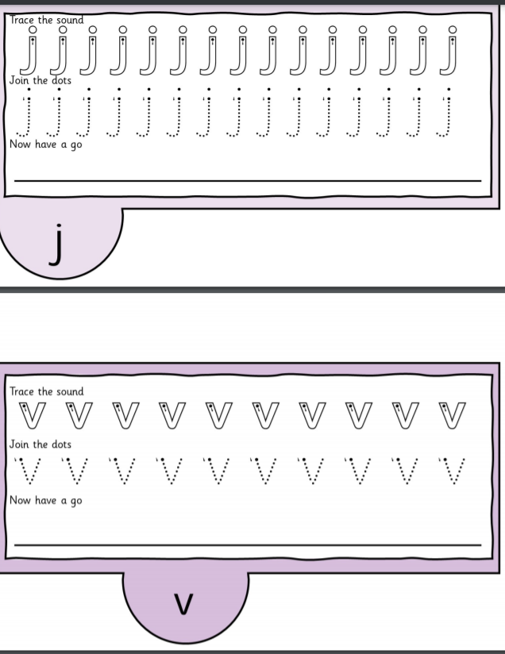
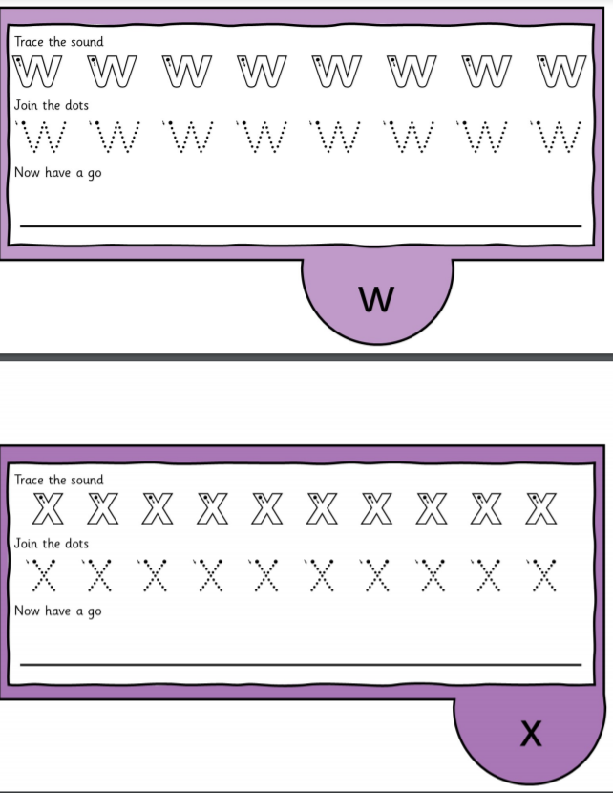
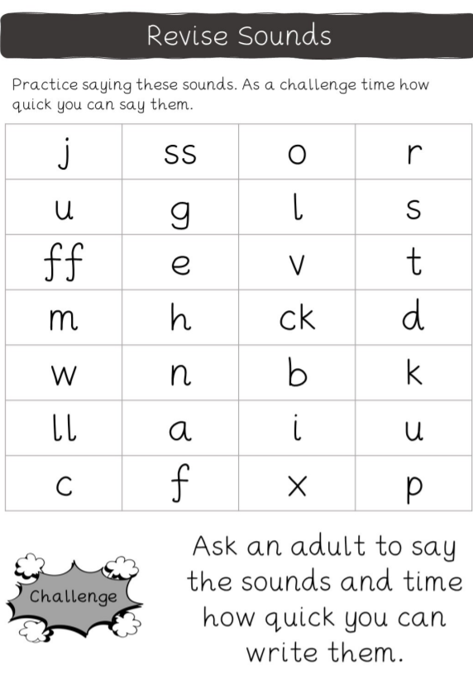

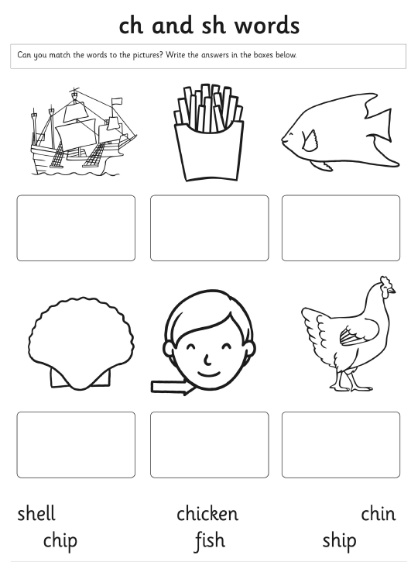
Revise
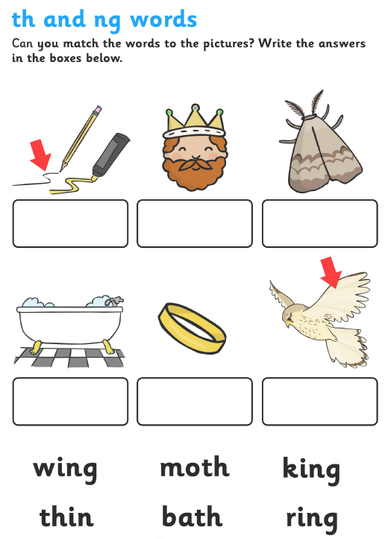
Review sounds and practise blending
https://www.youtube.com/watch?v=djUKCWUhmyk&list=PLuGr6z2H2KNGLy2Tckcy8Kk8u10mXgcmi&index=5
