**Phonics & Literacy Home Learning Jj, Vv, Ww, Xx Week 3**

For literacy this week I would like you to listen and respond to the story ‘The Noisy House’ narrated by Adam. Play the story video several times and then join in with Adam as he adds actions and voices to the characters. Can you think of your own actions? Is your house noisy?

How does a noisy house make you feel?

<https://classroom.thenational.academy/lessons/to-listen-to-and-respond-to-a-story-6hjkcr?activity=video&step=1>

Phonics: In Squirrel Class we do two daily phonic sessions. We focus on blending (reading) during the morning 15 minute session and in the afternoon we practise segmenting (spelling). This pack is designed with this in mind.

Please follow the link to watch the Letters and Sounds video each day to introduce new sounds.

Sing the alphabet song together by following the link

<https://www.bbc.co.uk/cbeebies/watch/get-squiggling-letters-alphabet-song?collection=little-learnerss://www.youtube.com/watch?v=OQ1AnMCGTzg>

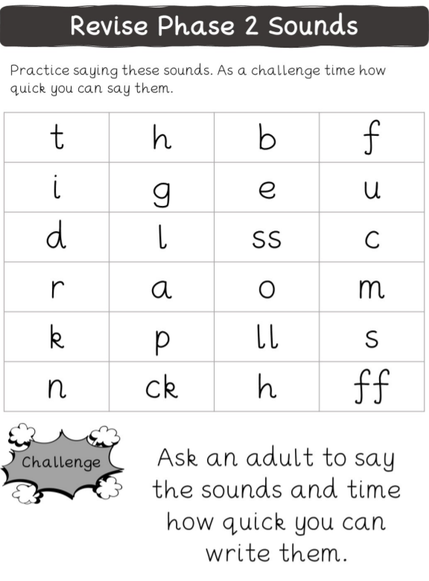

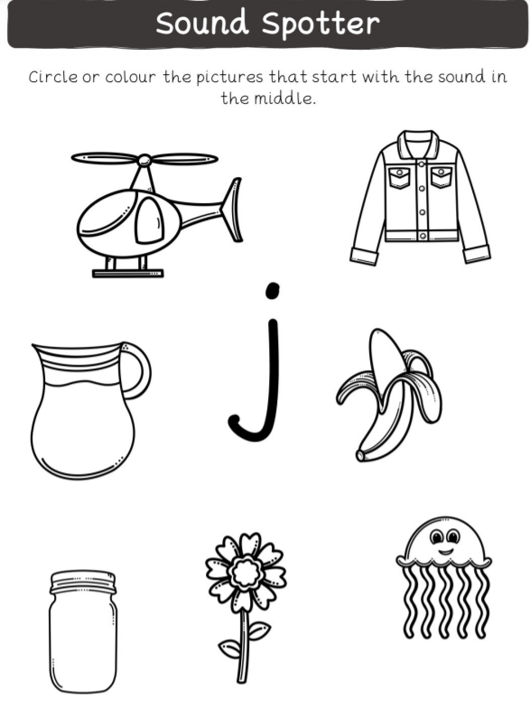

Practise writing your name? What sound does your name begin with? What are the names of your family members? What sound does their name begin with?

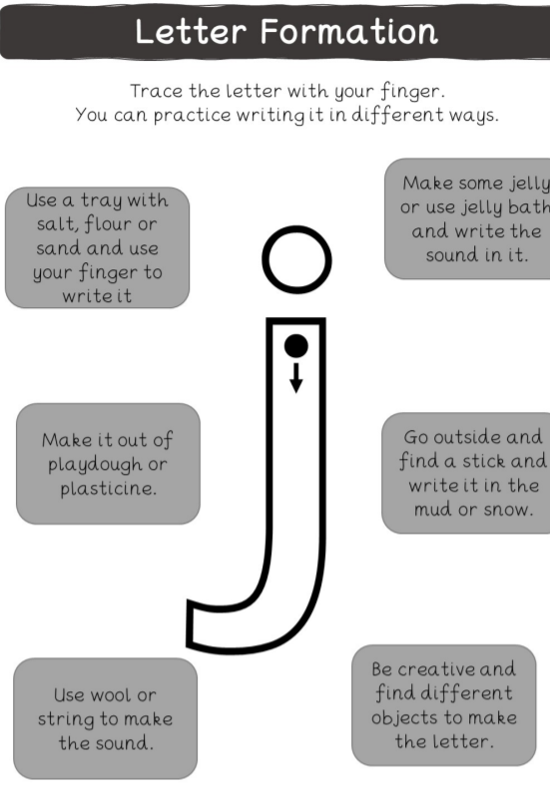

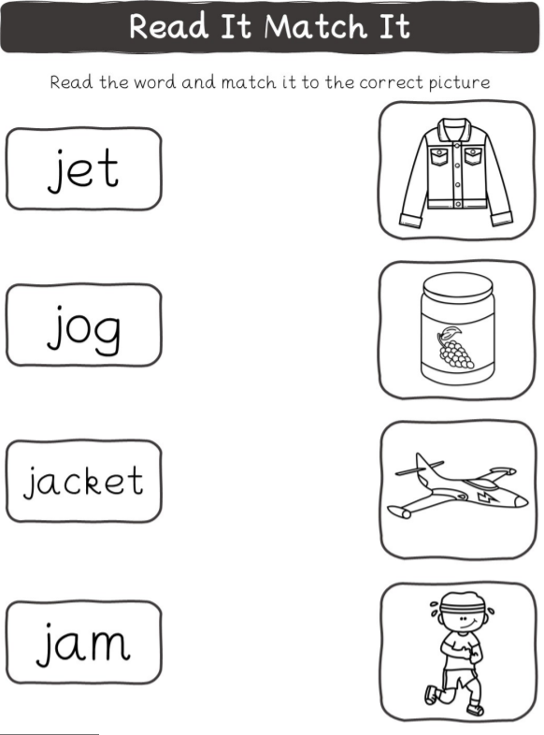

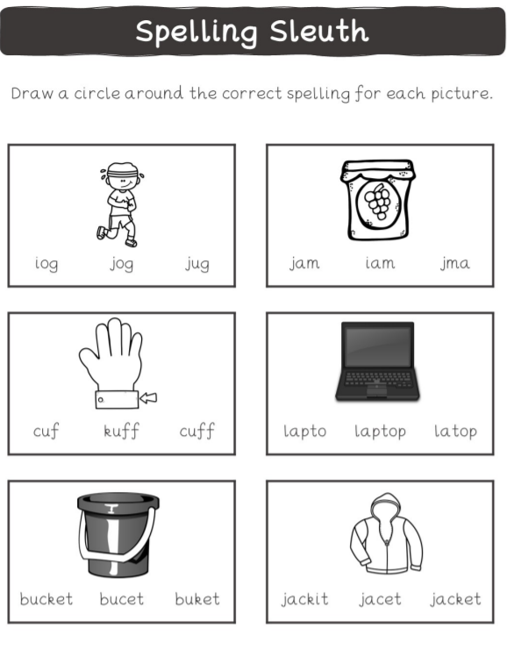

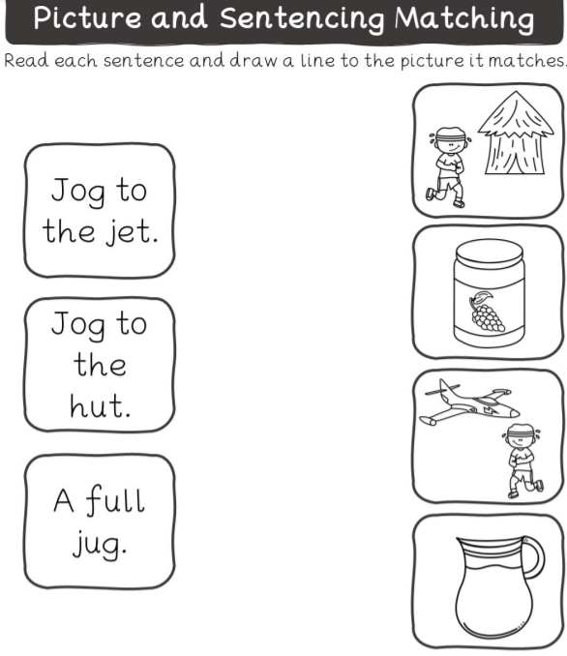

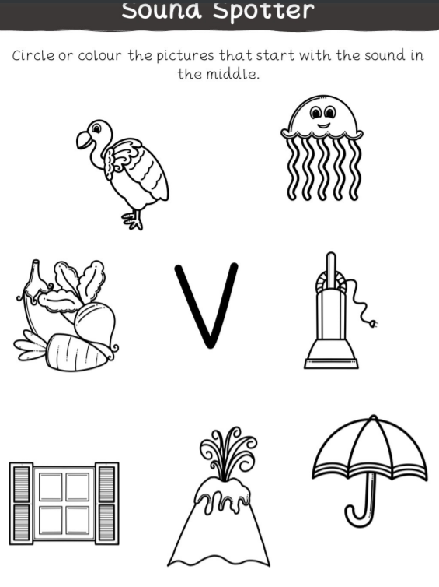

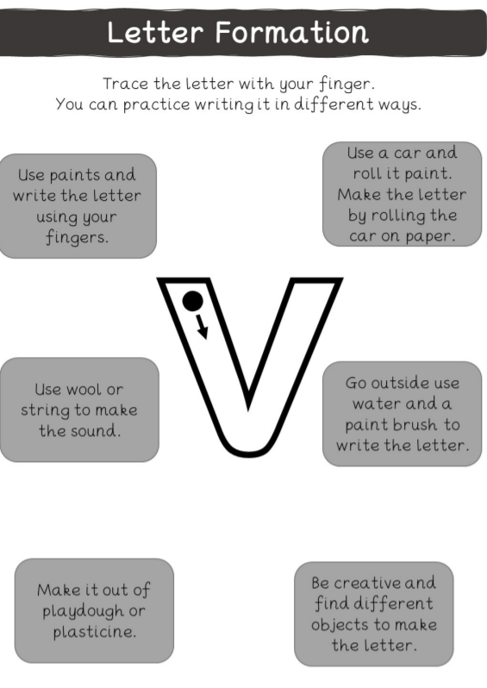

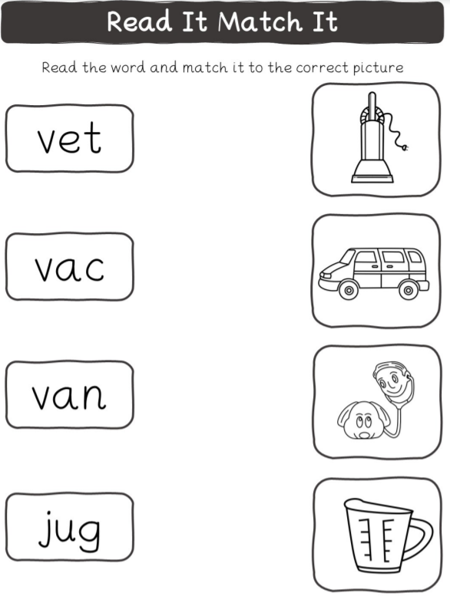

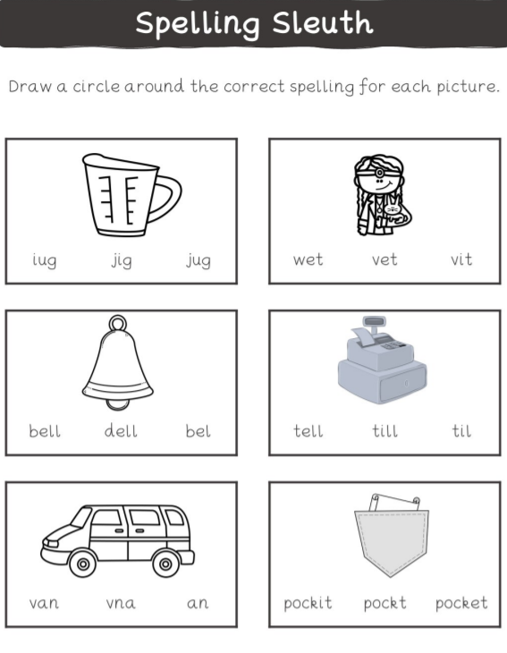

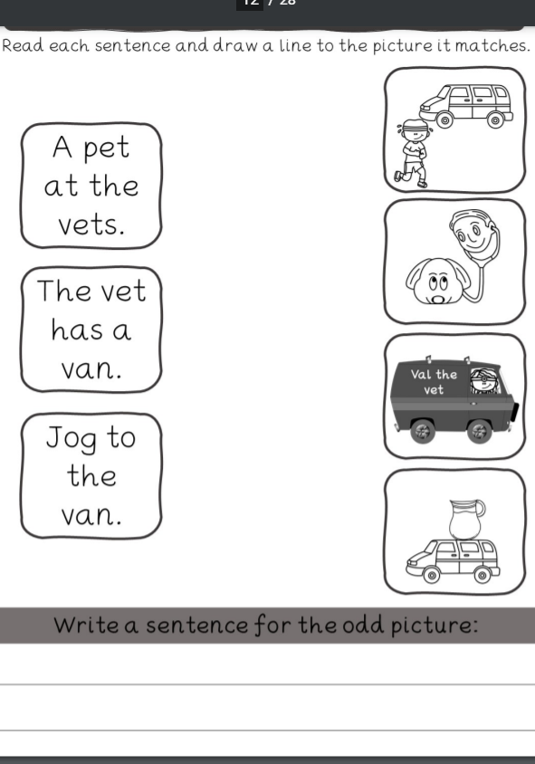

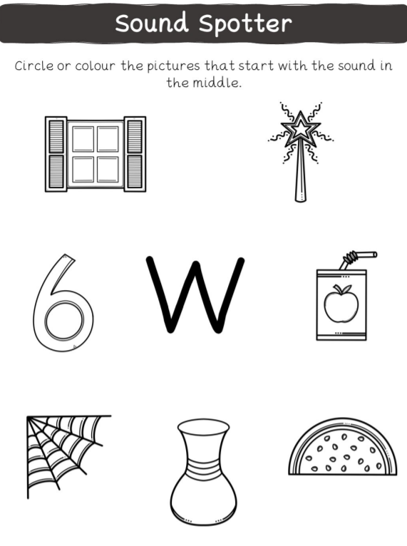

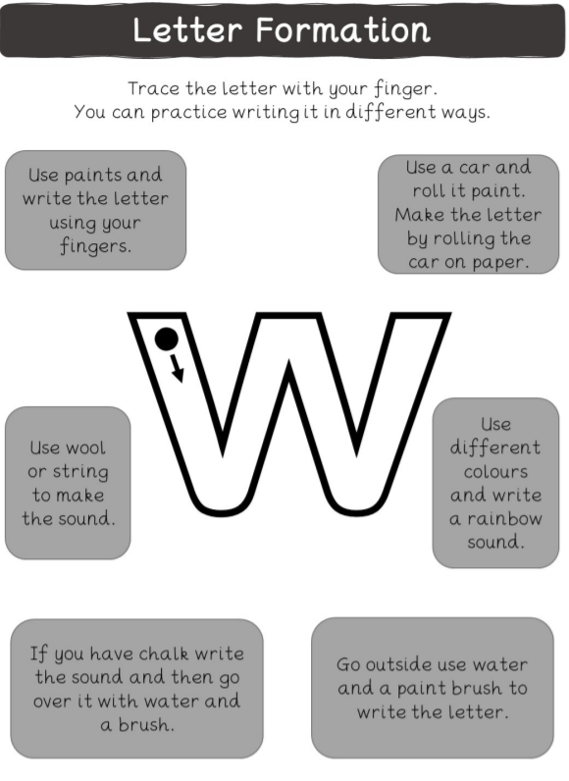

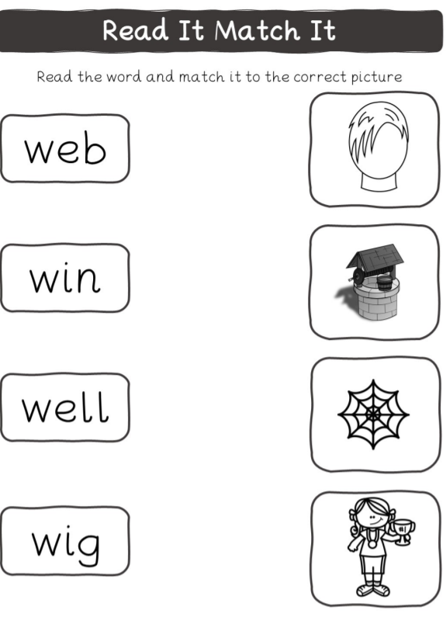

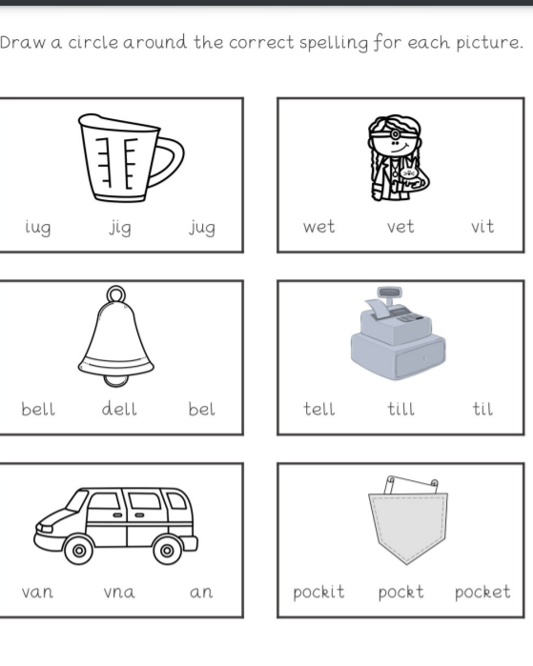

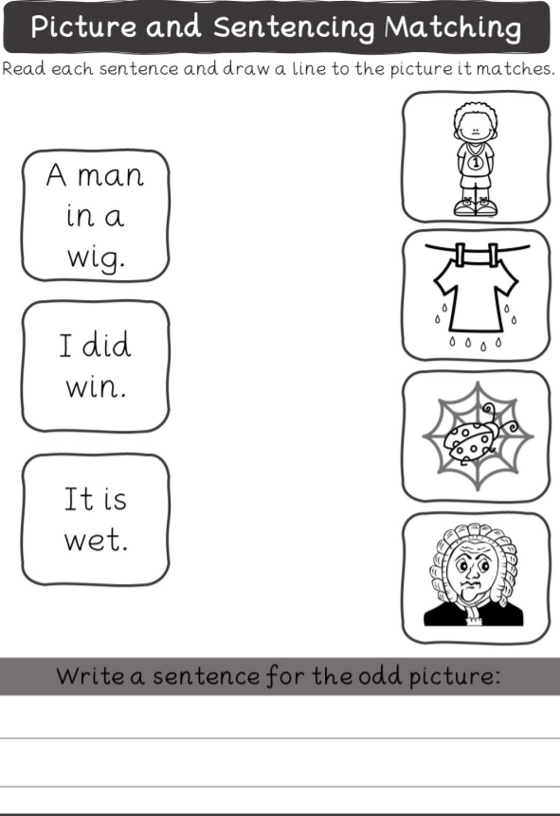

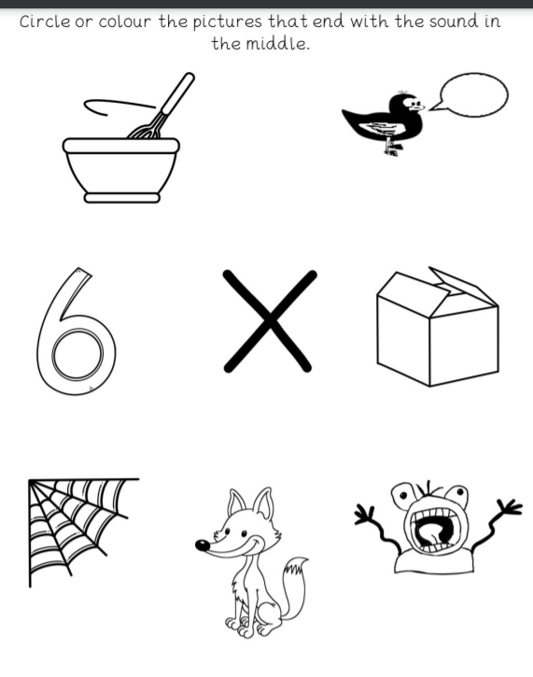

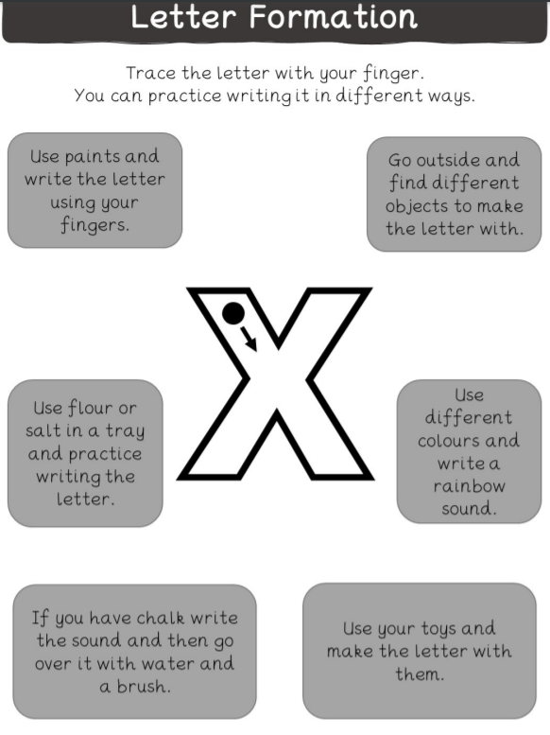

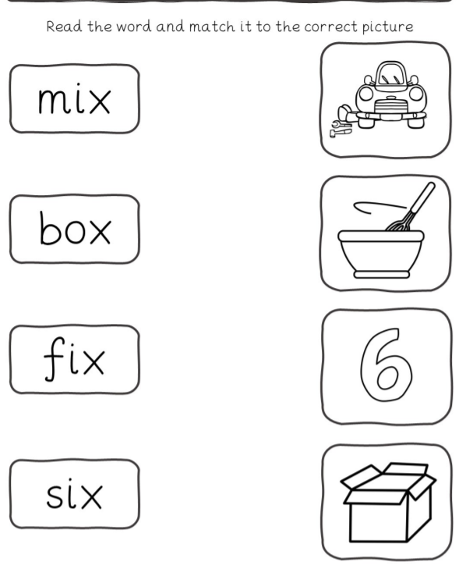

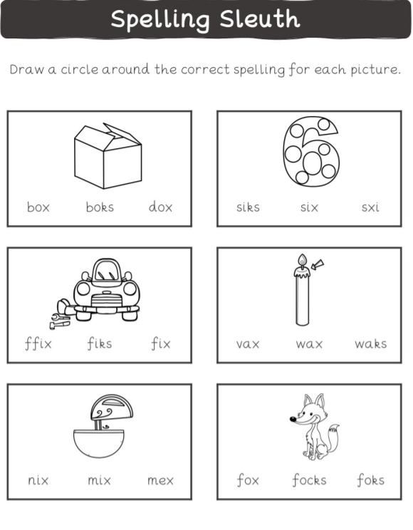

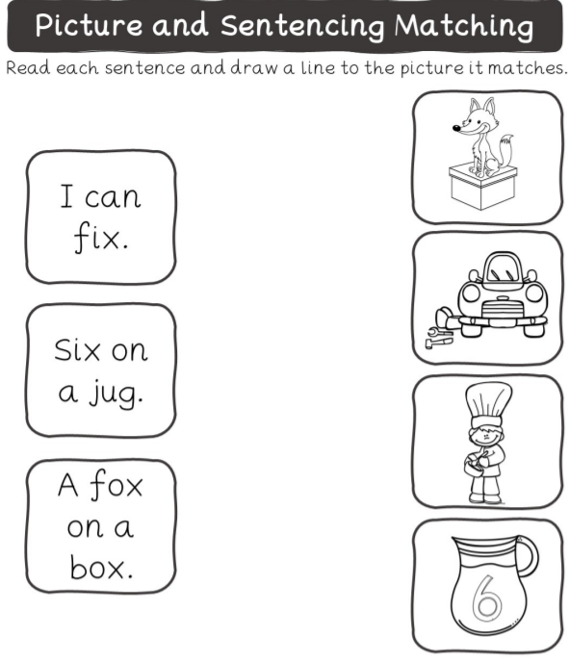

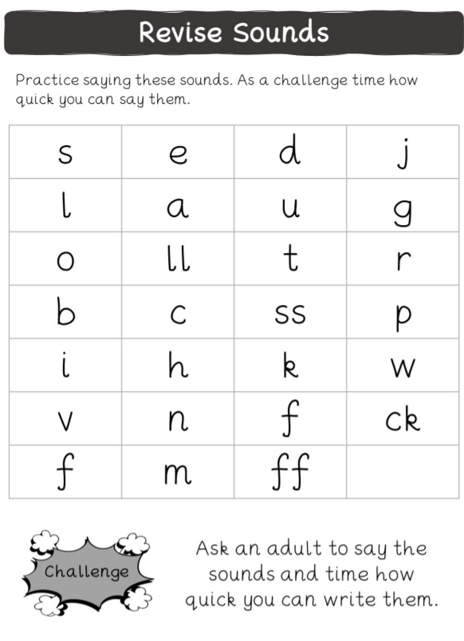

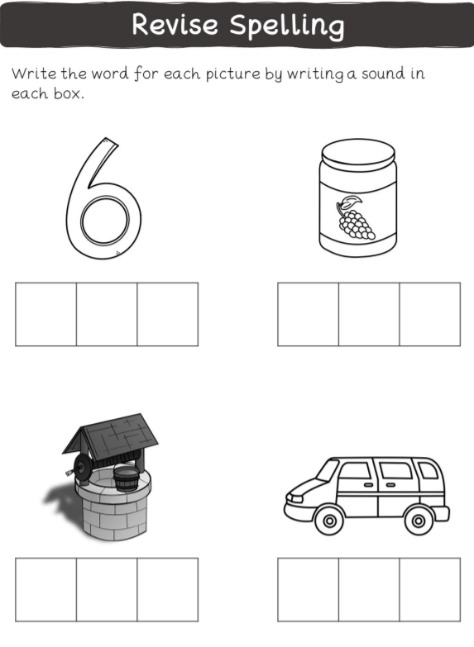

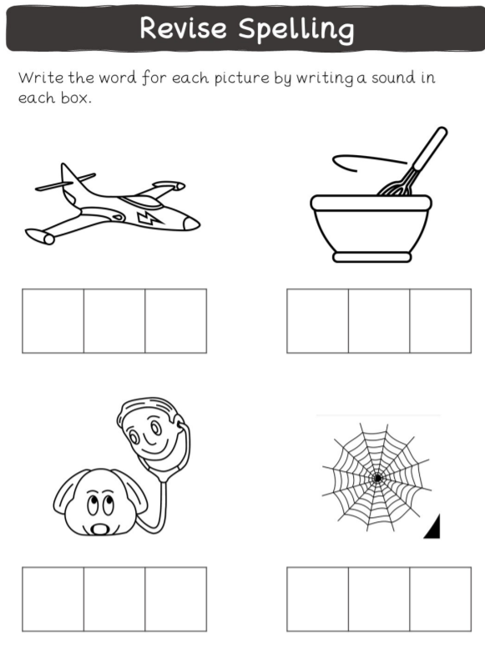

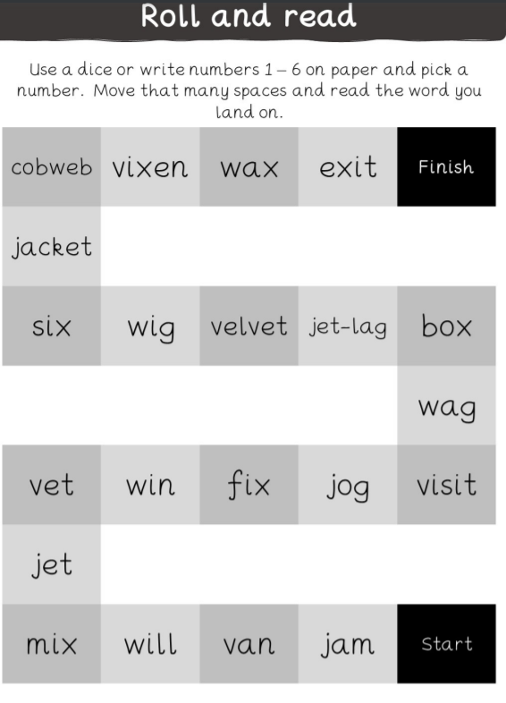

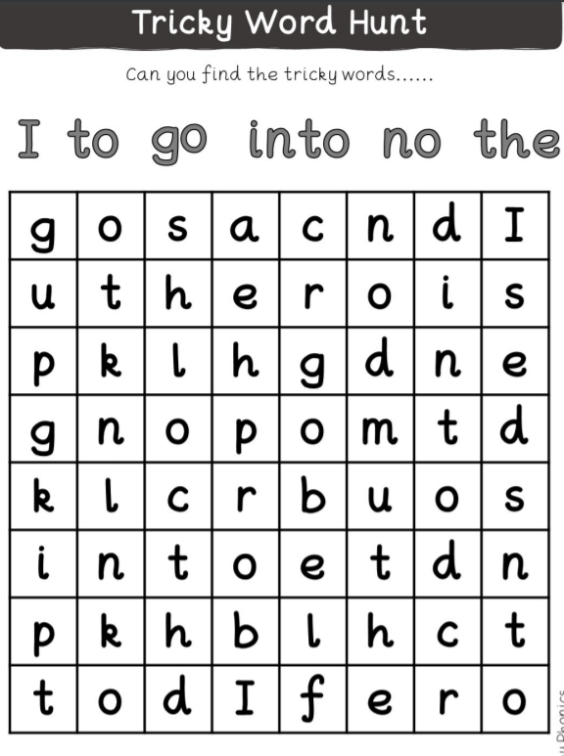

Practise reading and spelling the tricky word he.