

**Team Parkside**

**Personal Challenge**

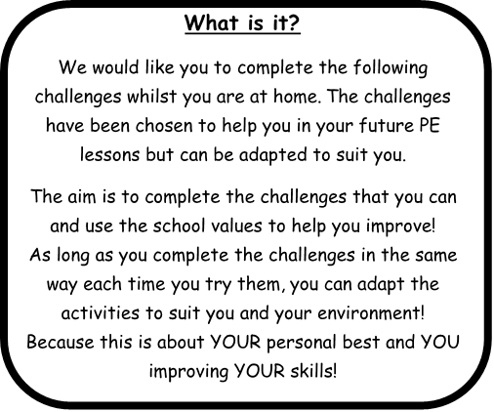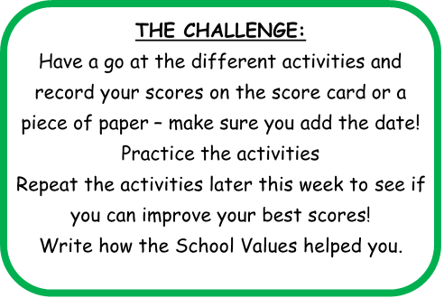

**Share your success!**

If you would like your child’s picture of them doing the challenges, uploaded onto the school website, then please email pictures, videos and permissions to [PE@parkside.kent.sch.uk](mailto:PE@parkside.kent.sch.uk)

**Go Team Parkside!**

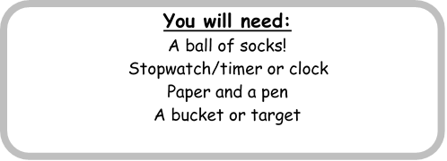

**Lap Run**

Lay out your socks and count how many steps apart they are.

How many times can you walk/run and touch each sock in 2 minutes?

Remember to pace yourself – 2 minutes is longer than it sounds!

Get 1 point every time you touch a sock, how many points can you get?

**Arm Raisers**

How many times can you raise your arms in 2 minutes? Remember to pace yourself. If 2 minutes is too long then try 1 minute to start with

**Arm Holds**

Raise one arm and time how long you can hold it for. Stop the time when you put your arm down.

Time how long you can raise your left arm and on your right arm.

**Resilience** – How long can you do the challenge for and never give up.

**Effort** – Hard work in every challenge and always looking to improve.

**Aspiration** - Can you aspire to achieve these targets? Can you aspire to do more?

**Courtesy** – To attempt the challenge in an environment that gives you the best chance to succeed.

**Honesty** - Have you tried your best? Could you try harder?

**Important!**

Always make sure you carry out all challenges in a safe way!

**CREATE YOUR OWN CHALLENGE**

Can you create your own challenge? Perhaps that helps you with either your

Endurance

Running

Co-ordination



**Lap Run**

How many can you do in 2 minute?

**Arm Raisers**

How many can you do in 1 minute or 2 minutes?

**Arm Holds**

**Left** **Right**

Time how long you can hold your arm in the air



**Personal Challenge Score Card**

**Name: Class:**





**Parkside Personal Challenge**

**Creating Your Own Challenge**

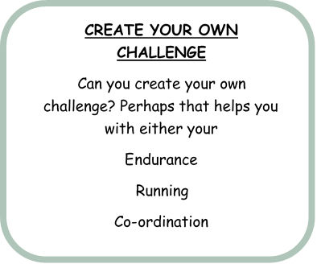

**Rules of my Challenge**

Clearly show how your own challenge works, with clear rules and directions, how you would like the scoring to be used and how does one school value is used or are all of them used. I will pick one challenge from all I receive to add into the next week challenges.