

**Team Parkside**

**Personal Challenge**

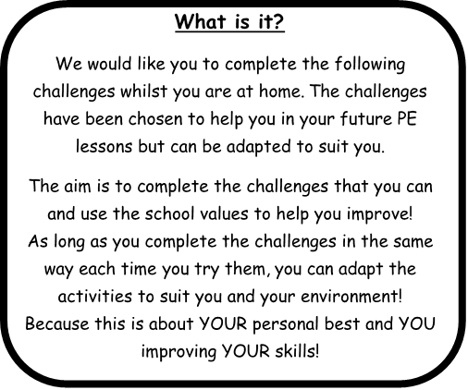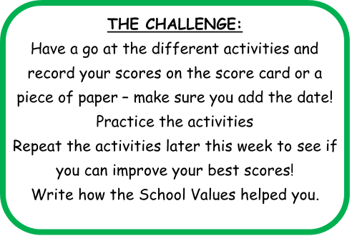

**Share your success!**

If you would like your child’s picture of them doing the challenges, uploaded onto the school website, then please email pictures, videos and permissions to [PE@parkside.kent.sch.uk](mailto:PE@parkside.kent.sch.uk)

**Go Team Parkside!**

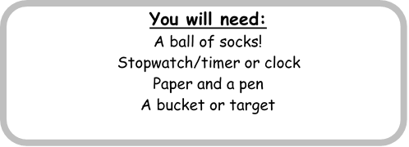

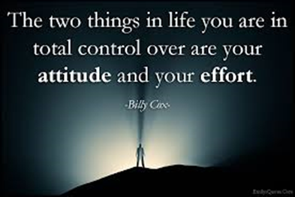

**Spped Steps**

Place your ball of socks on the floor and see how many times you can step over them and back in 1 minute.

You get 1 point for every step.

**Throw and tap**

Throw your ball of socks into the air and see how many times you can clap or tap your chair before they land. You will get 1 point for every tap.

**Sock Throw**

Find a target, for example a piece of paper or bucket, choose how many steps you would like to throw from and see how many times can you throw your ball of socks into the bucket, collect, return and throw again in 1 minute.

**Resilience** – How long can you do the challenge for and never give up.

**Effort** – Hard work in every challenge and always looking to improve.

**Aspiration** - Can you aspire to achieve these targets? Can you aspire to do more?

**Courtesy** – To attempt the challenge in an environment that gives you the best chance to succeed.

**Honesty** - Have you tried your best? Could you try harder?

**Important!**

Always make sure you carry out all challenges in a safe way!

**CREATE YOUR OWN CHALLENGE**

Can you create your own challenge? Perhaps that helps you with either your

Throwing

Catching

Co-ordination



**Sock Throw**

**Distance** **Score**

**Speed Steps**

How many can you do in 1 minute?

**Throw and Tap**

How many claps/taps can you do?



**Personal Challenge Score Card**

**Name: Class:**





**Parkside Personal Challenge**

**Creating Your Own Challenge**

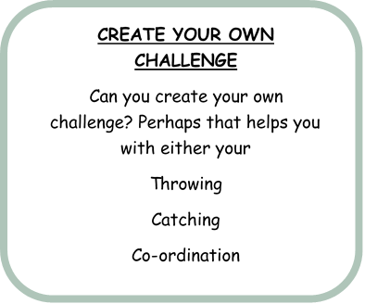

**Rules of my Challenge**

Clearly show how your own challenge works, with clear rules and directions, how you would like the scoring to be used and how does one school value is used or are all of them used. I will pick one challenge from all I receive to add into the next week challenges.