Topic/Lead Text | All About Me | Celebrations – Multi-Cultural – Seasonal Change | Winter Wonderland | Growing | Minibeasts | Seaside
 | 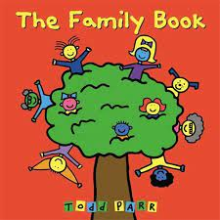 | 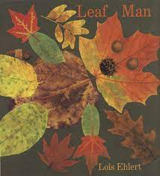 | 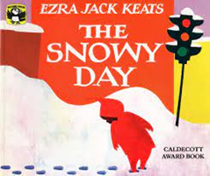 | 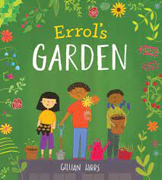 | 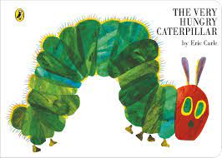 | 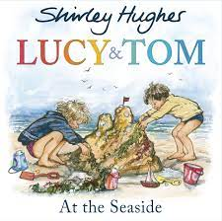
Key Texts/ Authors | Todd Parr  My Family  It’s Ok to be Different  The Family book  The School book | Leaf Man  Stick Man  Multi-cultural Celebrations (Diwali, Christmas) | The Snowy Day  Walking in a Winter Wonderland | Errol’s Garden  Oliver’s Vegetables  The Extraordinary Gardener | Eric Carle (catalogue)  Hungry Caterpillar | Shirley Hughes  Lucy and Tom at the seaside  Julian is a Mermaid
Poetry/Rhyme | 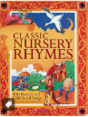  Nursery rhymes and songs | 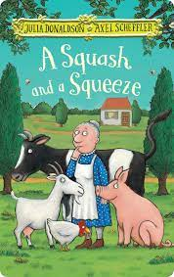  Alliteration and  rhyme J. Don’  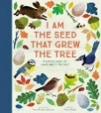365 poems  We’re … Bear Hunt | 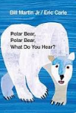  Alliteration and rhyme  Polar Bear, Polar Bear What do you see? | Alliteration and rhyme  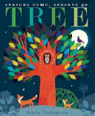  Tree by Britta Teckentrup | 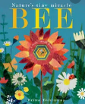  Alliteration  and rhyme  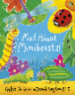  Bee by Britta Teckentrup  Mad about’ | 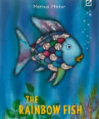  The Rainbow Fish by Marcus Pfister
Reading/Writing  Opportunities | Mark making, Phase 2 sounds | Phase 2 Initial sounds and CVC; labelling, role play (Santa letter, writing areas etc. | Writing own name clearly and consistently.  Winter wonderland writing materials | Phase 3 sounds, instructions, labelling, lists  Non fiction | Phase 3 sounds,  Labelling minibeasts’ writing features of … Non fiction | Phase 3/4 sounds, seaside stories, fantasy fiction; mermaids, pirates, creative writing
Reading Curriculum Year R

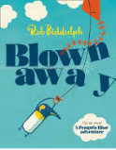
Reading Curriculum Year 1

Topic/Lead Text | Seasons  The Little Red Hen Geography | Hot and Cold Countries Lost and Found Geography | Old and New Toys  Old Bear History | We’re going on a Bear Geography | Bob the Man on the Moon History | Timelines and life-cycles History The Pencil
 | 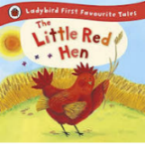 | 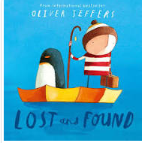 | 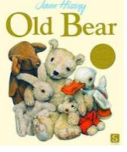 | 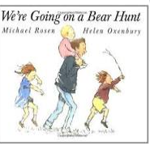 | 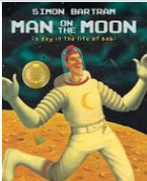 | 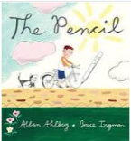
Key Texts/ Authors | Traditional Tales | Oliver Jeffers; Rob Biddulph | Jane Hussey | Michael Rosen | Simon Bartram | Allan Ahlberg Diary of a Worm - Science
Vipers | Lost and Found Oliver Jeffers | Sulwe by Lupita Nyong’o | Badgers Parting Gifts by Susan Varley | Bubbles Film Vipers | Ada Twist, Scientist by Andrea Beaty | After the Fall, How Humpty Dumpty Got Back Up Again Dan Santat
Poetry/Rhyme | 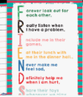  Acrostic Poems and Lists ‘Friends’ by John P. Read | Acrostic Poems -  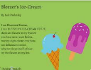  Bleezer’s Ice Cream’ by Jack Prelutsky | 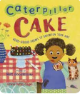  Free Verse Matt Goodfellow ‘When I Swing’ | 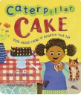  Free Verse Matt Goodfellow ‘Caterpillar Cake’ | Riddles – The Works  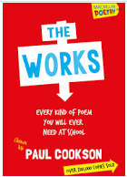 | Riddles – The Works  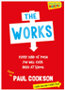
Reading/Writing  Opportunities | Narrative-Traditional Tales  Retelling a story- Makaton  Handwriting- ensure correct posture and pencil grip  Labels lists and captions- harvest/autumn/fruit captions outside  Autumn walk | Narrative- settings and characters  Oral rehearsal of sentences for writing  Recounts- walk around local area  Labels lists and captions- climates/animals | Narrative- stories with a familiar setting  Non-fiction- instructions, how to play with games and toys  Writing instructions for outdoor games  Lost toys posters | Information texts- facts about landscapes, cliffs, prepositions  Our school landscape- labels, lists and captions-maps  Recycling rubbish | Narrative- stories about Fantasy Worlds  Creative writing  Writing instructions for rockets | Narrative- stories about animal changes  Information texts- plants, animals  Recounts, diary writing  Labelling plants, animals, writing facts files

Reading Curriculum Year 2
Topic | Emma Jane’s Aeroplane History | Christmas Around the World Geography  The Lonely Christmas Tree | The Great Fire of London  History | The Owl who was Afraid of the Dark Geography | Castles Non-fiction  History | The Lighthouse Keeper’s Lunch Geography
 | 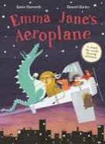 | 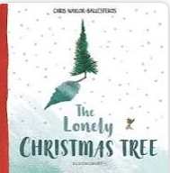 | 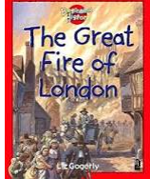 | 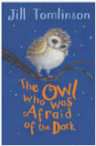 | 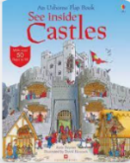 | 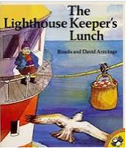
Key Texts/ Authors | Katie Haworth | Chris  Naylor-Ballesteros | Liz Gogerly | Jill Tomlinson | Katie Daynes | Ronda Armitage
Vipers | 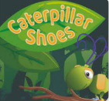  Caterpillar Shoes Film Vipers | 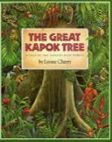  The Great Kapok Tree by Lynne Cherry | 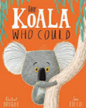  The Koala Who Could by Rachel Bright | 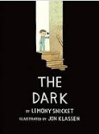  The Dark by Lemony Snicket and Jon Klassen | 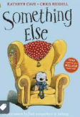  Something Else by Kathryn Cave Chris Riddell | 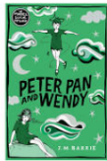  Peter Pan JM Barrie
Poetry/Rhyme | 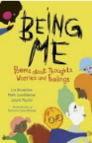  Free Verse poem Laura Mucha Thought Machine’ | 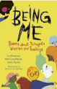  Free Verse poem ‘Being Me’ Laura Mucha | 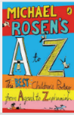  Repeating Pattern Poems  Down Behind the Dustbin’ by Michael Rosen | 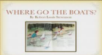  Repeating Pattern Poems Where go the boats?’ by Robert Louis Stevenson | 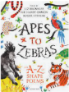  Shape & Diamante Poems In a Twist, Emperor Penguin by Liz Brownlee | 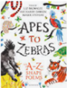  Shape & Diamante Poems  Liz Brownlee
Reading/Writing  Opportunities | Character descriptions  Stories from familiar settings  Recounts  Setting descriptions  Story mapping | Descriptive writing  Short narratives  Instructions  Predictions  Identifying vocabulary, | Diary entries- Samuel Pepys  Recounts of the events and feelings  Making predictions  Character descriptions  Information texts about the fire | Non chronological reports about owls  Stories with familiar settings  Night time poetry, Repeating Pattern Poems | Features of non-fiction texts- using each feature to write a non-fiction text about castles, Shape & Diamante Poems | Diary entries of living in a light house  Alternative versions of a story- what could happen  Writing instructions of how to stop the seagulls

Reading Curriculum Year 3
Topic | Ancient Egypt The Egyptian Cinderella, Shirley Climo  History | Fairtrade  Charlie and the Chocolate Factory, Chocolate Geography | Rocks and Rumbles The Firework Makers Daughter History | Predators Geography  Diary of a Killer Cat, Anne Fine | Mythical Gods and Mortals Ancient Greece/Modern Greece History | Scotland  Katie Morag delivers the Mail Geography
 | 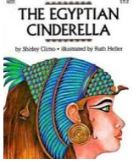 | 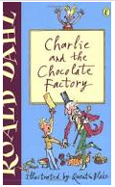 | 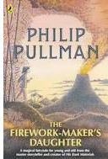 | 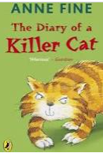 | 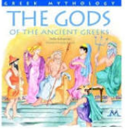 | 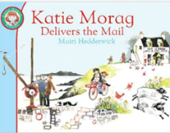
Key Texts/ Authors | Shirley Climo | Roald Dahl; Robin’s Kitthen | Philip Pullman | Anne Fine | Non-Fiction Texts; We’re From Greece This is Greece Perseus and the Gorgon | Mairi Hedderwick  Scottish Fairy-tales
Vipers | 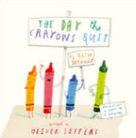  The Day The Crayons Quit by Drew Daywalt | 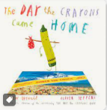  The Day The Crayons Came Home Drew Daywalt & Oliver Jeffers | 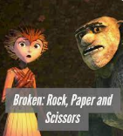  Broken: Rock, Paper, Scissors Film Vipers | 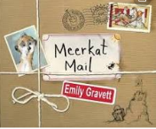  Meerkat Mail Emily Gravett | 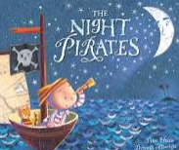  The Night Pirates by Peter Harris | 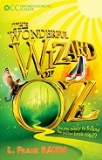  The Wizard of Oz by L. Frank Baum
Poetry/Rhyme | Free Verse Wide Open by Rachel Rooney. | Free Verse | Limericks and Clerihews  Loopy Limericks’ by John Foster | Limericks and Clerihews  clpe.org.uk/clerihews | Kennings and Quatrains beware by James Carter | Kennings and Quatrains ‘If I Could Be a Superhero’ by Steve Lazarowitz
Reading/Writing  Opportunities | Traditional Stories –story mountain, story maps, re-telling of an ancient traditional tail, descriptive writing and Stories with familiar Settings.  Information texts – NCR, Leaflet. | Instructional writing - methods, recipes. Persuasive writing -adverts, letters, fair-trade. Poetry – Heiku’s, Tanka and Cinquain. | NCR - Newspaper reports (Pompeii), report writing, journalistic writing.  Narrative writing, - inference, character description, setting description, paragraph writing and missing chapter. | Diaries/ recount, NCR meerkats, factual writing. Letter writing, NCR killer cats, limericks, clerihews | Myths and Legends, Historical Narratives, Greek Mythology, character/setting description, story writing. | Adventure and Mystery, Poems to Perform, acrostic poems, kennings and haiku. Dialogues/drama/play writing.
Reading Curriculum Year 4

Topic/Lead Text | Stone Age  Stone Age Boy by Satoshi Kitamura History | London  Katie in London Geography | Romans  Thieves of Ostia  History | Shang Dynasty  Ming’s Adventures with the Terracotta Army  History | England: North and South Lead Text: The Iron Man Geography | Lava by Disney Pixar CGP Volcano & Earthquakes Study Book Geography
 | 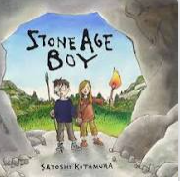 | 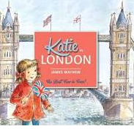 | 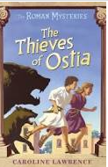 | 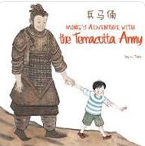 | 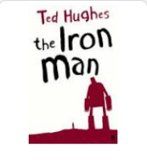 | 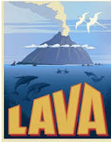
Key Texts/ Authors | Satoshi Kitamura, Who Were the First People? by Phil Roxbee-Cox | James Mayhew | Caroline Lawrence | Li Jian, The Magic Paintbrush by Julia Donaldson | Ted Hughes | Disney Pixar &  Non-fiction texts
Vipers | 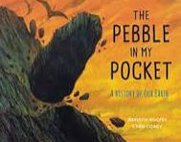  The Pebble In My Pocket by Meredith Hooper and Chris Caody | 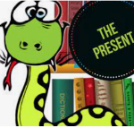  The Presen t Film Vipers | 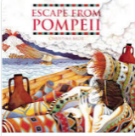  Escape from Pompeii by Christina Balit | 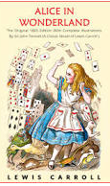  Alice in Wonderland by Lewis Carroll | 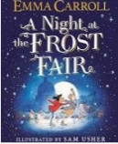  A Night at the Frost Fair by Emma Carroll | 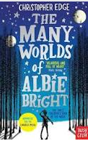  The Many World's of Albie Bright by Christopher Edge
Poetry/Rhyme | Free Verse The Water In The Glass You Are  Holding Right Now by Kate Wakeling | Free Verse The Water In The Glass You Are  Holding Right Now by Kate Wakeling | Simile and Metaphor An Emerald is as Green as  Grass’ by Christina Rossetti | Simile and Metaphor The Black Hat  Literacy Shed Clip | Haikus, Tankas and Cinquains Seaview Haiku’ by John Foster | Haikus, Tankas and Cinquains Winter’ by Adelaide Crapsey, ‘November Night’ by Adelaide Crapsey
Reading/Writing  Opportunities | Ancient civilisations, NCR, Narrative setting descriptions, Character descriptions, Newspaper reports, Range of fiction and non-fiction texts | Range texts, Writing from experiences, Writing adventure story, Persuasive writing (advert), Diary account | Newspaper article, Diary entry, Ancient civilisation, Explanation texts, recounts, Journalistic writing, Persuasive letter | Ancient civilisations, fiction and non-fiction texts, biographies, Persuasive writing, balanced arguments, balanced discussions | Character and setting descriptions, Play scripts, letter, diary and recounts, journalistic writing, biographies | A range of fiction and non-fiction texts, fact files, information booklets, writing for a website, recounts
Reading Curriculum Year 5

Topic | Anglo Saxons  Beowulf History | Anglo Saxons  Beowulf History | North America Geography  Holes | North America Geography Holes | Vikings History  The Dragon's Hoard: Stories from the Viking Sagas | Mountains  When the Mountains Roared Geography
 | 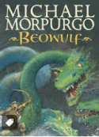 | 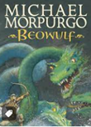 | 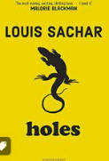 | 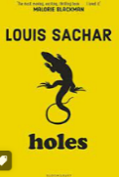 | 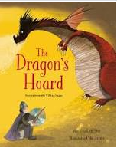 | 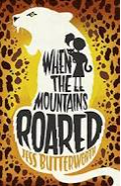
Key Texts/ Authors | Michael Morpurgo | Michael Morpurgo | Louis Sachar | Louis Sachar | Lari Don, The Saga of Bjorn – animation | Jess Butterworth
Vipers | 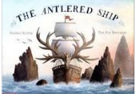  The Antlered Ship by Dashka Slater and The Fan Brothers | 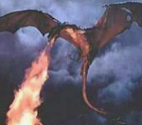  The Dragon Slayer Film Vipers | 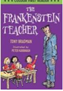  The Frankenstein Teacher by Tony Bradman | 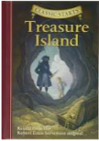  Treasure Island Robert Louis Stevenson | 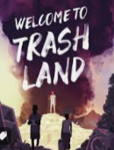  Welcome to Trash Land by Steve Cole | 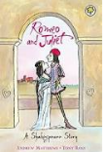  Romeo and Juliet William Shakespeare
Poetry/Rhyme | Figurative Language Don’t Be Scared’ by Carol Ann Duffy | Figurative Language, I Wandered Lonely as a Cloud’ By W.  Wordsworth | Narrative Poetry The Highwayman by Alfred Noyes | Narrative Poetry The Alchemist's letter | Free Verse Empty Head by Malick Fall | Free Verse ‘Den to Let’ by Gareth Owen,
Reading/Writing  Opportunities | Character description Warrior; Diary Warrior’s journey to Denmark; Persuasive writing Warrior quest application letter; Story writing Battle with Grendel; Persuasion – apply to be one of Beowulf’s 14 warriors; NCR Bearded Dragons | Setting description Dragon’s lair  Newspaper article –Dragon attack  Anti-Bullying wk writing; NCR dragons; Poetry Dragons; instructions – Honey Oatcakes | Diary entry – Stanley’s first day at camp;  Informal letter – Stanley’s letter home  Traditional story – Elya and the Pig; Character description – The garden; NCR American animals | Persuasive advert – Sam’s onion cures; Character description – Kissin’ Kate wanted poster  Biography- Louis Sachar; Play script – Rattlesnake Venom | Setting description – Valhalla Explanation – How the Vikings get their mead; Comic story– An Honourable Death; Character description – Saga from The Dragon’s Hoard; Newspaper article saga from The Dragon’s Hoard | Diary entry – leaving Australia; Setting description – arriving in India; Formal letter- complaint; NCR leopards; Persuasion – visiting India; Poetry
Reading Curriculum Year 6

Topic | The Maya History Ancient Mayan texts Mayan folktales; The Chocolate Tree – a Mayan folktale | World War 2 History Friend or Foe | World War 2 History Extracts from Anne Frank’s Diary; Friend or Foe Waiting for Anya | Our World Geography Kensuke’s Kingdom | Our World/ South American Geography Kensuke’s Kingdom The Explorer | Physical Geography  The Explorer;  When I grow up
 | 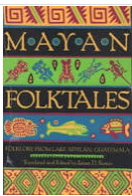  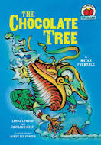 | 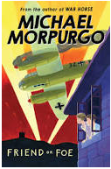 | 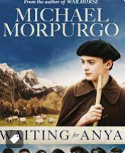  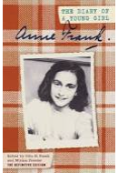 | 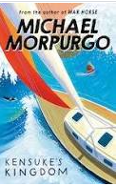 | 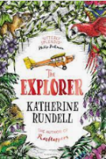  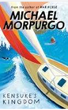 | 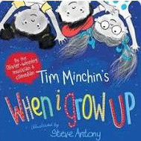  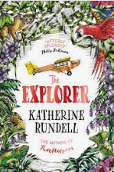
Key Texts/ Authors | Linda Lowrey  James. D. Sexton | Michael Morpurgo | Anne Frank and Mirjam Pressler | Michael Morpurgo | Catherine Rundell | Tim Minchin
Vipers | 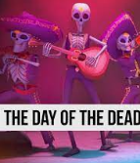  Dia de los Muertas - Day of the Dead – Film Vipers | 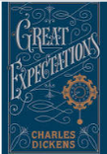  Great Expectations by Charles Dickens | 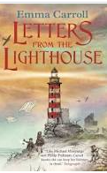  Letters from the Lighthouse by Emma Carroll | 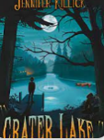  Crater Lake by Jennifer Killick | 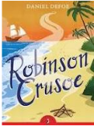  Robinson Crusoe Daniel Defoe | 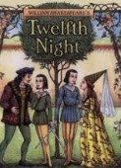  Twelfth Night William Shakespeare
Poetry/Rhyme | Classic Poetry The Lion  and Albert’ By Marriott Edgar | Narrative Poetry The Raven Edgar Allen Poe | Narrative Poetry Shadow of Blue | Free Verse I’m Free by John Kitching | Free Verse Arguing by Liz Brownlee and The  Sea’s Hands by George Szirtes | Sonnets Sonnet 22 by Wendy Cope
Reading/Writing  Opportunities | Description/Ancient Folk Tales, Ancient Civilisations, NCR, Explanation, Archaeology, Persuasive writing, multicultural texts, South America | Biographies, Journalistic writing, Diaries – recounts, Letters, NCR – Entertainment, WW1 remembrance poems, Persuasion, Propaganda posters | Journalistic writing, Newspaper articles, Explanation, Diaries & recounts, Letters - Evacuee Instructions, NCR, Holocaust, Persuasion | Balanced discussion, NCR, Fiction skills/narrative, settings Diary/recount – Kensuke and Michael  Japan, Indian Ocean | Letter, Fiction skills/narrative, setting descriptions, NCR Orang-utans, Recount, Letter, Instructions, Deforestation of the Rainforests | Fiction skills/narrative, Fact files/NCR, Explorers, Amazon Basin/South America, Poetry, Sonnets, Recount, Drama and play scripts
Reading Curriculum Year 6

