Year 6 English Home Learning
Week 1:
Creative Writing Task – A Portal to Another World
When the Pevensey children discovered Narnia, they did so by opening the door of the wardrobe. Similarly, Alice had her first glimpse of Wonderland after falling down the rabbit hole and peering through the keyhole. Doors and portals to other worlds are often used to structure fantasy stories, making them useful tools for descriptive writing.
Have a go at writing a story which includes your character(s) going through a portal to another world and returning again. Make sure you use a range of descriptive techniques to build an image of this new setting in the reader’s mind and think about how the experience affects the character.
Day 1
Before writing, you will need to plan what this new world will look like. You should also consider what the portal will be, where it is located and how your character(s) will use it. Have a go at drawing what you imagine your new setting and portal to look like and label with descriptive words and phrases to use in your writing. You could use your senses, ambitious adjectives and personification to up-level your work. You could also use the images below to inspire you:
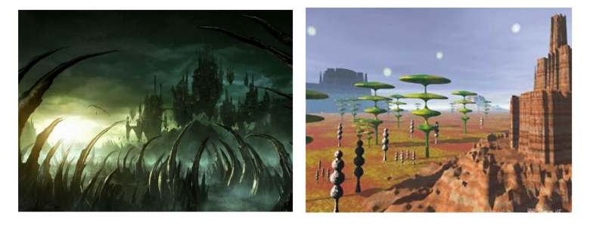
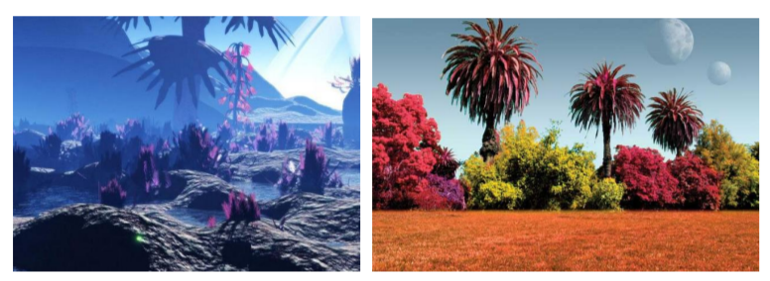

Day 2:
Today plan out the adventure your character will embark on. Use a planning template like the Story Mountain below to decide how your character will come across the portal, what happens to them on the other side, the new characters they will meet and what happens to them on their return.

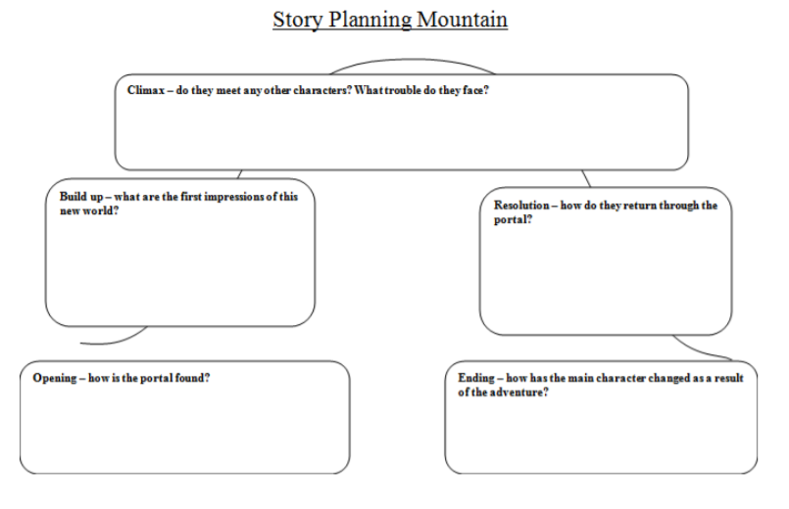

Day 3:
Have a go at writing the first part of your story today. Consider the following prompt questions as you write: - Who is your main character? What are they doing when they come across the portal? - Does your character decide to go through the portal straight away or are they cautious? - What is the first thing they notice when they set foot into the new world? - How will you vividly describe this new setting? Use your description ideas from session 1.

Day 4:
Continue and conclude your story considering the following prompt questions: - Does your main character meet anybody/anything in the new world? What is their interaction like? - Does your character face any trouble or obstacles in the new world? - How do they manage to escape or why do they decide to return to the real world? - What affect has the experience had on your main character? Do they change anything about themselves as a result, or do they appreciate anything more in the real world? Don’t forget to have a read through of your first draft before beginning the editing process.

Day 5:
Today you will edit your story for corrections and improvements: - Read your work aloud to someone at home. See if you have missed any important punctuation. - Check the spelling of any words you are unsure of using a dictionary or you could use this online version https://kids.britannica.com/kids/browse/dictionary
You could use the word bank below to up-level some of your word choices. Make sure you check the meaning of any words you are unfamiliar with to ensure that the word choice fits the sentence.

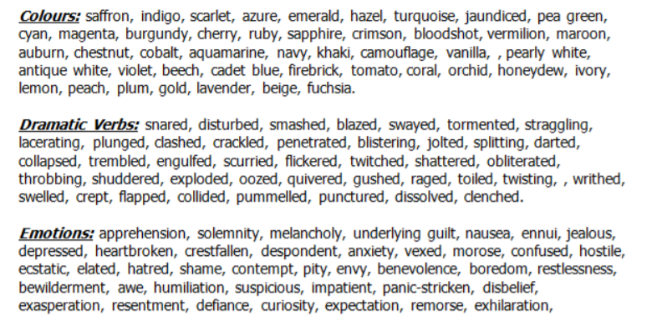
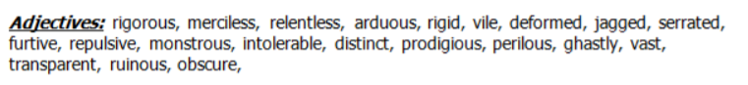

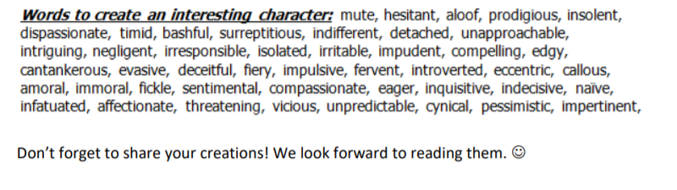

Week 2:
Creative Writing – Magazine Articles
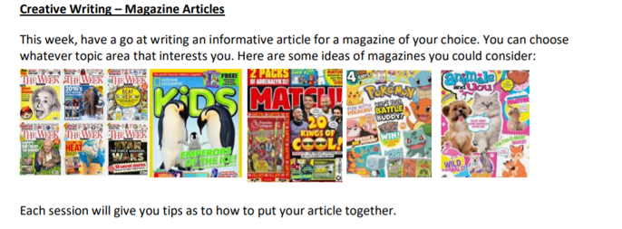
Day 1:
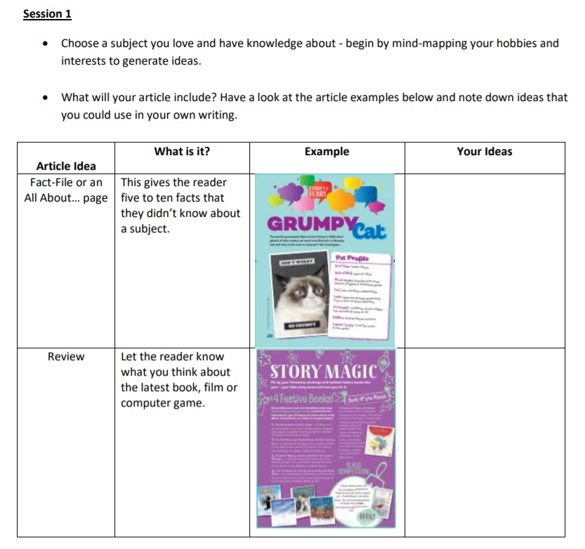

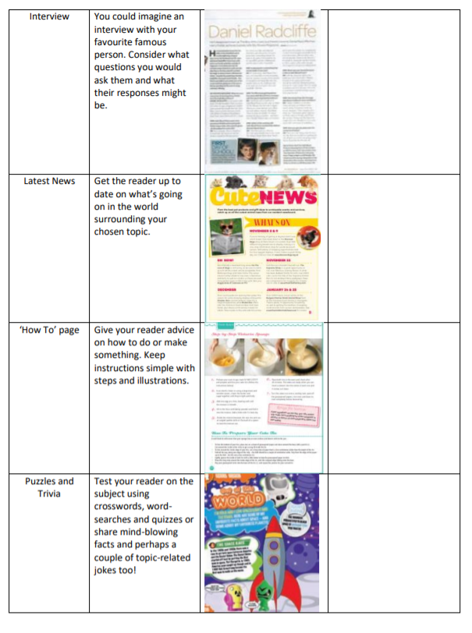

Day 2:
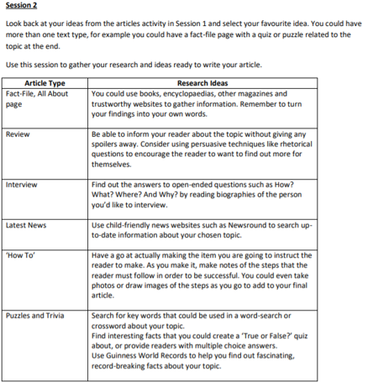
Day 3:
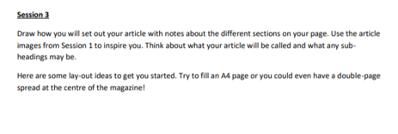

Day 4:
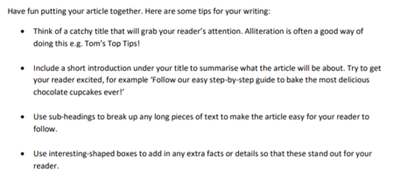

Day 5:
