Maths:
Please click the link below for 5 online videos (one for each day) to explain and model the learning before you have a go at the worksheets.
Spring Week 1 - Number: Decimals | White Rose Maths
Monday (video 1) – To understand decimals up to two decimal places
Tuesday (video 2) – To understand thousandths
Wednesday (video 3) – To understand decimal place value to three decimal places
Thursday (video 4) – To multiply decimals by 10,100,1000
Friday (video 5) – To divide decimals by 10,100,1000

There are two worksheets for each day, the second one being harder than the first. I would like everybody to complete the first sheet for each day and attempt the second, but please do not worry if the second sheet is a little too tricky as there are some reasoning questions. If you cannot print the worksheets don’t worry – you can jot your workings out and answers on paper at home
Use this place value chart to help you.

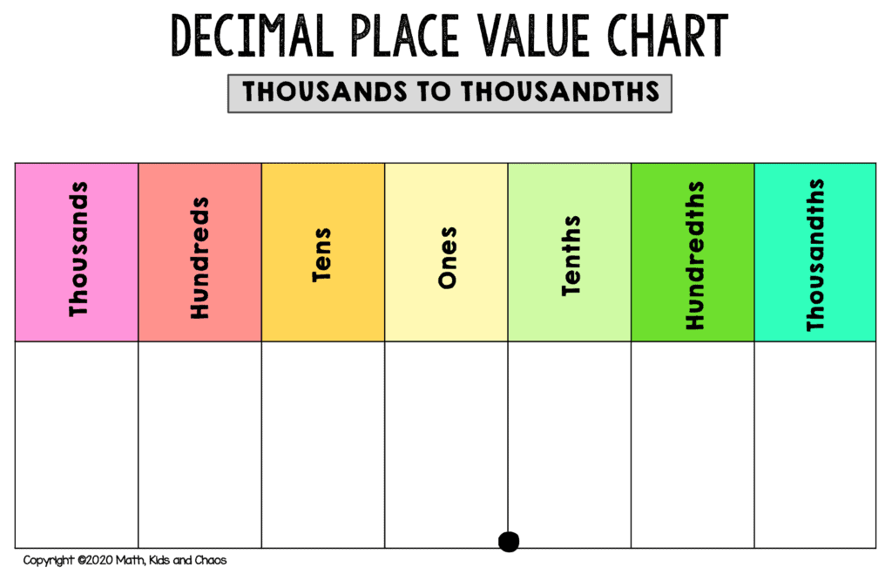
Monday Worksheet:
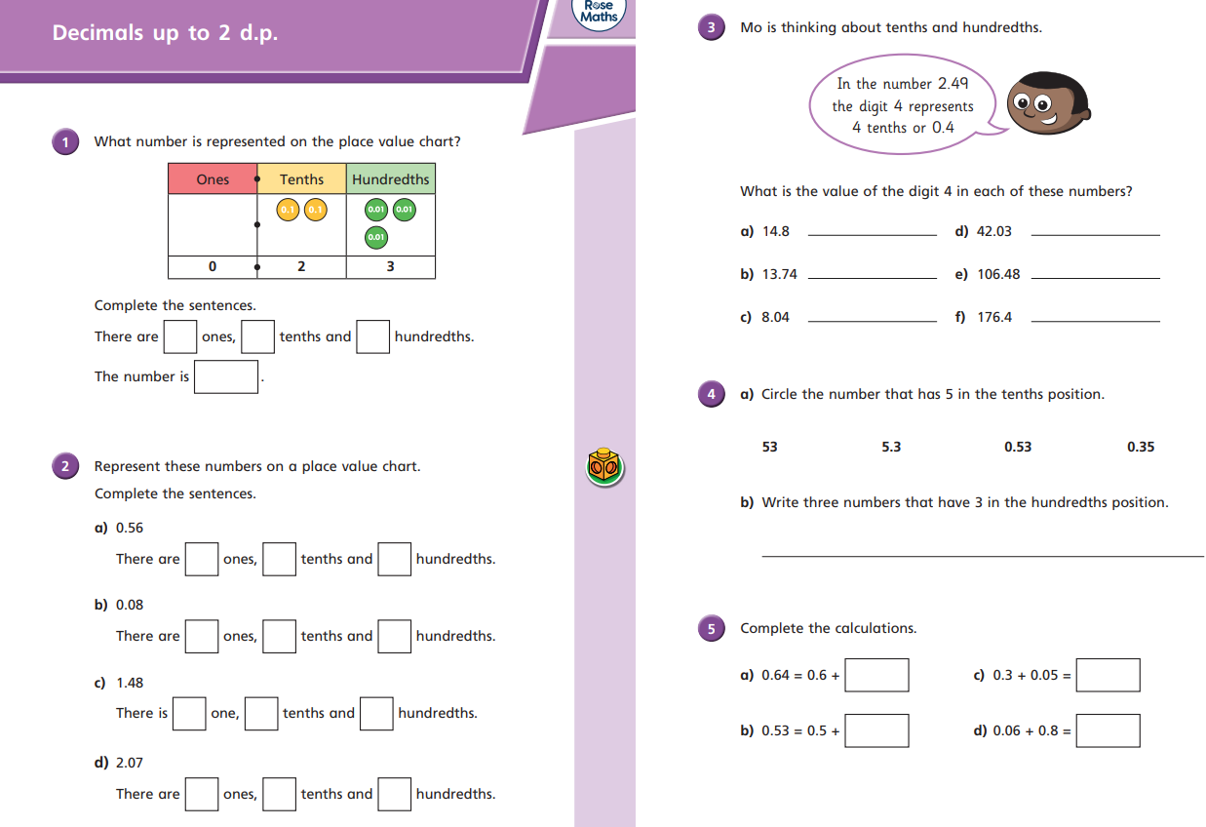
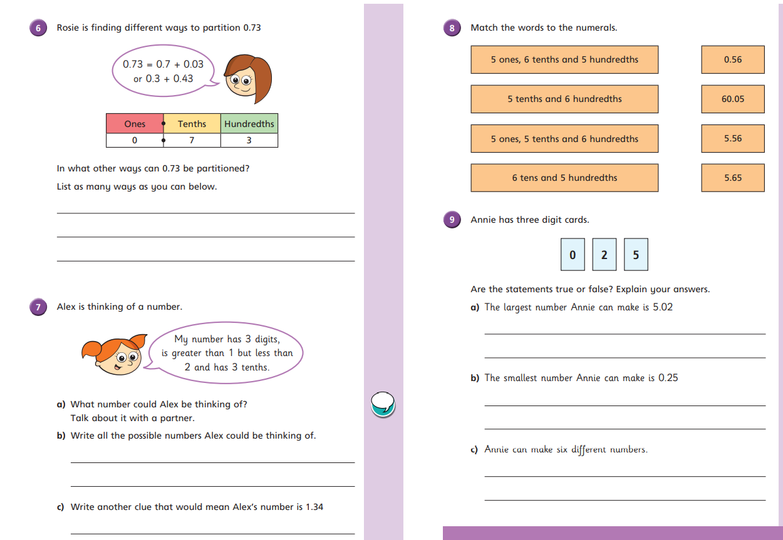
Tuesday Worksheet:
