Owl Class suggested home learning activities
WOW! We can’t believe this is the last full week before the summer holidays! You have all worked extremely hard over the course of the last few terms. Well done for completing another week of learning from home. We know that it can be tough at times but we are so proud of how you are all take responsibility for your learning.

Maths:
White Rose Maths Lessons
Last week the learning sequence was all about: Subtracting decimals with the same number of decimal places, Subtracting decimals with different number of decimal places, multiply decimals by 10, 100, 1000 and divide decimals by 10, 100 and 1000. Well done if you managed to complete some or all of the lessons. Remember to let us know how you got on and what bits you found challenging. The five lessons in this week’s sequence teach you how to: measure with a protractor, drawing lines and angles accurately, calculating angles on a straight line and calculating angles around a point. There is also the Friday maths challenge.
Check out our top tips below to help you work. When you click the link below please use Summer Term WEEK 10 – Lesson 1 – Measure with a protractor (you may have to scroll down the web page to find this). Year 5 link: https://whiterosemaths.com/homelearning/year-5/

Miss Murphy’s Top Tips:
• Angles on a straight line add up to 180 degrees.
• 90 degrees makes a right-angle, an angle smaller than 90 degrees is acute, an angle larger than 90 but smaller than 180 degrees is obtuse and an angle larger than 180 degrees is a reflex angle.
• An angle is a measure of the amount of turn between two lines
• Follow the instructions below to use a protractor accurately
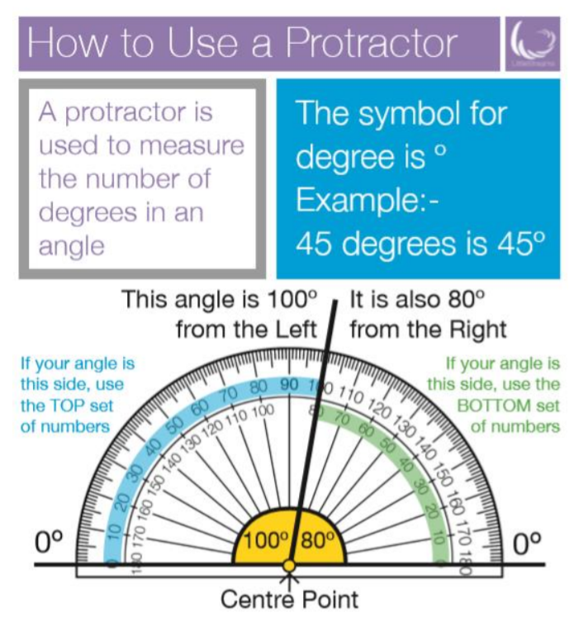
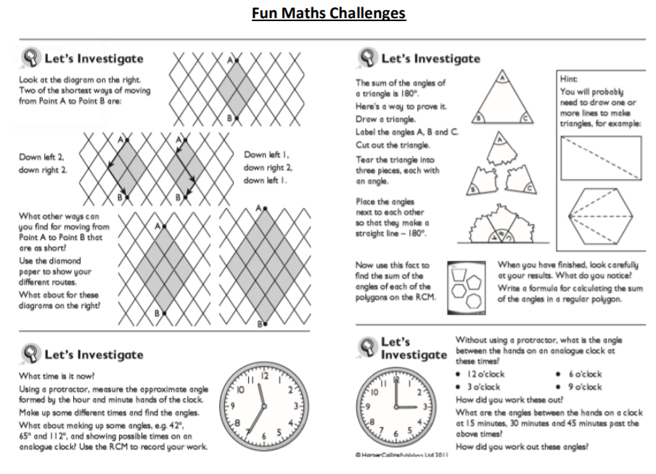

English:
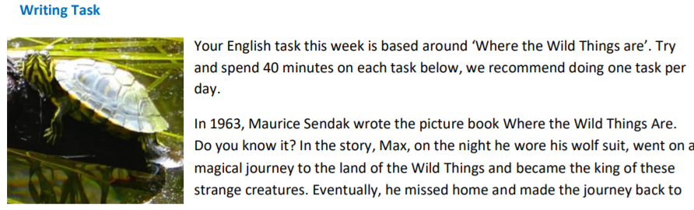 his bedroom, where it all began. It’s a wonderful story – you can listen to it here and see the wonderful illustrations. Follow this link to watch the video: https://cutt.ly/6yrU67Z
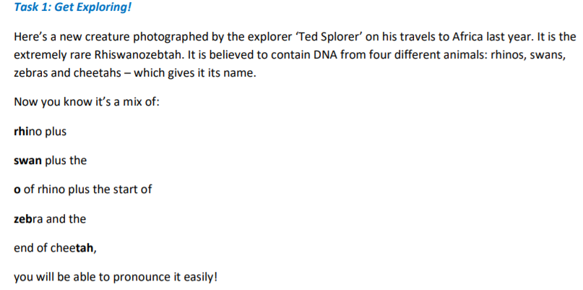
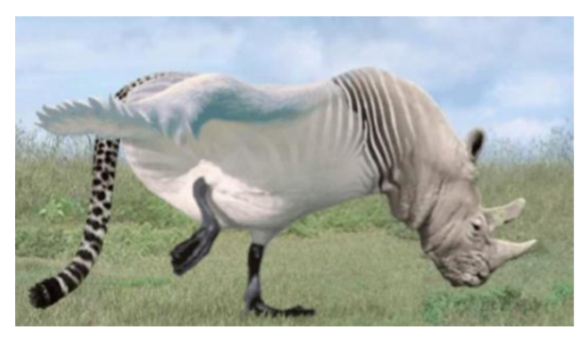
He has written a paper about it, using his research, to help you find out more about this wonderful animal. Read on and discover the world of the Rhiswanozebtah! You can listen to an audio version of the text here https://soundcloud.com/talkforwriting/rhi-swano-zebtah/sVRW2gbiXcMY
