Owl Class suggested home learning activities
Year 5:
English
Your English task this week is based around ‘Things around us’. Follow the tasks below, spending roughly 40mins on each task per day. This week the activities are more stand alone as we thought it would be nice to mix it up and have a change, complete the tasks in any order you like – be imaginative and have fun!
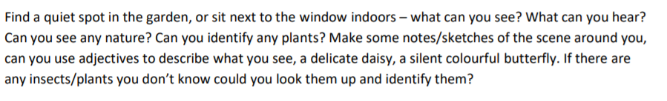
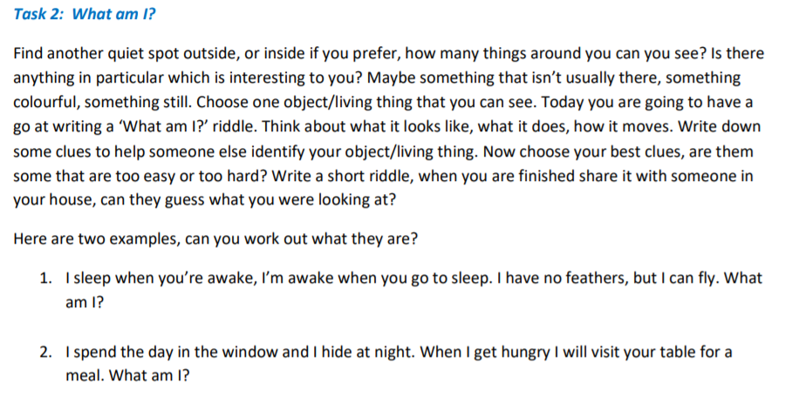

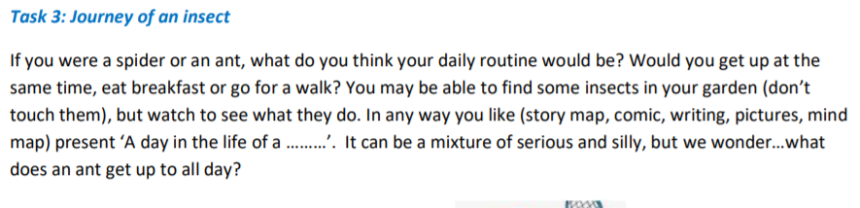
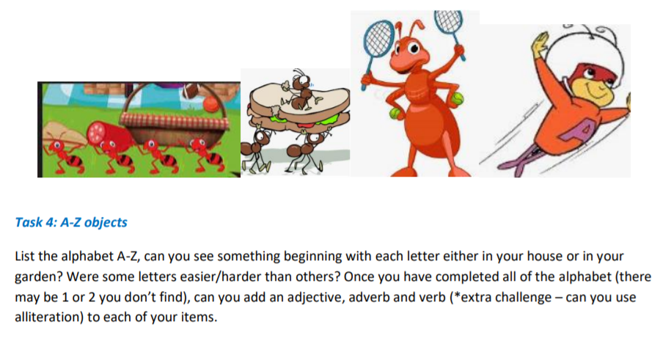
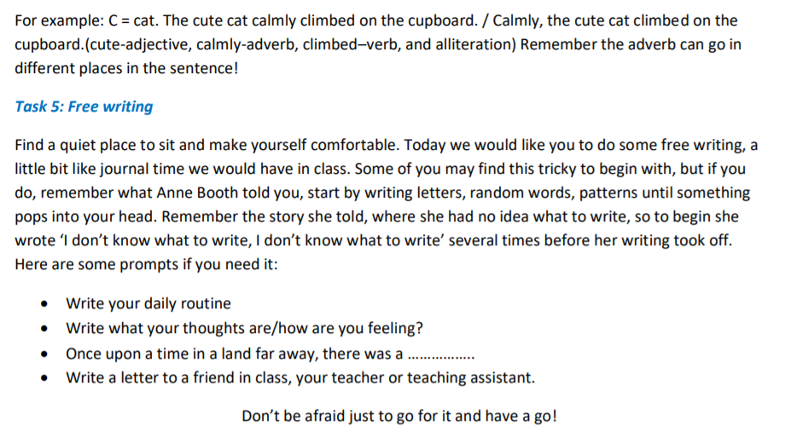

Maths
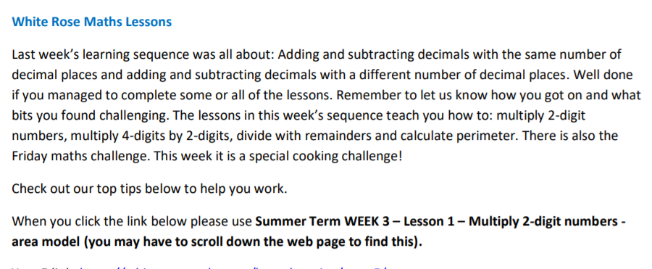
Year 5 link: https://whiterosemaths.com/homelearning/year-5/
Top Tips:
1. When using written formal methods, you MUST keep your presentation clear, using a ruler and keeping the digits in the correct column. Otherwise, you will end up changing the digits value and ultimately end up with an incorrect answer. (See picture 1 below).
2. Remember when multiplying by a 2 digit number you must start by multiplying all of the top digits by the units (see picture 2 below).
3. Then, you must remember to put in a zero at the start of the second answer row/box as here you are now multiplying by the tens not the units so by putting a zero in at the start your answer will be 10 times larger (see picture 3 below).
4. It is important that you remember to add both of your answers together to get the total after you have done both parts of the multiplication (see picture 4 below).
5. Remember, when carrying over, put the digit directly below that answer box in the next column (see picture 5 below)
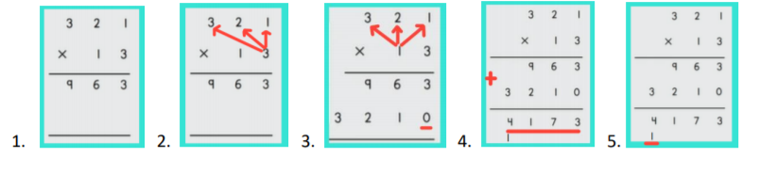

Fun Maths Challenges This week we have included some different maths activities for you to have a go at should you want to.
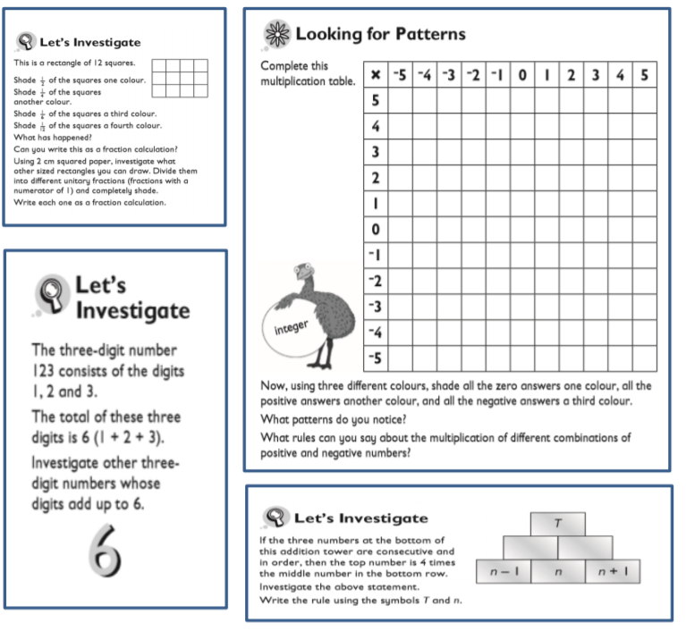

Year 6:
Maths:
White Rose Maths Lessons – Fractions Some of you may be at different stages with the White Rose resources due to various reasons. Please note – information in this letter is based on Summer Term Week 3. Summer Term Week 3 (04.05.20) on White Rose will continue to build on your work last week linked to angles and will progress to some problem solving activities. You can find the link to the suggested daily lessons here: https://whiterosemaths.com/homelearning/year-6/
Miss Murphy’s Top Tips:
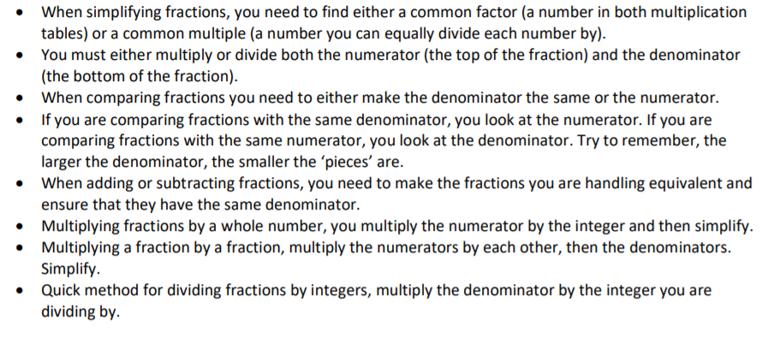
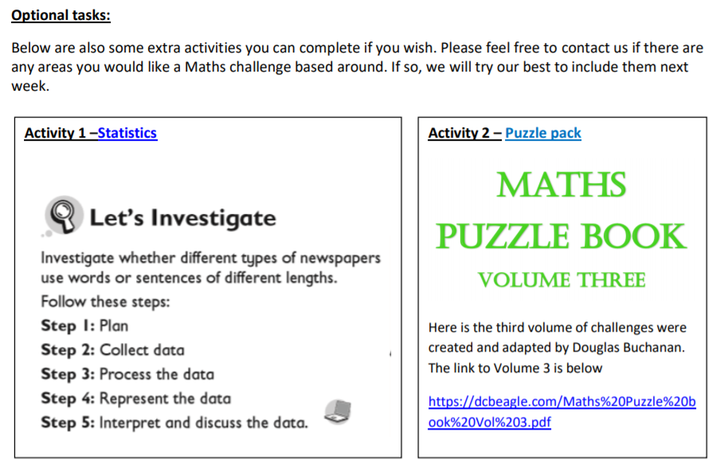

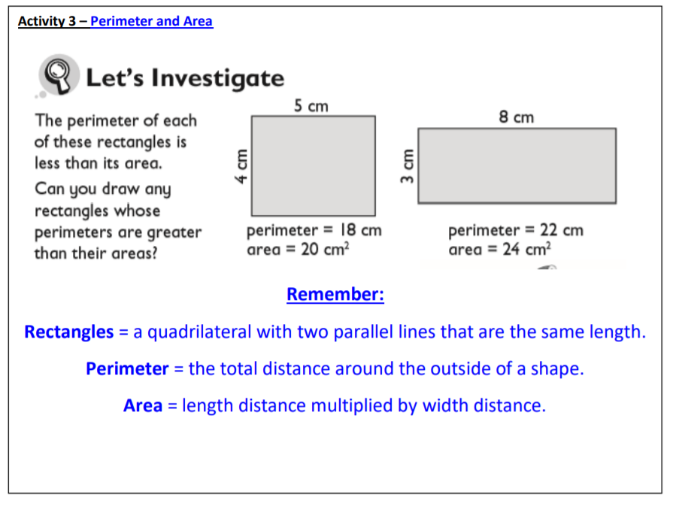

English:
