Owl Class suggested home learning activities

Physical and emotional well being
Exercise From what we gather, many of you have been joining in with the Joe Wicks workout which is brilliant.
We wanted to post a few other ideas too
1) Shuttle runs – using any equipment or markers in the garden (or any appropriate outdoor space) set out four different running points which are at different lengths from the starting position.
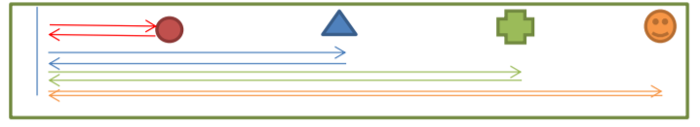

Run to the first marker, then back. Then the second then back and so on. Use a timer to measure how long it takes you to complete it. Can you improve on your times? Can you increase the distance in between each marker?
2) Circuit training – Create circuit, this will include a different challenges at each station. For example
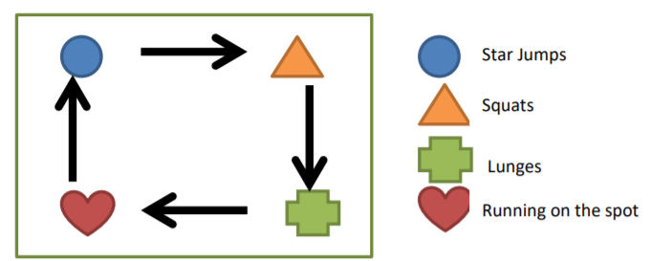

You might like to create your own circuit or exercise. If so, let us know, we would love to have a look and share some of them with the rest of the class.

PSHE Over the past few weeks we have suggested discussion tools that you could use during this time being spent at home. This week we wanted to offer a few suggestions for things you could try individually. The hope is that these could be reflective tools to learn more about yourself.
Activity 1 – How do I Feel? •
What do you notice about your body? Do you feel well? Do you ever have stomach pains or a headache? When would you say you feel like this? Would you like to write something about it, discuss it or make a drawing about it?
How does your body feel when you wake up? Do you feel well rested or tired?
Here is a thermometer. Copy one out seven times to represent every day of the week. Each day fill in the thermometer to indicate how you feel (tired at the bottom, well at the top). What do you notice?

Activity 2 – Mindful Walking
When you run up the stairs really fast, are only your legs running? Is anything else running too? Please note exactly which muscles are getting in on the action.
When you suddenly stop running, what do you notice about your body? What about your breathing, your muscles, your heartbeat?
Please note how often you automatically break in to a run and see if you can walk at a regular pace instead?

Year 5:
English
Poetry Your English task this week is based around poetry. Follow the tasks below, spending roughly 40mins on each task per day. To begin with, find an animal poem that interests you. If you prefer you can use the examples below. It could be a funny poem, silly poem, sad poem but the main thing is you like it! Once you have found your chosen poem complete task 1 below.
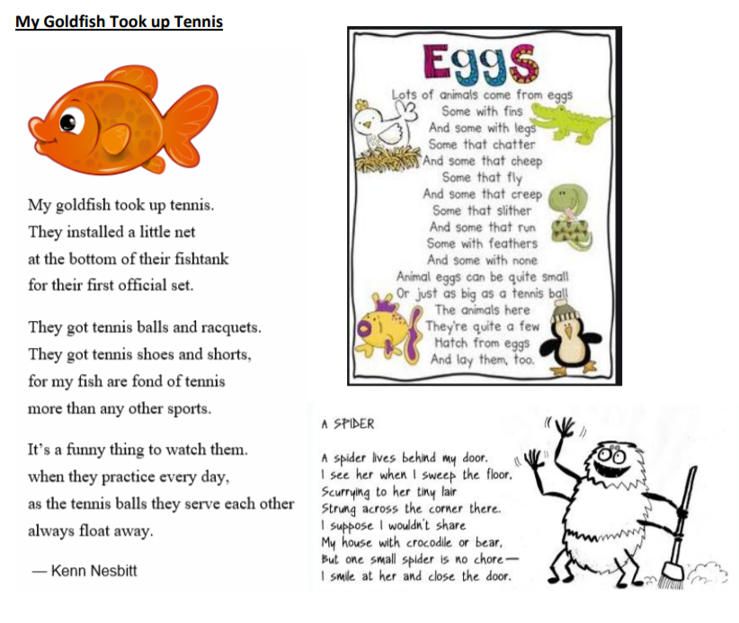
Task 1: Performance Poetry and recognising features:
1. Read your poem quietly to yourself – jot down anything you notice (rhyming, sentence length, punctuation, structure)
2. Now read the poem out loud – jot down anything new that you notice.
3. This time when you read it out loud change the tone of your voice. Can you read it in a deep voice, high voice, scary voice, grumpy voice) Have a few attempts using a different tone – perhaps ask someone to video so you can watch it back.

4. Ask someone else to read it to you, listen carefully for things that you didn’t notice before. 5. You should have now identified some features of poetry. Use the checklist below to see what features are shown in this poem.
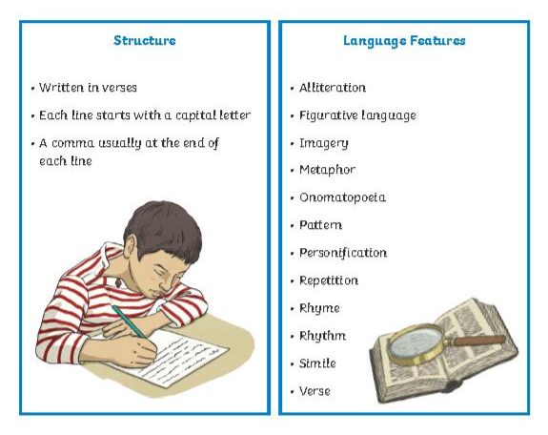

Task 2: Planning and rhyming words
1. Think of a creature that you will write your poem about – spider, cow, grasshopper, horse, snake
2. Draw your creature and around it label its body parts (legs, ears, tail, antennae, claws etc.)
3. Next to each body part list some adjectives/adverbs to describe what that body part is like and how it moves – e.g. skin – soft, green, wrinkly, swiftly, slithering
4. Now we need some rhyming words – see how many rhyming couplets you can make (for example for skin – green and seen, wrinkly and crinkly, soft and loft). Try and get a simile, metaphor, personification, onomatopoeia (WHIZZ! KAOOM! SPLASH!)

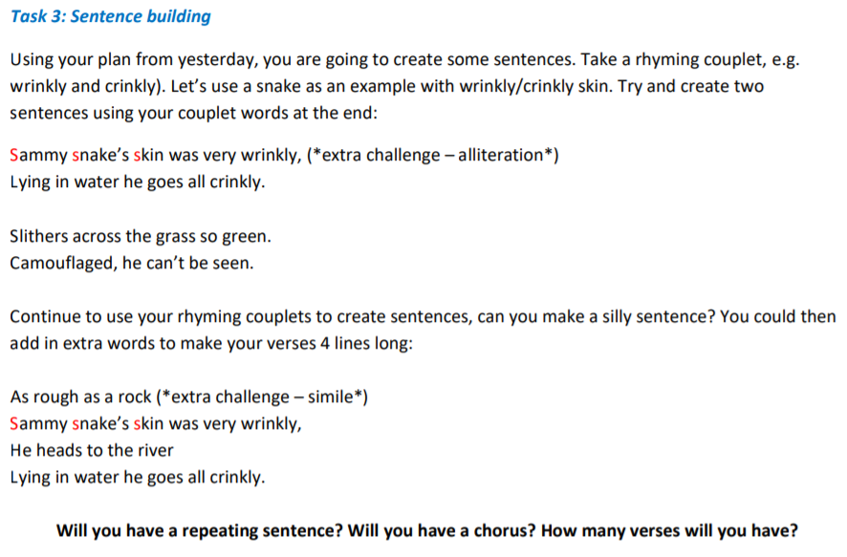

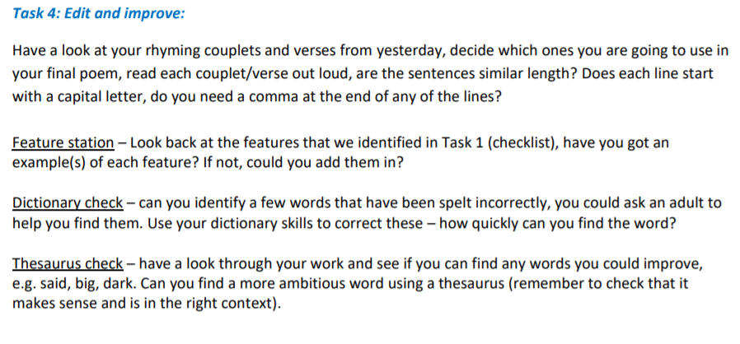

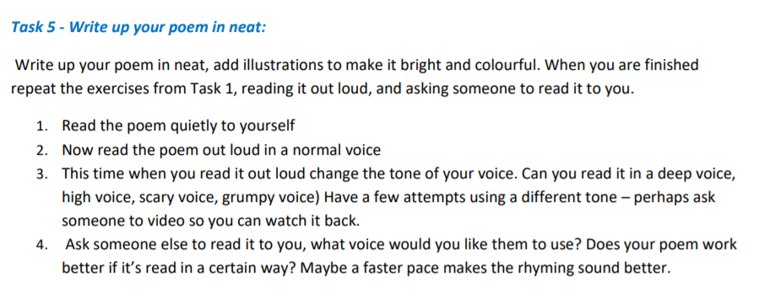

Year 5:

Maths
White Rose Maths Lessons – Week 3
Last week’s learning sequence was all about: adding and subtracting decimals within 1, complements to 1, and adding decimals crossing the whole. Well done if you managed to complete some or all of the lessons. Remember to let us know how you got on and what bits you found challenging. The five lessons in this week’s sequence teach you how to: add and subtract decimals with the same number of decimal places, add and subtract decimals with a different number of decimal places and the Friday maths challenge. Please note that for the Friday maths challenge, questions 1-5 are most suitable for Year 5 children. Although, please feel free to have a go at the other questions if wanted, it could be fun to work these out with an older sibling or your parents, helping each other out.
Check out our top tips below to help you work. When you click the link below please use Summer Term WEEK 2 – Lesson 1 – Adding Decimals with the same number of decimal places (you may have to scroll down the web page to find this). Year 5 link: https://whiterosemaths.com/homelearning/year-5/
Top Tips:
- When adding and subtracting decimal numbers, don’t forget to put a zero (0) in as a place holder to help where necessary. This makes it clearer because both numbers will then have the same amount of digits, making it easier to add or subtract them. E.g. 0.26 + 0.3 change to 0.26 + 0.30 (remember, this doesn’t change the value of 0.3, it just makes it clearer to see what you are working with).
- It is important that you keep your numbers in the correct column and your layout neat when using the column method to add or subtract, otherwise you might end up getting confused resulting in the wrong answer. You could always draw vertical lines on your paper if that helps.
- • Remember to put in the decimal points when using a column method to add or subtract decimal numbers.
- • You may also find it useful to use a decimal place value grid or chart like the example below to record numbers in whilst working to help organise them correctly.

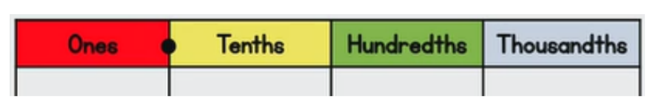

Fun Maths Challenges
This week we have included some different maths activities for you to have a go at should you want to.
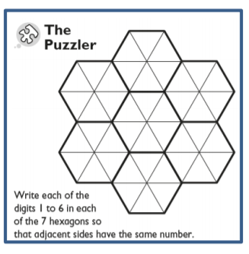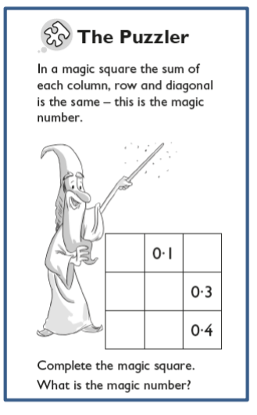

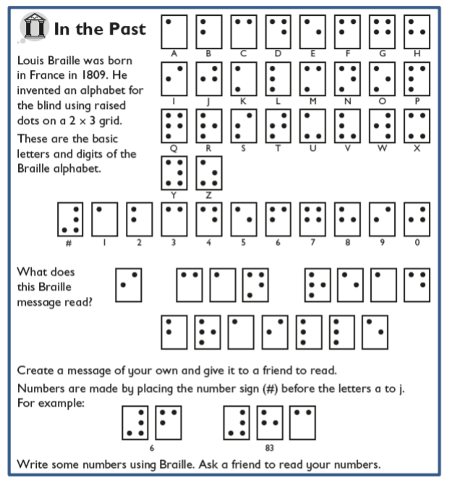
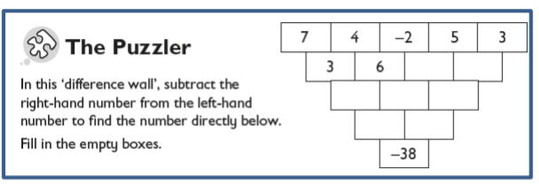

Year 6:
Maths:
White Rose Maths Lessons – Angles (cont.) Some of you may be at different stages with the White Rose resources due to various reasons. Please note – information in our letter is based on Summer Term Week 2. Summer Term Week 2 (27.04.20) on White Rose will continue to build on your work last week linked to angles and will progress to some problem solving activities. You can find the link to the suggested daily lessons here: https://whiterosemaths.com/homelearning/year-6/

Miss Murphy’s Top Tips:
• There are different types of quadrilaterals (parallelogram, rhombus, trapezium etc.) – it may be worth double checking what these are and discussing their properties.
• All of the internal angles in a quadrilateral add up to 360°
• Make sure you use what you know when finding missing angles. E.g. If I have 3 angles I can add them together to find the difference from 360° to give you the angle.
• Polygon – remember it is any 2D shape with straight edges
. • Some shapes you are able to split in to triangles – remember all the interior angles in a triangle add together to make 180°
• Exterior angles is the number of degrees around the vertex.

Optional tasks: Below are also some extra activities you can complete if you wish. Please feel free to contact us if there are any areas you would like a Maths challenge based around. If so, we will try our best to include them next week.
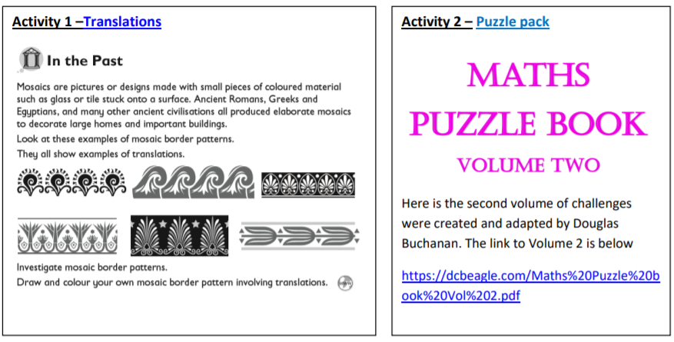

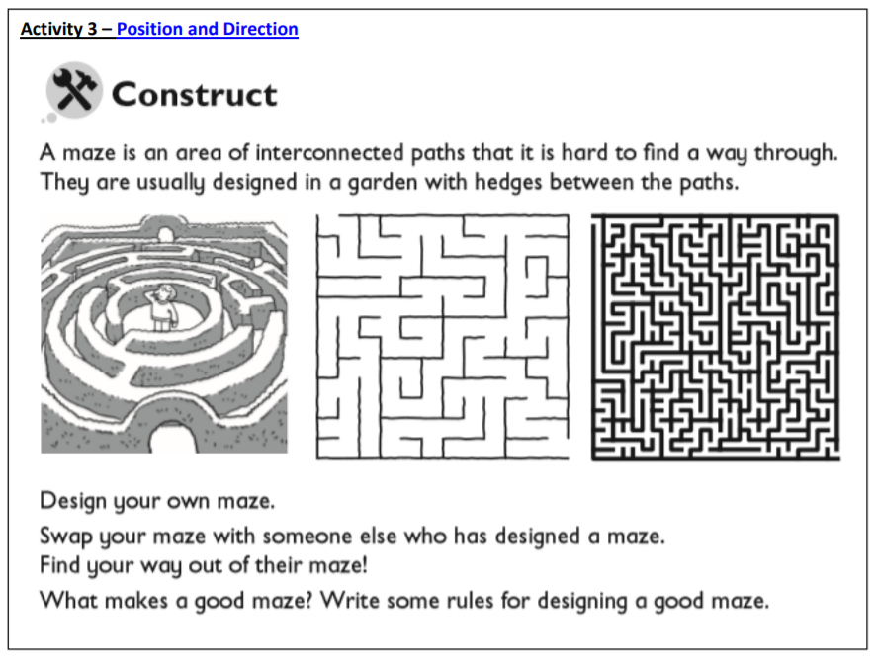

English:
Creative Writing Task – The Monsters’ Alphabet Read the poem below, ‘The Monsters’ Alphabet’, by Pie Corbett. What do you notice about the structure, layout and rhythm:

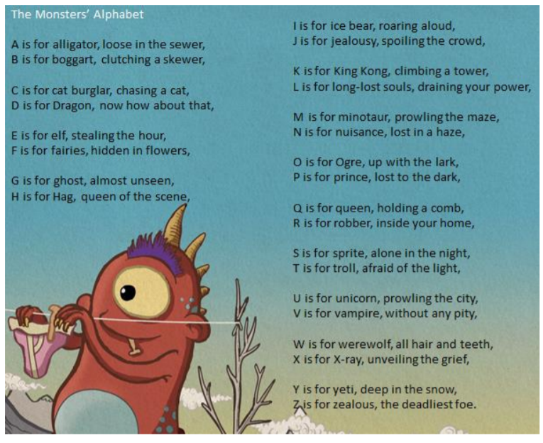

This week, you will have an opportunity to write your own ‘alphabet poem’ around a theme of your choice. You might want to keep to Corbett’s monster theme and create your own monster alphabet, or create an alphabet poem of gruesome snacks a monster might want to eat. You could also adapt this style of poem to your own theme – maybe sports, music or food! The choice is yours.

