Owl Class suggested home learning activities

Exercise We are sure that many of you are enjoying taking part in the daily Joe Wicks workout at home. This goes live at 9am Monday – Friday and the link can be found here:
https://www.youtube.com/channel/UCAxW1XT0iEJo0TYlRfn6rYQ
Have you been taking part in any other forms of exercise? We’d love to hear about what you’ve been up to. Maybe you could send a photo of you in action!

PSHE
Perhaps you could take some time this week to play ‘Roll a positive question’ with some of your family members. The aim of the game is to roll two dice to generate a question to ask others. Some of the questions include ‘What is the funniest memory you have?’ and ‘What is one thing you are really good at?’ You could always create your own number cards to turn over if you don’t have dice at home. The resource for this activity can be found at
https://www.elsa-support.co.uk/roll-apositive-question/
The ELSA website has many other lovely activities to support with emotional well-being.

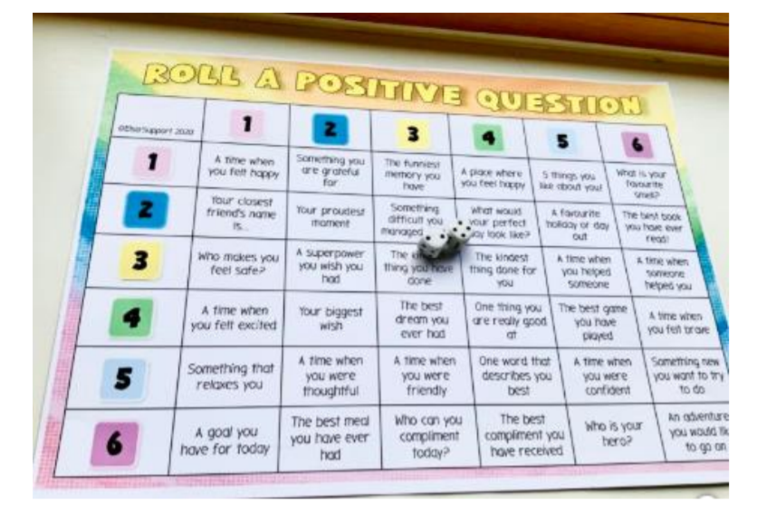

Year 5:

English:
Read the information below for a summary of the introduction to the book ‘Beowulf’ and the main characters. Then see below for activities linked to this.
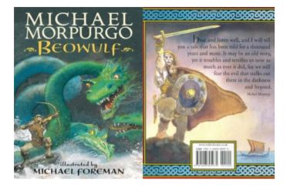

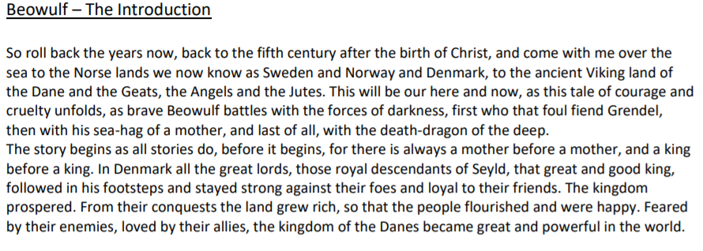
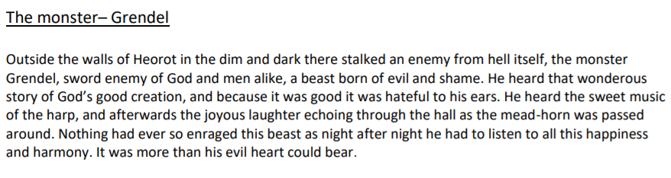

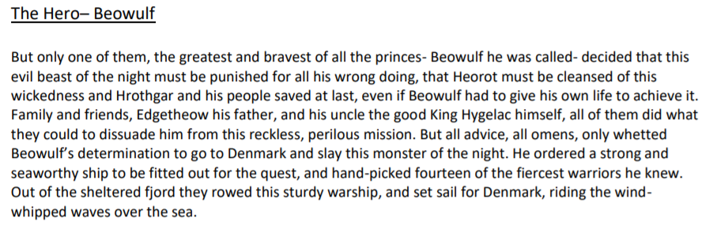
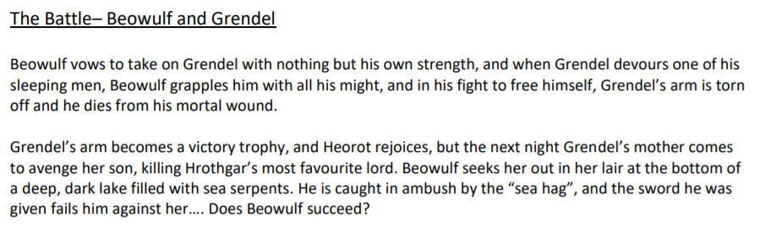

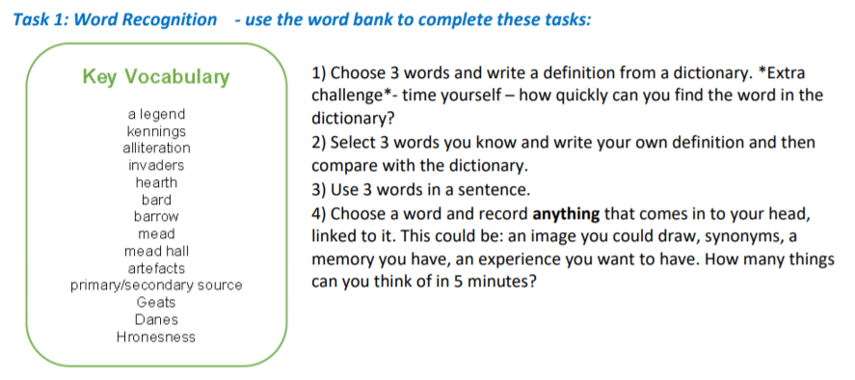

Task 2 – Identifying Features
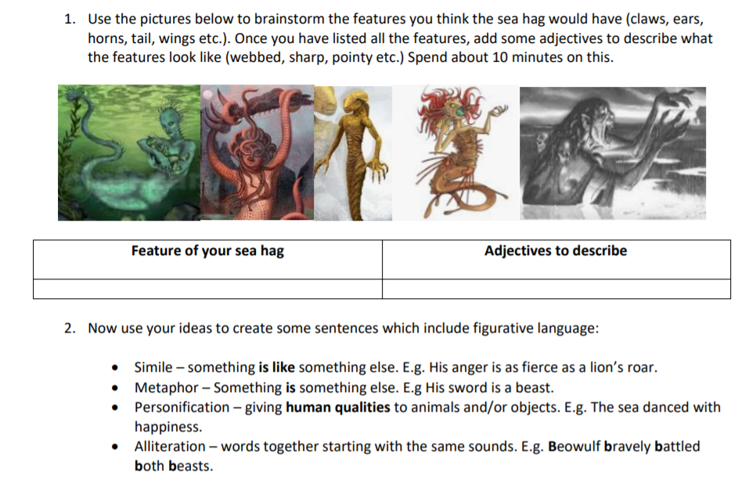

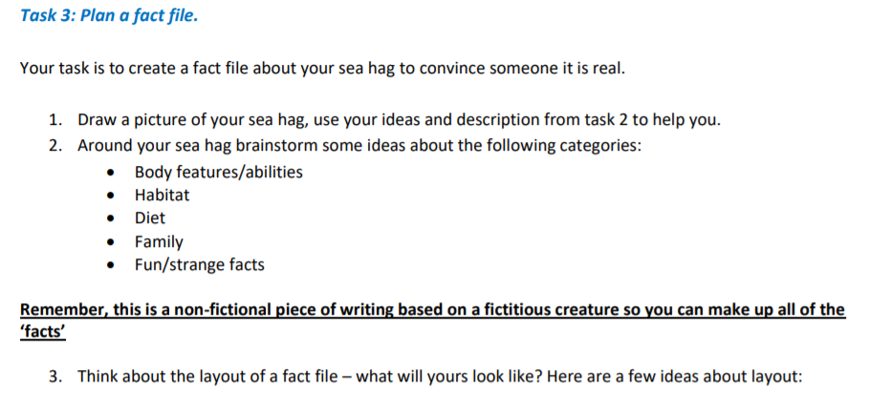
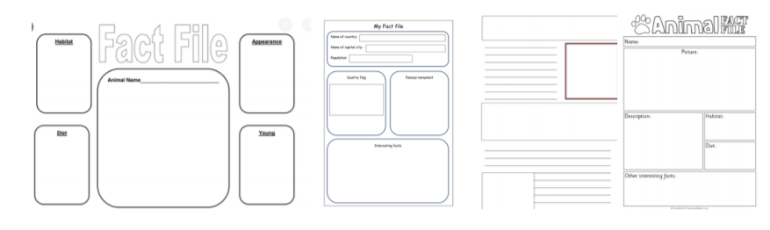

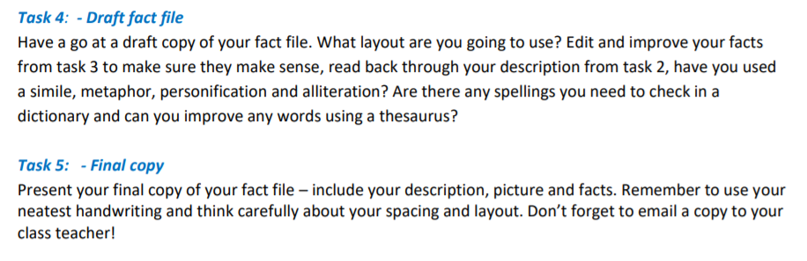

White Rose Maths Lessons – Week 2
Last week’s learning sequence was all about decimal numbers up to three decimal places. Well done if you managed to complete some or all of the lessons. Remember to let us know how you got on and what bits you found challenging. The five lessons in this week’s sequence teach you how to: round decimals; compare and order decimals; understand percentages; calculate percentages as fractions and decimals and how to find equivalent percentages, fractions and decimals. Check out our top tips below to help you work. When you click the link below please use WEEK 2 – Lesson 1 – Rounding Decimals.
Year 5 link: https://whiterosemaths.com/homelearning/year-5/

Top Tips!
- When working with numbers on a number line remember to always check what steps the interval markers go up in to ensure you accurately mark numbers on the line. When placing decimal numbers on a number line between two whole numbers, the interval markers will go up in decimal steps e.g. 0.1, 0.2, 0.3 and so on.
- • When rounding numbers we use the following rule: 5 and above, give it a shove (round up). 4 and below, let it go (round down). This rule applies when rounding decimal numbers too. E.g. 12.1, 12.2, 12.3, 12.4 all round down to 12. Whereas, 12.5, 12.6, 12.7, 12.8, 12.9 all round up to 13. This rule can be applied for rounding to the nearest 1, 2, or 3 decimal places, just remember to check what place value column (tenths, hundredths or thousandths) you are using to round.
- • Percent is always out of 100. Each percent is equivalent to 1/100 or one hundredth or 0.01 (100% is equivalent to 100/100, one whole or 1.00)
- You may also find it useful to use a decimal place value grid or chart like the one below to record numbers in whilst working to help organise them correctly

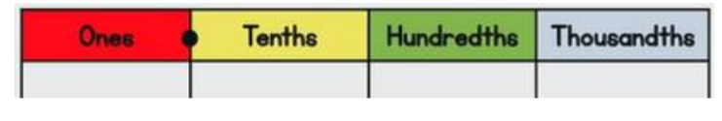

Year 6:
Maths:
White Rose Maths Lessons Week 2 - Angles Week 2 on White Rose will focus on angles - vertically opposite angles and angles in a triangle. You can find the link to the suggested daily lessons here: https://whiterosemaths.com/homelearning/year6/
Like last week, there are five sessions and we would suggest you complete one a day, you will notice that the first two lessons are consolidating the ratio and proportion lessons and then progress on to angles by lesson three. There is a short video for the children to watch and join with to start, followed by activities to complete.
Miss Murphy’s Top Tips!
• Try to remember the vocabulary: Acute – Smaller than 90° Obtuse – greater than 90° Right angle – exactly 90° Reflex – greater than 180°
• A straight line is 180° and all angles in a triangle must add up to 180°, also. Remember – a full turn is 360°. • An angle is created when any two straight lines meet.
• You are measuring the distance inside (unless told otherwise) so make sure you read from the correct part of the protractor (don’t worry parents the tasks have the angles put on to a protractor).

Optional tasks: Below are also some angle-related activities you can complete if you wish. Please feel free to share some answers with us through photos, written answers or scanned copies of your work.
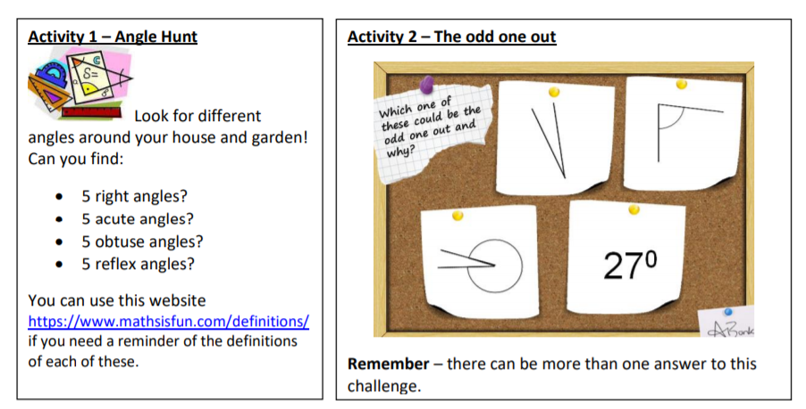

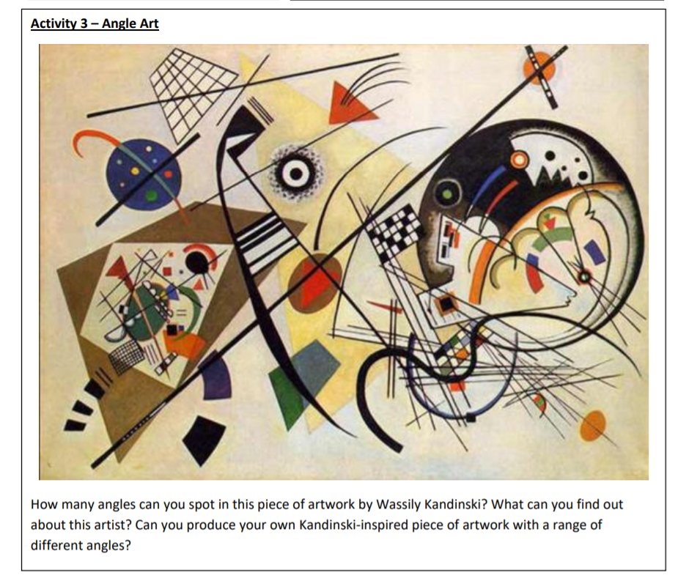

English:
Creative Writing Task – A Portal to Another World
When the Pevensey children discovered Narnia, they did so by opening the door of the wardrobe. Similarly, Alice had her first glimpse of Wonderland after falling down the rabbit hole and peering through the keyhole. Doors and portals to other worlds are often used to structure fantasy stories, making them useful tools for descriptive writing.
Have a go at writing a story which includes your character(s) going through a portal to another world and returning again. Make sure you use a range of descriptive techniques to build an image of this new setting in the reader’s mind and think about how the experience affects the character.
Session 1 Before writing, you will need to plan what this new world will look like. You should also consider what the portal will be, where it is located and how your character(s) will use it. Have a go at drawing what you imagine your new setting and portal to look like and label with descriptive words and phrases to use in your writing. You could use your senses, ambitious adjectives and personification to up-level your work. You could also use the images below to inspire you:
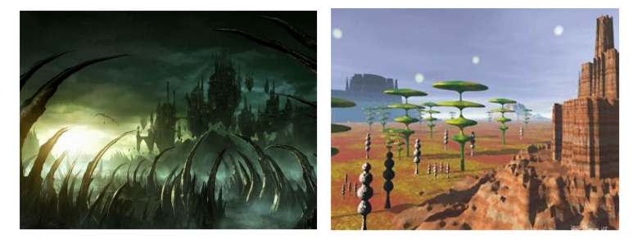
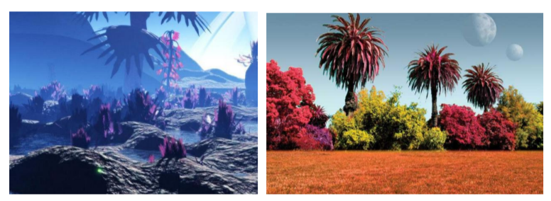

Session 2
Today plan out the adventure your character will embark on. Use a planning template like the Story Mountain below to decide how your character will come across the portal, what happens to them on the other side, the new characters they will meet and what happens to them on their return.

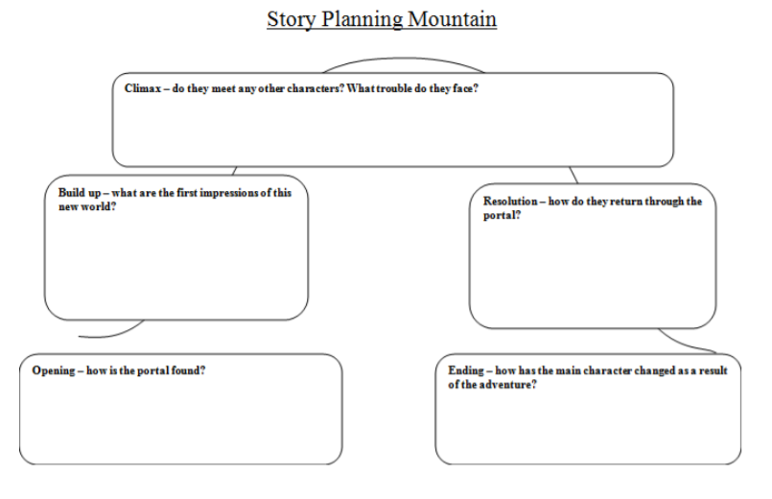

Session 3
Have a go at writing the first part of your story today. Consider the following prompt questions as you write: - Who is your main character? What are they doing when they come across the portal? - Does your character decide to go through the portal straight away or are they cautious? - What is the first thing they notice when they set foot into the new world? - How will you vividly describe this new setting? Use your description ideas from session 1.

Session 4
Continue and conclude your story considering the following prompt questions: - Does your main character meet anybody/anything in the new world? What is their interaction like? - Does your character face any trouble or obstacles in the new world? - How do they manage to escape or why do they decide to return to the real world? - What affect has the experience had on your main character? Do they change anything about themselves as a result, or do they appreciate anything more in the real world? Don’t forget to have a read through of your first draft before beginning the editing process.

Session 5
Today you will edit your story for corrections and improvements: - Read your work aloud to someone at home. See if you have missed any important punctuation. - Check the spelling of any words you are unsure of using a dictionary or you could use this online version https://kids.britannica.com/kids/browse/dictionary
You could use the word bank below to up-level some of your word choices. Make sure you check the meaning of any words you are unfamiliar with to ensure that the word choice fits the sentence.

