Here are the links for the afternoon lessons:
Monday | Tuesday | Wednesday
Science:  What is the Theory of Evolution?  In today’s lesson we look at Darwin’s observations from his trip on HMS Beagle. We will then put all his observations together to see how Darwin came up with his theory. His theory is called evolution. We will apply this new knowledge to two other examples of evolution, mice and giraffes.  Please click the link to access the lesson and task:  https://classroom.thenational.academy/lessons/what-is-the-theory-of-evolution-6ru32d  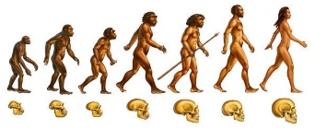 | RE:  How did the religion of Islam begin?  In this lesson, we will be exploring the beginning of the religion of Islam. We will learn about the life of the Islamic Prophet Muhammad, who established the religion following revelations from the Angel Gabriel.  Please click the link to access the lesson and task:  https://classroom.thenational.academy/lessons/how-did-the-religion-of-islam-begin-74vk2r | Music:  Understanding syncopation:  In this lesson, you will learn about syncopation. You will learn a new song and perform syncopated rhythms. The lesson finishes with a quiz to test your knowledge.  https://classroom.thenational.academy/lessons/understanding-syncopation-6cr64t

Thursday | Friday
History:  How do we know about Prehistoric Britain?  In this lesson, we will be going back in time millions of years to learn all about the earliest humans! As well as exploring the different species of human and how they migrated out of Africa, we will learn all about the clues that help us know more about the distant past.  https://classroom.thenational.academy/lessons/how-do-we-know-about-prehistoric-britain-61jp4c  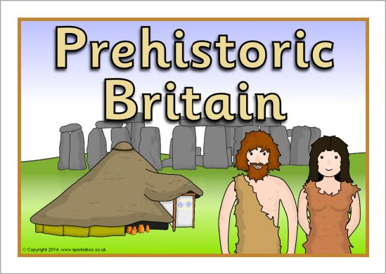 | Geography:  What is the geography of Scotland?  In this lesson, we will recap our knowledge of the seven continents, and locate the UK on a world map. We will then zoom into Scotland and look at the different human and physical geographical features. We can then compare these to the area where we live.  https://classroom.thenational.academy/lessons/what-is-the-geography-of-scotland-70vk4t  