Owl Class suggested home learning activities
English
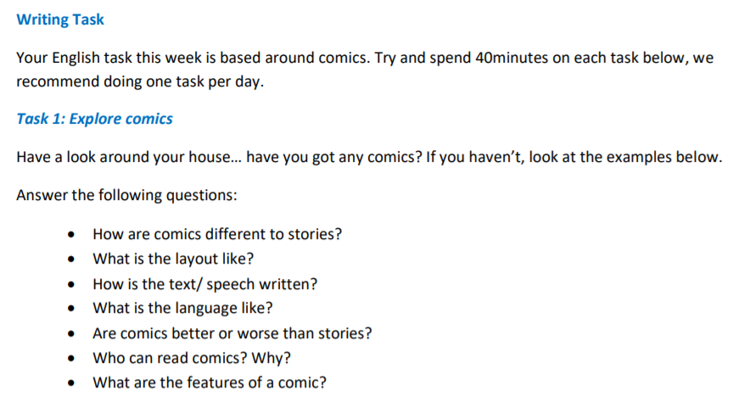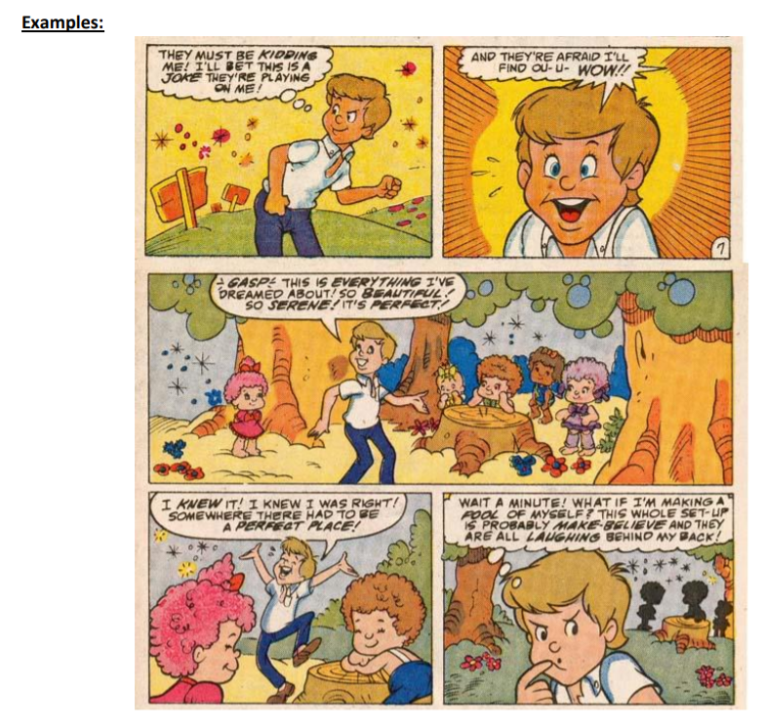
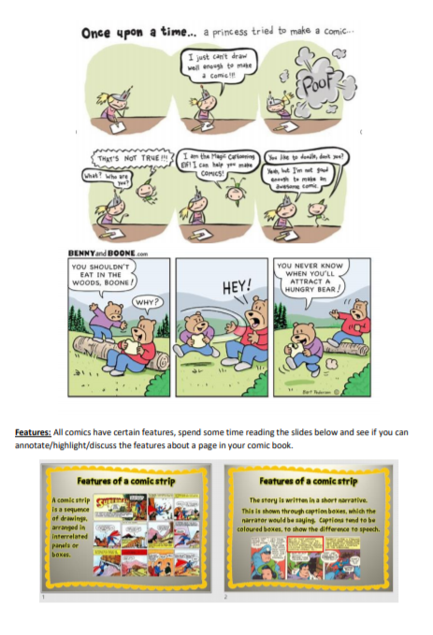

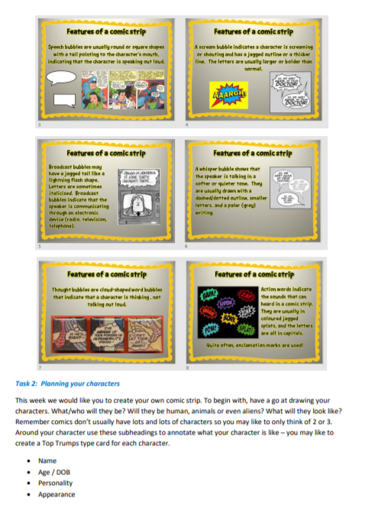

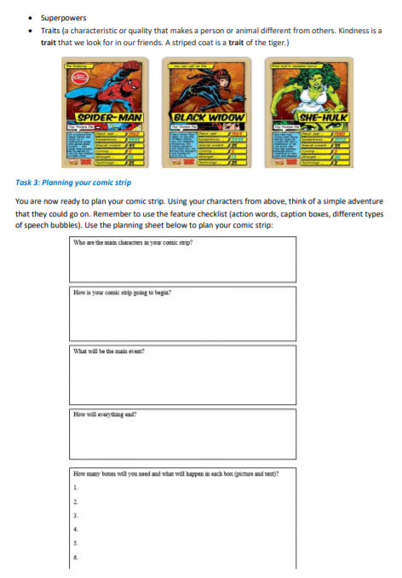

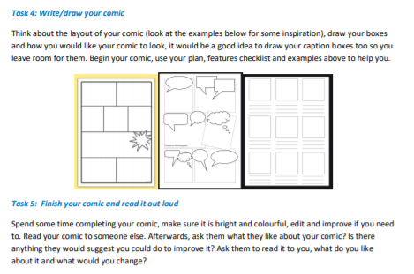

Don’t forget to email a copy of your comic strip to Miss Murphy at info@parkside.kent.sch.uk

Maths
White Rose Maths Lessons

Last week the learning sequence was all about: multiplying unit and non-unit fractions by integers, multiplying mixed numbers by integers, fractions of an amount and fractions as operators. Well done if you managed to complete some or all of the lessons. Remember to let us know how you got on and what bits you found challenging. The lessons in this week’s sequence teach you how to: Decimals as fractions, understanding thousandths, round decimals and order and compare decimals. Check out our top tips below to help you work.
When you click the link below please use Summer Term WEEK 7 – Lesson 1 – Decimals as Fractions (you may have to scroll down the web page to find this). Owl link: https://whiterosemaths.com/homelearning/year-5/
*Please note, this link will take you to the videos introducing the Maths concept, the worksheets can be found on the Owl page on the school website.

Miss Murphy’s Top Tips:
• When rounding, remember to use the rhyme to help you – 5 and above, give it a shove, 4 and below kick it down low.
• 1/10 is the same as 0.1, 1/100 is the same as 0.01. 1/1000 is the same as 0.001. Don’t forget that 0.10 and 0.1 are equivalent, 0.10 just has a place holder on the end.
• 32/100 is the same as 0.32. • 0.363, the value of the underlined number is 6 hundredths, or 6/100, or 0.06
• Remember when you are ordering, you could add a place holder to help you. For example: Which is larger 0.32 and 0.342? If we add a place holder to 0.32 we have 0.320 and 0.342, these numbers are now much easier to compare because they have the same number of digits after the decimal point. The largest number is 0.342. Use a grid like the one below if you need to:
