Owl Class suggested home learning activities

Physical and emotional well being
Exercise Exercise helps to focus the mind and we would recommend starting the day with the Joe Wicks workout at 9.00. https://www.youtube.com/channel/UCAxW1XT0iEJo0TYlRfn6rYQ
If you are unable to view or participate, you may wish to create your very own fitness challenge. How fast can you run to the shed and back? How many skips can you complete in a minute? Create a challenge for yourself and aim to beat your personal best week on week.
PSHE A useful website for both yoga and mindfulness is Cosmic Kids. This is a fantastic resource that has a variety of videos that help teach Yoga for children. The videos range in length from 5mins to 15mins and can be sorted into videos that help, focus, calm or activeness. https://www.cosmickids.com

Year 5:

English:

Your English task this week is based around writing a persuasive piece of writing. Follow the tasks below, spending roughly 40mins on each task per day. Your persuasive writing is going to be based on the question:

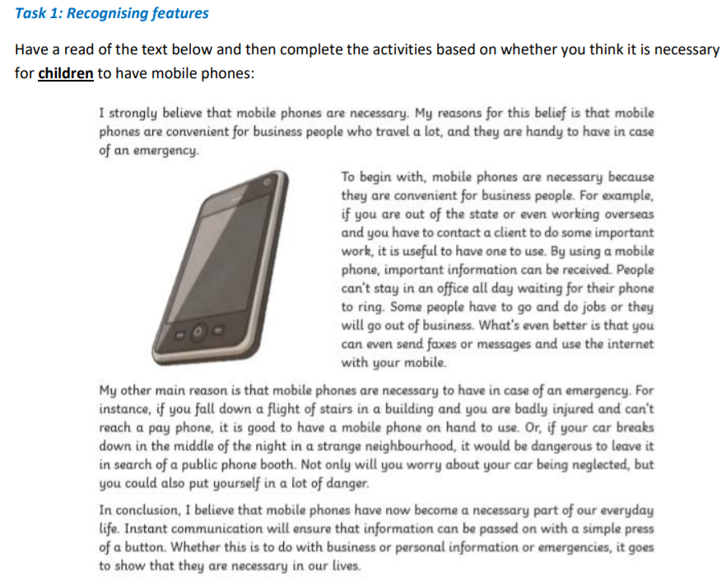

1. Clarify any words – if there are any words that you do not understand – look them up in a dictionary and write down the meaning.

2. Identify features - create a key and use a colour code system to highlight what you find. Use the feature checklist below to help you:

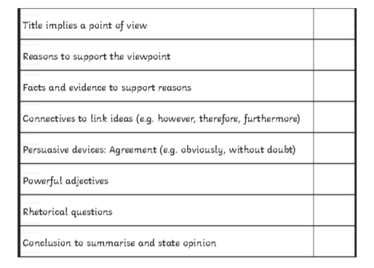

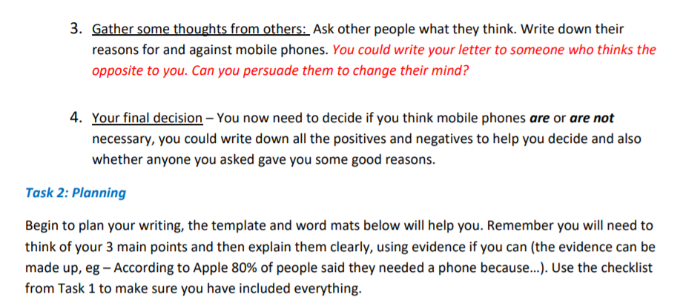
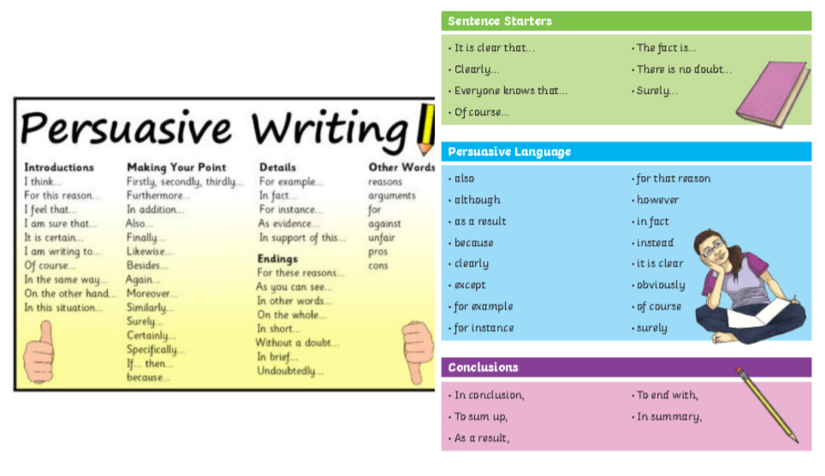

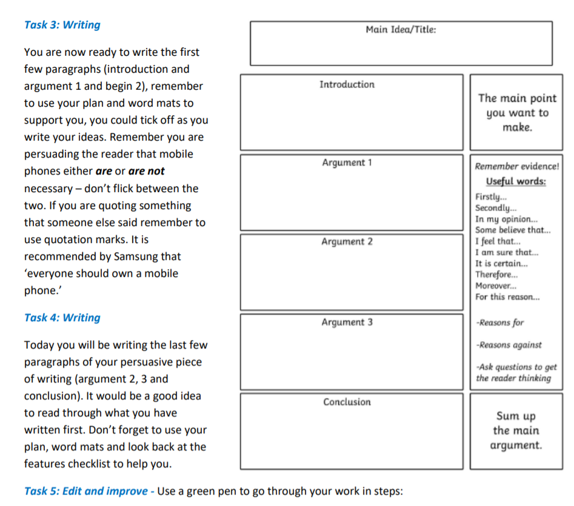

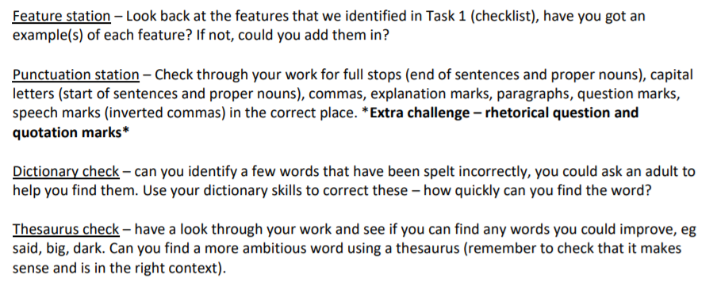

Maths
Last week’s learning sequence was all about: rounding, ordering and comparing decimals and understanding and calculating percentages. Well done if you managed to complete some or all of the lessons. Remember to let us know how you got on and what bits you found challenging.
The five lessons in this week’s sequence teach you how to: add and subtract decimals within 1, complements to 1, adding decimals crossing the whole and the Friday maths challenge linked to BBC Bitesize.
Please note that for the Friday maths challenge, questions 1-5 are most suitable for Year 5 children. Although, please feel free to have a go at the other questions if wanted, it could be fun to work these out with an older sibling or your parents, helping each other out. Check out our top tips below to help you work.
When you click the link below please use Summer Term WEEK 1 – Lesson 1 – Adding Decimals within 1. Year 5 link: https://whiterosemaths.com/homelearning/year-5/

Top Tips:
When adding and subtracting decimal numbers, don’t forget to put a zero (0) in as a place holder to help where necessary. This makes it clearer because both numbers will then have the same amount of digits, making it easier to add or subtract them. E.g. 0.26 + 0.3 change to 0.26 + 0.30 (remember, this doesn’t change the value of 0.3, it just makes it clearer to see what you are working with).
• Remember to put in the decimal points when using a column method to add or subtract decimal numbers.

• You may also find it useful to use a decimal place value grid or chart and a number line/bar model like the examples below to record numbers in whilst working to help organise them correctly.

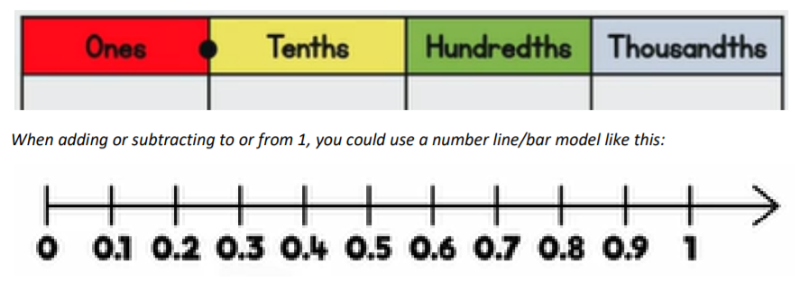

Something Different...BBC Bitesize BBC

Bitesize are releasing a range of daily lessons, all previous lessons can still be accessed (they began on 20th April), they cover a variety of subjects and we have received some positive feedback about them. We especially liked the different foundation subject activities including:
• Science – Mixing, Dissolving and Separating
• Science – The Solar System
• Geography – The World
• Geography – An Introduction to Settlements
• Wellbeing – The Importance of Teamwork
• Music – Duration, Tempo and Beethoven
• Music – Singing with Feeling
• Religious Education – An Introduction to Islam

If you would like to have a look you can find them following the link: https://www.bbc.co.uk/bitesize/tags/zhgppg8/year-5-and-p6-lessons/1

Year 6:
English
Creative Writing Task – The Kitchen Takeover “Some vegetables are frozen for a very good reason. Don’t believe me? Then keep reading.”
Above is the opening paragraph of popular children’s book Supertato by Sue Hendra & Paul Linnet and it will be the theme for our creative writing task this week. For those who haven’t read the story, there is a link to it being read below:
https://www.youtube.com/watch?v=QlaMeNmTG6c
Your task is to create your own kitchen-based piece of writing where good defeats evil, inspired by the popular children’s story. You could even create a comic strip which will appeal to a younger audience. Remember, all great authors take inspiration from somewhere and the hope is the structure of ‘Supertato’ will enable you to complete the challenge. If you choose to go in a completely different direction with your inspiration, that is fine too.
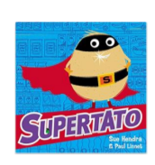
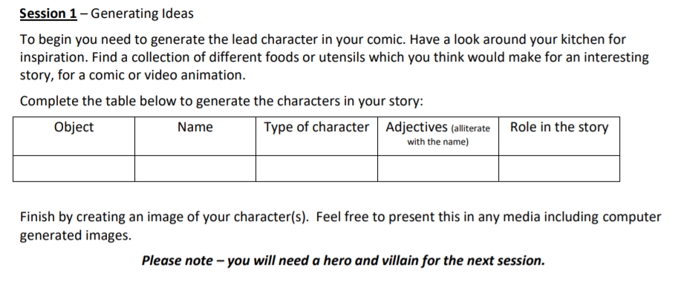
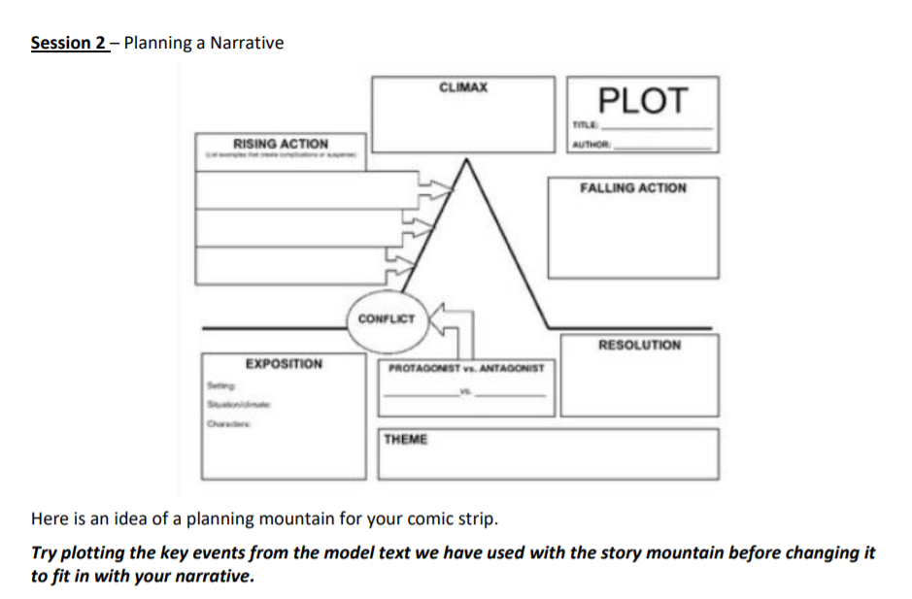

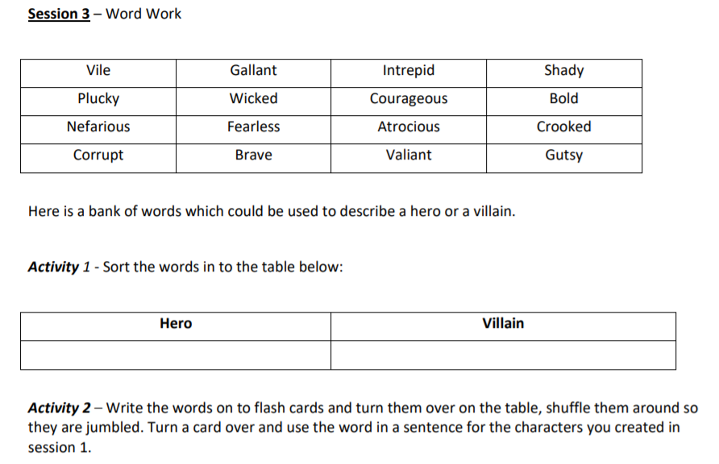

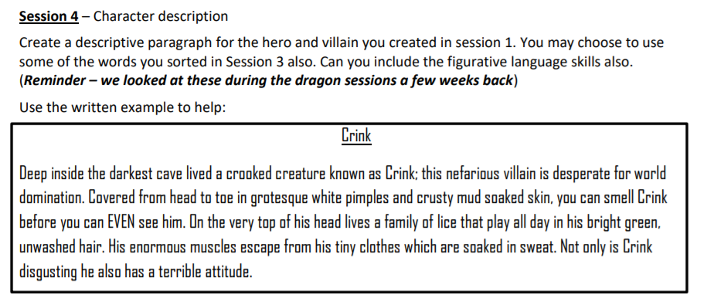

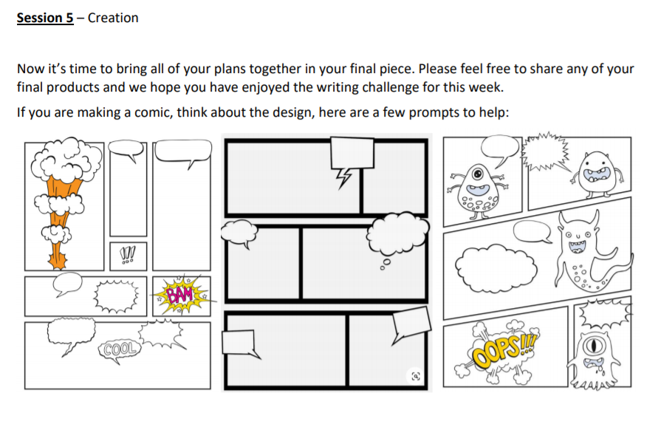

Maths:
White Rose Maths Lessons Week 3 – Angles (cont.)
Some of you may be at different stages with the White Rose resources due to various reasons. Please note – information in our letter is based on Summer Term Week 1. Summer Term Week 1 (20.04.20) on White Rose will continue to build on your work last week linked to angles. You can find the link to the suggested daily lessons here: https://whiterosemaths.com/homelearning/year-6/

Miss Murphy’s Top Tips:
• Vertically opposite angles share a vertex (point where two lines meet).
• Angles at a point on a straight line add up to 180° and the internal angles in a triangle total 180°.
• Remember the different types of triangles:
1) Equaliteral triangle – all sides are the same length and all internal angles are equal.
2) Isoceles triangle – two sides are the same length thus two internal angles will be equal.

3) Scalene – all sides and internal angles are different 4) Right-angled triangle – one internal angle is 90°.
• Triangles which have hatched marks on the sides indicate that they are the same measurement in length.
Optional tasks: Below are also some extra activities you can complete if you wish. Please feel free to share some answers with us through photos, written answers or scanned copies of your work
