Owl Class suggested home learning activities
Maths:
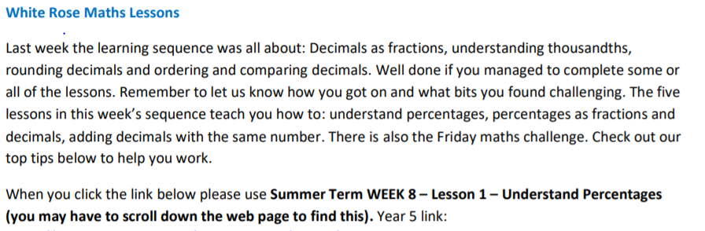
https://whiterosemaths.com/homelearning/year-5/

Miss Murphy’s Top Tips:
• Percent means out of 100, think of the word ‘cent’, century = 100 years
• 24/100 is written as 0.24 as a decimal.
• Remember 6/10 is the same as 60/100. Think of your equivalent fractions.
• Once you have a fraction out of 100, you can easily turn it into a percentage. 45/100 is 45%, 23/100 is 23%.
• When adding numbers with the same number of decimal places, make sure you think about your layout and out numbers in the correct column.
• When adding numbers with a different amount of decimal places, use a place holder to help you. For example 0.34 is the same as 0.340. Use a grid like the one below if you need to:
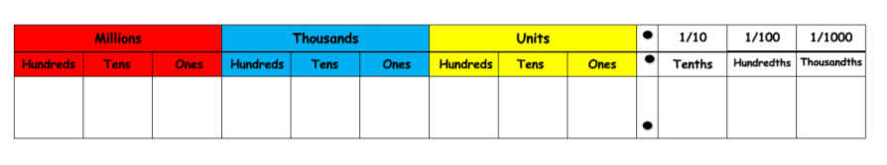

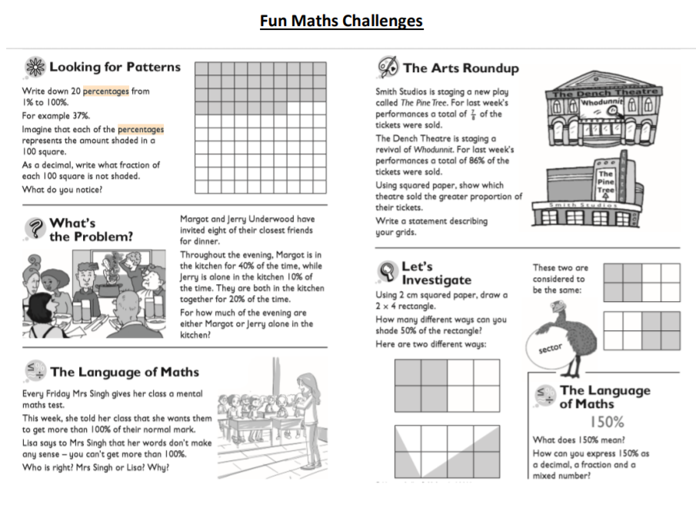

English:
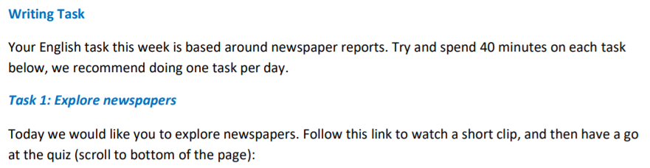
http://www.bbc.co.uk/bitesize/ks2/english/writing/newspapers/read/1/
