Owl Class suggested home learning activities
English
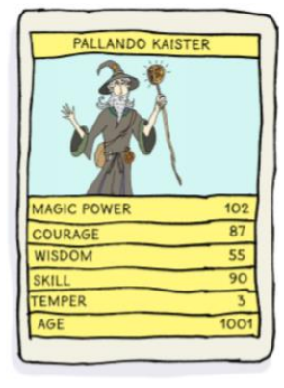
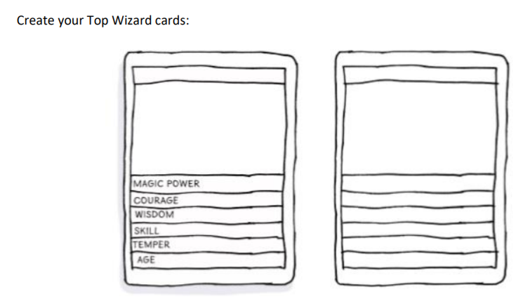
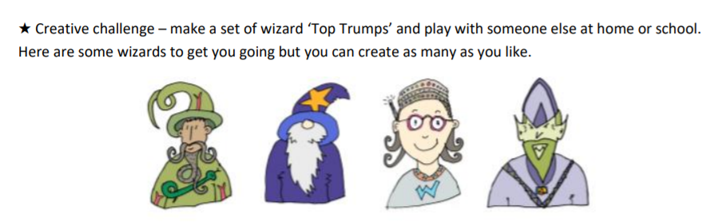
If you don’t know how to pay Top Trumps you can find out here: http://www.toptrumps.com/how-to-playtoptrumps/

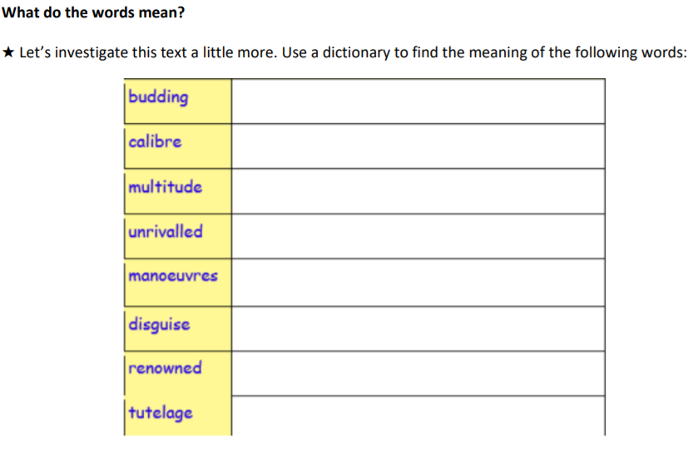
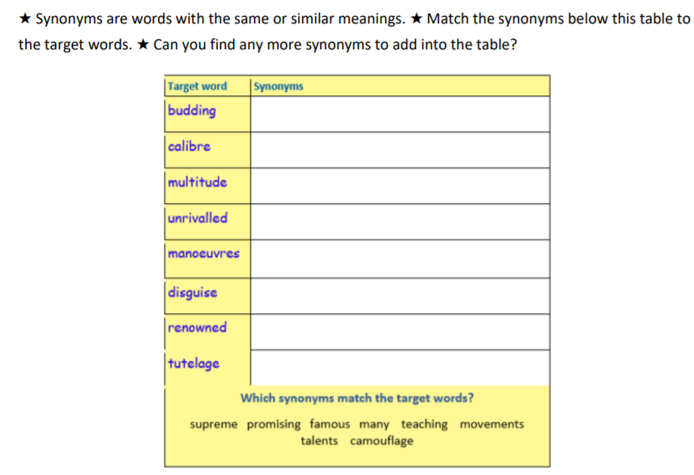
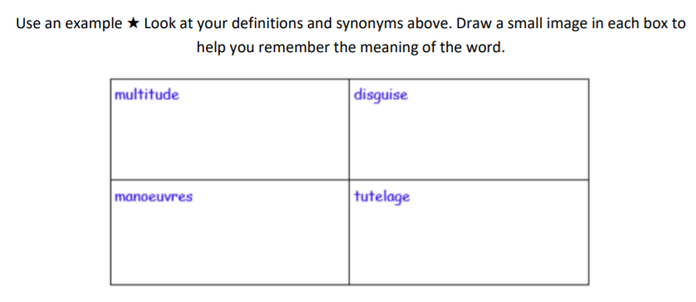
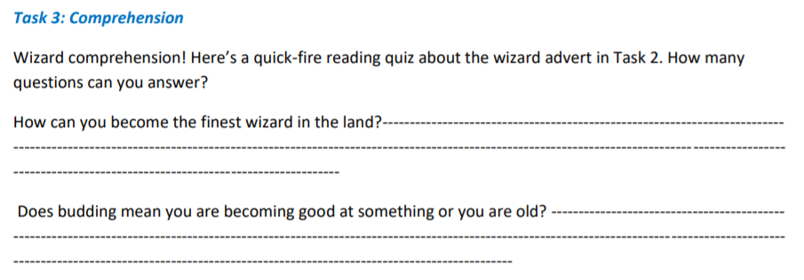

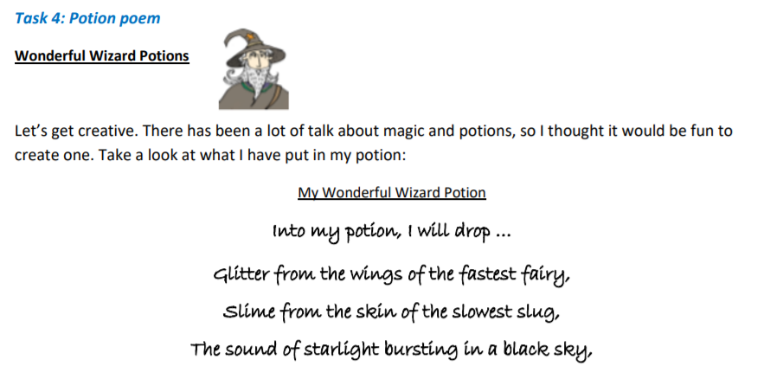

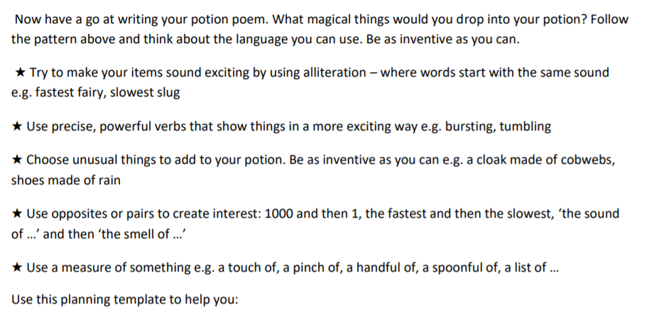
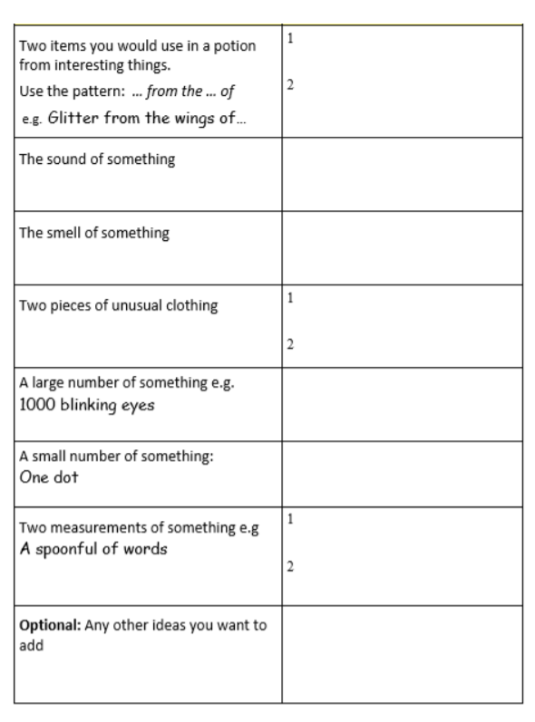

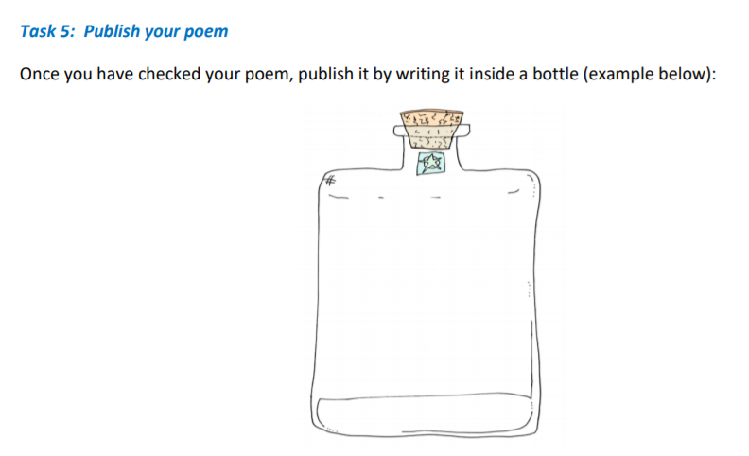

Don’t forget to email a copy of your poem to Miss Murphy at info@parkside.kent.sch.uk

Maths
White Rose Maths Lessons

White Rose Maths Lessons Last week the learning sequence was all about: : understanding percentages, percentages as fractions and decimals, adding decimals with the same number of decimal places and adding decimals with a different number of decimal places. Well done if you managed to complete some or all of the lessons. Remember to let us know how you got on and what bits you found challenging. The five lessons in this week’s sequence teach you how to: Subtract decimals with the same number of decimal places, subtract decimals with different number of decimal places, multiply decimals by 10, 100, 1000 and divide decimals by 10, 100 and 1000. There is also the Friday maths challenge. Check out our top tips below to help you work.

When you click the link below please use Summer Term WEEK 9 – Lesson 1 – Subtracting decimals with the same number of decimal places (you may have to scroll down the web page to find this). Year 5 link: https://whiterosemaths.com/homelearning/year-5/

Miss Murphy’s Top Tips:
- Percent means out of 100, think of the word ‘cent’, century = 100 years
- 24/100 is written as 0.24 as a decimal.
- Remember 6/10 is the same as 60/100. Think of your equivalent fractions.
- Once you have a fraction out of 100, you can easily turn it into a percentage. 45/100 is 45%, 23/100 is 23%.
- When subtracting numbers with the same number of decimal places, make sure you think about your layout and put numbers in the correct column.
- When subtracting numbers with a different amount of decimal places, use a place holder to help you. For example 0.34 is the same as 0.340.
- When multiplying or dividing by 10, 100, 1000 use a grid (like below if you need too), remember multiplying makes the answer bigger, and dividing makes the answer smaller.
- You could use the inverse to check your answers (add/subtract, divide/multiply) Use a grid like the one below if you need to:

