Year 3 English Home Learning
Week 1 Poetry:
Day 1:
Firstly read the poem through a few times so you get used to the words and the rhythm.
What features can you spot?
Can you underline or write down any repeating phrases or lines?
Can you underline the verbs in yellow, adjectives in green and nouns in orange?
What do you notice about the order of these word types?
Are they in a repeating pattern? How many verses does it have?

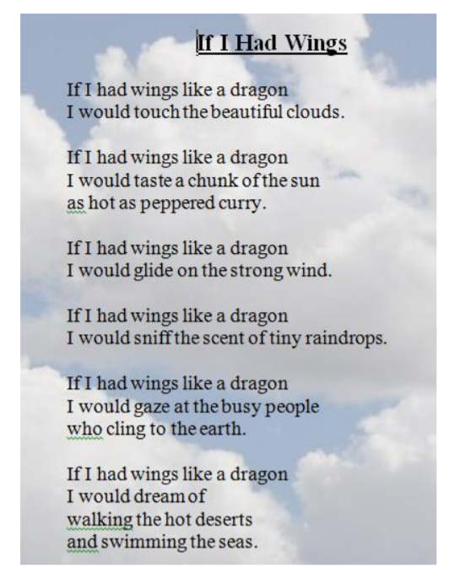

Day 2:
Brainstorm some ideas about what you would do if you had wings for a day.
You might like to watch this clip to help with your ideas; https://www.youtube.com/watch?v=pI63Rbxml5U

Day 3: Begin writing down ideas for your poem thinking about what you would do if you had wings for a day.Try to use the most interesting adjectives and verbs and even adverbs that you can think of. The lists below might help you.
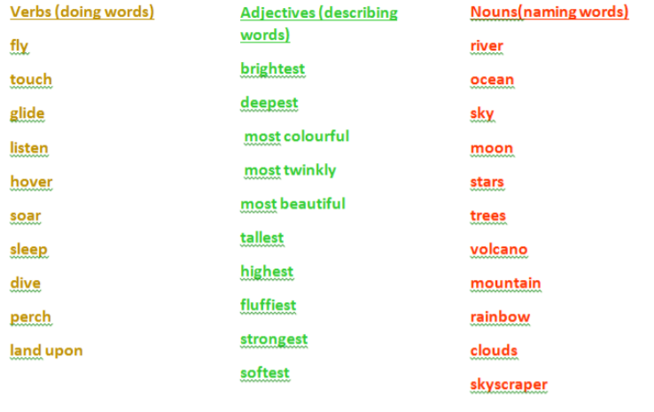
For example;
I would touch the most shimmering stars in the beautiful night sky.
I would glide majestically over the tallest snow-capped mountains.

Day 4:
Now that you have your ideas you can write your poem! Remember to follow Pie Corbett’s structure. You might want to change the flying creature to an eagle, an alicorn or even a hippogriff. Try to create four to six verses

Verse 1: If I had wings like a hippogriff
I would soar elegantly over huge green forests.
Verse 2: If I had wings like a hippogriff I would glide gently across crystal lakes, trailing my talons in their cool waters.

Day 5:
Finally you could try to learn your poem off by heart. Making up actions will help you to remember the words. Practice performing your poem using expression to bring you poem to life. Then perform your poem to an audience.

Week 2
We would like you to write us a “what am I?” riddle so we can try to guess the animal you are describing by the clues you have given us, try not to make them too hard for us!
Can you guess the animal we are describing?

I am the biggest cat in the world,
I have orange, black and white stripes which help me to blend into the forest,
Unlike other cats I am very good at swimming,
My favourite food is deer and pigs,
What am I?
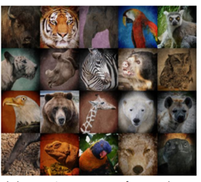

Day 1:
Your first job is to choose an animal. It can be any type of animal a pet, a bird or even a reptile.
Next spend some time researching some interesting facts about your chosen animal. Here are some websites that may help you or I am sure some of you may have some non-fiction books at home to help you
https://www.natgeokids.com/uk/category/discover/animals/
https://animalfactguide.com/animal-facts/

Day 2: Now you have researched your chosen animal you are ready to start writing your riddle.
Remember to start each clue on a new line, use capital letters, make your clues as interesting as you can and finish your riddle with what am I?

Day 3: Draw a picture of your animal to go with your riddle and make a flap to hide it under so people at home can see if they have guessed correctly.

Day 4: Now create a fact file about your chosen animal. Draw a picture and label your animal.

Day 5: Finish your factfile by including facts about what they eat, where they live and other interesting facts you have found out.

