Year 2 English Home learning

Week 1 – Descriptive Writing
Day 1: Using this picture as a starting point, draw and describe the magical plant, which might grow from these beans.
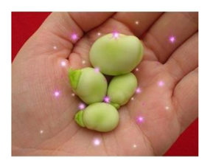
Day 2: With your grown up, look at the plant you drew describe each part of the plant using your best adjectives – look at this list of words to help you.
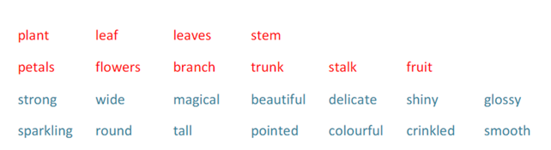

Day 3: Try and write 5 sentences to describe your magical plant using the words from yesterday.
You could start with: They looked out the window and saw…

Day 4: Now think about where you would be transported to if the magical plant you designed could be climbed or give a character magical powers. Now choose a setting (use the pictures below to help you or think of your own!) and draw where your magical plant will take you!
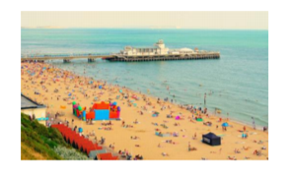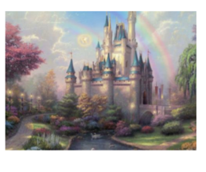

Day 5: Today we would like you to think of exciting adjectives to describe each part of the picture and then think about what you might hear and how you might feel if you were there. Write sentences to describe your settings – remember your capital letters and full stops. Try and use ‘and’ to join ideas

Week 2 – Instructions
Day 1: We would like you to make something at home - it could be anything from making a jam sandwich, a model rocket or an assault course in the garden! While you’re making it, we would like you to think about each step as you go.

Day 2: Today we would like you to draw each step of your instruction and label each step 1,2,3 etc to help you with your writing tomorrow.

Day 3 and Day 4: Over these two days you are going to write your instructions for your chosen item. Try and avoid using the word ‘you’ – it’s a challenge! Use the writing frame and the vocabulary below to help you.
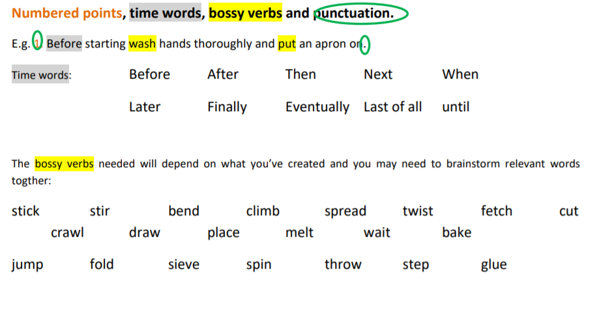
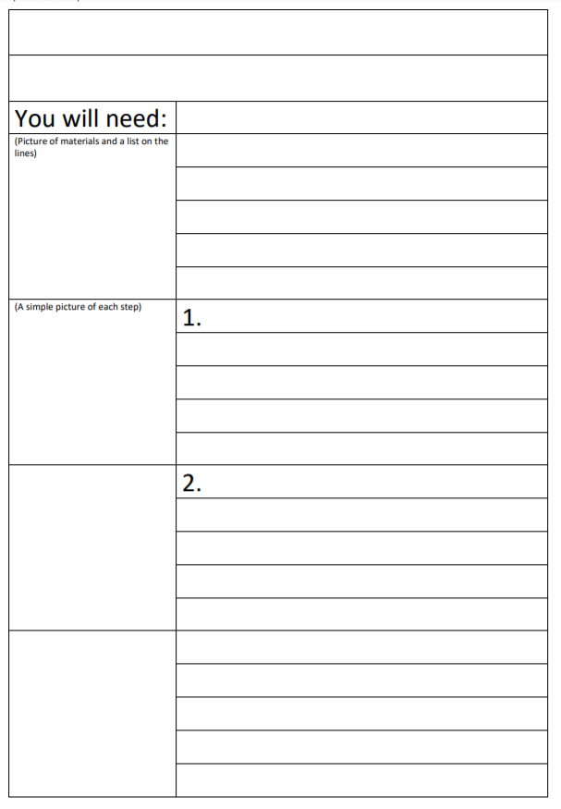

Day 5:
Today see if someone else in your household can follow your instructions! Can you edit – improve – your instructions in any way? Did you add numbers? Are your words clear enough? Do they make sense? Did you add ‘bossy’ verbs?

